
SANDRINGHAM COLLEGE
YEAR 7 MATHS



Topic 1: Integers and Algebra

Contents
Introduction 3
1. Adding and subtracting integers 5
2. Order of operations 13
3. Substitution 21
4. Solving Equations 28
5. The Cartesian plane 37
Early Finisher Activities 47

Introduction
This booklet covers 5 Big Ideas of Integers and Algebra. They are:
- Adding and subtracting integers
- Order of operations
- Substitution
- Solving
- The Cartesian Plane
There are two goals of our year 7 maths program: making progress and having fun!
To ensure all student are appropriately challenged and have opportunities to progress we have broken most Big Ideas into 3 skills of increasing difficulty.
- Skill A: Entry skill
- Skill B: Core skill
- Skill C: Enrichment skill
We have also created two levels of questions for each skill: Routine and Stretch.
To increase the Fun-Factor, the booklet contains lots of games, puzzles and investigations that can be used as early finisher activities and/or whole class activities.
Minimum Expectations
It is through regular practice and high expectations that you will maximise your progress in maths!
There are three things that will need to be included before work is considered complete:
- Copying of the question if in blue text – if it is in blue it is in our books!
- Inclusion of working out (where appropriate)
- Corrections. A tick ✓ if correct and retry until correct if incorrect.
In most cases, your teacher will require you to complete at least one set of questions for each big idea. Most students will start with Routine Questions at the Core Level, though there are options to move onto more challenging questions or less challenging questions as needed.
Assessed Learning Task (ALT)
At the end of the unit you will complete an ALT.
All skill based ALT questions will be developed from the questions in this book. All application questions will be of a similar structure, though not always familiar.
Most students will complete the mainstream ALT focusing on Core Level skills, though some students will complete a modified ALT focusing on Entry Level skills and others will complete an Enhanced ALT focusing on Enrichment Level Skills. Decisions around which ALT each student will do will happen towards the end of the topic ☺
You will be allowed to bring your maths workbook into the ALT and so there is great incentive to complete as many stretch questions as you can!!

MATHS BOOKWORK
Students’ bookwork will be assessed each unit. Below is the marking scheme and a sample page.
Workbook Assessment Schema Date: | 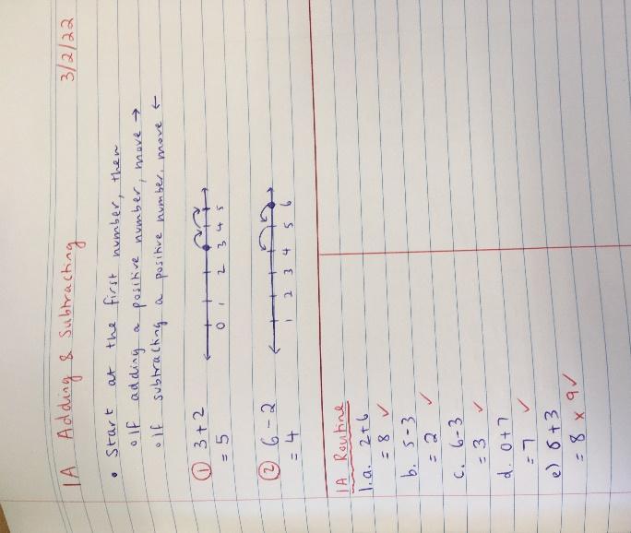
  Not Shown = 0 Very Low = 1 Low = 2 Satisfactory = 3 High = 4 Excellent = 5
  - I use a separate book for maths work only – and it is sequential
  - Each section includes a margin, headings and appropriate date
  - My workbook is neat and clear. It does not contain graffiti or blank pages
  - I have accurately recorded the class notes/examples for each lesson
  - I keep photocopied and loose leaf sheets in an organised manner with the workbook
  - My solutions include diagrams, correct units and working out
  - My working out demonstrates my understanding of skills and concepts learnt in this topic
  - My Rubric is pasted in my workbook AND is up to date
  - My workbook shows evidence of self-assessment/marking and action taken to address errors
  - My workbook is consistently up to date
  - All set class tasks have been completed
  Teacher Initials /25 %

Adding and subtracting integers

Setting the Goal
Learning intention:
- What are integers?
- How do we add and subtract integers?
- Why do we use a number line to model adding and subtracting of integers?
Success criteria: I know where to start and I know which way to go.

Key words
Addition is the process of adding two numbers. Eg. $3+2$ is an addition question.
Subtraction is the process of taking one number away from another. Eg. $3-2$ is an subtraction question.
The integers are made up of positive whole numbers, negative whole numbers and zero. Eg. 3, -4 and 0 are integers. -4.5 and $\frac{1}{2}$ are not integers.

Skill A: Entry skill

Activate prior knowledge
How many dots are here? How can you group the dots to count them more efficiently?
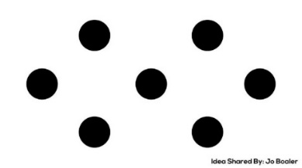

Explicit teaching
[NEW PAGE] 1A: Adding and subtracting
Workbook tips:
Start every new set of notes on a new page.
Blue text is intended as board notes that you would write into your workbook
- Start at the first number, then
  - If adding a positive number, move $→$,
  - If subtracting a positive number, move $←$

Worked Examples:
1. $3+2$ |  |  | 2. $6-2$
What we write:  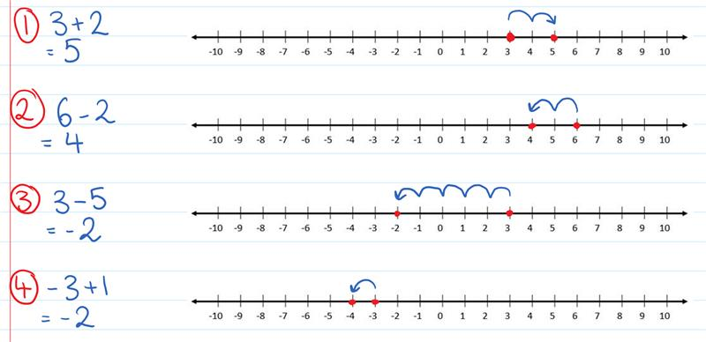 |  | What we think:  1. Start here  2. Move in the positive direction  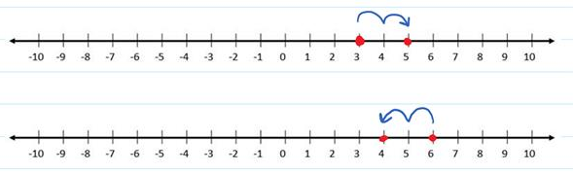  2. Move in the negative direction  1. Start here
Your turn:
1. $4+3$ |  |  | 2. $5-4$

PRACTICE
Workbook tip: Write out and answer questions one at a time.
Don’t copy all questions at once.
Use the answers link as often as you need to minimise errors.

1A Routine questions
- Calculate the following using a number line to assist your calculations if helpful. 4First Five Live
- $2+6$ | - $5-3$ | - $6-3$ | - $0+7$
- $6+3$ | - $10-8$ | - $3+6$ | - $2-1$
- $1+9$ | - $6+2$ | - $6-2$ | - $4-1$
- $4+6$ | - $4-4$ | - $7-3$ | - $1+1$
- $7-5$ | - $2+8$ | - $0+9$ | - $3-3$

☑ Correction Time! Click here for answers
Workbook tip: Copy all blue text into your workbook.
You do not need to copy black text

1A Stretch questions
- Jennifer works at the school canteen.
  - Chin buys some items costing $3 and pays with a $5 note. How much change does Chin receive?
  - In the fridge, there are 4 stacks of muffins, 7 stacks of brownies and 5 stacks of sausage rolls. How many stacks of dessert are there?
  - Write the addition sentence that fits this: “Jennifer prepares 3 new recipes for the next month. On top of the original 9 recipes she has, she has a total of 12 recipes.”
- The following questions are in groups as the answers to previous questions help with future ones.
a.i. $50+30$  ii. $7+9$  iii. $57+39$ | b.i. $30+80$  ii. $5+7$  iii. $35+87$ | c.i. $92-30$  ii. $92-37$ | d.i. $81-50$  ii. $81-57$
- Calculate the following sums mentally.
- $27 + 48$ | - $56 + 25$ | - $57+29$ | - $48 + 46$
- Calculate the following sums mentally.
- $43-37$ | - $63-49$ | - $84-25$ | - $83-38$


- Place the numbers 1, 2, 3, 4, 5 and 6 into the six circles so that:
  - Each side sums to 9
  - Each side sums to 10
  - (Optional) What other side sums can you create using the numbers 1-6? Explain why no other sums can be made.

☑ Correction Time! Click here for answers to MOST questions

Finished Early? Head to the Early Finishers Page to engage in a game, puzzle or investigation.

Skill B: core skill

Activate prior knowledge
Activity One: Think, pair, share:
      - How can a number line be used to calculate $3+2$?
      - How can a number line be used to calculate $3-2$?
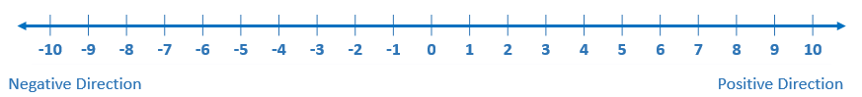
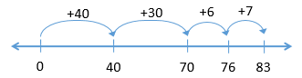
Challenge: The diagram shows how a number line can be used to model $46+37$. Can you find some other ways? Share your thinking with a peer.

Activity Two: Using a drawing of a thermometer from $-5℃$ to $5℃$ . Answer the following questions:
1. What is the new temperature it if was $3℃$ and then decreased by $4℃$?
2. What is the new temperature it if was $-2℃$ and then increased by $5℃$?

Activity Three: Where else do negative numbers appear in the world we live in?

Explicit Teaching
[NEW PAGE] 1B: Adding and subtracting a positive integer
Workbook tips:
Start every new set of notes on a new page.
Blue text is intended as board notes that you would write into your workbook
- Start at the first number, then
  - If adding a positive number, move $→$,
  - If subtracting a positive number, move $←$

Worked Examples:
Calculate the following then check the answer on your calculator.
1. $3-5$ |  |  | 2. $-2+5$
What we write: |  | What we think:  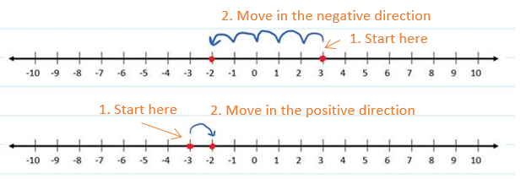  Workbook tip: Write out and answer questions one at a time.  Don’t copy all questions at once.  Use the answers link as often as you need to minimise errors.
Your turn:
1. $-2-1$ |  |  | 2. $-3+2$

Practice

1B ROUTINE QUESTIONS
- Calculate the following using a number line to assist your calculations. Check some answers on your calculator.
4First Five Live
- $1-5$ | - ${}_{}^{-}2-1$ | - ${}_{}^{-}3+2$ | - ${}_{}^{-}2+3$ | - ${}_{}^{-}2+5$
- ${}_{}^{-}5+2$ | - $0-1$ | - ${}_{}^{-}6+2$ | - ${}_{}^{-}2-2$ | - ${}_{}^{-}1+0$
- $3-3$ | - $3-1$ | - ${}_{}^{-}2-4$ | - ${}_{}^{-}1-3$ | - $6-1$
- ${}_{}^{-}4+3$ | - ${}_{}^{-}6+4$ | - ${}_{}^{-}5+2$ | - $1-2$ | - ${}_{}^{-}1+1$
☑ Correction Time! Click here for answers
Workbook tip: Copy all blue text into your workbook.
You do not need to copy black text

1B STRETCH questions
- Answer the following worded question:
  - Anoushka has a debt of $71. Once she’s paid back $55 how much debt will remain?
  - Noraiz has $92 of debt and borrows another $38. How much debt does he have now?
  - The reading on a thermometer falls 22°C from −4°C. What is the final temperature?
  - The reading on a thermometer rises 22°C from −4°C. What is the final temperature?
- Complete the following additions and subtractions.
- $65-80$ | - $-19-74$ | - $-47+11$ | - $-80+26$
- $-11-44$ | - $-62+11$ | - $68-46$ | - $-10-96$
- What number needs to go in each box to make the equation true?
- $\boxed{}+35=-24$ | - $24-\boxed{}=-17$ | - $\boxed{}+25=16$

- Jo says $-21+57$ is an addition question, and Hayden says it is a subtraction question. Explain why each person is partially correct.

☑ Correction Time! Click here for answers
Finished Early? Head to the Early Finishers Page to engage in a game, puzzle or investigation.

SKILL C: ENRICHMENT SKILL

Key workds
An operation combines numbers in a specific way. The most common operations in mathematics are: $+$, $-$, $×$ and $÷$
The sign of a number refers to whether it is positive or negative.

Activate prior knowledge
What numbers could be put into the boxes? Check your answer using a number line and on your calculator.
1. $-5+\boxed{}=positive number$ | 2. $5-\boxed{}=positive number$
3. $-5+\boxed{}=negative number$ | 4. $5-\boxed{}=negative number$

Explicit Teaching
[NEW PAGE] 1C: Adding and subtracting a negative number
- If an operation touches a sign, combine
  - $+{}_{}^{-}→ -$
  - $-{}_{}^{-}→$ $+$
- Calculator
  - take away: $-$
  - negative: $(-)$

Worked Examples:
1. $3+{}_{}^{-}2$ | 2. $3+{}_{}^{-}5$ |  | 3. $3-{}_{}^{-}2$ | 4. $-3-{}_{}^{-}2$
What we write:  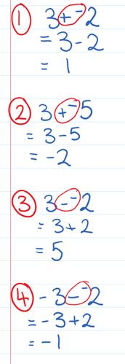 |  | What we think:  “An operation is touching a sign, let’s combine!”  $+{}_{}^{-}→ -$  Start at 3, move down 2.  “An operation is touching a sign, let’s combine!”  $+{}_{}^{-}→ -$  Start at 3, move down 5.  “An operation is touching a sign, let’s combine!”  $-{}_{}^{-}→$ $+$  Start at 3, move up 2  “An operation is touching a sign, let’s combine!”  $-{}_{}^{-}→$ $+$  Start at -3, move up 2
Your turn:
1. $4+{}_{}^{-}2$ | 2. $4+{}_{}^{-}5$ |  | 3.$4-{}_{}^{-}2$ | 4. $-4-{}_{}^{-}5$

Practice

1C ROUTINE QUESTIONS
- Calculate the following using a number line to assist your calculation. 4First Five Live
- $3+{}_{}^{-}4$ | - $1-{}_{}^{-}3$ | - ${}_{}^{-}2+{}_{}^{-}2$ | - $4-{}_{}^{-}5$ | - $3+{}_{}^{-}2$
- ${}_{}^{-}3-{}_{}^{-}4$ | - $0+{}_{}^{-}2$ | - $4-{}_{}^{-}1$ | - ${}_{}^{-}2+{}_{}^{-}3$ | - ${}_{}^{-}4-{}_{}^{-}4$
- $4+{}_{}^{-}3$ | - $3+{}_{}^{-}7$ | - ${}_{}^{-}3+{}_{}^{-}3$ | - $0-{}_{}^{-}3$ | - $4+{}_{}^{-}9$
- ${}_{}^{-}5-{}_{}^{-}4$ | - $2-{}_{}^{-}4$ | - ${}_{}^{-}1+{}_{}^{-}3$ | - ${}_{}^{-}4+{}_{}^{-}5$ | - $3-{}_{}^{-}4$
☑ Correction Time! Click here for answers

1C STRETCH questions
- Joe is playing a game with a regular die. If the number that turns up is even, he will gain 5 times the number that comes up. If it is odd, he will lose 10 times the number that comes up. He tosses a 3, then a 4 and then a 5. What is Joe’s final score?
- Calculate the following.
- ${}_{}^{-}{57}+{}_{}^{-}{39}$ | - $84-{}_{}^{-}{37}$ | - ${}_{}^{-}{137}-{}_{}^{-}{286}$ | - $367+{}_{}^{-}{886}$

- Complete the following questions then comment on what you notice about the answers:
- ${}_{}^{-}{37}+86$ | - ${}_{}^{-}{37}-86$ | - ${}_{}^{-}{37}-{}_{}^{-}{86}$ | - ${}_{}^{-}{37}+{}_{}^{-}{86}$
- $37+86$ | - $37-86$ | - $37-{}_{}^{-}{86}$ | - $37+{}_{}^{-}{86}$

- Below is an example of a simple addition table. Notice how the numbers in the white section are the sum of the number in the grey row above it and the grey column to its left.
+ | 2 | 5
2 | 4 | 7
6 | 8 | 11
Complete the addition table below.
+
 | $${}_{}^{-}2$$ | $${}_{}^{-}9$$ |  |  | 3
 |  | 4 |  | 10
 |  |  |  | 6 | 12
$${}_{}^{-}5$$ |  |  | 5
 | $${}_{}^{-}7$$ |  | 2

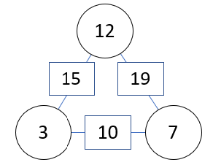
- Here is an arithmagon. Notice how the numbers in the rectangles are the sums of the two numbers in the circles on either side. Complete the following arithmagons.
a.  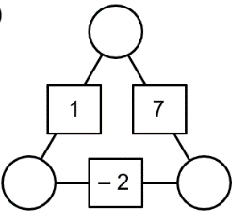 | b.  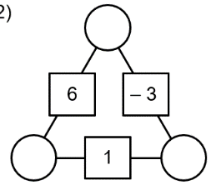 | c.  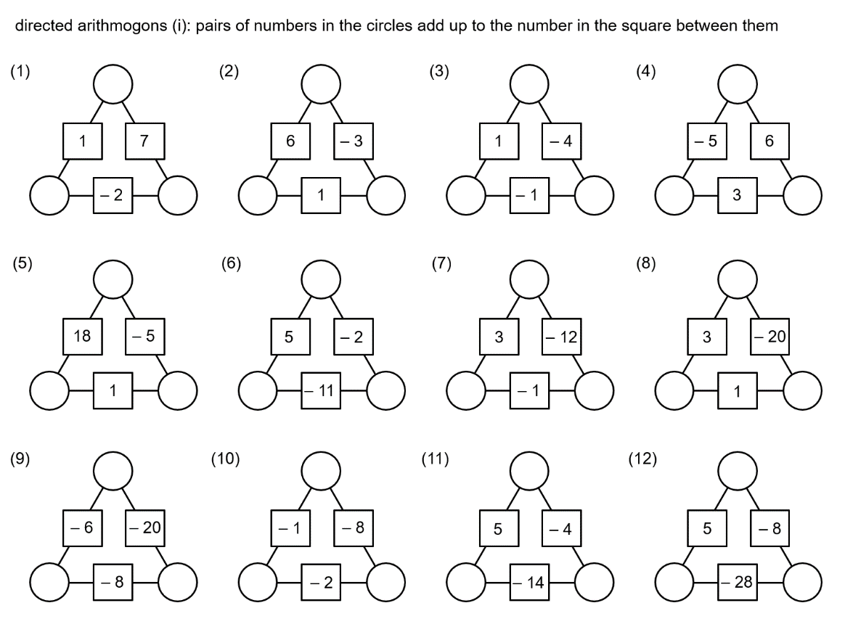
d.  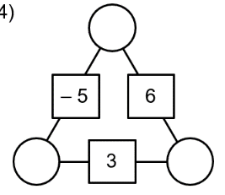 | e.  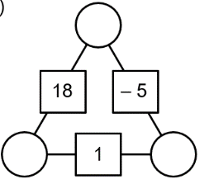 | f.
☑ Correction Time! Click here for answers
Finished Early? Head to the Early Finishers Page to engage in a game, puzzle or investigation.
In Summary…
𝅘𝅥𝅯𝅘𝅥𝅯 Addition and subtraction are really big words and need to be handled with care 𝅘𝅥𝅯𝅘𝅥𝅯
𝅘𝅥𝅯𝅘𝅥𝅯 Get your number line out, look at the first number and put your finger there 𝅘𝅥𝅯𝅘𝅥𝅯
𝅘𝅥𝅯𝅘𝅥𝅯 The only thing to know is which way to go and it’s easy so don’t you frown 𝅘𝅥𝅯𝅘𝅥𝅯
𝅘𝅥𝅯𝅘𝅥𝅯 To plus positive or take negative go up if not go down 𝅘𝅥𝅯𝅘𝅥𝅯

Skill 1 Application Questions – Think, Pair, Share/Teacher Modelling
Answer the questions you can. Explain your reasoning for at least one of the questions.
You may use your calculator at any time.
1. | 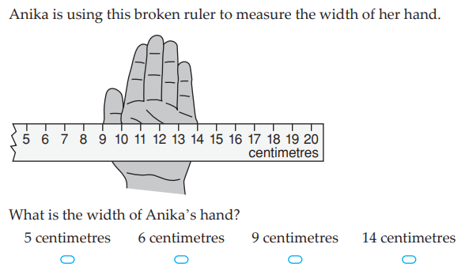
2. | 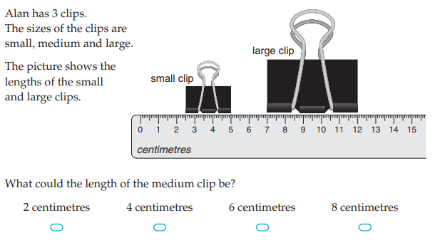
3. | Maria entered a challenging computer competition and there were 30 questions. For every correct answer she was awarded 3 points and for every incorrect answer 1 point was deducted. Maria attempted all the questions and her total score was -2. How many questions did Maria answer correctly?
4. | Leo the rabbit is climbing up a flight of steps. Leo can only hop up one or two stairs each time he hops. He never hops down, only up.  - How many different ways can Leo hop up a flight of 2 steps?  - How many different ways can Leo hop up a flight of 3 steps?  - How many different ways can Leo hop up a flight of 4 steps?  - How many different ways can Leo hop up a flight of 5 steps?  - How many different ways can Leo hop up a flight of 6 steps?  - How many different ways can Leo hop up the flight of 10 steps?  Further exploration: What if Leo could hop 1, 2 or 3 steps at a time?

Skill 1 Reasoning Questions

Entry | Core | Advanced
3 + 5 = 8. How can you show that this is true? | John says -3+5=-2 û. How could you convince John that he is incorrect? | A negative plus a positive is a negative. Is this sometimes, always or never true. Give reasons.

COLLABORATIVE TASK:
Strike it Out (nrich activity)
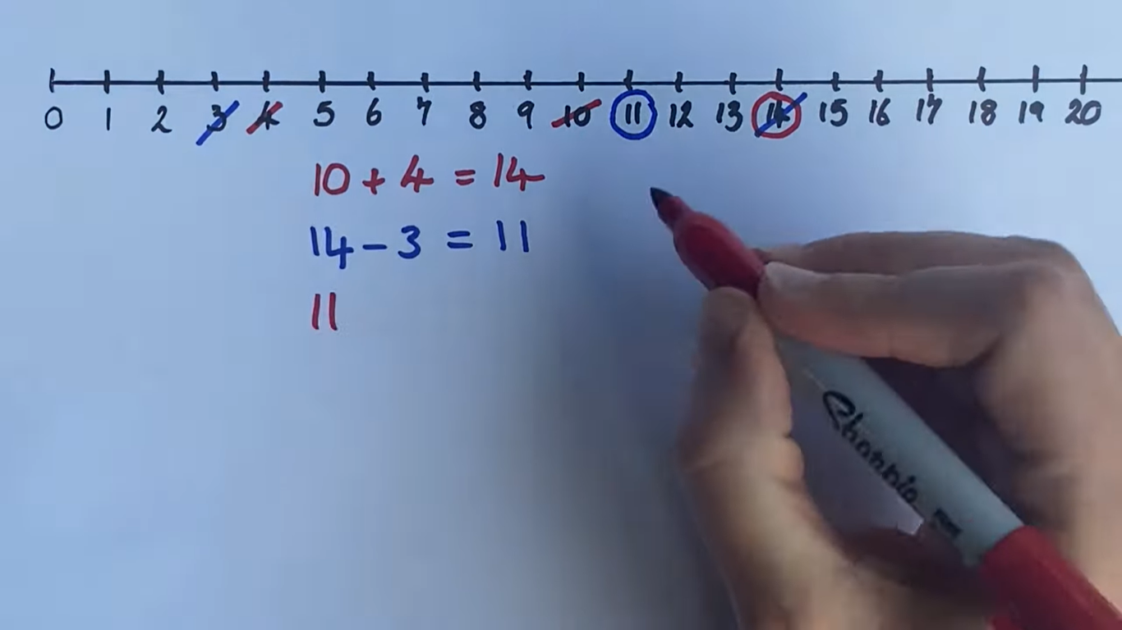

Assessment for Learning
Your progress will be monitored through your classwork and weekly homework sheets.

Reflection and Recognition
Let’s reflect on some key questions. Choose one or more of the questions below to answer.
- What are integers?
- How do we add and subtract integers?
- Why do we use a number line to model adding and subtracting of integers?
Let’s recognise something that went well and something that could be improved.
- What component of this work caused the most growth in your learning?
- Is there anything you’d like to improve?

Order of operations

Setting the Goal
Learning intention:
- What is the order that operations need to be computed in?
- How do we need to set out our work?
- Why do we need to calculate operations in a set order every time?
Success criteria: I know the order of operations AND can complete one operation in each line of working

Key words
An operation combines numbers in a specific way. The most common operations in mathematics are: $+$, $-$, $×$ and $÷$

Skill A: Entry skill

Activate prior knowledge
Let’s do one or more of these as a “think, pair, share.”
1. Suppose you didn’t know the answer to $6×7$, how could you work it out? How many different ways could you do this?
2. Suppose you didn’t know the answer to $48÷6$, how could you work it out? How many different ways could you do this?
3. How many different answers can you make using pairs of the following numbers 1, 2, 6, 8 and the four operations $+,-,×,÷$?

Explicit teaching
[NEW PAGE] 2A: The four basic operations
- The four basic operations are:
  - Addition $+$
  - Subtraction $-$
  - Multiplication $×$
  - Division $÷$

Worked Examples:
1. $4+3$ | 2. $6-2$ |  | 3. $3×5$ | 4. $6÷2$
What we write:  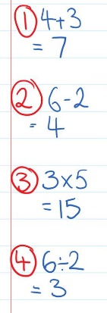 |  | What we think:  Start at 4 and count up 3. 4, 5 6 7  Start at 6 and count down 2. 6, 5 4  3 groups of 5. 5+5+5=15  How many groups of 2 in 6? 2, 4, 6, so 3 groups
Your turn:
1. $7+2$ | 2. $5-1$ |  | 3. $6×2$ | 4. $15÷3$

PRACTICE

2A Routine questions
- Calculate the following. 4First Five Live
- $4×6$ | - $14-8$ | - $18÷6$ | - $15+6$
- $18÷9$ | - $5×7$ | - $12+8$ | - $12-6$
- $11+7$ | - $12÷4$ | - $12-5$ | - $7×6$
- $21÷7$ | - $12×7$ | - $11-4$ | - $11-8$
- $18-9$ | - $16+8$ | - $8×6$ | - $18÷2$

☑ Correction Time! Click here for answers

2A Stretch questions
- The class is doing a math activity. There are 5 groups of 4 students.
  - How many students are there in the class?
  - Each group should have 2 pairs of scissors. How many pairs of scissors are needed in total?
  - Each student should get 2 worksheets and 3 sheets of construction paper. How many sheets of construction paper would each group of students have?

- What number needs to go in each box to make the equation true?
- $\boxed{}-3=7$ | - $3×\boxed{}=15$ | - $\boxed{}÷6=9$ | - $14+\boxed{}=5$

- Complete the following sums.
- $43+57$ | - $50-43$ | - $43-50$ | - $40-72$
- The following questions are in groups as the answers to previous questions help with future ones.
a.i. $3×5$  ii. $10×5$  iii. $13×5$ | b.i. $7×6$  ii. $10×6$  iii. $17×6$ | c.i. $3×9$  ii. $30×9$  iii. $27×9$ | d.i. $50×7$  ii. $2×7$  iii. $48×7$

- The following questions are in groups as the answers to previous questions help with future ones.
a.i. $50÷5$  ii. $15÷5$  iii. $65÷5$ | b.i. $60÷6$  ii. $48÷6$  iii. $108÷6$ | c.i. $270÷9$  ii. $36÷9$  iii. $234÷9$ | d.i. $350÷7$  ii. $42÷7$  iii. $392÷7$

☑ Correction Time! Click here for answers
Finished Early? Head to the Early Finishers Page to engage in a game, puzzle or investigation.

Skill B: core skill

Activate prior knowledge
Activity 1: Enter the below sum on your calculator. What answer do you get?
$$3+5×2$$

Activity 2: The Game of 24
In each puzzle you need to make the number 24 by using all 4 numbers and one or more of the following + - × / and ( ). The numbers can be used in any order.
Challenge: Can you give your answers as a single equation? The first one is done for you as an example. Check your answers on your calculator as you go.
- 1, 2, 3, 10  Ans: $2×10+3+1$ | - 10, 10, 10, 6 | - 3, 6, 6, 1 | - 1, 2, 3, 4
- 3, 3, 4, 6 | - 1, 1, 4, 10 | - [DIFFICULT] 6, 6, 6, 9 | - [V. DIFFICULT] 3, 3, 8, 8
Remember the workbook tips:
Start every new set of notes on a new page.
Blue text is intended as board notes that you would write into your workbook

Explicit Teaching
[NEW PAGE] 2B: Order of Operations
- When more than one operation is present operations must be completed in a specific order
  - B: Brackets (and other groupings)
Workbook tip: It is intended that black text is not copied into student workbooks
  - I: Indices (powers)
  - D,M: $÷$ and $×$from left to right
  - A,S: $+$ and $-$ from left to right
Step 1. Underline the part to be calculated first
Step 2. Underneath, copy anything not underlined, write the answer to the underlined part.
Step 3. Repeat Steps 1 and 2 until no operations remain.

Worked Examples:
1. $6×(2+3)$ |  | 2. $7-4+6$ | 3. $7+8÷2$
What we write:  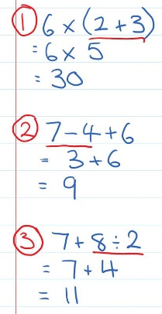 | What we think:  Brackets first, underline this calculation.  Copy the $6×$ as not underlined, calculate the underlined part.  Addition and subtraction are completed from left to right.  Calculate the underlined part, copy the $+6$ as not underlined.  Divisions are done before additions  Copy the $7+$ as not underlined, calculate the underlined part.
Your turn:
1. $4+12÷3$ |  | 2. $3×4÷6$ | 3. $7×5+2$

Practice

2B ROUTINE QUESTIONS
- Calculate the following. 4First Five Live
- $4×(3+2)$ | - $(35-5)÷10$ | - $6+4×3$ | - $20÷2×5$
- $3+5-2$ | - $8×(2+3)$ | - $(5+3)×2$ | - $3×(1+7)$
- $12÷3+9$ | - $4×6-4$ | - $(14-2)÷4$ | - $20-6×2$
- $6×6÷3$ | - $2×(3+5)$ | - $32-2+8$ | - $12÷3×4$
- $2×6+7$ | - $2×3+9$ | - $(3+9)÷12$ | - $(16+20)÷12$
☑ Correction Time! Click here for answers

2B STRETCH questions
- Sylvia bought 4 bananas for 50 cents each and 1 apple for 80 cents. Write a numerical expression to represent this situation and then find the total cost in cents then dollars.

- Calculate the following.
- $18÷9+60÷3$ | - $2×(9-4)÷5$ | - $33÷3×7+2×3$

- Insert brackets into these statements to make them true. Check if you are correct by completing the calculation with full working.
- $4+2×3=18$ | - $2×3+4-5=9$ | - $4+10÷21÷3=2$

- Decide if the brackets given in each statement are actually necessary; that is, do they make any difference to the problem?
- $2+(3×6)=20$ | - $22-(11-7)=18$ | - $2×\left(3+2\right)÷5=2$
- Insert one of the four standard operations in each box and use brackets as required to make each of the sums reach the target of 57. Each operation can be used more than once. Check if you are correct by completing the calculation with full working.
- $7 \boxed{} 8 \boxed{} 4 \boxed{} 3=57$ | - $18 \boxed{} 3 \boxed{} 32 \boxed{} 4=57$
- $10 \boxed{} 10 \boxed{} 14 \boxed{} 2=57$ | - $17 \boxed{} 10 \boxed{} 1 \boxed{} 3=57$
- (Optional) As in Q6 above, you will need to fill in the boxes with operations and use brackets as needed to make the equations true. No answers provided. Let’s see if you are a BIDMAS superstar!! The final two require use of fractions… good luck!!
- $2 \boxed{} 112 \boxed{} 2 \boxed{} 1=57$ | - $17 \boxed{} 10 \boxed{} 1 \boxed{} 3=57$
- $20 \boxed{} 1 \boxed{} 1 \boxed{} 3=57$ | - $19 \boxed{} 3 \boxed{} 8 \boxed{} 3=57$
☑ Correction Time! Click here for MOST answers
Finished Early? Head to the Early Finishers Page to engage in a game, puzzle or investigation.

SKILL C: ENRICHMENT SKILL

Activate prior knowledge
The Game of 24 again…
In each puzzle you need to make the number 24 by using all 4 numbers and one or more of the following + - × / and ( ). The numbers can be used in any order.
To practice your order of operations, give your answers as a single equation. The first one is done for you as an example. Check your answers on your calculator as you go.
- 2, 2, 6, 8  Ans: $(6-2)×(8-2)$ | - 2, 4, 4, 8 | - 2, 2, 4, 5 | - 1, 4, 5, 5
- 3, 8, 8, 9 | - 5, 6, 6, 8 | - 1, 3, 8, 8 | - 3, 4, 9, 9

Explicit Teaching
[NEW PAGE] 2C: Other mathematical operations
Note: Powers and square roots will be taught in greater depth in the third topic.
- Powers. Eg. $2^{3}=2×2×2=8$
- Square root. Eg. $\sqrt{49}=7$
- Factorials. Eg. $4!=4×3×2×1=24$
- If more than one operation ⇨ use BI[DM][AS]

Worked Examples:
1. $3!$ | 2. $4^{2}$ |  | 3. $\sqrt{81}$ | 4. $\sqrt{3!+2+2^{3}}$
What we write:  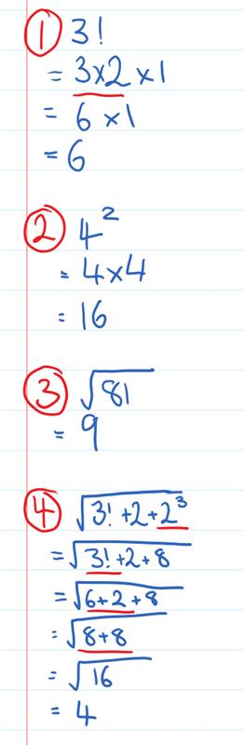 |  | What we think:  The factorial symbol ! tells us to multiply the numbers from 3 down to 1.  The power of 2 tells us that the four appears 2 times in the multiplication  Think: What numbered multiplied by itself makes 81?  B stands for brackets and other groupings. Complete the calculations within a square root sign before calculating the square root.
Your turn:
1. $5!$ | 2. $2^{4}$ |  | 3.$\sqrt{9}$ | 4. $\left(\sqrt{3^{3}-2}\right)!$

Practice

2C ROUTINE QUESTIONS
- Calculate the following. 4First Five Live
- $4×2^{3}$ | - $(4!-4)÷10$ | - $6+7^{2}$ | - $\sqrt{38+43}$
- $\sqrt{24-15}$ | - $8×(5+3!)$ | - $5-3!$ | - ${(11-9)}^{3}$
- $6^{2}÷3$ | - $1×6-4!$ | - $\left(2+3\right)!$ | - $21-6^{2}$
☑ Correction Time! Click here for answers

2C Stretch question
- Using four fours, the operations $+$, $-$, $×$ and $÷$ and brackets, powers, square roots and factorials create all whole numbers from 0 to 10. Note that the powers must be made using the fours. Four example (pardon the pun!)
$$4^{4÷4}+4=8$$
It might also be helpful to know that $4^{0}=1$.
Check if you are correct by completing the calculation with full working.
- (Optional) Can you make the whole numbers up to 20? What about up to 30? What about up to 100?? No answers provided for these!! Please check using your calculator as you go.

☑ Correction Time! Click here for answers.
Finished Early? Head to the Early Finishers Page to engage in a game, puzzle or investigation.

Skill 2 Application Questions – Think, Pair, Share/Teacher Modelling
Answer the questions you can. Explain your reasoning for at least one of the questions.
You may use your calculator at any time.
1. | 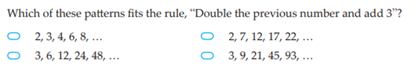
2. | 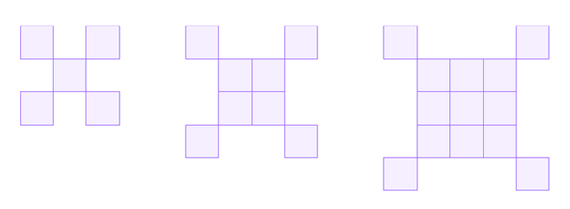  Here are the first three steps in a pattern.  How many squares in the 7th step?
3. | 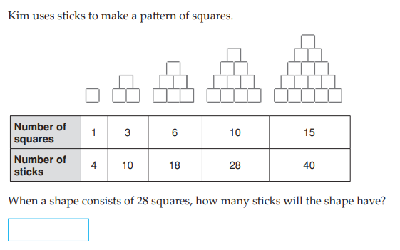
4. | Imagine a long thin strip of paper stretched out in front of you, left to right. Imagine folding this piece of paper so that the left end meets the right. Now press the strip flat so that it is folded in half with a crease. Repeat the whole operation on the new strip 2 more times.  - How many creases are there after 1 fold?  - How many creases are there after 2 folds?  - How many creases are there after 3 folds?  - How many creases are there after 10 folds?  - How many creases are there after n folds?  Further exploration: How many creases would there be if you alternated between horizontal and vertical folds?

Skill 2 Reasoning Questions

Entry | Core | Advanced
Jamie knows that 10x6 is 60. How can he use this fact to help him work out 9x6? | Alannah was asked to calculate $$6×3+2$$What is wrong with this working?  $6×3=18+2=20$û | Why is the following incorrect?  $4^{2}=8$ û

COLLABORATIVE TASK:
Using only one set of brackets, how many different answers can you get for:
$$40+60÷20+10×5$$

Assessment for Learning
Your progress will be monitored through your classwork and weekly homework sheets.

Reflection and Recognition
Let’s reflect on some key questions. Choose one or more of the questions below to answer.
- What is the order that operations need to be computed in?
- How do we need to set out our work?
- Why do we need to calculate operations in a set order every time?
Let’s recognise something that went well and something that could be improved.
- What component of this work caused the most growth in your learning?
- Is there anything you’d like to improve?

Substitution

Setting the Goal
Learning intention:
- What does substitution mean? What does evaluate mean? What do multiplications and divisions look like in algebra?
- How do we need to set out our work?
- Why don’t we write multiplication or division signs in algebra?
Success criteria:
I know that substitute means swap and evaluate means calculate. I can recognise algebraic multiplications and divisions.

Key words
Algebra is an area of maths where we use letters or symbols to represent numbers.
A letter or symbol used to represent a number is called a pronumeral
Substitution involves replacing a pronumeral with a given number.
Evaluate means calculate.

Skill A: Entry skill

Activate prior knowledge
Where have you heard the word substitution or substitute before? What did it mean?

Explicit teaching
[NEW PAGE] 3A: Substitution + and -
- Substitution means swap
- Evaluate means calculate

Worked Examples:
1. Substitute $x=6$ into $x+5$ and evaluate. |  | 2. Substitute $x=7$ into $x-3$ and evaluate.
What we write:  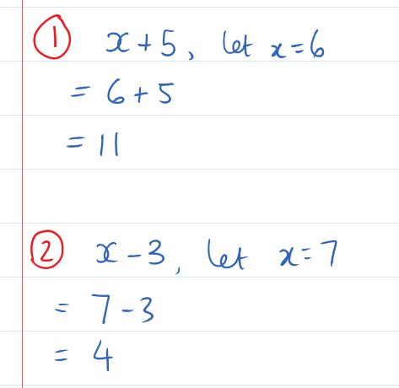 | What we think:  Substitute means swap.  Replace the $x$with 6.  Evaluate means calculate.  Substitute means swap.  Replace the $x$with 7.  Evaluate means calculate.
Your turn:
1. Substitute $x=2$ into $x+8$and evaluate. |  | 2. Substitute $x=9$ into $x-4$ and evaluate.

PRACTICE

3A Routine questions
- Complete the following substitutions. 4First Five Live
- Substitute $x=2$ into $x+4$ and evaluate | - Substitute$x=7$ into $x-2$ and evaluate | - Substitute $x=8$ into $x-1$ and evaluate | - Substitute $x=9$ into $x-3$ and evaluate
- Substitute$x=2$ into $x+8$ and evaluate | - Substitute $x=1$ into $x+1$ and evaluate | - Substitute $x=4$ into $x-1$ and evaluate | - Substitute$x=5$ into $x+8$ and evaluate
- Substitute $x=12$ into $x+7$ and evaluate | - Substitute $x=8$ into $x-7$ and evaluate | - Substitute$x=4$ into $x+5$ and evaluate | - Substitute $x=11$ into $x+2$ and evaluate
- Substitute $x=6$ into $x-6$ and evaluate | - Substitute$x=0$ into $x+7$and evaluate | - Substitute $x=2$ into $x+5$ and evaluate | - Substitute $x=8$ into $x-2$ and evaluate
- Substitute$x=9$ into $x+2$ and evaluate | - Substitute $x=3$ into $x-2$ and evaluate | - Substitute$x=3$ into $x+5$ and evaluate | - Substitute $x=2$ into $x-1$ and evaluate

☑ Correction Time! Click here for answers

3A Stretch questions
- Alan is $y$ years old. His sister is $y+3$ years old. If Alan is 8, how old is his sister?

- Complete the following substitutions.
- Substitute $u=12$ into $59+u$ and evaluate | - Substitute$v=67$ into $v-32$ and evaluate | - Substitute $w=67$ into $100-w$ and evaluate | - Substitute $x=28$ into $x+57$ and evaluate
- Complete the following substitutions.
- Substitute $p=3$ into $-4+p$ and evaluate | - Substitute$r=7$ into $r-10$ and evaluate | - Substitute $t=7$ into $3-t$ and evaluate | - Substitute $s=5$ into $-2+s$ and evaluate
- Complete the following substitutions.
- Substitute $p=60$ into $-4+p$ and evaluate | - Substitute$r=70$ into $r-100$ and evaluate | - Substitute $t=20$ into $3-t$ and evaluate | - Substitute $s=40$ into $-2+s$ and evaluate
- Copy and complete the following tables. Note that $x$and $y$ are whole numbers (0, 1, 2, 3, …)
a. | b.
  $$n$$ | 1 | 2 | 3 | 4 | 5 | 6
  $$n+3$$ | 4 |  |  | 7
  $$x$$ | 1 | 2 | 3 | 4 | 5 | 6
  $$10-x$$ |  |  | 7
c.
$$x$$ | 6 | 11 | 3
$$y$$ | 2 | 5 |  | 6
$$x+y$$ |  |  | 8 | 17 | 7
$$x-y$$ |  |  |  |  | 3

- Under what circumstances will $a+b$ be smaller than $a-b$?
- Classify each of the following as always, sometimes or never true. Give reasons for your answers where you can.
  - $a+b=b+a$
  - $a+b=a-b$
  - $a-\left(b+c\right)=a-b+c$
  - $a-\left(b+c\right)=a-b-c$
  - $-\left(a+b\right)=-a-b$
☑ Correction Time! Click here for most answers
Finished Early? Head to the Early Finishers Page to engage in a game, puzzle or investigation.

Skill B: core skill

Activate prior knowledge
What comes to mind when you see $\frac{6}{2}$ ? How do you put this on your calculator?

Explicit Teaching
[NEW PAGE] 3B: Substitution $×$ and $÷$
- No multiplication or division symbols in algebra.
  - $3x$ means $3×x$
  - $\frac{x}{3}$ means $x÷3$

Worked Examples:
1. Substitute $x=6$ into $3x$ and evaluate. |  | 2. Substitute $x=10$ into $\frac{x}{2}$ and evaluate.
What we write:  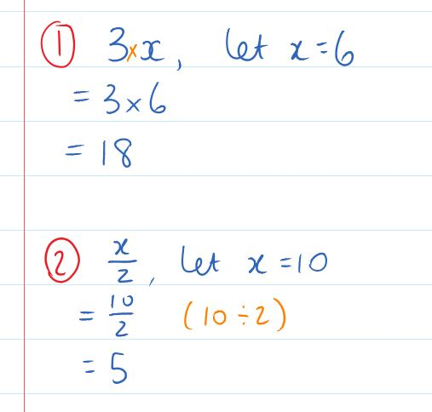 | What we think:  When I see $3x$ I think $3×x$  Replace the$x$ with $6$  Evaluate the answer  When I see $\frac{x}{2}$ I think $x÷2$  Replace the$x$ with $10$  Evaluate the answer
Your turn:
1. Substitute $x=5$ into $3x$ and evaluate. |  | 2. Substitute $x=12$ into $\frac{x}{2}$ and evaluate.

Practice

3B ROUTINE QUESTIONS
- Complete the following substitutions. 4First Five Live
- Substitute $x=7$ into $2x$ and evaluate | - Substitute$x=12$ into $\frac{x}{3}$and evaluate | - Substitute $x=6$ into $\frac{x}{3}$and evaluate | - Substitute $x=2$ into $8x$ and evaluate
- Substitute $x=90$ into $\frac{x}{9}$ and evaluate | - Substitute$x=2$ into $\frac{x}{2}$ and evaluate | - Substitute $x=1$ into $8x$ and evaluate | - Substitute $x=3$ into $5x$ and evaluate
- Substitute $x=12$ into 3$x$and evaluate | - Substitute$x=0$ into $\frac{x}{9}$ and evaluate | - Substitute $x=9$ into $7x$ and evaluate | - Substitute$x=18$ into $\frac{x}{3}$and evaluate
- Substitute $x=8$ into $3x$ and evaluate | - Substitute$x=80$ into $\frac{x}{10}$ and evaluate | - Substitute $x=56$ into $\frac{x}{7}$ and evaluate | - Substitute$x=18$ into $\frac{x}{2}$ and evaluate
- Substitute $x=6$ into $8x$and evaluate | - Substitute$x=30$ into $\frac{x}{6}$ and evaluate | - Substitute $x=12$ into $4x$ and evaluate | - Substitute $x=6$ into $2x$ and evaluate

☑ Correction Time! Click here for answers

3B STRETCH questions
- Bananas cost $c$ cents each. The cost of 5 bananas is $5c$. If bananas cost 60 cents each, how much does 5 bananas cost?

- Complete the following substitutions.
- Substitute $u=8$ into $59u$ and evaluate | - Substitute$v=67$ into $3v$ and evaluate | - Substitute $w=240$ into $\frac{w}{6}$ and evaluate | - Substitute $x=28$ into $\frac{112}{x}$ and evaluate
- Complete the following substitutions.
- Substitute $p=6$ into $p^{2}$ and evaluate | - Substitute$r=16$ into $\sqrt{r}$ and evaluate | - Substitute $t=2$ into $t^{5}$ and evaluate | - Substitute $s=225$ into $\sqrt{s}$ and evaluate

- Find the missing value in each case.
  - A number is substituted for $b$ in the expression $7b$ and gives the result $84$. What is the value of $b$?
  - A number is substituted for $x$ in the expression $\frac{100}{x}$ and gives the result $25$. What is the value of $x$?
  - A number is substituted for $z$ in the expression $z^{2}$ and gives the result $196$. What is the value of $z$?

- Copy and complete the following tables. Note that $x$and $y$ are whole numbers (0, 1, 2, 3, …)
a. | b. | c.
  $$x$$ | $$1$$ | $$2$$ | $$3$$ | $$4$$ | $$5$$
  $$3x$$ |  |  |  | $$12$$
  $$x$$ | $$3$$ | $$6$$ | $$7$$
  $$14x$$ |  |  |  | $$56$$ | $$126$$
  $$x$$ | $$1$$ | $$7$$ | $$8$$ | $$75$$ | $$96$$
   |  | $$3.5$$ | $$4$$

☑ Correction Time! Click here for answers

Finished Early? Head to the Early Finishers Page to engage in a game, puzzle or investigation.

SKILL C: ENRICHMENT SKILL

Activate prior knowledge
The Game of 24, let’s play again!
In each puzzle you need to make the number 24 by using all 4 numbers and one or more of the following + - × / and ( ). The numbers can be used in any order.
To practice your order of operations, give your answers as a single equation. The first one is done for you as an example. Check your answers on your calculator as you go.
- 1, 5, 7, 8  Ans: $(7-5+1)×8$ | - 1, 1, 2, 9 | - 1, 1, 8, 4 | - 2, 2, 4, 6
- 2, 4, 5, 7 | - 1, 5, 6, 8 | - 1, 4, 6, 9 | - 3, 5, 8, 9

Explicit Teaching
[NEW PAGE] 3C: 2-step Substitutions
- Recall
  - BI[DM][AS]
  - An implied multiplication is between a number and a letter or bracket

Worked Examples:
1. Substitute $x=6$ into $3(x-2)$ and evaluate. |  | 2. Substitute $x=9$ into $\frac{x+5}{2}$ and evaluate.
What we write:  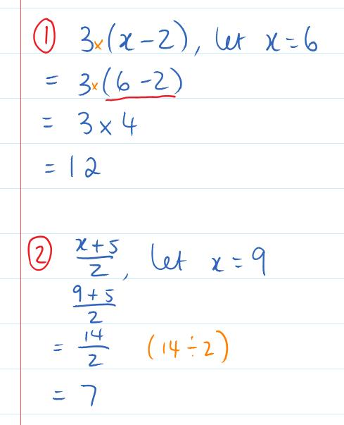 | What we think:  Substitute means swap  Replace the $x$with $6$. Underline the calculation in the bracket  Copy down parts not underlined, calculate the underlined part.  When a number is next to a bracket, multiplication is implied.  Substitute means swap  Replace the $x$with $9$. B stands for brackets and other groupings. Complete the calculations within the numerator.  Continue calculating until no operations remain.
Your turn:
1. Substitute $x=5$ into $4+3x$ and evaluate. |  | 2. Substitute $x=23$ into $\frac{x-5}{3}$ and evaluate.

Practice

3C ROUTINE QUESTIONS
1. Evaluate the following expressions after substituting the given value for $x$. 4First Five Live
- $\frac{x-5}{4}$, $x=29$ | - $5(x+4)$, $x=7$ | - $3x+7$, $x=9$ | - $\frac{x}{2}-3$, $x=10$
- $\frac{x}{9}+6$, $x=18$ | - $\frac{x-9}{2}$, $x=13$ | - $\frac{x+21}{6}$, $x=33$ | - $5(x+2)$, $x=3$
- $9(x-2)$, $x=4$ | - $5x-3$, $x=5$ | - $\frac{x+39}{6}$, $x=15$ | - $4(x+5)$, $x=2$
- $\frac{x}{2}-2$, $x=8$ | - $2(x-2)$, $x=3$ | - $\frac{x}{9}-1$, $x=63$ | - $\frac{x-6}{6}$, $x=60$
- $3x+2$, $x=6$ | - $5x+7$, $x=5$ | - $\frac{x+22}{7}$, $x=27$ | - $\frac{x+2}{5}$, $x=8$
☑ Correction Time! Click here for answers

3C Stretch questionS
- An orange costs $y$ cents, an apple costs $z$ cents and a banana costs 20 cents. This means that 4 apples costs $4z$ and the total cost of 3 oranges, 2 apples and 1 banana is $3y+2z+20.$ Write an expression for the total cost of:
  - 3 oranges and 2 apples
  - 20 apples, 10 oranges and 3 bananas
  - 4 oranges, 3 apples and n bananas

- Substitute $x=5$ into the following.
- $3x+2-x$ | - $30-(4x+1)$ | - $\frac{30}{x}+2x(x+3)$ | - $\frac{6(3x-8)}{x+2}$
- Substitute $a=2$and $b=3$into the following.
- $3a+b$ | - $5a-2b$ | - $\frac{12}{a}+\frac{6}{b}$ | - $\frac{ab}{3}+b$
- Substitute $a=9, b=3$and $c=5$into the following.
- $3c^{2}$ | - $\sqrt{a}+\sqrt{3ab}$ | - ${\left(2c\right)}^{2}-a^{2}$ | - $2b^{2}+\frac{a}{3}-2c$

- Substitute $a=-9, b=3$and $c=-5$into the following.
- $a+5b$ | - $a+b+c$ | - $6(b-a)$ | - $\frac{c-a}{4}$
☑ Correction Time! Click here for answers
Finished Early? Head to the Early Finishers Page to engage in a game, puzzle or investigation.

Skill 3 Application Questions – Think, Pair, Share/Teacher Modelling
Answer the questions you can. Explain your reasoning for at least one of the questions.
You may use your calculator at any time.
1. | 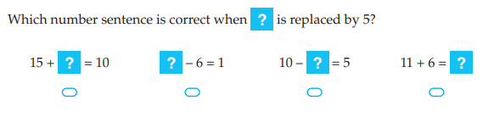
2. | 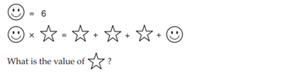
3. | 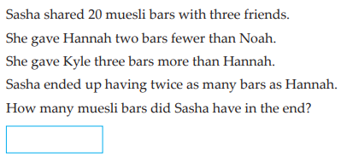
4. | - There are three lily pads, and a blue frog and a red frog.    We want them to swap sides. There can only be one frog on a lily pad at a time. Frogs can jump onto an empty lily pad that is next to them or jump over a frog to an empty lily pad. How many jumps does it take to make the swap?  - There are five lily pads and 2 blue frogs and 2 red frogs.    We want them to swap sides. The above rules apply. What is the smallest number of jumps this could take?  - What if there were 3 frogs of each colour? What is the smallest number of jumps this could take now?  - What if there were 4 frogs of each colour? What is the smallest number of jumps this could take now?  - Predict and then check what is the smallest number of jumps for 5 frogs.  Further exploration: What if there were n frogs of each colour? What is the smallest number of jumps this could take now? What if there were n frogs on one side and m frogs on the other? What is the smallest number of jumps this could now take?

Skill 3 Reasoning Questions

Entry | Core | Advanced
Substitution in mathematics means swap. In what other everyday situations do we use the word substitute to mean swap? | Why is the following incorrect?  Substitute $x=5$ into $6x$ and evaluate:  Ans: $6x=65$ û | Why is the following incorrect?  Substitute $x=10$ into $\frac{x+8}{2}$ and evaluate:  $\frac{x+8}{2}=\frac{10+8}{2}=5+8=13$ û

COLLABORATIVE TASK:
Truth Tiles (from Mathematical Task Centre Cameos)

Assessment for Learning
Your progress will be monitored through your classwork and weekly homework sheets.

Reflection and Recognition
Let’s reflect on some key questions. Choose one or more of the questions below to answer.
- What does substitution mean? What does evaluate mean? What do multiplications and divisions look like in algebra?
- How do we need to set out our work?
- Why don’t we write multiplication or division signs in algebra?
Let’s recognise something that went well and something that could be improved.
- What component of this work caused the most growth in your learning?
- Is there anything you’d like to improve?

Solving Equations

Setting the Goal
Learning intention:
- What is solving?
- How do we need to set out our work?
- Why do we need to “do the same to both sides”?
Success criteria: I can solve an algebraic equation using opposite operations and “doing the same to both sides”

Key words
Solving is the process of finding the value of the unknown that makes the equation true.

Skill A: Entry skill

Activate prior knowledge
Activity One:
The scales are balanced. How many lollies are in the orange bag?
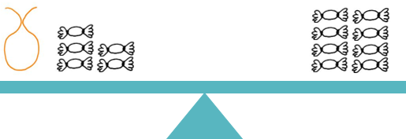
Here are a few more you can try: Note: Each bag of the same colour has the same number of lollies inside.
How many lollies are in the blue bag?  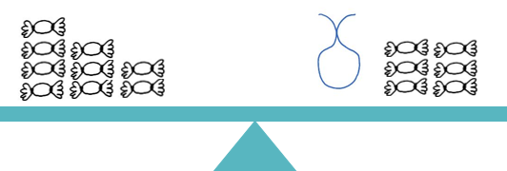 | How many lollies are in each pink bag?  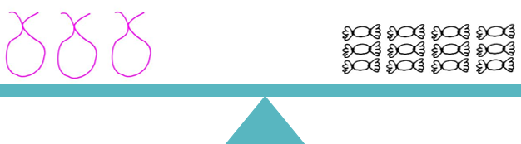
How many lollies are in each purple bag?  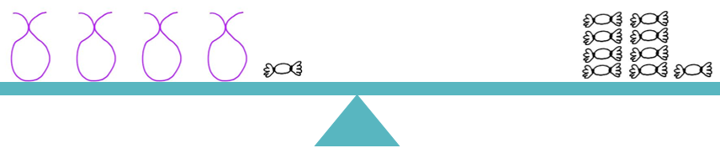 | How many lollies are in each green bag?  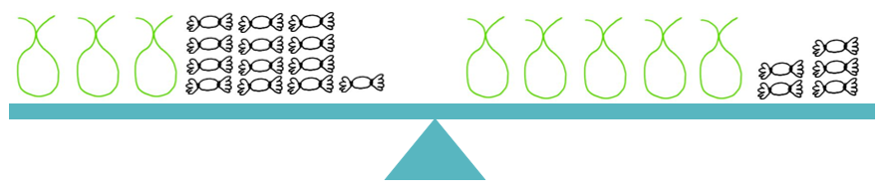

Activity Two: Calculate the following and talk to your partner about what you notice.
- $5+0=$  - $6+0=$  - $7+0=$ | - $7+3-3=$  - $7+4-4=$  - $7+5-5=$ | - $8-2+2=$  - $8-3+3=$  - $8-4+4=$

Activity Three: Fill in the missing values in each table below.
Number in $→$Add 4 $→$ Number out  . Number out $→$?? $→$ Number in | Number in $→$Subtract 2 $→$ Number out  Number out $→$?? $→$ Number in
  In | Out
  3 | 7
  7
  12
   | 8
   | 16
  In | Out
  10 | 8
  3
  7
   | 5
   | 12

Explicit teaching
[NEW PAGE] 4A: Solving Equations + and -
- Solving: find the value of the unknown that makes the equation true
- Opposite operations:
  - + and – are opposites
- Do “the same to both sides” to keep the equation true

Worked Examples:
1. Solve $x+6=8$ |  | 2. Solve $x+6=10$ | 3. Solve $x-6=8$
What we write:  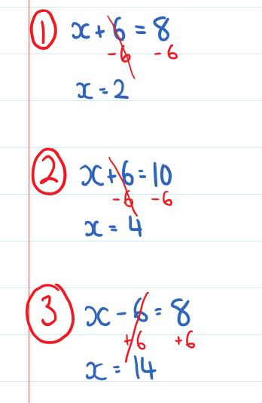 | What we think:  When solving we want to isolate the unknown.  The opposite operation of $+6$is $-6$. We $-6$ from both sides.  When solving we want to isolate the unknown.  The opposite operation of $+6$is $-6$. We $-6$ from both sides.  When solving we want to isolate the unknown.  The opposite operation of $-6$is $+6$. We $+6$ to both sides.
Your turn:
1. Solve $x+3=8$ |  | 2. Solve $x+3=10$ | 3. Solve $x-3=8$

PRACTICE

4A Routine questions
- Solve the following equations. Remember to include working out that shows your use of the opposite operation.
4First Five Live
- $x+9=12$ | - $x-3=15$ | - $x-7=3$ | - $x+9=16$
- $x-9=6$ | - $x-5=3$ | - $x+8=17$ | - $x+7=19$
- $x+4=15$ | - $x+3=15$ | - $x-7=6$ | - $x-8=4$
- $x-7=12$ | - $x+6=10$ | - $x-8=6$ | - $x+10=16$
- $x-3=12$ | - $x+5=7$ | - $x-4=6$ | - $x+3=8$

☑ Correction Time! Click here for answers

4A Stretch questions
- Write equations for each of the following and solve the equation.
  - The sum of 3 and $x$ is equal to 10.
  - Eight is added to a number $b$ to give a result of twelve.
  - Five is subtracted from a number $k$ and the result is two.
- Solve the following equations. Remember to include working out that shows your use of the opposite operation.
- $r+9=12$ | - $15=s-3$ | - $t-7=3$ | - $9+u=16$
- Solve the following equations. Remember to include working out that shows your use of the opposite operation.
- $38=x+27$ | - $x-35=17$ | - $142+x=357$ | - $571=x-193$
- Solve the following equations. Remember to include working out that shows your use of the opposite operation.
- $x+9=3$ | - $-2=x-3$ | - $-10=x-7$ | - $9+x=-2$
- Solve the following equations. Remember to include working out that shows your use of the opposite operation.
- $2=19+x$ | - $-40=x-3$ | - $x-20=-37$ | - $x+80=-12$
☑ Correction Time! Click here for answers
Finished Early? Head to the Early Finishers Page to engage in a game, puzzle or investigation.

Skill B: core skill

Activate prior knowledge
Activity One: We return to our lolly bags, though simplify our pictures using numbers. Note: Each bag of the same colour has the same number of lollies inside.

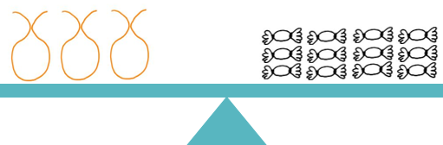 |  | 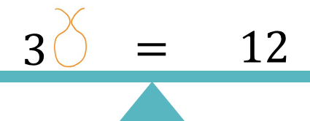

How many lollies are in each orange bag?
Here are a few more you can try:
How many lollies are in each blue bag?  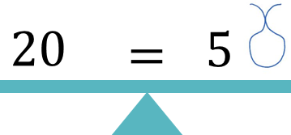 | How many lollies are in each pink bag?  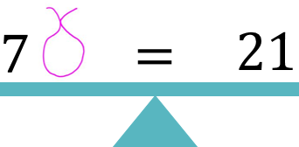
How many lollies are in each purple bag?  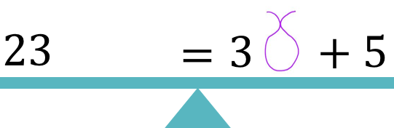 | How many lollies are in each green bag?  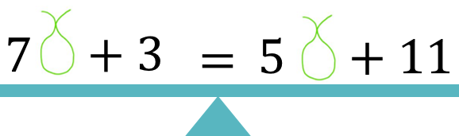

Activity Two: Calculate the following and talk to your partner about what you notice.
- $\frac{3}{3}=$  - $\frac{5}{5}=$  - $\frac{7}{7}=$ | - $\frac{20}{4}×4=$  - $\frac{20}{5}×5=$  - $\frac{20}{10}×10=$ | - $\frac{4×3}{4}=$  - $\frac{5×3}{5}=$  - $\frac{6×3}{6}=$

Activity Three: Fill in the missing values in each table below.
Number in $→$Multiply by 3 $→$ Number out  . Number out $→$?? $→$ Number in | Number in $→$Divide by 2 $→$ Number out  Number out $→$?? $→$ Number in
  In | Out
  2 | 6
  7
  12
   | 12
   | 87
  In | Out
  10 | 5
  12
  20
   | 12
   | 78

Explicit Teaching
[NEW PAGE] 4B: Solving $×$ and $÷$
- Opposite operations:
  - $×$ and $÷$ are opposites
- When solving always do “the same to both sides” to keep the equation true

Worked Examples:
1. Solve $3x=12$ | 2. Solve $5x=10$ |  | 3. Solve $\frac{x}{2}=6$ | 4. Solve $\frac{x}{3}=5$
What we write:  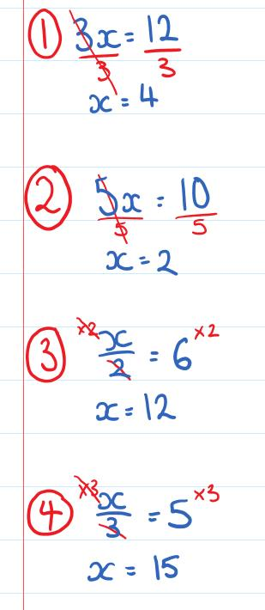 | What we think:  When solving we want to isolate the unknown.  The opposite operation of $×3$is $÷3$. We $÷$ both sides by $3$.  When solving we want to isolate the unknown.  The opposite operation of $×5$is $÷5$. We $÷$ both sides by $5$.  When solving we want to isolate the unknown.  The opposite operation of $÷2$is $×2$. We $×$ both sides by $2$.  When solving we want to isolate the unknown.  The opposite operation of $÷3$is $×3$. We $×$ both sides by $3$.
Your turn:
1. Solve $3x=6$ |  | 2. Solve $5x=20$ | 3. Solve $\frac{x}{2}=8$ | 4. Solve $\frac{x}{5}=2$

Practice

4B ROUTINE QUESTIONS
- Solve the following equations. Remember to include working out that shows your use of the opposite operation.
4First Five Live
- $8x=16$ | - $\frac{x}{6}=10$ | - $\frac{x}{6}=12$ | - $9x=27$
- $\frac{x}{4}=10$ | - $\frac{x}{8}=3$ | - $12x=60$ | - $7x=0$
- $3x=18$ | - $4x=8$ | - $\frac{x}{5}=3$ | - $\frac{x}{9}=8$
- $6x=0$ | - $\frac{x}{7}=5$ | - $7x=21$ | - $3x=3$
- $\frac{x}{7}=6$ | - $\frac{x}{5}=11$ | - $8x=8$ | - $9x=81$
☑ Correction Time! Click here for answers

4B STRETCH questions
- Write equations for each of the following and solve the equation.
  - Nine times a number $c$ gives a result of sixty-three.
  - The number $x$ is divided by 4 and the answer is 5.
  - When $p$ is tripled, the result is 21.
- Solve the following equations. Remember to include working out that shows your use of the opposite operation.
- $42=7r$ | - $\frac{s}{4}=8$ | - $9=\frac{t}{6}$ | - $12u=108$
- Solve the following equations. Remember to include working out that shows your use of the opposite operation. Use answers to previous questions to predict answers before calculating them formally.
- $3x=156$ | - $3x=312$ | - $3x=3120$ | - $1040x=3120$
- Solve the following equations. Remember to include working out that shows your use of the opposite operation. Use answers to previous questions to predict answers before calculating them formally.
- $\frac{x}{9}=15$ | - $\frac{x}{9}=45$ | - $\frac{x}{9}=450$ | - $\frac{x}{9}=225$
- Solve the following equations. Remember to include working out that shows your use of the opposite operation. Note that squaring and square roots are opposite operations. In each case $x$ is positive.
- $5=\sqrt{x}$ | - $81=x^{2}$ | - $196=x^{2}$ | - $\sqrt{x}=16$
☑ Correction Time! Click here for answers Finished Early? Head to the Early Finishers Page

SKILL C: ENRICHMENT SKILL

Activate prior knowledge
Activity One: Fill in the missing values in each table below.
Number in $→$Multiply by 3 $→$ Add 2 $→$ Number out  . Number out $→$?? $→$ ?? $→$Number in | Number in $→$Add 3 $→$Divide by 2 $→$ Number out  Number out $→$?? $→$ ?? $→$Number in
  In | Out
  2 | 8
  7
  12
   | 14
   | 299
  In | Out
  11 | 7
  19
  51
   | 7
   | 51

Activity Two: Solve the following equations. Each question in the bottom row is closely connected to the one above it.
- $x+3=12$  - $2y+3=12$ | - $\frac{x}{3}=12$  - $\frac{y-6}{3}=12$ | - $3x=12$  - $3\left(y+1\right)=12$ | - $x-3=12$  - $\frac{y}{4}-3=12$

Explicit Teaching
[NEW PAGE] 4C: Solving 2-step Equations
- State the order that the operations “act on $x$” – Always start with the pronumeral!!
- The last operation you say is the first operation you remove

Examples:
1. Solve $4x+7=31$ |  | 2. Solve $18=3(5+x)$ | 3. Solve $10=\frac{x-3}{4}$ | 4. Solve $4+\frac{x}{7}=9$
What we write:  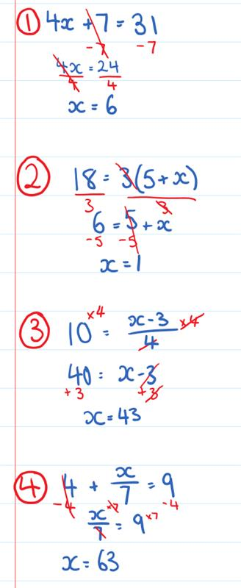 | What we think:  $x→ ×4→+7$. Undo the final step.  The opposite operation of $+7$is $-7$. We $-7$ from both sides  The opposite operation of $×4$is $÷4$. We $÷$ both sides by $4$  $x→+5→ ×3$. Undo the final step.  The opposite operation of $×3$is $÷3.$We $÷$ both sides by $3$ The opposite operation of $+5$is $-5$. We $-5$ from both sides  $x→-3→ ÷4$. Undo the final step.  The opposite operation of $÷4$is $×4.$We $×$ both sides by $4$ The opposite operation of $-3$is $+3$. We $+3$ to both sides  $x→ ÷7→+4$. Undo the final step.  The opposite operation of $+4$is $-4$. We $-4$ from both sides  The opposite operation of $÷7$is $×7.$We $×$ both sides by $7$
Your turn:
1. Solve $3x-7=29$ |  | 2. Solve $15=5(x-2)$ | 3. Solve $4=\frac{x+3}{5}$ | 4. Solve $\frac{x}{7}-5=9$

Practice

4C ROUTINE QUESTIONS
- Solve the following equations. Remember to include working out that shows your use of two different opposite operations. Your final solution for each of the questions below will always include 3 separate equations. 4First Five Live
- $8=\frac{x}{5}-2$ | - $2\left(x+4\right)=8$ | - $7=\frac{x-5}{3}$ | - $2x+4=28$
- $\frac{x}{3}+2=9$ | - $9=\frac{x+15}{3}$ | - $13=7+3x$ | - $40=9x+4$
- $0=\frac{x}{3}-5$ | - $6=\frac{x}{9}+3$ | - $4=9x-59$ | - $37=4x+9$
- $15=2x+9$ | - $30=3(x+4)$ | - $9=\frac{x-6}{4}$ | - $\frac{x-4}{2}=7$
- $4x-12=0$ | - $7\left(x+5\right)=84$ | - $8+9x=62$ | - $3=\frac{x}{7}+2$
☑ Correction Time! Click here for answers

4C Stretch questionS
- For each of the following, write an equation and solve it showing your use of opposite operations.
Note: product means times. Eg. The product of $4$ and $x$ is $4x$.
  - The sum of 3 and $x$ is 7
  - The product $5$and $y$ is $95$
  - 7 is subtracted from $b$. The results is doubled, giving 20.
  - 10 is subtracted from half of $y$, giving a result of 8.

- Solve the following. Include working that shows your use of opposite operations.
- $3x+87=363$ | - $\frac{x}{5}-8=34$ | - $248=4(x+23)$ | - $124=\frac{389+x}{5}$
- Solve the following. Include working that shows your use of opposite operations.
- $\frac{3\left(t+2\right)}{5}=6$ | - $16=2\left(\frac{r}{3}-5\right)$ | - $\frac{4s+3}{5}=3$ | - $4\left(5+\frac{x}{3}\right)=48$

- Solve the following. Include working that shows your use of opposite operations.
- $3\left(x+9\right)=6$ | - $2=\frac{x+23}{5}$ | - $\frac{x+17}{5}=37$ | - $6\left(x-45\right)=108$
☑ Correction Time! Click here for answers
Finished Early? Head to the Early Finishers Page to engage in a game, puzzle or investigation.

Skill 4 Application Questions – Think, Pair, Share/Teacher Modelling
Answer the questions you can. Explain your reasoning for at least one of the questions.
You may use your calculator at any time.
1. | 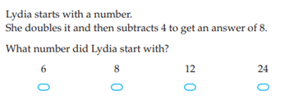
2. | 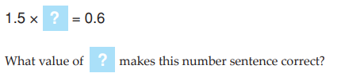  *Optional challenge: How many different ways can you solve this problem?
3. | 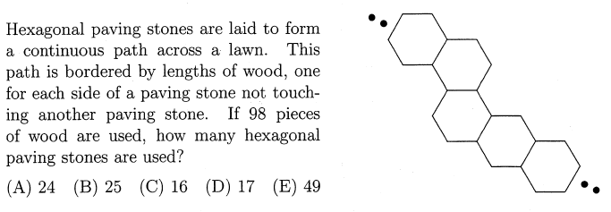
4. | 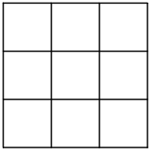  - Consider the 3x3 grid shown on the right.  - How many 1x1 squares are on this grid?  - How many 2x2 squares are on this grid?  - How many 3x3 squares are on this grid?  - Consider a 4x4 grid.  - How many 1x1 squares are on this grid?  - How many 2x2 squares are on this grid?  - How many 3x3 squares are on this grid?  - How many 4x4 squares are on this grid?  - It was once claimed that there are 204 squares on an ordinary chessboard. Can you justify this claim?  Further exploration: How many rectangles are on a chessboard?

Skill 4 Reasoning Questions

Entry | Core | Advanced
Why are + and – considered opposite operations? | Why are $×$ and $÷$ considered opposite operations? | In a two-step equation, how do you decide which operation you will remove first?

COLLABORATIVE TASK:
Using the following rules, create and solve increasingly complex equations:
Algebra Rules  - Addition and subtraction on the right  - Multiplication on the left with brackets around everything except a single pronumeral  - Division Underneath | Example 1. Creating the equation:  $$x=6$$  $$x+8=14$$  $$2\left(x+8\right)=28$$  $$\frac{2\left(x+8\right)}{7}=4$$ | Example 2. Solving the equation:  $$\frac{2\left(x+8\right)}{7}=4$$  $$2\left(x+8\right)=28$$  $$x+8=14$$  $$x=6$$

Assessment for Learning
Your progress will be monitored through your classwork and weekly homework sheets.

Reflection and Recognition
Let’s reflect on some key questions. Choose one or more of the questions below to answer.
- What is solving?
- How do we need to set out our work?
- Why do we need to “do the same to both sides”?
Let’s recognise something that went well and something that could be improved.
- What component of this work caused the most growth in your learning?
- Is there anything you’d like to improve?

The Cartesian plane

Setting the Goal
Learning intention:
- What is the Cartesian plane?
- How do we label points on the Cartesian plane?
- Why do we always move across first?
Success Criteria:
I can plot a point by starting at the origin then moving across, then moving up or down.

Skill A: Entry skill

Activate prior knowledge
Describe the position of Wally as best you can. Click here for your super challenge!!
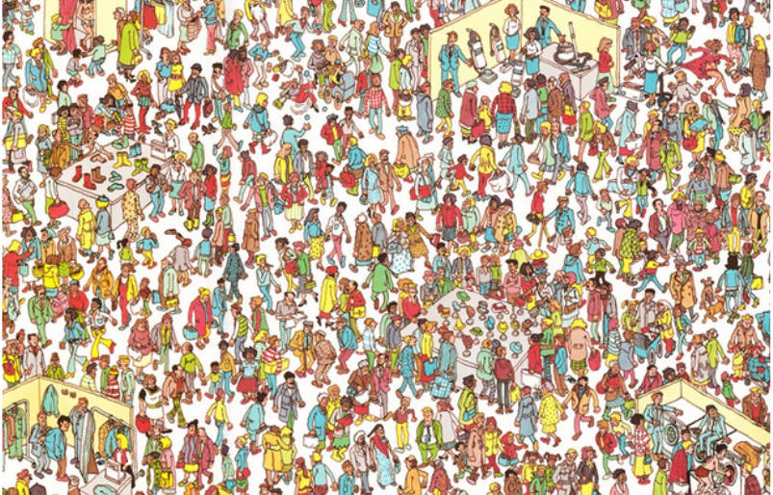

Explicit teaching
[NEW PAGE] 5A: Grid Reference
- To state a location on a grid reference,
  - First say how far horizontally ⬄
  - Then say how vertically 

Worked Examples:
1. Where’s Wally’s head? | 2. Where’s Odlaw’s head?
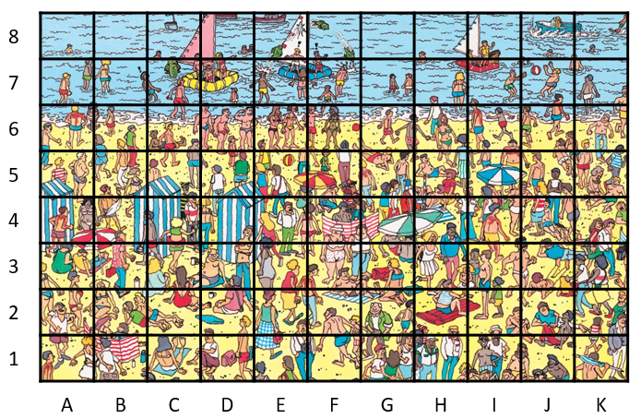
What we write:
1. F5
2. C5
Your turn:
1. Where is the red and white beach ball? | 2. Where is the red and yellow beach ball?

PRACTICE

5A Routine questions
State the grid reference of each object. 4First Five Live
- h  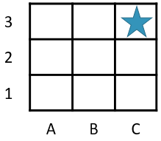 | - h  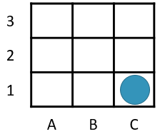 | - h  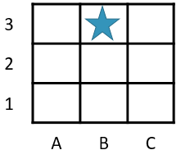 | - h  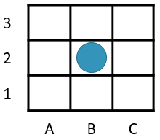
- h  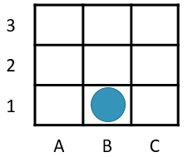 | - h  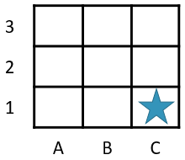 | - h  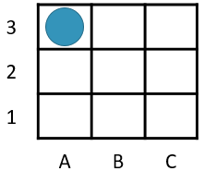 | - h  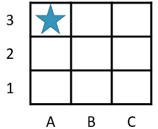
- h  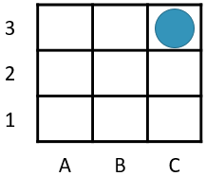 | - h  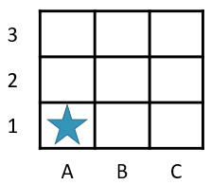 | - h  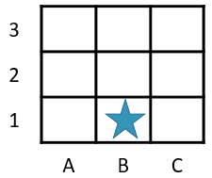 | - h  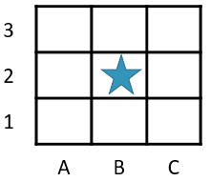
- h  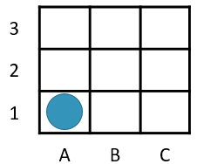 | - h  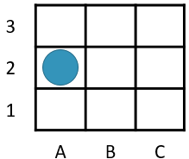 | - h  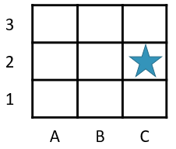 | - h  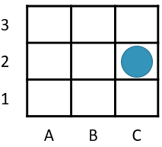

☑ Correction Time! Click here for the answers

5A Stretch Questions
State the grid reference of each object.
  2 | a. | b. | c. | d. | e. | f. | g. | h.
   | 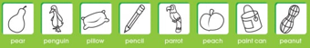
  3 | a. | b. | c. | d. | e. | f. | g. | h.
   | 
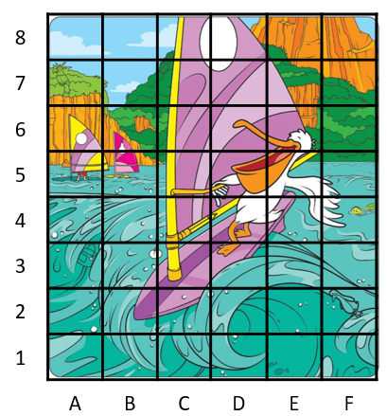 | 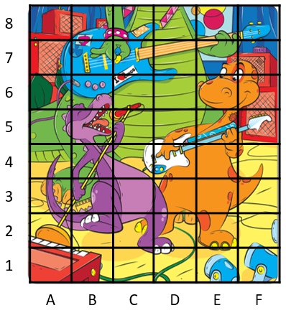

☑ Correction Time! Click here for SOME of the answers
Finished Early? Head to the Early Finishers Page to engage in a game, puzzle or investigation.

Skill B: core skill

Key words
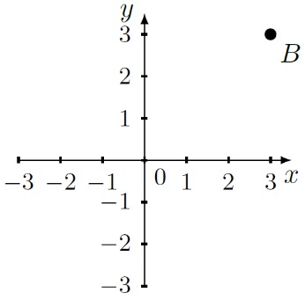
The Cartesian plane is a plane made up of an x-axis (a horizontal number line) and a y-axis (a vertical number line). An example of a Cartesian plane is shown on the right.

Activate prior knowledge
What comes first in the alphabet; x or y? What do you learn to do first as a baby; crawl or climb?

Explicit Teaching
[NEW PAGE – To be Printed]

5B: Plotting points
- The origin, 0, is the centre of the Cartesian Plane
- A coordinate looks like $(x,y)$ and gives a single location on the Cartesian Plane.
  - Start at the origin. Crawl before you climb. $x$ is across. $y$ is up/down.
Worked Examples:
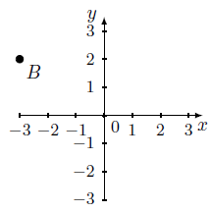  1. State the coordinates of point $B$ | 2. Plot the point$A=(1,-2)$
What we write:  1. $(-3,2)$  2.  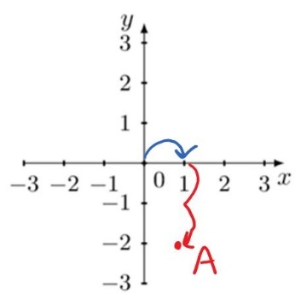 |  | What we think:  To get to point $B$ we start at the origin. Then move across to -3 and then up to 2.  To get to (1,-2) we start at the origin then move across to 1 and then down to -2.
Your turn:
1. State the coordinates of point $B$  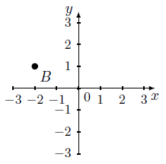 | 2. Plot the point$A=(0,3)$  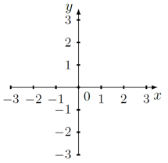

Practice

5B ROUTINE QUESTIONS
- Plot the following points on the Cartesian planes. 4First Five Live
a. $A=(3,1)$ | b.$B=(-1,0)$ | c. $C=(2,-3)$ | d. $D=(0,2)$
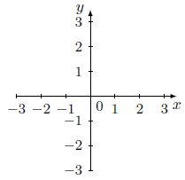
e. $E=(2,1)$ | f. $F=(-1,-2)$ | g. $G=(0,0)$ | h. $H=(3,2)$
☑ Correction Time! Click here for answers
- State the coordinates of point $A$ in each diagram. 4First Five Live
a. | b. | c. | d.
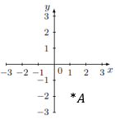 | 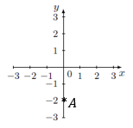 | 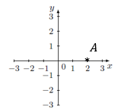 | 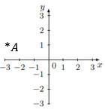
e. | f. | g. | h.
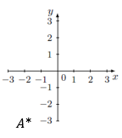 | 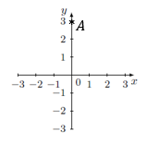 | 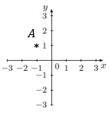 | 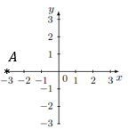
☑ Correction Time! Click here for answers

5B STRETCH questions
- Point A(1, 1) is the bottom left-hand corner of a square of side length 3. State the other three coordinates of the square.
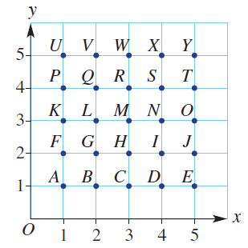
- A grid system can be used to make secret messages. Jake decides to arrange the letters of the alphabet on a Cartesian plane in the following manner.
  - Decode Jake’s following message: (3, 2), (5, 1), (2, 3), (1, 4)
  - Code the word SECRET.
  - To increase the difficulty of the code, Jake does not include brackets or commas and he uses the origin to indicate the end of a word. What do the following numbers mean? 13515500154341513400145354001423114354.
  - Code the phrase: BE HERE AT SEVEN.
- ABCD is a rectangle. The coordinates of A, B and C are given below. State the coordinates of the missing corner, D.
  - A(0, 5) B(0, 3) C(4, 3) D(?, ?)
  - A(4, 4) B(1, 4) C(1, 1) D(?, ?)
  - A(0, 2) B(3, 2) C(3, 0) D(?, ?)
  - A(4, 1) B(8, 4) C(5, 8) D(?, ?)

☑ Correction Time! Click here for answers
Finished Early? Head to the Early Finishers Page to engage in a game, puzzle or investigation.

SKILL C: ENRICHMENT SKILL

Activate prior knowledge
What does the word reflection mean to you?
State the coordinates of the points A to F in the diagram to the right. | 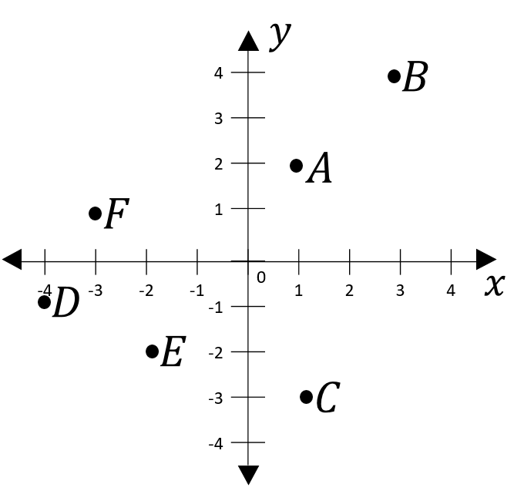

Explicit Teaching
[NEW PAGE] 5C: Transforming points on the Cartesian Plane
- A translation involves a shift ⬄
- A reflection involves a flip across a line.
- The image is the special name of a transformed point.
- The image of A is A’

Worked Examples:
1. State the image of $(3,1)$ after it is reflected in the x-axis |  | 2. State the image of $(-2,-1)$ after it is translated 1 unit down
What we write:  1. $(3,-1)$  2. $(-2,-2)$ | What we think:  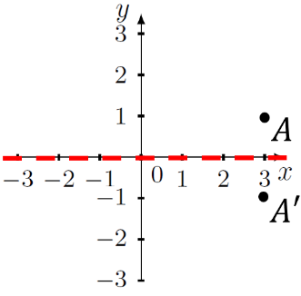  When reflecting in the x-axis, the x-axis acts as a mirror. The point flips across the x-axis and ends up on the other side, at the exact same distance away.  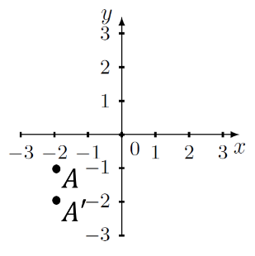  When translating we shift. Moving the point down one we move from a y-value of -1 to -2.
Your turn:
1. State the image of $(3,1)$ after it is reflected in the y-axis |  | 2. State the image of $(-2,-1)$ after it is translated 3 units right

Practice

5C ROUTINE QUESTIONS
- State the coordinates of the image of each point after it undergoes the given transformation. 4First Five Live
- Reflect (-2,1) in the x-axis | - Reflect (-1,-3) in the x-axis | - Translate (-1,2) 4 units to the right
- Reflect (1,-1) in the y-axis | - Translate (-3,3) 4 units to the right | - Translate (0,2) 1 unit to the left
- Reflect (-1,2) in the x-axis | - Reflect (-1,0) in the x-axis | - Translate (2,0) 3 units down
- Translate (-1,0) 3 units up | - Reflect (-3,-2) in the x-axis | - Reflect (0,-2) in the y-axis
- Translate (-1,2) 3 units down | - Reflect (1,3) in the y-axis | - Translate (-1,2) 3 units up
☑ Correction Time! Click here for answers

5C Stretch questionS
- Write the coordinates of the image point after each sequence of transformations. For each part, apply the next transformation to the image of the previous transformation.
a. (2, 3)  • reflection in the x-axis  • reflection in the y-axis  • translation 2 units left and 2 units up | b. (−1, 6)  • translation 5 units right and 3 units down  • reflection in the y-axis | c. (−4, 2)  • reflection in the y-axis  • translation 3 units left and 4 units up  • reflection in the y-axis | d. (−3, −7)  • reflection in the x-axis  • translation 6 units left and 2 units down  • reflection in the y-axis
- A rotation involves a centre of rotation, an amount of rotation given as an angle and a direction. A good way to think about a rotation is an imaginary piece of string between the centre of rotation and your point and then moving that point in the direction specified.  The diagram on the right show the image of the point (3,1) after it has been rotated 90$°$ anti-clockwise around the origin. | 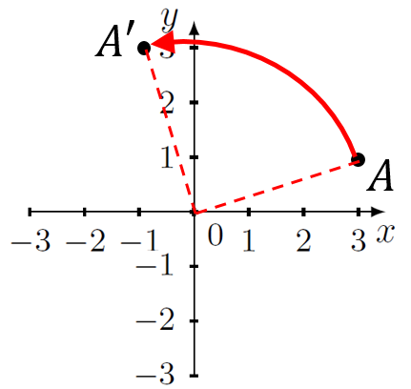
State the coordinates of the image of each point after it undergoes the given transformation. Sketching a Cartesian plane and plotting the point first may help.
- Rotate (1,3) 90$°$ clockwise around the origin. | - Rotate (1,3) 180$°$ clockwise around the origin. | - Rotate (-1,2) 90$°$  anti-clockwise around the origin. | - Rotate (-1,-2) 270$°$ anti-clockwise around the origin.
- Write the image of the transformed point. The first one has been done for you.
- Translate $(a,b)$ 3 units up.  Answer: $(a,b+3)$ | - Translate $(a,b)$ 3 units down. | - Translate $(a,b)$ 3 units left. | - Translate $(a,b)$ 3 units right.
- Reflect $(a,b)$ in the x-axis | - Reflect $(a,b)$ in the y-axis | - Rotate $(a,b)$ 90$°$  clockwise around the origin. | - Rotate $(a,b)$ 180$°$  clockwise around the origin.
☑ Correction Time! Click here for answers
Finished Early? Head to the Early Finishers Page to engage in a game, puzzle or investigation.

Skill 5 Application Questions – Think, Pair, Share/Teacher Modelling
You may use your calculator at any time.
1. | 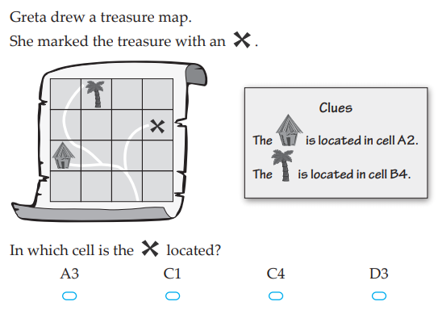
2. | 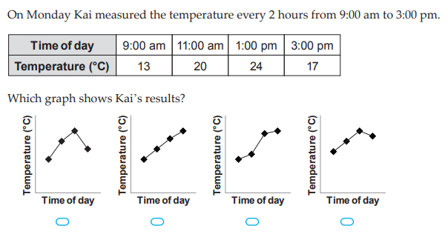
3. | 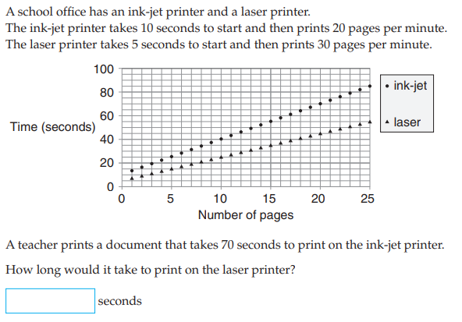
4. |   - There are four discs on the bottom of this triangle. How many discs are there altogether?  - How many discs would there be altogether if there were 10 discs on the bottom?  - How many discs would there be altogether if there were 100 discs on the bottom?  - How many discs would there be altogether if there were n discs on the bottom?  Further exploration: Consider triangles with rows containing only even numbers of discs what happens now? What if instead only odd numbers of discs were used? What other patterns could you explore?

Skill 5 Reasoning Questions

Entry | Core | Advanced
Wendy says that the star is at 2C û  What mistake has Wendy made?  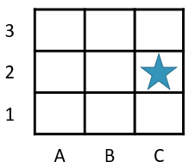 | Wendy says that B is at (3,-2) û  What mistake has Wendy made?  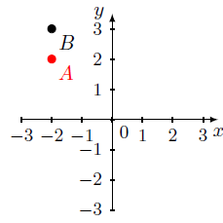 | When transforming points the order doesn’t matter. Is this always, sometimes or never true?

COLLABORATIVE TASK:
Creating pictures using coordinates (or you may like to make your own)

Assessment for Learning
Your progress will be monitored through your classwork and weekly homework sheets.

Reflection and Recognition
Let’s reflect on some key questions. Choose one or more of the questions below to answer.
- What is the Cartesian plane?
- How do we label points on the Cartesian plane?
- Why do we always move across first?
Let’s recognise something that went well and something that could be improved.
- What component of this work caused the most growth in your learning?
- Is there anything you’d like to improve?

Early Finisher Activities
Games | Puzzles | Investigations

Games
Individual Games:
- https://www.abcya.com/games/mystic_numbers - Online addition puzzle / one player game
- https://www.topmarks.co.uk/maths-games/hit-the-button - Timed practice for number bonds and times tables. What is the best score you can get?
- https://www.nctm.org/Classroom-Resources/Illuminations/Interactives/Product-Game/ - One/two player multiplication game
- https://incoherency.co.uk/countdown/practice/#numbers – Countdown Numbers Game
Games in Pairs:
- https://mathsbot.com/puzzles/fourOpsPuzzle - Online number puzzle involving the four operations
- https://nrich.maths.org/strike-it-out - A number line game played in pairs
- https://nrich.maths.org/5864 – “Connect 3” is a game for practicing adding and subtracting integers

Puzzles
- Choose 4 different numbers and put them in the boxes (see Figure 1). Doing this forms four 2-digit numbers (reading across and down). Is it possible to place four different numbers so that the sum of the four 2-digit numbers is 100? My first attempt is shown in Figure 2. Can you get closer than I did?
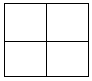  Figure 1. Blank boxes | 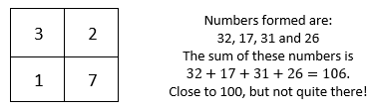  Figure 2. My first try

- Using the numbers 1 through 9 once each make each equation true.
$\boxed{}+\boxed{}=\boxed{},$ $\boxed{}×\boxed{}=\boxed{}$, $\boxed{}-\boxed{}=\boxed{}$
How many different solutions can you find to this problem?

- Solve the following puzzles.
a.  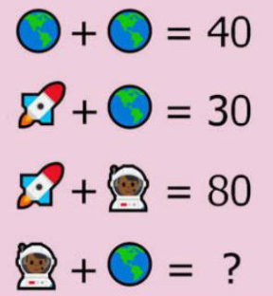 | b.  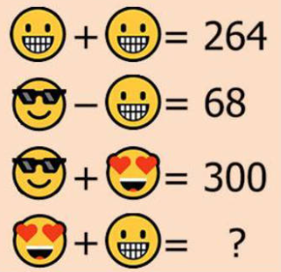 | c.  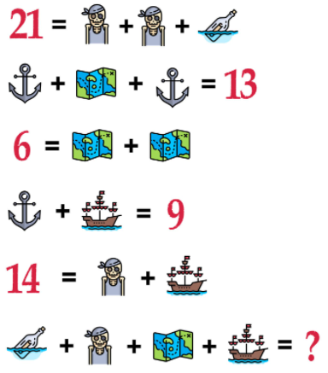 | d.  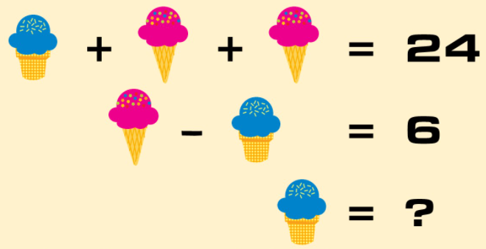

- The coloured shapes stand for eleven of the numbers from 0 to 12. Each shape is a different number. Can you work out what they are from the multiplications below?  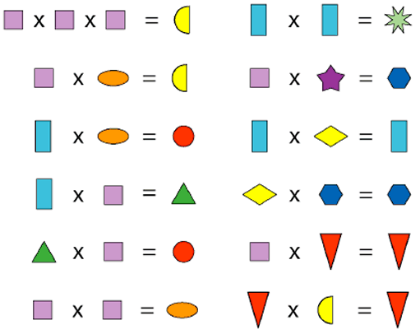 | - Each symbol has a numerical value. The total for the symbols is written at the end of each row and column.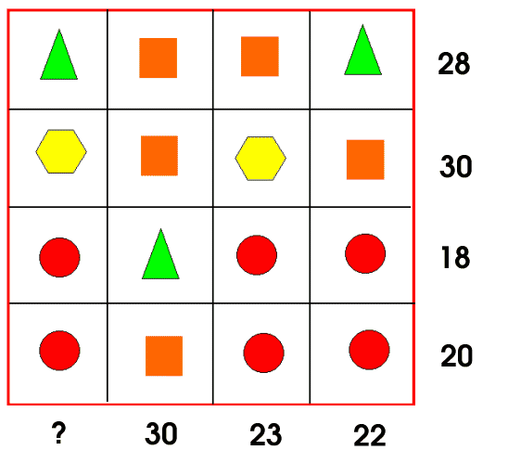

Investigations
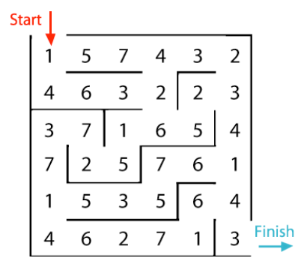
- Make your way through the maze (without backtracking), adding numbers as you go.
  - What total did you get? Check your answer with a calculator.
  - Go through the maze again and try to get a bigger sum. What is the biggest number you can make?
  - Go through the maze again and try to make a smaller sum. What is the smallest number you can make?
  - Can you go through the maze so that the numbers add to 100 exactly?
  - How many different totals can be made by travelling through this maze?

- The powers of 2 are 1, 2, 4, 8, 16 etc. Each whole number from 1 to 31 can be written as a sum of these numbers. For example, $13=8+4+1$. How would you write 27 as a sum of these powers of 2? Can you write all numbers from 1 to 31?

- Consider the sum: $1+1-3-3+9+9-27-27$. Each number is connected to the operation in front of it.
By eliminating different parts of the sum (but always keeping the operation in front) I can create different values.
For example,
$$1+1-3=-1$$ | $$-27-27=-54$$ | $$1+9=10$$ | $$-3-27=-30$$
  - Can you make 6? Could you make 15? What about 4? How about -10?
  - Is it possible to create every value between -60 and 22 by eliminating different parts of the sum?

- Imagine having 16 double sided cards. The front of the cards are numbered 1 to 16, and the back of the card has the negative of the front. Eg. The back of card 1 is -1 and the back of card 2 is -2. Can you arrange the cards in the table below so that every row and every column adds to zero? Can you do this in more than one way?
If you have time, explore similar problems for 3x3, 5x5 and 6x6 grids. Some can be solved, some cannot.

- Research the history of algebra and write a paragraph in your own words of the part(s) you find most interesting.

Answers

1A Routine Questions (ans)
1.a. 8 b.2 c. 3 d. 7 e. 9 f. 2 g. 9 h. 1 i. 10 j. 8 k. 4 l. 3
m. 10 n. 0 o. 4 p. 2 q. 2 r. 10 s. 9 t. 0 BackToQns

1A Stretch Questions (ans)
2.a. $2 b. 11 c. 3+9=12 3.a.i. 80 ii. 16 iii. 96 b.i. 110 ii. 12 iii. 122 c.i. 62 ii. 55 d.i. 31 ii. 24 4.a. 75 b. 81 c. 86 d. 94 5.a. 6 b. 14 c. 59 d. 45 6.a. One possibility: Working clockwise from the top circle we have 1, 6, 2, 4, 3 and 5. b. One possibility: Working clockwise 1, 6, 3, 2, 5, 4 c. Side sums of 11 and 12 can be made. Check your own answers here. A total of 8 cannot be made. Let’s explain why this is. The 6 has to go somewhere, and we pair it with 1 because the sum of the three numbers needs to be 8. The number 1 is the only option for the empty circle and 1 has already been used. Can you explain why a side sum of 13 cannot be made using a similar argument? BackToQns

1B Routine Questions (ans)
1.a. -4 b. -3 c. -1 d. 1 e. 3 f. -3 g. -1 h. -4 i. -4 j. -1 k. 0
l. 2 m. -6 n. -4 o. 5 p. -1 q. -2 r. -3 s. -1 t. 0 BackToQns

1B Stretch Questions (ans)
2.a. $16 b. $130 c. $-26℃$ d. $18℃$ 3.a. -15 b. -93 c. -36 d. -54 e. -55 f. -51 g. 22 h. -106. 4.a. -59 b. 41 c. -9
5. It’s an addition question because we are adding two numbers. It is a subtraction question because we need to calculate 57-21 BackToQns

1C Routine Questions (ans)
1.a. -1 b. 4 c. -4 d. 9 e. 1 f. 1 g. -2 h. 5 i. -5 j. 0 k. 1 l. -4 m. -6 n. 3 o. -5 p. -1 q. 6 r. -4 s. -9 t. 7 BackToQns

1C Stretch Questions (ans)
2. -60 3.a. -96 b. 121 c. 149 d. -519 4.a. 49 b. -123 c. 49 d. -123 e. 123 f. -49 g. 123 h. -49 All answers are $±49$, $±123$
5.
+ | 1 | -6 | 10 | 0 | $$6$$
-3 | $${}_{}^{-}2$$ | $${}_{}^{-}9$$ | 7 | -3 | 3
10 | 11 | 4 | 20 | 10 | 16
6 | 7 | 0 | 16 | 6 | 12
$${}_{}^{-}5$$ | -4 | -11 | 5 | -5 | 1
-8 | $${}_{}^{-}7$$ | -14 | 2 | -8 | -2
BackToQns

2A Routine questions (ans)
1.a. 24 b. 6 c. 3 d. 21 e. 2 f. 35 g. 20 h. 6 i. 18 j. 3 k. 7
l. 42 m. 3 n. 84 o. 7 p. 3 q. 9 r. 24 s. 48 t. 9 BackToQns

2A Stretch Questions (ans)
2.a. 20 b. 10 c. 12 3.a. 10 b. 5 c. 54 d. 9 4.a. 100 b. 7
c. -7 d. -32 5.a.i. 15 ii. 50 iii. 65 b.i. 42 ii. 60 iii. 102
c.i. 27 ii. 270 iii. 243 d.i. 350 ii. 14 iii. 336 6.a.i. 10 ii. 3 iii. 13 b.i. 10 ii. 8 iii. 18 c.i. 30 ii. 4 iii. 26 d.i. 50 ii. 6 iii. 56 BackToQns

2B Routine Questions (ans)
1.a. 20 b. 3 c. 18 d. 50 e. 6 f. 40 g. 16 h. 24 i. 13 j. 20
k. 3 l. 8 m. 12 n. 16 o. 38 p. 16 q. 19 r. 15 s. 1 t. 3 BackToQns

2B Stretch Questions (ans)
2.a. $4×50+1×80=280c=\$2.80$ 3.a. 22 b. 2 c. 83 4.a. $(4+2)×3=18$
b. $2×\left(3+4\right)-5=9$ c. $\left(4+10\right)÷\left(21÷3\right)=2$
5.a. no b. yes c. yes 6. (Other possible solutions)
a. $7×8+\left(4-3\right)=57$ b. $18+3+32+4=57$
c. $(10×10+14)÷2$ d. ($(17×10)+1)÷3$ BackToQns

2C Routine Questions (ans)
1.a. 32 b. 2 c. 55 d. 9 e. 3 f. 88 g. -1 h. 8 i. 12 j. -18
k. 120 l. -15 BackToQns

2C Stretch Questions (ans)
2. Some possible answers are: Though of course yours won’t match these exactly ☺
$$0=4+4-\left(4+4\right)$$ | $$6=(4+\sqrt{4})×(4÷4)$$
$$1=(4+4)÷\left(4+4\right)$$ | $$7=4+\sqrt{4}+4÷4$$
$$2=\sqrt{4×4^{4-4}}$$ | $$8=(4+4)÷(4÷4)$$
$$3=\sqrt{4}+4^{4-4}$$ | $$9=\left(4+4\right)+(4÷4)$$
$$4=4×4^{4-4}$$ | $$10=4×4-4-\sqrt{4}$$
$$5=4+4^{4-4}$$
BackToQns

3A Routine questions (ans)
1.a. 6 b. 5 c. 7 d. 6 e. 10 f. 2 g. 3 h. 13 i. 19 j. 1 k. 9 l. 13 m. 0 n. 7 o. 7 p. 6 q. 11 r. 1 s. 8 t. 1 BackToQns

3A Stretch Questions (ans)
2. 11 3.a.71 b. 35 c. 33 d. 85 4.a. -1 b. -3 c. -4 d. 3
5.a. 56 b. -30 c. -17 d. 38
6a.
$$n$$ | 1 | 2 | 3 | 4 | 5 | 6
$$n+3$$ | 4 | 5 | 6 | 7 | 8 | 9
6b.
$$x$$ | 1 | 2 | 3 | 4 | 5 | 6
$$10-x$$ | 9 | 8 | 7 | 6 | 5 | 4
6c.
$$x$$ | 6 | 11 | 3 | 11 | 5
$$y$$ | 2 | 5 | 5 | 6 | 2
$$x+y$$ | 8 | 16 | 8 | 17 | 7
$$x-y$$ | 4 | 6 | -2 | 5 | 3
7. When $b$ is negative. 8.a. always b. sometimes (when $b=0)$. c-e. Check with your teacher BackToQns

3B Routine Questions (ans)
1.a. 14 b. 4 c. 2 d. 16 e. 10 f. 1 g. 8 h. 15 i. 36 j. 0 k. 63 l. 6 m. 24 n. 8 o. 8 p. 9 q. 48 r. 5 s. 48 t. 12 BackToQns

3B Stretch Questions (ans)
2. $3 (300c) 3.a. 472 b. 201 c. 40 d. 4 4.a. 36 b. 4 c. 32 d. 15 5.a. 12 b. 4 c. 14
6a.
$$x$$ | $$1$$ | $$2$$ | $$3$$ | $$4$$ | $$5$$
$$3x$$ | $$3$$ | $$6$$ | $$9$$ | $$12$$ | 15
6b.
$$x$$ | $$3$$ | $$6$$ | $$7$$ | $$4$$ | $$9$$
$$14x$$ | $$42$$ | $$84$$ | $$98$$ | $$56$$ | $$126$$
6c.
$$x$$ | $$1$$ | $$7$$ | $$8$$ | $$75$$ | $$96$$
$$\frac{x}{2}$$ | $$0.5$$ | $$3.5$$ | $$4$$ | 37.5 | 48
BackToQns

3C Routine Questions (ans)
1.a. 6 b. 55 c. 34 d. 2 e. 8 f. 2 g. 9 h. 25 i. 18 j. 22 k. 9
l. 28 m. 2 n. 2 o. 6 p. 9 q. 20 r. 32 s. 7 t. 2 BackToQns

3C Stretch Questions (ans)
2.a. 2.a. 12 b. 9 c. 86 d. 6 3.a. 9 b. 4 c. 8 d. 5 4.a. 75 b. 12
c. 19 d. 11 5.a. 6 b. -11 c. 72 d. 1 . BackToQns

4A Routine questions (ans)
1.a. $x=3$ b. $x=18$ c. $x=10$ d. $x=7$ e. $x=15$
f. $x=8$ g. $x=9$ h. $x=12$ i. $x=11$ j. $x=12$ k. $x=13$ l. $x=12$ m. $x=19$ n. $x=4$ o. $x=14$ p. $x=6$
q. $x=15$ r. $x=2$ s. $x=10$ t. $x=5$ BackToQns

4A Stretch Questions (ans)
2.a. $3+x=10, x=7$ b. $b+8=12, b=4$
c. $k-5=2, k=7$3.a. $r=3$ b. $s=18$ c. $t=10$ d. $u=7$ 4.a. $x=11$ b. $x=52$ c. $x=215$ d. $x=764$ 5.a. $x=-6$ b. $x=1$ c. $x=-3$ d. $x=-11$ 6.a. $x=-17$ b. $x=-37$
c. $x=-17$ d. $x=-92$ BackToQns

4B Routine Questions (ans)
1.a. $x=2$ b. $x=60$ c. $x=72$ d. $x=3$ e. $x=40$
f. $x=24$ g. $x=5$ h. $x=0$ i. $x=6$ j. $x=2$ k. $x=15$
l. $x=72$ m. $x=0$ n. $x=35$ o. $x=3$ p. $x=1$
q. $x=42$ r. $x=55$ s. $x=1$ t. $x=9$ BackToQns

4B Stretch Questions (ans)
2.a. $9c=63$, $c=7$ b. $\frac{x}{4}=5, x=20$ c. $3p=21, p=7$
3.a. $r=6$ b. $s=32$ c. $t=54$ d. $u=9$ 4.a. $x=52$
b. $x=104$ c. $x=1040$ d. $x=3$ 5.a. $x=135$
b. $x=405$ c. $x=4050$ d. $x=2025$ 6.a. $x=25$
b. $x=9$ c. $x=14$ d. $x=256$ BackToQns

4C Routine Questions (ans)
1.a. $x=50$ b. $x=0$ c. $x=26$ d. $x=12$ e. $x=21$
f. $x=12$ g. $x=2$ h. $x=4$ i. $x=15$ j. $x=27$ k. $x=7$ l. $x=7$ m. $x=3$ n. $x=6$ o. $x=42$ p. $x=18$ q. $x=3$ r. $x=7$ s. $x=6$ t. $x=7$ BackToQns

4C Stretch Questions (ans)
2.a. $x+3=7$, $x=4$ b. $5y=95, y=19$
c. $2\left(b-7\right)=20$, $b=17$ d. $\frac{y}{2}-10=8, y=36$
3.a. $x=92$ b. $x=210$ c. $x=39$ d. $x=231$ 4.a. $t=8$ b. $r=39$ c. $s=3$ d. $x=21$ 5.a. $x=4$ b. $y=19$
c. $b=17$ d. $y=36$ 6.a. $x=-7$ b. $x=-13$ c. $x=168$
d. $x=63$ BackToQns

5A Routine questions (ans)
1.a. C3 b. C1 c. B3 d. B2 e. B1 f. C1 g. A3 h. A3 i. C3 j. A1 k. B1 l. B2 m. A1 n. A2 o. C2 p. C2 BackToQns

5A Stretch Questions (ans)
2.a. B6 b. F2 c. F7… you’ll have to search for the others!
3.a. B5/C5 b. E2 c. E5… over to you! BackToQns

5B Routine Questions (ans)
1.
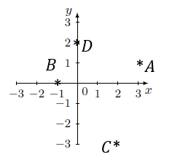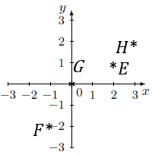
2.a. (1,-2) b. (0,-2) c. (2,0) d. (-3,1) e. (-2,-3) f. (0,3)
g. (-1,1) h. (-3,0) BackToQns

5B Stretch Questions (ans)
3.a. (4,1), (4,4), (1,4) 4.a. HELP b. (4,4), (5,1), (3,1), (3,4), (5,1), (5,4) c.KEY_UNDER_POT_PLANT
d. 21510032513451001154004451255141 5.a. (4,5) b. (4,1) c. (0,0) d. (1,5) BackToQns

5C Routine Questions (ans)
1.a. (-2,-1) b. (-1,3) c. (3,2) d. (-1,-1) e. (1,3) f. (-1,2)
g. (-1,-2) h. (-1,0) i. (2,-3) j. (-1,3) k. (-3,2) l. (0,-2)
m. (-1,-1) n. (-1,3) o. (-1,5) BackToQns

5C Stretch Questions (ans)
2.a. (-4,-1) b. (-4,3) c. (-1,6) d. (9,5) 3.a. (3,-1) b. (-1,-3)
c. (-2,-1) d. (-2,1) 4.a. (a,b+3) b. (a,b-3) c. (a-3,b) d. (a+3,b) e. (a,-b) f. (-a,b) g. (b,-a) h. (-a,-b) BackToQns

