 |  | Year 7 Mathematics
 |  | PRACTICE ALT 1: Integers and Algebra
 |  | Name:

DESCRIPTION
In this Assessed Learning Task, you will use you understanding of integers and algebra to answer a variety of questions using the skills listed in the rubric.
Enrichment | This section will test your understanding of enrichment levels skills and how you apply enrichment level skills in problem solving and reasoning sections.
Core | This section will test your understanding of core levels skills and how you apply core level skills in problem solving and reasoning sections.
Entry | This section will test your understanding of entry levels skills and how you apply entry level skills in problem solving and reasoning sections.
This ASSESSED LEARNING TASK will be used to measure your growth and achievement against the skills and understandings in the unit of work studied before this assessment.
Type of Task: | Test in two sections
Conditions: | Section 1: 60 mins writing time  - Technology free  - Workbook |  | Section 2: 30 mins writing time  - Calculator allowed  - Workbook
Materials Allowed | - Workbook  - Pen / pencil / eraser
KEY SKILLS
 | Entry | Core | Enrichment
Adding and subtracting integers | Can add and subtract positive integers, answers between 0 and 10 | Adding and subtracting positive integers, answers between -10 and 10 | Adding and subtracting negative integers, answers between -10 and 10
Order of operations | Can calculate sums involving the four basic operations | Can show step by step working out for order of operation questions involving two basic operations | Can calculate with more complex operations (powers, square roots and factorials) and apply these within order of operation questions.
Substitution | Substituting into a one-step expression involving addition and subtraction | Substituting into a one-step expression involving multiplication and division | Substituting into any two-step expression, involve all four operations
Solving | Solving a one-step equations involving addition and subtraction, showing use of an opposite operation | Solving a one-step equation involving multiplication and division, showing use of an opposite operation | Solve a two-step equation showing line by line working out
Cartesian plane | Can state grid references. | Plot and label points in the Cartesian plane | Translations and reflections of points in the Cartesian plane.
Application | Apply entry level skills in a context and explain reasoning | Apply entry level skills in a context and explain reasoning | Apply extension level skills in a context and explain reasoning
Reasoning | Can reason with entry level skills | Can reason with core level skills | Can reason with enrichment level skills

Student Declaration
By submitting this task I declare that this assessment is my individual work after seeking and receiving feedback from my peers and teacher. I have not copied from another student’s work or from any other source, except where due acknowledgement is made explicit, nor has any part being written or completed for me by another person.

Section 1: Entry Level Skills
- Calculate the following. [1A/2A]

- $8-3$ |  | - 2 $×$ 6

- Substitute $x=5$ into $x+4$ and evaluate

- Solve the following equation. Remember to include working out that shows your use of the opposite operation. [4A]

$$x-5=3$$

- State the grid reference of the Star. [5A]
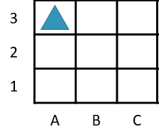

Section 2: Core Level Skills
- Calculate the following. [1B/2B]

- ${}_{}^{-}3+5$ |  | - $2×(4+3)$

- Substitute $x=18$ into $\frac{x}{3}$and evaluate. [3B]

- Solve the following equation. Remember to include working out that shows your use of the opposite operation. [4B]

$2x=10$

- On the Cartesian Plane: [5B]
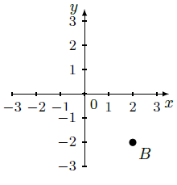
- Plot the point $A=\left(3,2\right)$ | - State the coordinates of point B.

Section 3: ENRICHMENT Skills
- Calculate the following. [1C / 2C]

- $1-{}_{}^{-}2$ |  | - $\sqrt{2^{3}+17}$

- Evaluate the following expression after substituting the given value for $x.$ [3C]

$2x+7$, $x=4$

- Solve the following equation. Remember to include working out that shows your use of two opposite operations. [4C]

$$3x+5=29$$

- State the coordinates of the image of the point after it undergoes the given transformation.
  - Translate $(-1,3)$ 3 units down

SECTION 4: EXTENSION LEVEL SKILLS (Enhanced only)
- Complete the following subtraction.

$${}_{}^{-}{317}+{}_{}^{-}{453}$$

- Use four 4s to make the following number. As well as the four basic operations, you may use brackets, powers, square roots, factorials. Show full working to check your answer. A sample question and solution is provided on the right.

$$81$$ | Sample Question: $40$  Sample Solution:  $$4^{4}÷4-4!$$  $$=256÷4-4!$$  $$=256÷4-24$$  $$=64-24$$  $=40$

- Substitute $a=-9, b=9$and $c=-5$into the following and then evaluate.

$$\frac{3(c-a)}{4}-b$$

- A number $x$ has 300 added to it and then is multiplied by 4. The result 720. Write an equation for this situation and solve it using opposite operations.

- Write the coordinates of the image of points after each sequence of transformations. For each part, apply the next transformation to the image of the previous transformation. Start with (2,-1) and then:

• rotate 180$°$ clockwise around the origin
• reflect in the y-axis
• translate 1 unit left and 3 units up

PRACTICE ALT

Year 7 Post Unit Summative Assessment Unit 1 – Integers and Algebra Part 2: Technology Active

Student Name…………………………………………………………
Technology Active – Calculator Allowed

Application Questions
1. | 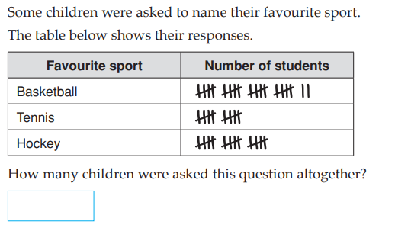
2. | 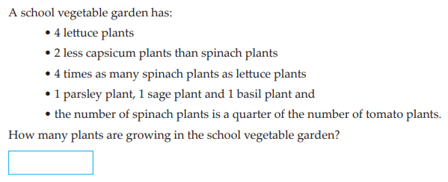
3. | 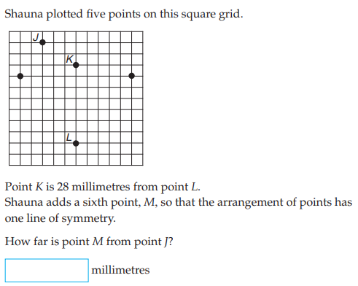
4. | 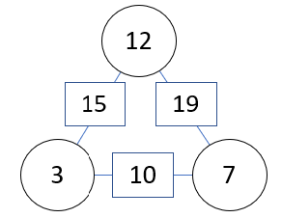  Here is an arithmagon. Notice how the numbers in the rectangles are the sums of the two numbers in the circles on either side.  Complete the below arithmagon by working out what numbers go in the circles.  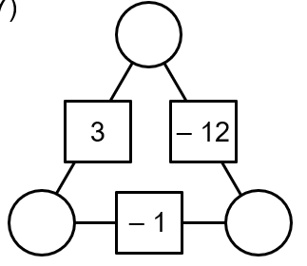

Reasoning Questions
1. | Jamie is solving $x+7=10$ and says the solution is $x=17$. Explain to Jamie what mistake he has made.
2. | Jamie knows that $10×6=60$, how can he use this fact to work out $15×6$?

3. | Consider the statement:  “A negative subtract a negative gives a positive answer”  Is this always, sometimes or never true? Give reasons.
4. | Explain why ${\left(a+b\right)}^{2}≠a^{2}+b^{2}$

