
SANDRINGHAM COLLEGE
YEAR 7 MATHS
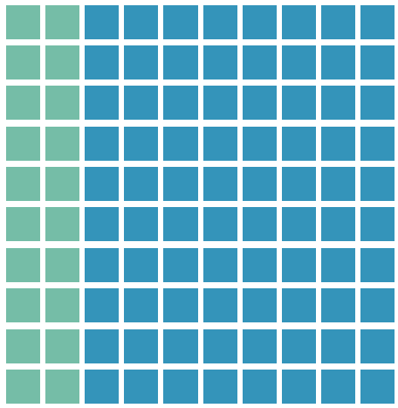
Topic 2: Decimals

Contents
Introduction: 2
1. Decimal Place Value 3
2. Multiplying and dividing decimals by 10 and 100 10
3. Addition and Subtraction Algorithms 18
4. The Multiplication Algorithm 28
5. The Division Algorithm 36
6. Percentage of a number 46
Early Finisher Activities 52
The big ideas of this topic are listed above.

Introduction:
Reminders
Minimum Expectations
It is through regular practice and high expectations that you will maximise your progress in maths!
There are three things that will need to be included before work is considered complete:
- Copying of the question if in blue text – if it is in blue it is in our books!
- Inclusion of working out (where appropriate)
- Corrections. A tick ✓ if correct and retry until correct if incorrect.
In most cases, your teacher will require you to complete at least one set of questions for each big idea. Most students will start with Routine Questions at the Core Level, though there are options to move onto more challenging questions or less challenging questions as needed.
Assessed Learning Task (ALT)
At the end of the unit you will complete an ALT.
All skill based ALT questions will be developed from the questions in this book. All application questions will be of a similar structure, though not always familiar.
Most students will complete the mainstream ALT focusing on Core Level skills, though some students will complete a modified ALT focusing on Entry Level skills and others will complete an Enhanced ALT focusing on Enrichment Level Skills. Decisions around which ALT each student will do will happen towards the end of the topic ☺
You will be allowed to bring your maths workbook into the ALT and so there is great incentive to complete as many stretch questions as you can!!

Decimal Place Value

Setting the Goal
Learning Intention:
- What are the place-value names for digits after the decimal point?
- How do we round numbers?
- Why do we round numbers?
Success Criteria: I know that the decimal place value names begin with tenths, hundredths, thousandths, ten-thousandths. I can round decimal numbers accurately by looking at the critical digit.

Skill A: Entry skill

Key words
A decimal number is a number that contains values less than one whole.
The decimal point is the name given to the symbol that separates the whole and decimal parts of a number.
The 10 digits are 0, 1, 2, 3, 4, 5, 6, 7, 8, 9. Digits are to numbers, what letters are to words.

Activate prior knowledge
What is the biggest number you can write down in digits and words?
Eg. 999 is nine hundred and ninety nine

Explicit teaching
[NEW PAGE] 1A: Decimal Place Value
- The first four place value names in a decimal number are tenths, hundredths, thousandths and ten-thousandths.
- Example:
Ones | Tenths | Hundredths | Thousandths | Ten-thousandths
2 | 5 | 3 | 4 | 1

Examples:
What is the place value of the underlined number in each of the following?
1. 5.261 |  |  | 2. 10.3005
What we write:  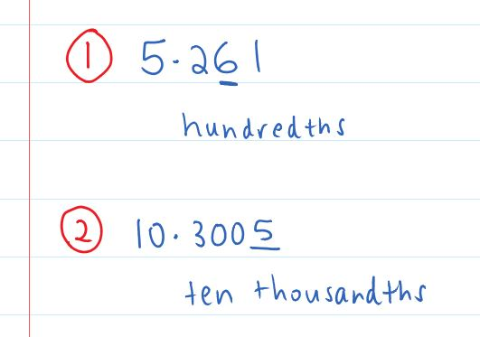 |  | What we think:  The place value names after the decimal point are tenths, hundredths, thousandths and ten-thousandths. This means that the 2 is in the tenths place value and the 6 is in the hundredths place value.  The place value names after the decimal point are tenths, hundredths, thousandths and ten-thousandths. This means that the 3 is in the tenths place value, the first 0 is in the hundredths place value, the second 0 is in the thousandths place value and the 5 is ten-thousandths place value.
Your Turn:
1. 163.2 |  |  | 2. 3.0417

PRACTICE

1A Routine questions
- What is the place value of the underlined number in each of the following? 4First Five Live
- 3.451 | - 1.203 | - 10.2 | - 12.36 | - 19.8123
- 51.0762 | - 3.0782 | - 0.102 | - 169.3 | - 5.2716
- 0.2 | - 0.02 | - 0.12 | - 15.1 | - 0.0002

☑ Correction Time! Click here for answers

1A Stretch questions
- Write the following numbers as decimals using digits
- 3 hundredths | - 7 ten thousandths | - 6 tenths | - 5 thousandths
- Read these fractions aloud and then write them as a decimal.
- $\frac{3}{10}$ | - $\frac{7}{100}$ | - $\frac{1}{10 000}$ | - $\frac{9}{1 000}$
- The following table shows the place value names for whole numbers containing up to 15 digits.
Note H = hundreds, T = tens and O = ones
Trillion |  |  | Billion |  |  | Million |  |  | Thousand |  |  | (Ones)
H | T | O | H | T | O | H | T | O | H | T | O | H | T | O
Use this table to write the following numbers using words
- $150 003$ | - $20 050 004 000$ | - $7 300 006 000 020$ | - $27 000 450 002 000$

- The decimal place value names follow the same pattern as the place value names in whole numbers. Use this fact to state the place value of the 2 in each of the following numbers.
- $0.000 2$ | - $0.000 002$ | - $0.000 000 02$ | - $0.000 000 000 000 2$

☑ Correction Time! Click here for answers to most questions

Finished Early? Head to the Early Finishers Page to engage in a game, puzzle or investigation.

Skill B: core skill

Key words
Rounding is the process of approximating a number by removing smaller place value parts.

Activate prior knowledge
I have an imaginary bag containing only 5c coins. If there are 912 753 coins, what is the total value of the money in my bag?
Students take turns to guess the total weight without using a calculator. Teacher to document guesses on the board and respond only with “higher” or “lower”.
Play a second time using another random number between 100 000 and 1 000 000. Did you find the answer using less guesses?

Explicit Teaching
[NEW PAGE] 1B: Rounding Decimals
- You can round decimals by
  - Underlining the number to the specified number of decimal places
  - Circling the next digit – This is the critical digit
  - If
    - The critical digit is less than 5 the underlined number is the answer
    - The critical digit is 5 or more increase the underlined “number” by 1. This is the new answer.

Examples:
1. 13.742 (1 dp.) |  | 2. 5.2361 (2 dp.) | 3. 125.703 (2 dp.)
What we write:  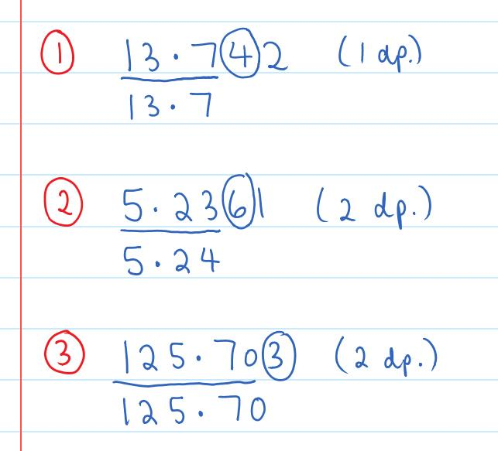 | What we think:  Since the circled digit is less than 5, the underlined number is the answer.  Since the circled digit is 5 or bigger then we increase the underlined “number” by 1. This means 5.23 is rounded up to 5.24  Since the circled digit is less than 5, the underlined number is the answer. It is important to keep the zero as we need to give an answer with exactly 2 decimal places.
Your Turn:
1. 4.862 (1 dp.) |  | 2. 25.017 (1 dp.) | 3. 15.2767 (2 dp.)

Practice

1B ROUTINE QUESTIONS
1. Round each number to the number of decimal places indicated. 4First Five Live
a. | 4.63 (1 dp.) | b. | 5.04 (1 dp.) | c. | 0.187 (2 dp.) | d. | 4.9727 (3 dp.)
e. | 0.97381 (2 dp.) | f. | 0.367 (2 dp.) | g. | 31.864 (1 dp.) | h. | 4.6749 (3 dp.)
i. | 1.9400 (3 dp.) | j. | 33.192 (2 dp.) | k. | 1.868 (1 dp.) | l. | 42.387 (2 dp.)
m. | 3.68751 (2 dp.) | n. | 0.387 (2 dp.) | o. | 36.81 (1 dp.) | p. | 1.027 (1 dp.)
q. | 2.9420 (3 dp.) | r. | 21.9061 (2 dp.) | s. | 1.368 (1 dp.) | t. | 0.3501 (2 dp.)
☑ Correction Time! Click here for answers

1B STRETCH questions
- Recurring decimals are decimals where digits repeat in a pattern forever. A line drawn above digits is used to show this repetition. For example $3.5\overline{81}=3.581818181…$
Round the following recurring decimals to the number of decimal places requested.
- $0.\overline{26}$ (2 dp.) | - $4.2\overline{93}$ (4 dp.) | - $3.8\overline{754}$ (4 dp.) | - $19.8\overline{74}$ (5 dp.)
- When you need to round up a number that ends in a 9 you have to think a little harder. For example 3.4972 rounded to 2 decimal places is 3.50. Round the following numbers to the number of decimal places indicated.
- 5.994 (1 dp.) | - 3.198 (2 dp.) | - 3.1579 (3 dp.) | - 3.997 (2 dp.)

- Round the following numbers to the number of decimal places indicated.
- 15.4499899 (1 dp.) | - 15.4499899 (2 dp.) | - 15.4499899 (3 dp.) | - 15.4499899 (4 dp.)
- State the value indicated on each diagram below.
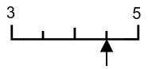 | 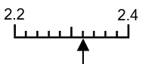 | 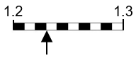 | 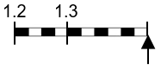

☑ Correction Time! Click here for answers
Finished Early? Head to the Early Finishers Page to engage in a game, puzzle or investigation.

SKILL C: ENRICHMENT SKILL

Activate prior knowledge
Meet Blockzilla (up to 4 min 20 sec)

Explicit Teaching
[NEW PAGE] 1C: Comparing Decimals
- Important symbols:
- < is “less than”
- = is “equals”
- > is “greater than”
- To compare decimals,
  - Align the digits by place value, compare digits starting on the far left
(see examples for details)

Helpful Information
- An example of less than: 2 < 7
- An example of equals: 4 = 4
- An example of greater than: 7 < 2
- Notice that the big open part opens towards the bigger number

Examples:
Put a <, = or > between the decimals and, if possible, underline the biggest decimal.
1. $0.02 0.2$ |  | 2. $0.26 0.260$ | 3.$3.92$ $3.4813$
What we write:  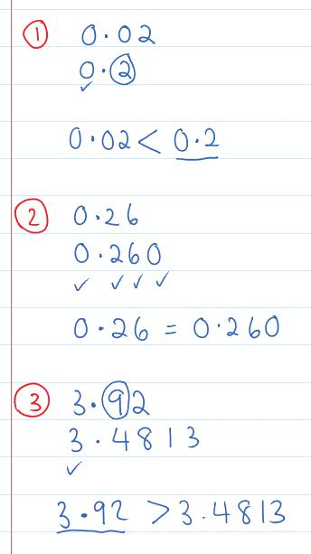 | What we think:  After aligning the digits by place value we look to the far left and start comparing digits in the same place value position. Both numbers have 0 wholes. The first number has 0 tenths, but the second number has 2 tenths. 2 tenths is bigger than 0 tenths so the second number is bigger. The bigger opening goes towards the second number.  After aligning the digits by place value we look to the far left and start comparing digits in the same place value position. Both numbers have 0 wholes, 2 tenths and 6 hundredths. Both numbers also have 0 thousandths (0.26 has no thousandths which is the same as 0 thousandths). Both numbers are equal so we put an equals sign between them.  After aligning the digits by place value we look to the far left and start comparing digits in the same place value position. Both numbers have 3 wholes. The first number has 9 tenths, but the second number has 4 tenths. 9 tenths is bigger than 4 tenths so the first number is bigger. The bigger opening goes towards the first number.
Your Turn:
Put a <, = or > between the decimals and, if possible, underline the biggest decimal.
1. $12.3798 12.37$ |  | 2. $0.05 0.5$ | 3.$2.10$ $2.100$

Practice

1C ROUTINE QUESTIONS
1. Put a $<$, $=$ or $>$ between the decimals and, if possible, underline the biggest decimal. 4First Five Live
- 1.06 1.053 | - 8.130 8.13 | - 0.063 0.06 | - 15.621 6.06729
- 0.7 0.96 | - 1.35 1.35612 | - 1.324 1.2431 | - 5.9 5.15
- 0.1 0.01 | - 3.1206 3.12 | - 0.02 0.20 | - 0.5 0.50
- 4.6 4.06 | - 3.21 3.210 | - 0.39 0.197 | - 1.75 1.08
- 7.601 7.016 | - 0.005 0.500 | - 0.2 0.103 | - 0.90 0.9000
☑ Correction Time! Click here for answers

1C STRETCH questions
- Put these six decimals in ascending order (smallest to largest)
$$0.1, 0.41, 0.7, 0, 0.01, 0.251$$
- The batting averages for five retired Australian Cricket test captains are: Adam Gilchrist 47.60, Steve Waugh 51.06, Mark Taylor 43.49, Allan Border 50.56 and Kim Hughes 37.41.
    - List the five players in descending order of batting averages (i.e. largest to smallest).
    - Ricky Ponting’s test batting average is 56.72.Where does this rank him in terms of the retired Australian test captains listed above?
- Put a <, = or > between the integers and, if possible, underline the biggest integer.
- ${}_{}^{-}5 {}_{}^{-}2$ | - ${}_{}^{-}8 {}_{}^{-}1$ | - ${}_{}^{-}1 {}_{}^{-}4$ | - ${}_{}^{-}3 {}_{}^{-}2$
- Put a <, = or > between the decimals and, if possible, underline the biggest decimal.
- ${}_{}^{-}{2.1} {}_{}^{-}{2.01}$ | - ${}_{}^{-}{0.7} {}_{}^{-}{0.16}$ | - ${}_{}^{-}{1.09} {}_{}^{-}{1.1}$ | - ${}_{}^{-}{0.05} {}_{}^{-}{0.050}$
☑ Correction Time! Click here for answers
Finished Early? Head to the Early Finishers Page to engage in a game, puzzle or investigation.

Skill 1 Reasoning Questions

Entry | Core | Advanced
Which is bigger out of 0.3 and 0.03? How do you know? | Which number out of 1.52 and 1.53 is closer to 1.528? How do you know? | Explain why 0.038 is smaller than 0.04

COLLABORATIVE TASK:
Spiralling decimals or Spiralling decimals for two

Assessment for Learning
Your progress will be monitored through your classwork and weekly homework sheets.

Reflection and Recognition
Let’s reflect on some Routine questions. Choose one or more of the questions below to answer.
- What are the place-value names for digits after the decimal point?
- How do we round numbers?
- Why do we round numbers?
Let’s recognise something that went well and something that could be improved.
- What component of this work caused the most growth in your learning?
- Is there anything you’d like to improve?

Multiplying and dividing decimals by 10 and 100

Setting the Goal
Learning Intention:
- What is the process for multiplying a whole number by zero?
- How is multiplying and a whole number by 10 similar and/or different to multiplying a decimal by 10?
- Why do some zeros count and others don’t?
Success Criteria: I multiply by powers of 10 by adding zeros or moving the decimal point right to make the numbers bigger. I divide by powers of 10 by removing zeros or moving the decimal point left to make the number smaller.

Skill A: Entry skill

Activate prior knowledge
Activity 1: Gerome says “To multiply a number by 10 you just add a zero”. Use your calculator to create two questions. One where Gerome’s statement is true, and another where Gerome’s statement is false.
Can you adjust Gerome’s statement to provide a helpful, yet accurate tip for multiplying by 10?
Activity 2: Calculate the following (mentally or with a calculator) and describe what you notice.
Set 1 | $$1×10$$ | $$10×10$$ | $$100×10$$ | $$1 000×10$$ | $$100 000×10$$
Set 2 | $$100÷10$$ | $$10÷10$$ | $$1÷10$$ | $$0.1÷10$$ | $$0.01÷10$$

Explicit teaching
[NEW PAGE] 2A: Multiplying and Dividing Whole Numbers by 10
- Multiplying by 10 makes a number bigger. Dividing by 10 makes a number smaller.
- Multiplying by 10
  - For whole numbers, simply add a zero on the end
- Dividing by 10
  - For whole numbers ending in a zero, simply remove a zero from the end
Helpful Information
- Multiplying by 10 moves each digit up one place value position
- Dividing by 10 moves each digit down one place value position
Examples:
1. $30÷10$ | 2. $72×10$ | 3. $3500×10$ | 4. $94600÷10$
What we write:  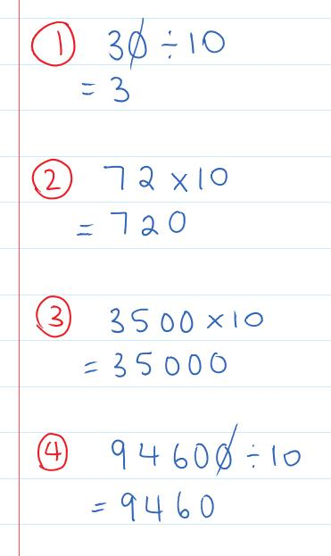 | What we think:  We are dividing by 10. Since this is a whole number ending in a zero we can remove it from the end. (Removing the zero results in each digit moving down one place value position.)  We are multiplying by 10. Since this is a whole number we simply add a zero to the end. (Adding the extra zero results in each digit moving up one place value position.)  We are multiplying by 10. Since this is a whole number we simply add a zero to the end. (Adding the extra zero results in each digit moving up one place value position.)  We are dividing by 10. Since this is a whole number ending in a zero we can remove it from the end. (Removing the zero results in each digit moving down one place value position.)
Your Turn:
1. $400×10$ | 2. $700÷10$ | 3. $720×10$ | 4. $45000÷10$

PRACTICE

2A Routine questions
1. Calculate the following. 4First Five Live
- $3400×10$ | - $800÷10$ | - $5430÷10$ | - $70×10$
- $35400×10$ | - $1040÷10$ | - $3500×10$ | - $80÷10$
- $7100÷10$ | - $100÷10$ | - $1900×10$ | - $8×10$
- $60÷10$ | - $18000×10$ | - $5200×10$ | - $6310÷10$
- $470×10$ | - $950×10$ | - $2600÷10$ | - $310÷10$

☑ Correction Time! Click here for answers

2A Stretch questions
- Complete the following worded questions.
  - A restaurant bill of $370 is to be split equally between 10 people. How much does each person have to pay?
  - A document takes 12 seconds to print. How long will it take to print 10 of these documents? Give your answer in seconds and then in minutes.
- The following questions are in groups as the answers to previous questions help with future ones.
a.i. $4×5$  ii. $40×5$ | b.i. $3×8$  ii. $30×8$ | c.i. $7×5$  ii. $7×50$ | d.i. $9×3$  ii. $9×30$
- Calculate the following using order of operations.
- $16×10+240÷10$ | - $(18+15)×10$ | - $18×10×10÷10$
- Recall that $2^{3}=2×2×2$ and $2^{4}=2×2×2×2$. Use this fact to calculate the following powers of 10 and then to write each number in words (refer to 1A Stretch Question 4 if needed).
- ${10}^{4}$ | - ${10}^{7}$ | - ${10}^{9}$ | - ${10}^{13}$
- Calculate the following.
- $4×10×10×10$ | - ${4×10}^{3}$ | - $460×{10}^{6}$ | - $70670×{10}^{3}$
- Calculate the following.
- $90 000 000÷{10}^{5}$ | - ${72 000 000÷10}^{4}$ | - $860 000 000÷{10}^{6}$ | - $6040 000 000÷{10}^{6}$
☑ Correction Time! Click here for answers
Finished Early? Head to the Early Finishers Page to engage in a game, puzzle or investigation.

Skill B: core skill

Activate prior knowledge
Which zero count?
Every number below is written slightly incorrectly. Correct each number by removing or including something.
A. | B. | C. | D. | E. | F.
$$4100.$$ | $$0041$$ | $$41.00$$ | $$0.0410$$ | $$00.41$$ | $$.4100$$

Challenge: give an example of a question where C, D and F are in the perfect form for the correct answer.

Explicit Teaching
[NEW PAGE] 2B: Multiplying and Dividing Decimals by 10
- Multiplying by 10 makes a number bigger. Dividing by 10 makes a number smaller.
- Multiplying by 10
  - For decimal numbers, simply move the decimal point one position right
- Dividing by 10
  - If not a whole number ending in a zero, move the decimal point one position left
Helpful Information
- Multiplying by 10 moves each digit up one place value position
- Dividing by 10 moves each digit down one place value position
- Leave space before and after the number to allow for decimal point movement
- There is an invisible decimal point at the end of every whole number. Write this in if needed.
- After moving the decimal point:
  - Remove zeros at the beginning of whole numbers or at the end of decimals.
  - Remove decimal points from the end of whole numbers.
  - Include zeros at the end of whole numbers or at the start of decimals, making sure the ones position is never empty.

Examples:
1. $0.25÷10$ | 2. $0.73×10$ |  | 3. $1.2×10$ | 4. $5÷10$
What we write:  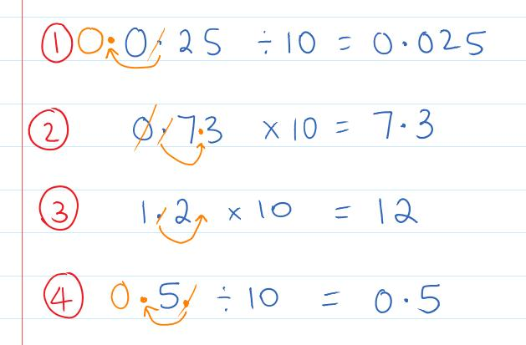 |  | What we think:  We are dividing by 10. Since this isn’t a whole number ending in a zero we move the decimal point one place to the left. We include a zero at the start of the number because the ones position is never empty.  We are multiplying by 10. Since this is a decimal number we move the decimal point one position to the right. We remove the zero from the start of the whole number.  We are multiplying by 10. Since this is a decimal number we move the decimal point one position to the right. We remove the decimal point because decimal points at the end of whole numbers are invisible.  We are dividing by 10. Since this isn’t a whole number ending in a zero we insert a decimal point at the end of the whole number and move the decimal point one place to the left. We include a zero at the start of the number because the ones position is never empty.
Your Turn:
1. $0.561×10$ | 2. $12.37÷10$ |  | 3. $4÷10$ | 4. $4.5×10$

Practice

2B ROUTINE QUESTIONS
- Calculate the following. 4First Five Live
- $0.35×10$ | - $0.103÷10$ | - $207÷10$ | - $3.2×10$
- $0.59×10$ | - $10.6÷10$ | - $0.053÷10$ | - $0.076×10$
- $3.8×10$ | - $23÷10$ | - $0.12÷10$ | - $3.67×10$
- $2.6×10$ | - $3.091×10$ | - $73÷10$ | - $40.3÷10$
- $0.75×10$ | - $5.603÷10$ | - $20.7÷10$ | - $3.7×10$
☑ Correction Time! Click here for answers

2B STRETCH questions
- Answer the following worded questions.
  - A petrol station charges $1.39 per litre of petrol. How much will it cost George to fill their car with 100 litres of petrol?
  - Wendy is on a mobile phone plan that charges her 3 cents per text message. On average, Wendy sends 10 text messages per day. What will it cost Wendy for 100 days of sending text messages at this rate? Give your answer in cents and then convert your answer to dollars.

- Calculate the following using order of operations.
- $(23-17)÷10$ | - $3.5÷(10÷10)$ | - $5.7÷10÷10÷10$
- Write the following using digits
- $30$tenths | - $300$tenths | - $0.3$hundredths | - $30$thousandths
- Calculate the following. Note that some questions and answers are related and using these could be helpful.
- $10÷5$ | - $100÷5$ | - $0.1÷5$ | - $1÷5$
- $100÷4$ | - $10÷4$ | - $0.1÷4$ | - $0.01÷4$
- State the value indicated on each diagram below.
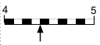 | 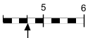 | 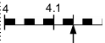 | 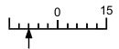
- Calculate the following.
- $0.3÷10÷10÷10$ | - $0.3÷{10}^{3}$ | - $56÷{10}^{3}$ | - $350÷{10}^{5}$
- Calculate the following.
- $90 000÷{10}^{8}$ | - ${72 000 000÷10}^{10}$ | - $860 000 000÷{10}^{12}$ | - $6 040 000÷{10}^{12}$
☑ Correction Time! Click here for SOME answers. Where answers aren’t given, check them with a peer or your teacher.

Finished Early? Head to the Early Finishers Page to engage in a game, puzzle or investigation.

SKILL C: ENRICHMENT SKILL

Activate prior knowledge
Once again, which zero count?
Every number below is written slightly incorrectly. Correct each number by removing or including something.
A. | B. | C. | D. | E. | F.
$$0.0570$$ | $$5700.$$ | $$.5700$$ | $$00.57$$ | $$57.00$$ | $$0057$$

Explicit Teaching
[NEW PAGE] 2C: Multiplying and dividing by powers of 10
- Powers of 10: 10¹ = 10, 10² = 10 x 10 = 100, 10³ = 10 x 10 x 10 = 1 000
Helpful Information:
- To multiply by 100, we multiply by 10 twice.
- To multiply by 1 000, we multiply by 10 three times. Etc.
- To divide by 100, we divide by 10 twice.
- To divide by 1 000, we divide by 10 three times. Etc.

Examples:
1. $34×100$ | 2. $5.2÷100$ |  | 3. $410÷{10}^{3}$ | 4. $0.42×{10}^{2}$
What we write:  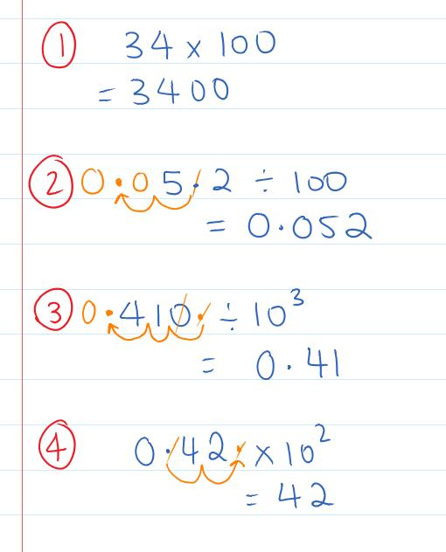 |  | What we think:  To multiply by 100, we multiply by 10 twice. We have a whole number so add two zeros to the end.  To divide by 100, we divide by 10 twice. We have a decimal number so we move the decimal point 2 places to the left. We fill in empty place value positions (including the ones place) with zeros.  To divide by 10³ = 1000, we divide by 10 three times. There are not enough zeros at the end of the whole number so we draw in the invisible decimal point and move it three places to the left. We include a zero at the start of the number because the ones position is never empty. We also remove the zero from the end of the decimal.  To multiply by 10² = 100, we multiply by 10 two times. We have a decimal number so we move the decimal point 2 places to the right. We remove the zero from the beginning of the whole number. We remove the decimal point because decimal points at the end of whole numbers are invisible.
Your Turn:
1. $270×100$ | 2. $63.5÷100$ |  | 3. $400÷{10}^{4}$ | 4. $0.67×{10}^{3}$

Practice

2C ROUTINE QUESTIONS
- Calculate the following. 4First Five Live
- $0.0301×100$ | - $23.1÷{10}^{2}$ | - $250÷{10}^{3}$ | - $1.8×100$
- $0.0041×{10}^{2}$ | - $3.4÷1000$ | - $8.5×100$ | - $93÷{10}^{2}$
- $0.00301×{10}^{3}$ | - $23.1÷{10}^{2}$ | - $6.01×100$ | - $0.0205×1000$
- $0.035×{10}^{2}$ | - $203÷{10}^{3}$ | - $67.3×100$ | - $0.32÷100$
☑ Correction Time! Click here for answers

2C Stretch question
- Put the following values in ascending order.
$$0.075÷10, 715÷{10}^{5}, 0.0072×10, 0.000705×{10}^{2}$$
- Put the following in descending order. Hint: What is the connection between fractions and division?
$$\frac{72}{100}, 0.075, \frac{721}{1000}, 0.071, \frac{0.7}{10}$$
- State the value of the other end point in the diagrams below. Calculators may be used to assist where needed.
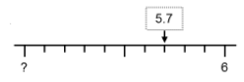 | 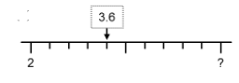
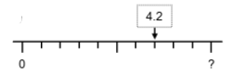 | 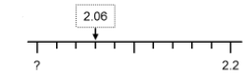
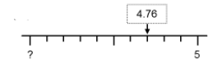 | 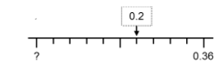
- At a factory it takes 408 seconds to make 100 chocolates. Use your calculator to work out…
  - How long, in minutes, does it take to make 10 000 chocolates?
  - How long, in seconds, does it take to make 10 chocolates?
  - How many chocolates can be made in 408 000 seconds?
- The following questions involve unit conversions.
  - How many centimetre in a meter?
  - How many meter in a kilometre?
  - How many centimetre in a kilometre?
  - Convert 36.4km to centimeters
  - Convert 27.6cm to kilometers

☑ Correction Time! Click here for SOME answers. Where answers aren’t given, check them with a peer or your teacher.
Finished Early? Head to the Early Finishers Page to engage in a game, puzzle or investigation.

Skill 1&2 Application Questions – Think, Pair, Share/Teacher Modelling
Answer the questions you can. Explain your reasoning for at least one of the questions.
1. | 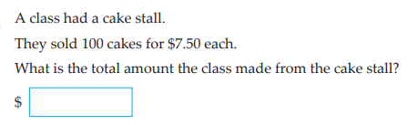
2. | Which of these is the longest distance?
  - 0.1203 km | - 123 m | - 1230 cm | - 12030 mm
3. | - Calculate $\sqrt{5}$ giving your answer to 1 decimal places. Calculate the difference between 5 and the square your rounded answer.  - Calculate $\sqrt{5}$ giving your answer to 2 decimal places. Calculate the difference between 5 and the square your rounded answer.  - Calculate $\sqrt{5}$ giving your answer to 3 decimal places. Calculate the difference between 5 and the square your rounded answer.  - Describe the trend in the differences and explain why this trend will or will not continue forever.
4. | - Using only 5¢ and 10¢ coins, in how many ways can you make 20¢?  - Using only 5¢ and 10¢ coins, in how many ways can you make 50¢?  - Using only 5¢ and 10¢ coins, in how many ways can you make 100¢?  - Using only 5¢ and 10¢ coins, in how many ways can you make 100n ¢?  Further exploration: What happens when you have 5c, 10c and 20c coins?

Skill 2 Reasoning Questions

Entry | Core | Advanced
How could you convince someone that $35×10=350$? | Jodie says: “To multiply a number by 10, you just need to add a zero.”  Caleb says: “This isn’t always true”  Who do you agree with? Why? | How could you convince someone that $0.1×10=1$?

COLLABORATIVE TASK:
Learn a little bit about Scientific Notation: Maths Antics Video

Assessment for Learning
Your progress will be monitored through your classwork and weekly homework sheets.

Reflection and Recognition
Let’s reflect on some Routine questions. Choose one or more of the questions below to answer.
- What is the process for multiplying a whole number by zero?
- How is multiplying and a whole number by 10 similar and/or different to multiplying a decimal by 10?
- Why do some zeros count and others don’t?
Let’s recognise something that went well and something that could be improved.
- What component of this work caused the most growth in your learning?
- Is there anything you’d like to improve?

Addition and Subtraction Algorithms

Setting the Goal
Learning Intention:
- What is an algorithm?
- How is the addition algorithm similar to the subtraction algorithm? How are they different?
- Why do we start adding and subtracting digits on the right? When do we need to carry? When do we need to borrow?
Success Criteria: I can set up the algorithm by aligning digits by place value. I can start on the right. I can “carry” and “borrow”.

Skill A: Entry skill

Key words
An algorithm is a step by step process.
Addition is the process of adding numbers ($+$)
Subtraction is the process of taking one number away from another number ($-$)

Activate prior knowledge
By adding some of the numbers below, how close can you get to 600? You can use your calculator any time.
$$100, 24, 360, 90, 160, 375$$

Explicit teaching Part 1
[NEW PAGE] 3A Part 1: Addition Algorithm
- To add large numbers using the addition algorithm
  - Write the bigger number on top
  - Align digits by place value
  - Add digits, starting on the right
  - Answers go directly underneath, though if the sum of the digits is bigger than 9 you need to carry the tens part up.

Examples:
1. $508+3729$ | 2. $1695+284$
What we write/ what we think:  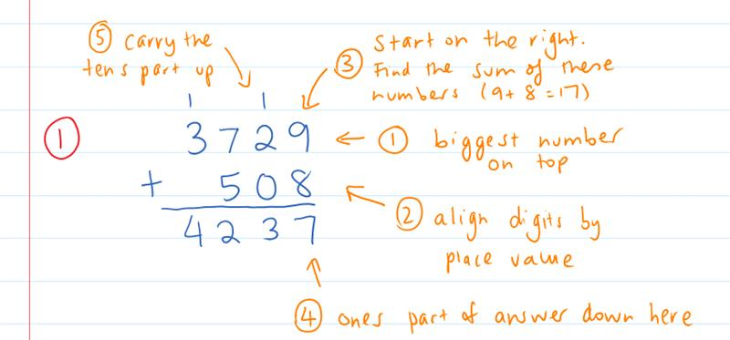 | What we write:  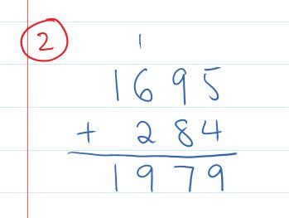
Your Turn:
1. $1327+349$ | 2. $946+5067$

PRACTICE

3A Part 1 Routine questions
- Calculate the following additions. 4First Five Live
- $456+2072$ | - $9367 + 2459$ | - $3367 + 3073$ | - $785 + 2062$
- $355 + 1074$ | - $2427 + 2059$ | - $3151 + 1071$ | - $634 + 2084$
- $2361 + 1068$ | - $184 + 2056$ | - $2741 + 591$ | - $481 + 3054$
- $1521 + 397$ | - $2784 + 268$ | - $3271 + 1051$ | - $3684 + 737$
- $1193 + 397$ | - $1472 + 1042$ | - $3146 + 785$ | - $1177 + 654$
☑ Correction Time! Click here for answers

3A Part 1 Stretch questions
- Farmer Green owns 287 sheep, farmer Brown owns 526 sheep and farmer Grey owns 1041 sheep. How many sheep are there in total?
- For each of the following, fill in the missing digit to make the addition correct.
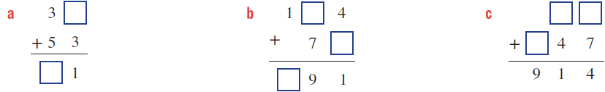
- Make six different 3-digit numbers from the digits 5, 6 and 9. What is the sum of these 6 numbers?
- Describe a process which gives a more efficient way of finding the sum of the 6 numbers in Q4. Use this strategy to work out the sum of the 6 3-digit numbers that can be made with the digits 3, 7, and 9.
☑ Correction Time! Click here for answers
Finished Early? Head to the Early Finishers Page to engage in a game, puzzle or investigation.

Explicit teaching Part 2
[NEW PAGE] 3A Part 2: Subtraction Algorithm
- To take away one large number from another using the subtraction algorithm
  - Write the bigger number on top
  - Align digits by place value
  - Start on the right
    - If the top digit is bigger: calculate “top digit – bottom digit”
    - If the top digit is smaller: borrow from the digit to the left
  - Answers go directly underneath.

Examples:
1. $1451-536$ | 2. $965-591$ |  | 3*. $3036-194$
What we write/what we think:  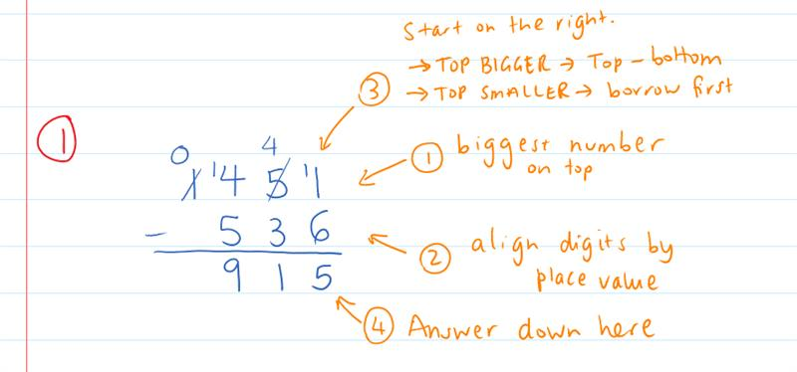 |  | What we write/what we think:  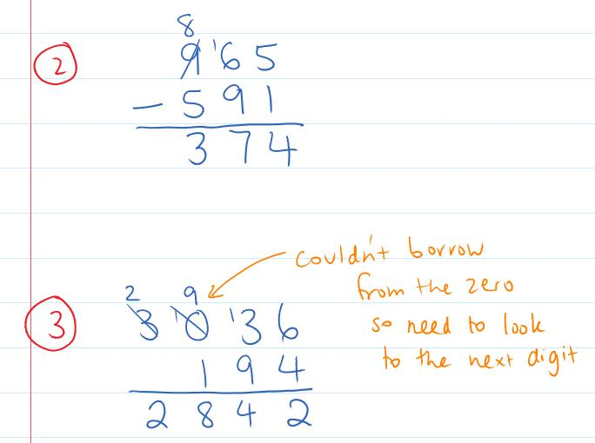
Your Turn:
1. $784-295$ | 2. $2516-732$ |  | 3*. $3506-879$

PRACTICE

3A Part 2 Routine questions
- Calculate the following subtractions. Note that questions q. to t. require the double borrow. 4First Five Live
- $1854-791$ | - $1341 - 527$ | - $1119 - 551$ | - $1126 - 727$
- $883 - 357$ | - $610 - 133$ | - $720 - 374$ | - $1214 - 728$
- $922 - 563$ | - $765 - 593$ | - $566 - 237$ | - $1450 - 799$
- $1392 - 577$ | - $1249 - 555$ | - $810 - 685$ | - $1155 - 696$
- *$1027-751$ | - *$1011-622$ | - *$608-469$ | - *$1070-190$

☑ Correction Time! Click here for answers

3A Part 2 Stretch questions
- What is the difference between the biggest and smallest 3 digit numbers that you can make with the digits 3, 7 and 8?
- Holly thinks that $912-768=256$. Explain the mistake Holly made and why the algorithm doesn’t work this way.
- For each of the following, fill in the missing digit to make the addition correct.
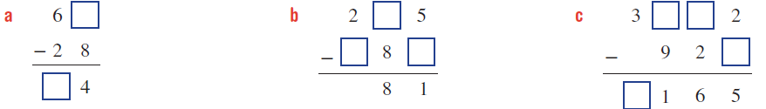
- A box contained 6431 different shapes, of which 1001 were squares, 882 were triangles, 2988 were circles and the rest were star shaped. How many star shapes were in the box?
- In a magic square, each row, column and diagonal add to the same value. Complete the magic squares below.
a. | b.
  62 | 67 | 60
   |  | 65
  101 |  | 114
   | 106 |  | 109
   | 110
  113 | 103 | 102 | 116

☑ Correction Time! Click here for answers
Finished Early? Head to the Early Finishers Page to engage in a game, puzzle or investigation.

Skill B: core skill

Activate prior knowledge
Estimate the total of the following purchases. We will do one at a time and discuss strategies as we go.
Purchase 1 | Purchase 2
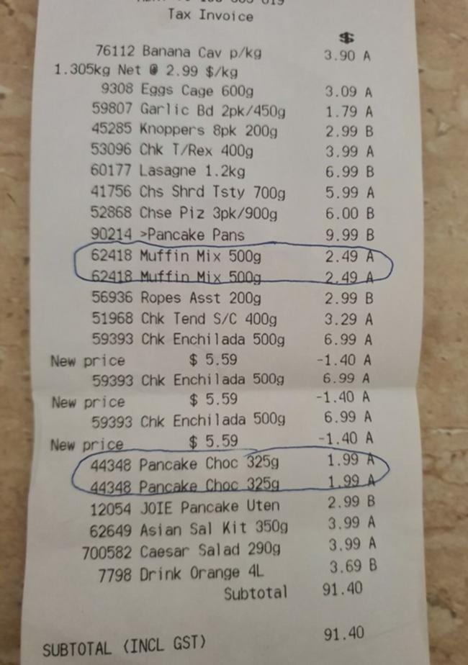

Purchase 3 | Purchase 4

Explicit Teaching
[NEW PAGE] 3B: Adding and Subtracting Decimals
- Use an algorithm
  - Recommended: Filling empty place value positions with zeros
  - Remember to: Include the decimal point in answer so it lines up with decimal points in the question
Examples:
1. $3.5-2.88$ |  | 2. $5.8+1.57$ | 3*. $35.01-5.74$
What we write:  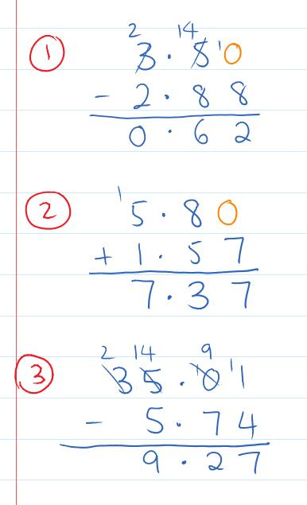 | What we think:  Biggest number on top, align digits by place value. Fill in empty place value positions. Carry out the algorithm. Remember to include the decimal point in the answer so it lines up with the decimal points in the question.  Biggest number on top, align digits by place value. Fill in empty place value positions. Carry out the algorithm. Remember to include the decimal point in the answer so it lines up with the decimal points in the question.  Biggest number on top, align digits by place value. Fill in empty place value positions. Carry out the algorithm (recall the double borrow). Remember to include the decimal point in the answer so it lines up with the decimal points in the question.
Your Turn:
1. $6.7+5.62$ |  | 2. $2.7-1.29$ | 3*. $10.26-8.69$

Practice

3B ROUTINE QUESTIONS
- Complete the following calculations. Note that questions q. to t. require the double borrow. 4First Five Live
- $5.29-3.6$ | - $7.72+5.76$ | - $3.4-1.57$ | - $5.46-0.8$
- $1.64+15.6$ | - $11.5-3.18$ | - $3.38-2.7$ | - $3.6+4.99$
- $8.7-3.67$ | - $1.99+4.6$ | - $1.7+3.58$ | - $2.47-1.6$
- $4.2-0.78$ | - $1.59+3.7$ | - $2.34-1.76$ | - $0.59+3.6$
- *$30.6-0.79$ | - *$5.06-2.27$ | - *$70.5-1.92$ | - *$10.07-2.9$

☑ Correction Time! Click here for answers

3B STRETCH questions
- Stuart wants to raise $100 for the Rainbow Club charity. He already has three donations of $30.20, $10.50 and $5.00. How much does Stuart still need to raise?
- If $a = 2.8$, $b = 1.31$ and $c = 3.928$, find:
- $a+b+c$ | - $a+b-c$ | - $c+b-a$ | - $c-(b+b)$
- Complete the addition table below.
$$+$$ | $$0.01$$ |  | $$0.99$$
$$0.3$$
$$0.75$$ |  | $$1.13$$
 | $$1.21$$ | $$1.58$$
- Solve the following equations.
- $a+7.2=9.71$ | - $12.36=b-9.78$ | - $53.3=4.12+c$ | - $d-3.61=14.812$

☑ Correction Time! Click here for answers

Finished Early? Head to the Early Finishers Page to engage in a game, puzzle or investigation.

SKILL C: ENRICHMENT SKILL

Activate prior knowledge
Will the answer be positive or negative? Make a prediction then check on your calculator.
Level 1:
- $142-357$ | - $-142-357$ | - $-142+357$ | - $142+357$

Level 2:
- $142-{}_{}^{-}{357}$ | - $-142-{}_{}^{-}{357}$ | - $-142+{}_{}^{-}{357}$ | - $142+{}_{}^{-}{357}$

Explicit Teaching
[NEW PAGE] 3C: Adding and Subtracting Larger Negative Numbers
- Model additions and subtractions on the number line.
  - Think carefully about whether you need to add or subtract the numbers AND what the sign of your answer must be.

Examples:
1. ${}_{}^{-}{462}+{}_{}^{-}{1097}$ |  | 2. ${}_{}^{-}{462}-{}_{}^{-}{1093}$
What we write:  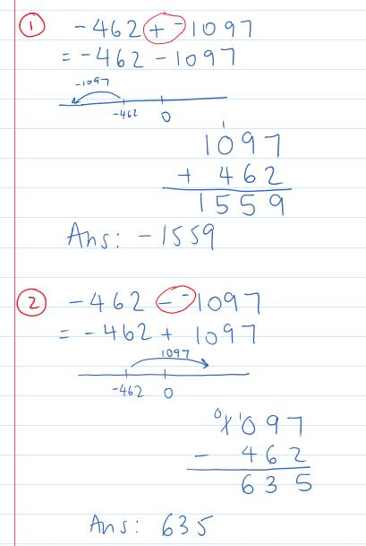 | What we think:  Operation is touching a sign, combine $+{}_{}^{-}→ -$  First number tells us where to start. Move in the negative direction.  Need to add numbers together to work out how far negative we go.  Operation is touching a sign, combine $-{}_{}^{-}→+$  First number tells us where to start. Move in the positive direction.  Need to find the difference between numbers to work out how far past zero we end up.
Your Turn:
1. $358+{}_{}^{-}{2052}$ |  | 2. ${}_{}^{-}{358}-{}_{}^{-}{2052}$

Practice

3C ROUTINE QUESTIONS
1. Calculate the following. 4First Five Live
- ${}_{}^{-}{743}-403$ | - $91+{}_{}^{-}{68}$ | - $158-{}_{}^{-}{38}$ | - $-96+372$
- ${}_{}^{-}{415}-{}_{}^{-}{32}$ | - $57+{}_{}^{-}{148}$ | - $703+{}_{}^{-}{137}$ | - ${}_{}^{-}{76}-138$
- $531+{}_{}^{-}{248}$ | - ${}_{}^{-}{546}-{}_{}^{-}{462}$ | - $79-{}_{}^{-}{57}$ | - ${}_{}^{-}{991}-682$
- ${}_{}^{-}{24}+{}_{}^{-}{441}$ | - ${}_{}^{-}{119}-{}_{}^{-}{63}$ | - $-291+527$ | - $245+{}_{}^{-}{689}$
- ${}_{}^{-}{124}+{}_{}^{-}{497}$ | - $182+{}_{}^{-}{57}$ | - ${}_{}^{-}{305}-68$ | - $61-{}_{}^{-}{293}$
☑ Correction Time! Click here for answers

3C Stretch questionS
- Calculate the following
- $5.25-9.27$ | - $-6.23+1.9$ | - $12.46-{}_{}^{-}{3.8}$ | - ${}_{}^{-}{12.8}-{}_{}^{-}{27.83}$

- If $a = -2.8$, $b = 1.31$ and $c = -3.928$, find:
- $a+b+c$ | - $a+b-c$ | - $c-b-a$ | - $c-(b+b)$
- Complete the addition table below.
$$+$$ | $${}_{}^{-}{3.5}$$ |  | $$1.78$$
$${}_{}^{-}{1.21}$$
 |  | $${}_{}^{-}{12.5}$$
 | $$7.21$$ | $$1.58$$

- Solve the following equations.
- $a+7.2=1.71$ | - $-12.36=b-9.78$ | - $53.3={}_{}^{-}{4.12}+c$ | - $d-3.61=-14.812$
☑ Correction Time! Click here for answers
Finished Early? Head to the Early Finishers Page to engage in a game, puzzle or investigation.

Skill 3 Application Questions – Think, Pair, Share/Teacher Modelling
Answer the questions you can. Explain your reasoning for at least one of the questions.
1. | 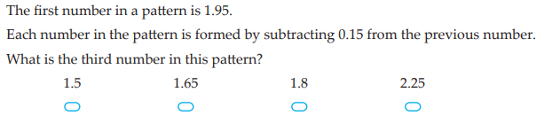
2. | 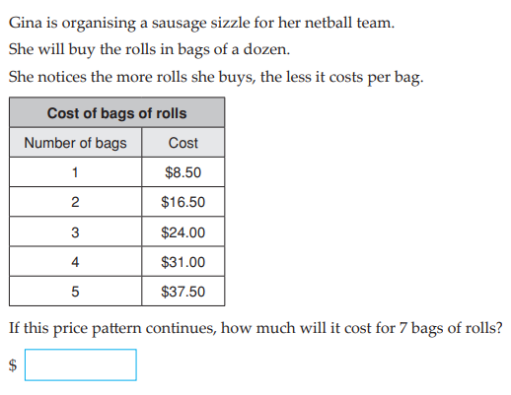
3. | True or False: $0.99999…=1$. Give reasons for your answer.
4. | The pages in a book are numbered starting with page 1. One digit is used to represent the numbers from 1 to 9, whereas two digits are used to represent the numbers from 10-99 (and so on).  - If there are 10 pages in a book. How many digits are used?  - If there are 100 pages in a book. How many digits are used?  - If there are 183 pages in a book. How many digits are used?  Further Exploration: If there are n pages in a book where n=1000a+100b+10c+d. How many digits are used?

Skill 3 Reasoning Questions

Entry | Core | Advanced
Jo is calculating 521-97 and her working out is shown below. What makes her answer so unreasonable? What error has Jo made?  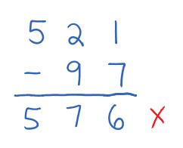 | Jo thinks $0.5+0.7=0.12$ . What makes her answer so unreasonable? What error has Jo made? | Jo thinks $-572-100=-472$ . What makes her answer so unreasonable? What error has Jo made?

COLLABORATIVE TASK:
Fays nines or Number Tiles (both from Mathematical Task Centre Cameos)

Assessment for Learning
Your progress will be monitored through your classwork and weekly homework sheets.

Reflection and Recognition
Let’s reflect on some Routine questions. Choose one or more of the questions below to answer.
- What is an algorithm?
- How is the addition algorithm similar to the subtraction algorithm? How are they different?
- Why do we start adding and subtracting digits on the right? When do we need to carry? When do we need to borrow?

Let’s recognise something that went well and something that could be improved.
- What component of this work caused the most growth in your learning?
- Is there anything you’d like to improve?

The Multiplication Algorithm

Setting the Goal
Learning Intention:
- What is an algorithm? What is multiplication?
- How do we need to set out our work?
- Why do we start multiplying digits on the right? Why do we multiply before adding on the carried amount?
Success Criteria: I can multiply numbers using the multiplication algorithm. I know to multiply the numbers first and then add the carried value.

Key Words
The product of two numbers is the answer when the numbers are multiplied together.

Skill A: Entry skill

Activate prior knowledge
Option 1
Let’s do these as a “think, pair, share.” How many different ways can you work out the answer to the following questions?
1. $9×12$ | 2. $5×16$ | 3.$12×18$
Option 2
Choose any two numbers that add to 25. Multiply them together, what did you get? What is the biggest number you can make this way?

Explicit teaching
[NEW PAGE] 4A: Multiplication Algorithm
- To multiply a large numbers using the multiplication algorithm
  - Write the bigger number on top
  - Multiply digits, starting on the right
  - Answers go directly underneath, though if the product of the digits is bigger than 9 you need to carry the tens part up, and then ADD this on AFTER you’ve multiplied the next digit

Examples:
1. $8×374$ | 2. $863×4$
What we write/what we think:  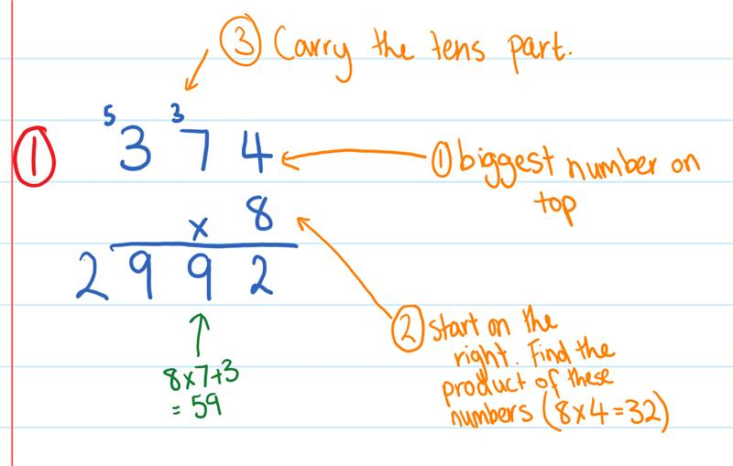 | What we write:  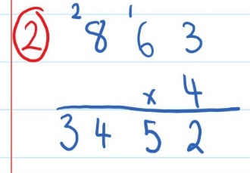
Your Turn:
1. $9×507$ | 2. $632×4$

PRACTICE

4A Routine questions
- Calculate the following multiplications. 4First Five Live
- $6×971$ | - $9×107$ | - $614×7$ | - $9×205$
- $852×3$ | - $623×6$ | - $8×187$ | - $391×3$
- $990×5$ | - $464×7$ | - $7×664$ | - $3×799$
- $713×4$ | - $6×177$ | - $3×798$ | - $803×6$
- $177×7$ | - $7×397$ | - $3×685$ | - $318×6$

☑ Correction Time! Click here for answers

4A Stretch questions
- A circular race track is 240 meters long and Rory runs seven laps. How far does Rory run in total?
- Fill in the missing digits in the calculations below.
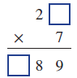 | 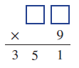 | 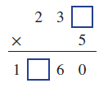 | 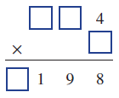
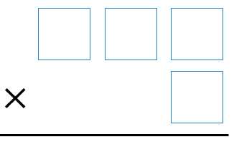
- Using only digits 1 to 9 inclusive (and only once each at most), what is the largest number you can by multiplying a 1 digit number by a 3 digit number?
- We are going to work towards generalising the answer in Q4. Using only digits 1 to 9 inclusive (and only once each at most), what is the largest number you can by multiplying a
  - 1 digit number by a 4 digit number?
  - 1 digit number by a 5 digit number?
  - Without calculating it, what do you predict will be the largest number you can create by multiplying a 1 digit number by an 8 digit number? Check your prediction.

☑ Correction Time! Click here for answers

Finished Early? Head to the Early Finishers Page to engage in a game, puzzle or investigation.

Skill B: core skill

Activate prior knowledge
Use your estimation skills to eliminate incorrect answers. If you can estimate the actual answer that’s great! No calculators allowed for this one!
Q1. $0.5kg$ of chicken wings @$\$4.91/kg$  A. $\$9.82$  B. $\$4.41$  C.$\$2.455$ | Q2. $3.5kg$ of stones $@\$2.8/kg$  A. $\$6.3$  B. $\$9.8$  C.$\$12.7$ | Q3. $3.65kg$ of sausages $@\$7/kg$  A. $\$25.55$  B. $\$2.555$  C.$\$0.2555$ | Q4. $3.65kg$of cinnamon $@\$0.7/kg$  A. $25.55$  B. $2.555$  C.$0.2555$

Explicit Teaching
[NEW PAGE] 4B: Multiplying Decimals
- Multiply numbers as if the decimal point(s) aren’t there.
- Re-write your whole number answer with as many decimal places as there were in total between the numbers in the original question
- If possible, check if answer seems reasonable

Examples:
1. $5.79×0.4$ |  | 2. $0.02×0.95$
What we write:  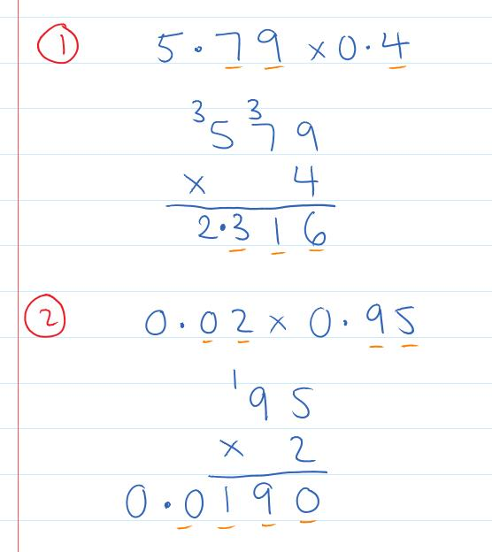 | What we think:  When we ignore the decimal points, 5.79x0.4 becomes 579x4. Using the standard algorithm we see that 579x4=2316. There are 2 decimal places in 5.79 and 1 decimal place in 0.4 making a total of 3 decimal places in the question. This means there are 3 decimal places in the answer, making the answer 2.316. Since 5.79x0.4 is approximately equal to 5x0.5=2.5 this answer seems reasonable.  When we ignore the decimal points, 0.02x0.95 becomes 2x95. Using the standard algorithm we see that 2x95=190. There are 2 decimal places in 0.02 and 2 decimal places in 0.95 making a total of 4 decimal places in the question. This means there are 4 decimal places in the answer, making the answer 0.0190. However, we don’t need to include the final zero in our final answer as this zero “doesn’t count”. Let’s check if our answer is reasonable, 0.02x0.95 is almost 0.02x1=0.02, 0.019 is very close to 0.02 so this answer seems reasonable.
Your Turn:
1. $3.65×2$ |  | 2. $1.43×0.04$

Practice

4B ROUTINE QUESTIONS
- Calculate the following multiplications. 4First Five Live
- $7.35×0.4$ | - $4.07×5$ | - $2.41×0.05$ | - $2.61×2$
- $0.87×0.03$ | - $0.204×0.04$ | - $0.78×0.4$ | - $4.85×0.03$
- $2.79×3$ | - $2.87×0.3$ | - $23.6×0.04$ | - $0.9×5$
- $30.4×6$ | - $4.89×3$ | - $4.89×0.3$ | - $0.86×0.04$
- $0.031×0.02$ | - $3.72×2$ | - $0.08×0.05$ | - $4.77×0.6$
☑ Correction Time! Click here for answers

4B STRETCH questions
- Answer these worded questions.
  - If one can of spaghetti weighs 0.445kg, how much does 8 cans of spaghetti weigh?
  - Calculate, to the nearest cent, the total cost of 2kg of sausages, 0.5kg of burgers and 800g of chicken wings if their costs, respectively, are $5.99 per kg, $8.50 per kg and $4.99 per kg.

- Complete the table below.
$$×$$ | $$0.009$$ | $$0.09$$ | $$0.9$$ | $$9$$
$$0.08$$
$$0.8$$
$$8$$ |  |  |  | $$72$$
$$80$$

- Answer the questions in pairs, using the first answer to assist with the second.
- i. $31.75×8$  ii. $31.75×80$ | - i. $0.0053×7$  ii. $0.0053×7 000$ | - i. $0.0034×2$  ii. $0.0034×20 000$
- Calculate the following mentally. Check your answer using the method introduced in this section if you are not confident in your prediction.
- ${0.3}^{2}$ | - ${0.8}^{2}$ | - ${0.08}^{2}$ | - ${\left(\frac{7}{1000}\right)}^{2}$
☑ Correction Time! Click here for most answers

Finished Early? Head to the Early Finishers Page to engage in a game, puzzle or investigation.

SKILL C: ENRICHMENT SKILL

Activate prior knowledge
What is the difference between a decimal point and a decimal place?

Explicit Teaching
[NEW PAGE] 4C: Multiplying Decimals Part 2
- If multiplying a large number by a 2 digit number, multiply by each digit separately.
- Insert a place holder zero before multiplying by the tens digit.
- Add answers to each individual multiplication to get the final answer.

Examples:
1. $256×47$ |  | 2. $0.13×0.197$
What we write:  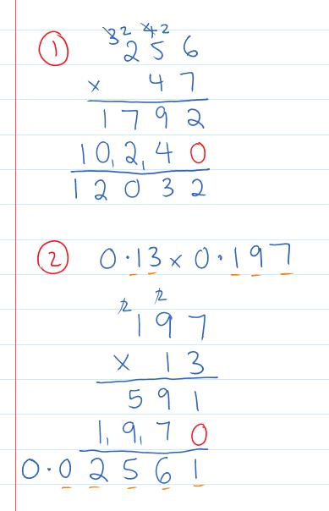 | What we think:  We multiply 256 by the ones digit, 7, first. 256x7=1792. Before multiplying by the 4 in 40 we include a place holder zero in the next line. We then see that 256x40=10240. Adding the answers of 1792 and 10240 gives us our final answer of 12032.  When we ignore the decimal points, 0.13x0.197 becomes 13x197. Using the standard algorithm we see that 13x197=2561. There are 2 decimal places in 0.13 and 3 decimal places in 0.197 making a total of 5 decimal places in the question. This means there are 5 decimal places in the answer, making the answer 0.02561. Since 0.13x0.197 is approximately equal to 0.1x0.197=0.0197 this answer seems reasonable.
Your Turn:
1. $23×184$ |  | 2. $3.05×8.9$

Practice

4C ROUTINE QUESTIONS
- Calculate the following multiplications. 4First Five Live
a. | $1.8×5.07$ | b. | $0.21×0.187$ | c. | $42×0.099$ | d. | $0.27×0.297$
e. | $1.3×30.9$ | f. | $0.66×43$ | g. | $0.298×54$ | h. | $1.1×2.68$
i. | $0.458×5.3$ | j. | $54×20.7$ | k. | $11×0.598$ | l. | $19.6×5.2$
m. | $0.075×5.5$ | n. | $35×0.257$ | o. | $26.7×27$ | p. | $3.66×51$
q. | $4.5×30.5$ | r. | $59×0.076$ | s. | $3.68×5.5$ | t. | $0.29×0.357$
☑ Correction Time! Click here for answers

4C Stretch questionS
- Calculate the cost of buying the following. Give each answer to the nearest cent.
  - 1.86kg of breadcrumbs at $0.95 per kilogram.
  - 4.3m of PVC piping at $3.45 per meter.
  - 4.5m of rope at $2.70 per meter.

- Use the related fact to answer the question in each case.
- $1293×57=73701$  $129.3×5.7$ | - $475×38=18050$  $4.75×0.38$ | - $192×25=4800$  $192×0.25$
- Work out the answer to the following. Try to give a general rule and test it out. Optional Challenge: Can you explain why this happens?
- $3×85.47×1.3$ | - $5×85.47×1.3$ | - $6×85.47×1.3$

- Using the digits 1 through 9 at most once each make the below statement true. Note that 3 and 2 are already part of the equation and cannot be used again. How many different solutions can you find?
$$\boxed{}.\boxed{}×3.2=\boxed{}.\boxed{}$$

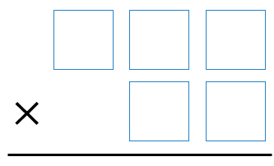
- Optional Challenge 1: Using only digits 1 to 9 inclusive (and only once each at most), what is the largest number you can by multiplying a 2 digit number by a 3 digit number? Hint: The answer is bigger than 83 850 (You will need to check this answer with your teacher)

- Optional Challenge 2: Use your calculator to explore the largest case of the above question. Using only digits 1 to 9 inclusive (and only once each at most), what is the largest number you can by multiplying a 4 digit number by a 5 digit number? (You will need to check this answer with your teacher)

☑ Correction Time! Click here for answers
Finished Early? Head to the Early Finishers Page to engage in a game, puzzle or investigation.

Skill 4 Application Questions – Think, Pair, Share/Teacher Modelling
Answer the questions you can. Explain your reasoning for at least one of the questions.
1. | 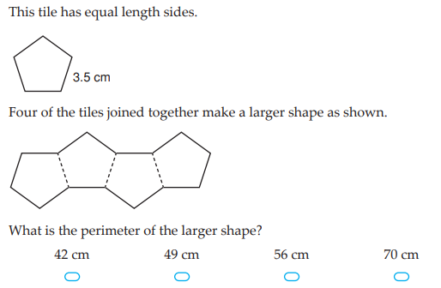
2. | 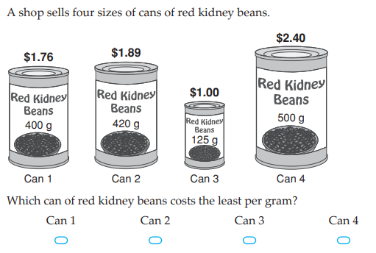
3. | 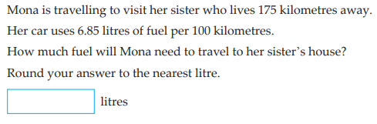
4. | - How many 2 digit numbers have 6 as the sum of their digits?  - How many 3 digit numbers have 6 as the sum of their digits?  - How many 4 digit numbers have 6 as the sum of their digits?  Further Exploration: How many 10 digit numbers have 6 as the sum of their digits?

Skill 4 Reasoning Questions

Entry | Core | Advanced
Jo is calculating $18×3$ and her working out is shown below. What makes her answer so unreasonable? What error has Jo made?  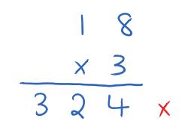 | Jo thinks multiplying makes bigger. When is this true? When is it not true? | How can knowing that  $$5.3264×13.24=70.521536$$  help you work out the answer to  $$53264×1324$$

COLLABORATIVE TASK:
Using the digits 1, 2, 3, 4, 5 and 6. Create two numbers that can be multiplied to produce the biggest product.

Assessment for Learning
Your progress will be monitored through your classwork and weekly homework sheets.

Reflection and Recognition
Let’s reflect on some Routine questions. Choose one or more of the questions below to answer.
- What is an algorithm? What is multiplication?
- How do we need to set out our work?
- Why do we start multiplying digits on the right? Why do we multiply before adding on the carried amount?
Let’s recognise something that went well and something that could be improved.
- What component of this work caused the most growth in your learning?
- Is there anything you’d like to improve?

The Division Algorithm

Setting the Goal
Learning Intention:
- What is a remainder?
- How do we use a multiplication grid to answer division questions with remainders? How do we set out the division algorithm?
- Why do we start dividing digit on the left?
Success Criteria: When using the division algorithm, I know to put the answer above and the remainder before the next digit to the right.

Skill A: Entry skill

Activate prior knowledge
Let’s complete one or more of the following.
Option 1: If you didn’t know the answer to $36÷9,$describe how a multiplication grid can be used to support your calculation.
Option 2: Watch Numberblocks episode “I can count to 20” Why don’t they let Numberblock 3 count to 20?

Explicit teaching
[NEW PAGE] 5A: Divisions with Remainders
- Division can be thought of as “how many groups of”
- If there is an amount left over it is called a remainder

Examples:
1. $12÷4$ | 2. $23÷5$ |  | 3. $3÷4$
What we write:  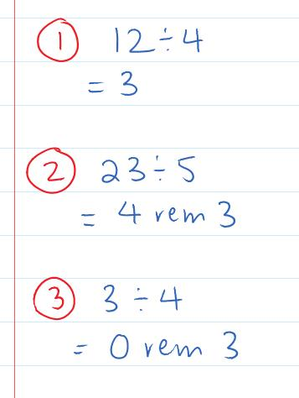 |  | What we think:  1 group of 4 makes 4  2 groups of 4 makes 8  3 groups of 4 makes 12  1 group of 5 makes 5  2 groups of 5 makes 10  3 groups of 5 makes 15  4 groups of 5 makes 20  Not enough to make another group of 5 so there are three left over.  Not enough to even make one group of 4 so there are 3 left over.
Your Turn:
1. $35÷5$ | 2. $13÷4$ |  | 3. $5÷7$

PRACTICE

5A Routine questions

1. Calculate. 4First Five Live
- $14÷3$ | - $63÷6$ | - $3÷7$ | - $3÷2$
- $15÷11$ | - $16÷9$ | - $18÷7$ | - $91÷10$
- $39÷11$ | - $75÷7$ | - $5÷4$ | - $4÷5$
- $19÷2$ | - $12÷7$ | - $7÷12$ | - $41÷9$
- $16÷5$ | - $105÷9$ | - $4÷8$ | - $3÷7$
☑ Correction Time! Click here for the answers

5A Stretch questionS
- Answer these worded questions
  - Jake has 35 chocolates that he would like to share between his five friends. How many chocolates will each person receive?
  - Pam makes a batch of biscuits to take to the local market to sell. Pam is selling these biscuits in packs of four. If Pam makes 72 biscuits. How many packs will Pam take with her to the market?
  - Three classes of 25 combine to make a large group. This large group is split into groups of 4.
i. How many groups will there be?
ii. How many students will not be in a group of 4?

- Fill in the boxes with the smallest possible remainder. Note that the remainder is the final number.
- $17=\boxed{}×3+\boxed{}$ | - $41=\boxed{}×3+\boxed{}$ | - $73=\boxed{}×3+\boxed{}$ | - $151=\boxed{}×3+\boxed{}$

- A number is divided by 7 and the answer is 5 remainder 6. What was the original number? Check your answer by calculating the division.

- Work out the following:
  - What is the smallest number that leaves a remainder of 1 when divided by 2, 3 and 4?
  - What is the smallest number that leaves a remainder of 1 when divided by 2, 3, 4 and 5?
  - What is the smallest number that leaves a remainder of 1 when divided by 2, 3, 4, 5 and 6?
  - What is the smallest number that leaves a remainder of 1 when divided by 2, 3, 4, 5, 6 and 7?

- Optional challenge: Frances and Rashi were given a bag of lollies. They shared them out evenly and had one left over. Just as they had finished sharing them their friends Kishan, Hayley and Paul came along. They wanted some lollies too so the children shared them out again between all of them. This time they had two lollies left over. How many lollies could there have been in the bag? Can you describe all possible solutions?
☑ Correction Time! Click here for answers
Finished Early? Head to the Early Finishers Page to engage in a game, puzzle or investigation.

Skill B: core skill

Activate prior knowledge
Use your estimation skills to approximate the answer to the following questions.
- $5,884 is distributed equally among 6 people. Approximately how much money will each person get?
- 6896 toys are to be shared equally between 8 charities. Approximately how many toys will each charity receive?
- A function for 938 people is going to be held at Crown Palladium. If all tables seat 12 people, approximately how many tables will be needed?

Explicit Teaching
[NEW PAGE] 5B: Division Algorithm
- The first number always goes underneath the “algorithm lines”
- Start dividing the left most digit of the number underneath
- Answer goes above, the remainder goes before the next digit to the right
- Helpful tip: Spread out the digits so there is space for the remainders ☺

Examples:
1. $5376÷8$ | 2. $8264÷8$
What we write/what we think:  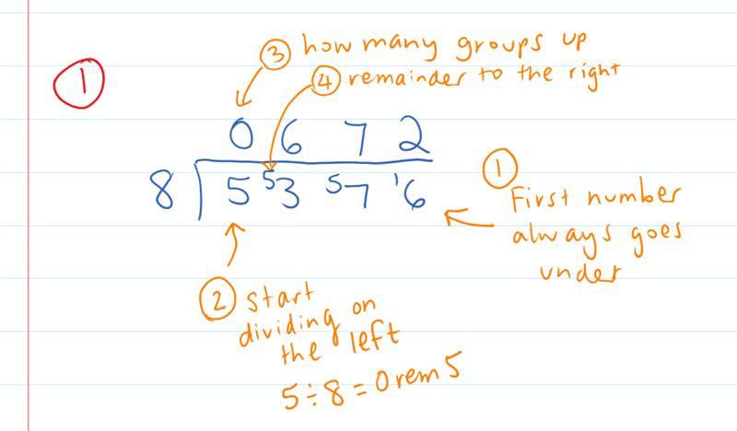 | What we write:  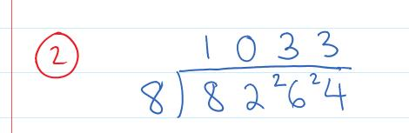
Your Turn:
1. $3720÷6$ | 2. $7242÷6$

Practice

5B ROUTINE QUESTIONS
- Calculate the following divisions. 4First Five Live
- $7160÷4$ | - $3830÷5$ | - $8276÷4$ | - $1696÷8$ | - $4692÷6$
- $2872÷8$ | - $8970÷6$ | - $1750÷5$ | - $2187÷3$ | - $2616÷4$
- $4431÷7$ | - $3464÷4$ | - $9312÷4$ | - $9228÷4$ | - $6126÷3$
- $7168÷8$ | - $8274÷3$ | - $4560÷8$ | - $7425÷9$ | - $6440÷5$
☑ Correction Time! Click here for answers

5B STRETCH questions
- Complete the following worded questions.
  - A bricklayer earns $1215 per week. How much will the bricklayer earn per day if they work for five days in the week.
  - Over three days, Mr Brown recorded using his smartwatch, the number of steps he took throughout each day. On Day 1, he took 3400 steps. On Day 2, he took 6000 steps and on Day 3 he took 7325 steps. How many steps on average did Mr Brown take over these three days? (To find the average, add all the steps together and then divide by the number of days)
  - Ms Longley decides to buy pizza for her Year 7 class at the end of the year. There are 24 students in her class. If Ms Longley buys 15 large pizzas with 8 slices per pizza, how many slices of pizza can each student have so every student receives the same number of slices?
  - A number is divided by 8 and the answer is 7026. What was the original number? Check your answer using the division algorithm.

- Divisions can also be written as fractions. That is $\frac{32}{8}=32÷8=4$. Calculate the following.
- $\frac{4536}{8}$ | - $\frac{6462}{6}$ | - $\frac{33552}{12}$ | - $\frac{3924720}{12}$

- Jack is calculating $1540÷7$. He says “you can’t do it because all the digits are smaller than 7”. Do you agree with Jack? Explain why he is right or wrong.

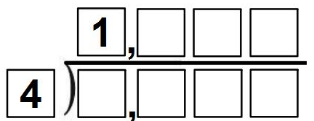
- Fill in the blanks using all different non-zero digits (except the numbers 1 and 4, which have already been used) to make the calculation true. Challenge: What is the biggest possible answer you can make?

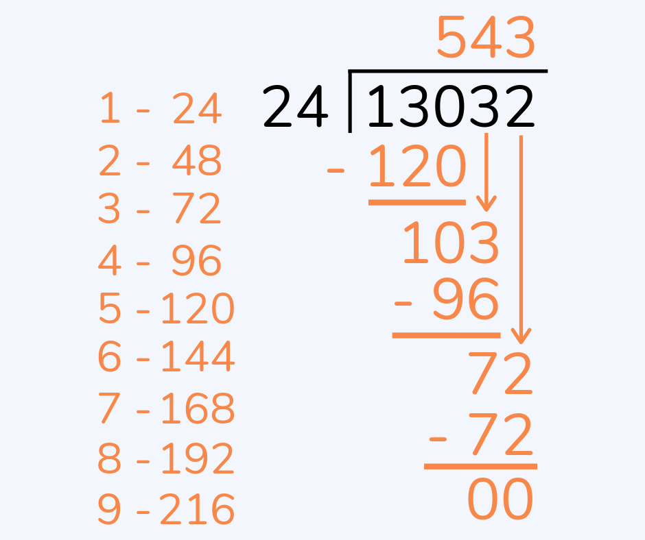
- (Optional) Have you ever done long division? An example of long division is shown on the right. Can you mimic this strategy (possibly with the assistance of your teacher or a peer) to calculate the following?
  - $8664÷24$
  - $59064÷24$
  - $77349÷57$ (hint below)
Hint: To help with part c. start by writing out the first 9 multiples of 57.

☑ Correction Time! Click here for answers
Finished Early? Head to the Early Finishers Page to engage in a game, puzzle or investigation.

SKILL C Part 1: ENRICHMENT SKILL

Activate prior knowledge
Activity One: Use your calculator to evaluate the following. [insert the fraction then press equals]
- $\frac{15}{5}$ | - $\frac{12}{3}$ | - $\frac{60}{10}$
Where have we seen the connection between fractions and division before?

Activity Two: A key step in our process today is creating fractions that have whole number denominators. Fill in the missing boxes in the questions below.
- $\frac{1.74}{0.3}=\frac{1.74×10}{0.3×10}=\frac{\boxed{[[\{[}}{3}$ | - $\frac{1.2}{0.7}=\frac{1.2×10}{0.7×10}=\frac{\boxed{[[[\{}}{\boxed{[[[\{}}$
- $\frac{1.3}{0.06}=\frac{1.3×10}{0.06×10}=\frac{\boxed{[[[\{}}{\boxed{[[[\{}}=\frac{\boxed{[[[\{}×10}{\boxed{[[[\{}×10}=\frac{\boxed{[[[\{}}{\boxed{[[[\{}}$

Explicit Teaching
[NEW PAGE] 5C Part 1: Dividing by a Decimal
- Write the division as a fraction
- Multiply numerator and denominator by 10 until the denominator is a whole number
- Use the division algorithm to calculate the answer
- Where appropriate, include a decimal point in the answer so it aligns with the decimal point in the question.
When dividing by a decimal we give a decimal answer. So, if there is a remainder in the final step we will need to include extra zeros until either there are no more remainders or a pattern emerges.
Note 1: If you are adding a zero onto a whole number you must also include a decimal point
Note 2: For this exercise, eventually there will be no more remainders. Recurring patterns come later ☺
Examples:
1. $1.34÷0.5$ |  |  | 2. $0.14÷0.08$
What we write/what we think:  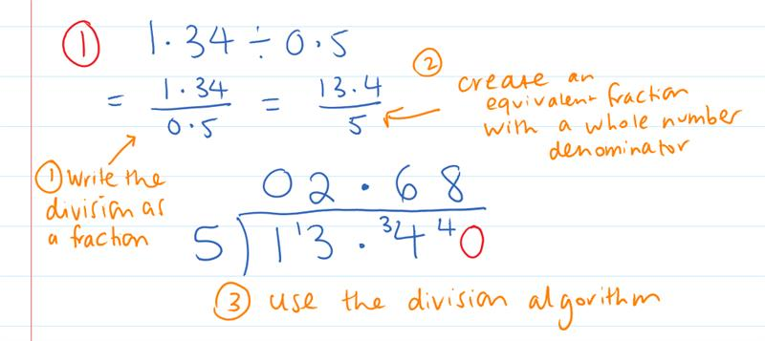 |  | What we write:  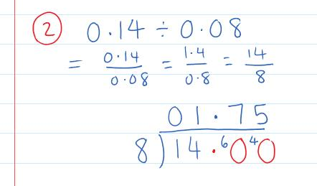
Your Turn:
1. $5.3÷0.8$ | 2. $5.73÷0.05$

Practice

5C PART 1 ROUTINE QUESTIONS
- Calculate the following divisions. 4First Five Live
- $0.014÷0.04$ | - $1.56÷0.06$ | - $0.915÷0.6$ | - $5.71÷0.02$
- $1.102÷0.4$ | - $275.1÷0.6$ | - $0.118÷0.2$ | - $0.237÷0.06$
- $0.17÷0.05$ | - $0.18÷0.3$ | - $0.057÷0.02$ | - $0.561÷0.6$
- $0.0861÷0.03$ | - $0.97÷0.02$ | - $0.074÷0.04$ | - $1.08÷0.6$
- $0.132÷0.5$ | - $13.2÷0.03$ | - $0.061÷0.2$ | - $3.942÷0.04$
☑ Correction Time! Click here for answers

5C PART 1 Stretch questionS
- While the numbers in the following questions are all the same, their answers aren’t…
  - 17 people need to go home from a party by taxi. Each taxi can hold 5 people. How many taxis do you need?
  - Grandma has $17 in her purse and she wants to share it out among her 5 grandchildren. How much will they get each?
  - I have 17 metres of curtain material and I need to make 5 curtains. How long will each curtain be?
  - Scooters cost $5 per day to hire. You have $17. How many days can you hire a scooter for?
  - There are 17 lollies which will be shared equally between 5 people. How many lollies will be left over?

- Calculate the following
- $5.73÷0.05+6.51÷0.6$ | - $17.83+ 1.8(8.17÷0.02)$

- Answer these worded questions. For parts a and b, you might like to work out the value of 1 unit first using division.
  - If 3 cans of spaghetti weigh 1.38kg, how much does 5 cans of spaghetti weigh?
  - If 1.2m of fabric cost $10.74, how much does 6 meters cost?
  - Clara purchases 1.2 kg of apples for $3.90. Her friend Sophia buys 900 g of bananas for $2.79 at the same shop. Find the cost per kilogram of each fruit. Which type of fruit is the best value in terms of price per kilogram?

- The perimeter of a rectangle is the length around the outside. The area of a rectangle is found by multiplying the length and the width. Algebraically, $P=2l+2w$ and $A=lw$.
  - What is the perimeter of a rectangle with length 3cm and height 4cm?
  - What is the area of a rectangle with length 3cm and height 4cm?
  - A rectangle has an area of 4.272m² and a width of 1.2m. What is the perimeter of this rectangle?
  - A rectangle has a perimeter of 21.9m and a length of 7.35m. What is the area of this rectangle?

- Given that$24.53×1.97 = 48.3241$, write down the value of each of the following divisions, without a calculator.
- $48.3241÷1.97$ | - $4.83241÷1.97$ | - $483.241÷19.7$ | - $4.83241÷0.2453$
☑ Correction Time! Click here for answers

Finished Early? Head to the Early Finishers Page to engage in a game, puzzle or investigation.

SKILL C PART 2: ENRICHMENT SKILL

Activate prior knowledge
Activity One: Calculate the following. Look back at your notes for a reminder of each process if needed.
- $2.62+3.2$ | - $14.7+5.63$ | - $0.3×45.2$ | - $4.58÷0.04$

Activity Two: Solve the following equations. Each question in the bottom row is closely connected to the one above it.
- $x+7=15$  - $4y+7=15$ | - $\frac{x}{4}=8$  - $\frac{y+6}{4}=8$ | - $9x=27$  - $9\left(y-5\right)=27$ | - $x-8=4$  - $\frac{y}{5}-8=4$

Explicit Teaching
[NEW PAGE] 5C Part 2: Solving equations involving decimals
- Successful Solving:
  - Eliminate values using opposite operations
  - Do the same to both sides

Examples:
1. Solve $4x-3=5.14$ | 2. Solve $29.5=\frac{x-8}{5}$ |  | 3. Solve $13.2=8(1+x)$
What we write:  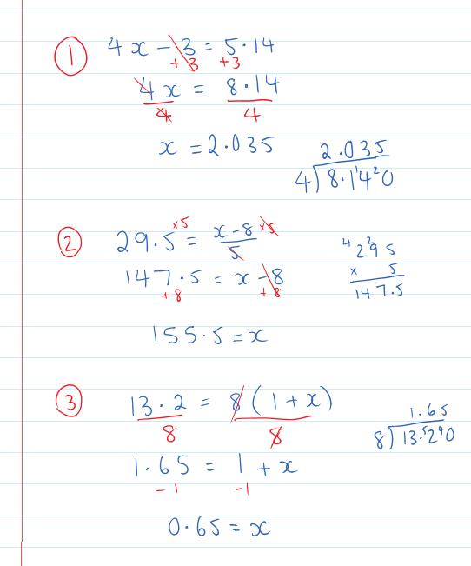 |  | What we think:  $x→ ×4→-3$. Undo the final step.  The opposite operation of $-3$is $+3$. We $+3$ to both sides  The opposite operation of $×4$is $÷4$. We $÷$ both sides by $4$  $x→-8→ ÷5$. Undo the final step.  The opposite operation of $÷5$is $×5.$We $×$ both sides by $5$  The opposite operation of $-8$is $+8$. We $+8$ to both sides  $x→+1→ ×8$. Undo the final step.  The opposite operation of $×8$is $÷8.$We $÷$ both sides by $8$  The opposite operation of $+1$is $-1$. We $-1$ from both sides
Your Turn:
1. Solve $10(x+2)=56.82$ | 2. Solve $7+\frac{x}{4}=17.4$ |  | 3. Solve $4.27=2+4x$

Practice

5C PART 2 ROUTINE QUESTIONS
1. Solve the following equations. Show your use of opposite operations. 4First Five Live
- $9x+1=24.94$ | - $25.2=10(x-2)$ | - $504=5\left(12+x\right)$ | - $0.183=\frac{x-2}{8}$
- $\frac{x}{10}-1=0.178$ | - $4\left(x+4\right)=228.8$ | - $43.08=12x-6$ | - $4\left(x+3\right)=73.6$
- $\frac{5+x}{4}=13.2$ | - $0.148=\frac{x-5}{12}$ | - $\frac{x-5}{4}=0.08$ | - $133.1=11+10x$
- $6.025=\frac{x}{2}-9$ | - $35.84=8x-4$ | - $3\left(x-4\right)=9.51$ | - $11+\frac{x}{4}=24.05$
- $\frac{x}{4}+4=16.775$ | - $0.042=\frac{x-5}{5}$ | - $147.2=2\left(x+11\right)$ | - $\frac{x-2}{5}=1.562$
☑ Correction Time! Click here for answers

5C PART 2 Stretch questionS
- Write an equation to represent each of the following and then solve it to find the mystery number.
  - When I add 4.5 to my number and then multiply by 6, the answer is 30.
  - When I divide my number by 3 and then add 2.9, the answer is 3.
  - When I multiply my number by 100 and then add 9, the answer is 10.
  - When I subtract 0.8 from my number, then divide by 0.2 and then divide by 0.1, the answer is 200.

- Solve the following equations. Show your use of opposite operations.
- $\frac{x}{0.4}$ $+1.243=16.19$ | - $0.18=0.3(x-3.1)$ | - $\frac{x-4.53}{1.7}$ $=17.6$
- Solve the following equations. Show your use of opposite operations.
- $2.625=0.3(x+9.5)$ | - $1.53=$ $\frac{x+24.2}{8.7}$ | - $1.2\left(17.2+x\right)=15.3$

☑ Correction Time! Click here for answers
Finished Early? Head to the Early Finishers Page to engage in a game, puzzle or investigation.

Skill 5 Application Questions – Think, Pair, Share/Teacher Modelling
Answer the questions you can. Explain your reasoning for at least one of the questions.
1. | 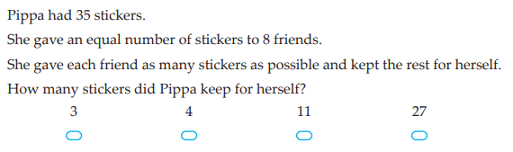
2. | 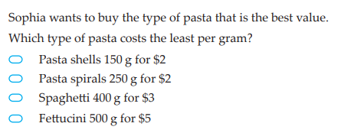
3. | 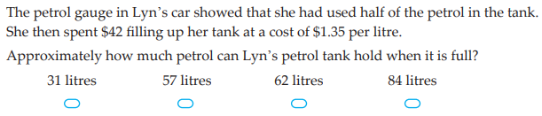
4. | - What is the sum of all underlined digits, that is the ones digits, of 10, 11, 12,…, 19?  - What is the sum of all the ones digits of 20, 21, 22,…, 29?  - What is the sum of all the ones digits of all 2 digit numbers, 10, 21, 22,…, 99?  - What is the sum of all the tens digits of the 2 digit numbers?  - Now, what is the sum of the digits of all 2 digit numbers, 10 to 99?  - What is the sum of the digits of all 3 digit numbers, 100 to 999?  Further Exploration: Wendy tried to find the formula for the sum of the digits of all n digit numbers, this is what she got: $45×{10}^{n}+9×n×45×{10}^{n-1}.$Is she right? Either convince us that she is correct, or fix the formula and convince us why it works.

Skill 5 Reasoning Questions

Entry | Core | Advanced
Jo says that $15÷4=2 rem 7$. What went wrong? | Jo is calculating $8192÷4$ and her working out is shown below. What makes her answer so unreasonable? What error has Jo made?  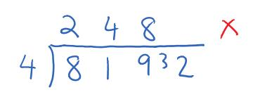 | Jo is calculating $31.92÷0.5$ and her working out is shown below. What makes her answer so unreasonable? What error has Jo made?  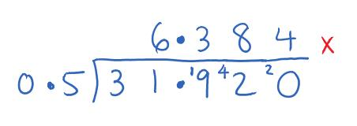

COLLABORATIVE TASK:
21 Flags

Assessment for Learning
Your progress will be monitored through your classwork and weekly homework sheets.

Reflection and Recognition
Let’s reflect on some Routine questions. Choose one or more of the questions below to answer.
- What is a remainder?
- How do we use a multiplication grid to answer division questions with remainders? How do we set out the division algorithm?
- Why do we start dividing digit on the left?
Let’s recognise something that went well and something that could be improved.
- What component of this work caused the most growth in your learning?
- Is there anything you’d like to improve?

Percentage of a number

Setting the Goal
Learning Intention:
- What does percent mean?
- How do we calculate a percentage of a number?
- How do we check if our answers are reasonable?
- Why do we convert between decimals and percentages?
Success Criteria: I know that percent means out of 100. I can convert a percentage to a decimal by dividing it by 100. I know “of” means times.

Key words
Percent means “out of 100”.

Skill A: Entry skill

Activate prior knowledge
Outside of a maths class, where have you seen percentages being used?

Explicit teaching
[NEW PAGE] 6A: Converting a percentage to a decimal
- Percent means “out of 100”
- Two ways to think about converting percentages to decimals:
  - $7\%=\frac{7}{100}="7 hundredths"=0.07$
  - $7\%=\frac{7}{100}=7÷100=0.07$

Examples:
Convert the following decimals to percentages
1. 9% | 2. 14% |  | 3. 20% | 4. 140%
What we write:  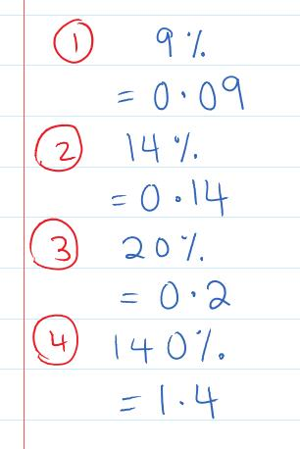 |  | What we think:  9% means 9 out of 100, which is $\frac{9}{100}=9÷100=0.09$  14% means 14 out of 100, which is $\frac{14}{100}=14÷100=0.14$  20% means 20 out of 100, which is $\frac{20}{100}=20÷100=0.2$  (we don’t include zeros at the end of decimals)  140% means 140 out of 100, which is $\frac{140}{100}=140÷100=1.4$  (we don’t include zeros at the end of decimals)
Your Turn:
1. 6% | 2. 23% |  | 3. 40% | 4. 172%

PRACTICE

6A Routine questions
- Convert the following percentages to a decimal. 4First Five Live
- $4\%$ | - $56\%$ | - $30\%$ | - $120\%$
- $13\%$ | - $50\%$ | - $113\%$ | - $7\%$
- $90\%$ | - $22\%$ | - $3\%$ | - $160\%$
- $135\%$ | - $10\%$ | - $87\%$ | - $2\%$
- $8\%$ | - $70\%$ | - $145\%$ | - $72\%$

☑ Correction Time! Click here for answers

6A Stretch questions
- Convert the following percentages to a decimal or whole number.
- 100% | - 3.5% | - 0.6% | - 400%
- Percentage increases and decreases can be represented by an overall percentage. For example, if something increases by 20% the new value is 120% of the original (100%+20%=120%). Similarly, if something decreases by 20% the new value is 80% of the original (100%-20%=80%).
- An increase by 25% is equivalent to what overall percentage? | - A decrease of 25% is equivalent to what overall percentage? | - An increase by 0.3% is equivalent to what overall percentage? | - A decrease of 0.3% is equivalent to what overall percentage?
- Put the following values in ascending order.
$$0.2, \frac{1}{2}, \frac{1}{4}, 2\%, 0.12, 1.2\%$$
- What percentage of the shape below is shaded?
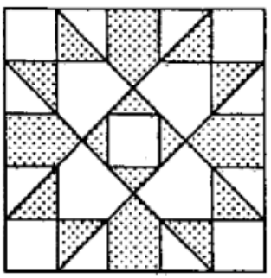

☑ Correction Time! Click here for answers
Finished Early? Head to the Early Finishers Page to engage in a game, puzzle or investigation.

Skill B: core skill

Activate prior knowledge
Small group discussion: Do you know the short cut for calculating 10% of a number? For example, what is 10% of 80?
How would you work out 5% of a number? For example, what is 5% of 30? What is similar/what is different?

Explicit Teaching
[NEW PAGE] 6B: Calculating a Percentage of a Number
- Rewrite the sentence with
  - The percentage as a decimal
  - “of” replaced with $×$
- Calculate the answer
- Check if answer is reasonable

Examples:
1. 40% of 68 |  | 2. 8% of 65
What we write:  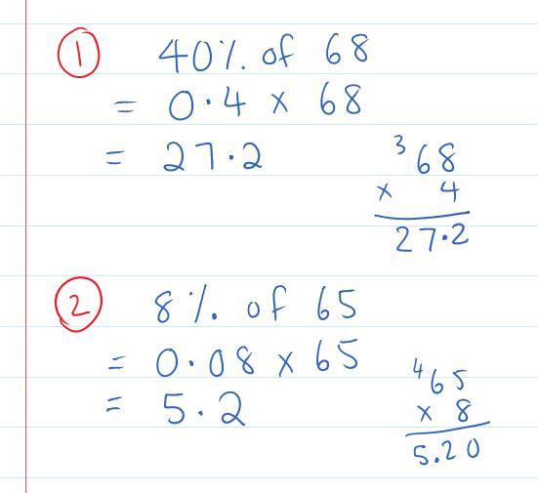 | What we think:  1. Write the percentage as a decimal and replace ‘of’ with $×$  2. Calculate the multiplication (ignore decimal points in $0.4×68$, calculate $4×68$, then insert decimal point so the number of decimal places in the answer is equal to the number of decimal places in the question).  3. 50% of 68 is 34, since 40% is just a bit smaller than 50% and 27.2 is just a bit smaller than 34 the answer is reasonable.  1. Write the percentage as a decimal and replace ‘of’ with $×$  2. Calculate the multiplication (ignore decimal points in $0.08×65$, calculate $8×65$, then insert decimal point so the number of decimal places in the answer is equal to the number of decimal places in the question).  3. 10% of 65 is 6.5, since 8% is just a bit smaller than 10% and 5.2 is just a bit smaller than 6.5 the answer is reasonable.
Your Turn:
1. 70% of 47 |  | 2. 6% of 71

Practice

6B ROUTINE QUESTIONS
- Complete the following questions. 4First Five Live
- 7% of 15 | - 5% of 59 | - 30% of 56 | - 80% of 59
- 80% of 74 | - 3% of 59 | - 4% of 94 | - 60% of 64
- 40% of 5 | - 8% of 47 | - 40% of 13 | - 20% of 6
- 60% of 41 | - 70% of 71 | - 5% of 26 | - 2% of 32
- 4% of 91 | - 9% of 8 | - 30% of 88 | - 80% of 12
☑ Correction Time! Click here for answers

6B STRETCH questions
- Answer the following worded questions.
  - Joe scored 60% on his Percentages test. If the test is out of 30 marks, what was Joe’s mark out of 30?
  - A store has a 40% off sale. If the original price of a pair of jeans was $47, how much is the discount? What is the new price of the jeans?

- Calculate the following
- 3.2% of 16 | - 0.9% of 27 | - 320% of 93 | - 120% of 4.65
- Use algebra to work out the original value. Eg. If 4% of some value is 3.48 we’d have to solve $0.04x=3.48$.
- $7\%$ of some value is 4.34 | - $60\%$ of some value is 54.72 | - $1.2\%$ of some value is 0.768
- Calculate the final value when…
- 42 is increased by 5% | - 15.2 is decreased by 20% | - 15.2 is decreased by 3.1%
- Calculate the following. Then make a comment on your answers.
Optional challenge: Can you explain why this will always happen?
- i. 12% of 30  ii. 30% of 12 | - i. 27% of 6  ii. 6% of 27 | - i. 17% of 35  ii. 35% of 17

☑ Correction Time! Click here for answers

6C ROUTINE QUESTIONS
- Complete the following questions. 4First Five Live
- 560% of 86 | - 77.1% of 4200 | - 2.6% of 680 | - 99.1% of 0.2
- 50% of 3100 | - 18.2% of 0.66 | - 36.9% of 2900 | - 850% of 43
- 40.2% of 470 | - 3.6% of 200 | - 1.3% of 8 | - 560% of 5.9
- 850% of 100 | - 920% of 340 | - 700% of 190 | - 72.7% of 7000
- 50% of 0.77 | - 24.2% of 25 | - 70% of 0.5 | - 9.8% of 7200
☑ Correction Time! Click here for answers

Finished Early? Head to the Early Finishers Page to engage in a game, puzzle or investigation.

Skill 6 Application Questions – Think, Pair, Share/Teacher Modelling
Answer the questions you can. Explain your reasoning for at least one of the questions.
1. | 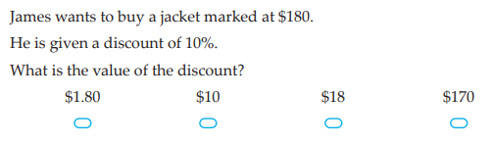
2. | 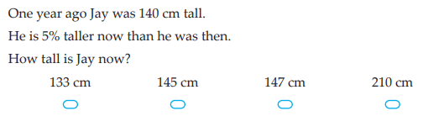
3. | A 1 litre bucket of water was left outside.  It was a hot day and 15% of the water evaporated. Later that day, being a typical Melbourne day, it rained and the amount of water in the bucket increased by 15%.  Is there now more, less or the same amount of water as there was in the beginning? Explain why.
4. | 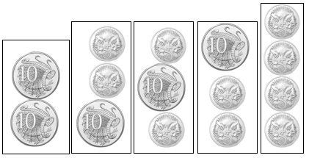  Below shows the different ways we can make a line out 5c and/or 10c coins that totals 20c  - Lay out the 5c and 10c coins that make up 30c in a line. How many orders are there for these coins?  - Lay out the 5c and 10c coins that make up 40c in a line. How many orders are there for these coins?  - Lay out the 5c and 10c coins that make up 60c in a line. How many orders are there for these coins?  Further exploration: Consider what happens when we have 5c, 10c and 20c coins.

Skill 6 Reasoning Questions

Entry | Core | Advanced
Jo says that $7\%=0.7$. Convince Jo that she is wrong. | If you had to calculate 25% of 57 would you multiply by 0.25 or divide by 4? Why? | Calculate 40% of 75 and 75% of 40. What do you notice? Will this always happen? Why/why not?

COLLABORATIVE TASK:
Use these 12 numbers, once each, in the gaps below. 10, 20, 25, 35, 40, 50, 60, 70, 75, 80, 90, 100
$__ increased by __% = $__, $__ increased by __% = $__, $__ increased by __% = $__, $__ increased by __% = $__.

Assessment for Learning
Your progress will be monitored through your classwork and weekly homework sheets.

Reflection and Recognition
Let’s reflect on some essential questions. Choose one or more of the questions below to answer.
- What does percent mean?
- How do we calculate a percentage of a number?
- How do we check if our answers are reasonable?
- Why do we convert between decimals and percentages?
Let’s recognise something that went well and something that could be improved.
- What component of this work caused the most growth in your learning?
- Is there anything you’d like to improve?

Early Finisher Activities
Games | Puzzles | Investigations

Games
Individual Games:
- https://www.mathsisfun.com/numbers/ordering-game.php?m=Dec-Tricky – An ordering decimals game
- https://www.topmarks.co.uk/maths-games/hit-the-button - Timed practice for number bonds and times tables. What is the best score you can get?
- https://www.transum.org/Maths/Puzzles/Product_Square/Default.asp?Level=1 – Product squares, an online game to practice multiplication. There are lots of levels, how high can you go?
- https://www.transum.org/Maths/Exercise/Pyramid/Default.asp?Level=1 – Partial Pyramids, an online game to practice adding and subtracting. There are lots of levels, how high can you go?
- https://incoherency.co.uk/countdown/practice/#numbers – Countdown Numbers Game
Paired Game:
- https://www.mathspad.co.uk/interactives/decimalsTool/decimalsTool.php - A ‘Guess Who’ type game with decimals

Puzzles
- Use the digits 1-9 at most once each to make the following equation true
$$\boxed{}\boxed{}\boxed{}+\boxed{}\boxed{}\boxed{}=\boxed{}\boxed{}\boxed{}$$
How many different solutions can you find?

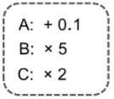
- Decimal Steps:
  - Starting with 2.4 and using steps A, B or C (with repeats if you like), how can you get to
    - 24.1 in 3 steps
    - 24.2 in 3 steps
    - 24.5 in 3 steps
    - 24.3 in 4 steps
    - 24.4 in 4 steps
  - Using the same operations as in part a. how can you change between the following numbers in just two steps?
    - 3.6 to 7.3
    - 4.2 to 21.5
    - 2.9 to 29
    - 0.8 to 1.7
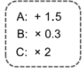
    - 3.9 to 19.6
  - Here are some different steps. In just two of the new steps, how can you change
    - 8.5 to 20
    - 20 to 7.5
    - 7.5 to 4.5
    - 4.5 to 1.8
    - 1.8 to 5.1
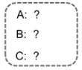
  - All of the changes below need exactly two steps. What could the operations be? There is more than one answer ☺
    - 3 to 9.6
    - 1 to 6
    - 0.8 to 2
    - 1.2 to 2.8
    - 5 to 15.6

From Don Steward’s Median

- How close to 1000 can you get by filling in the boxes below using each digit from 1-9 exactly once? You can use your calculator any time.
$$+ \boxed{} \boxed{} \boxed{} \\ + \boxed{} \boxed{} \boxed{} \\ + \boxed{} \boxed{} \boxed{} \\ \overline{ }$$
- Which of the following patterns can be drawn by connecting the dots and only ever going over each line once? Click here for an interactive version.
a. 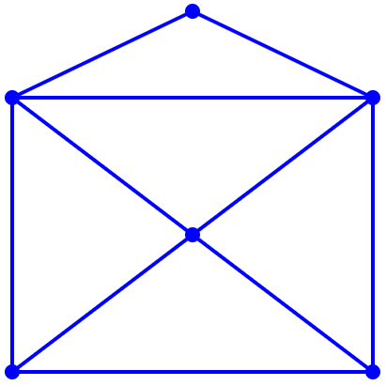 | b.  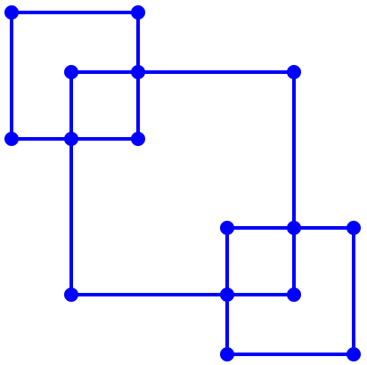 | c. 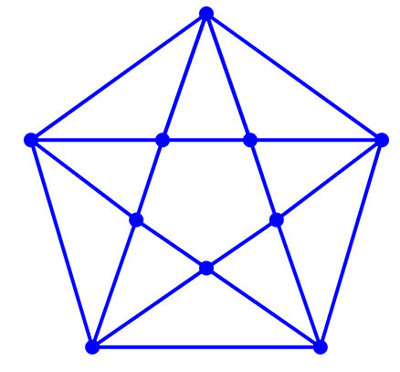
d.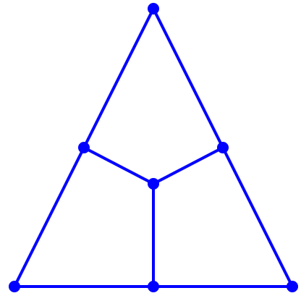 | e.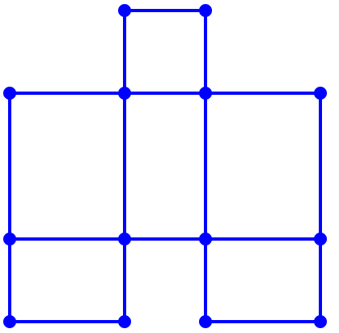 | f.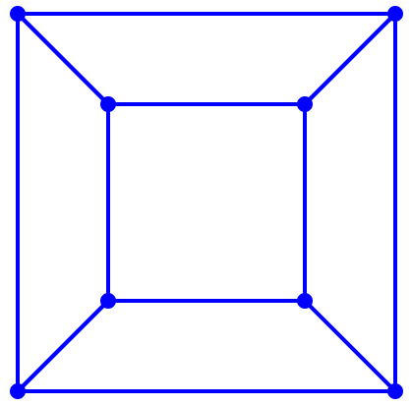

From Transum Puzzles

- Begin with the number 100 on your calculator. Move down or sideways (never up). As you cross a segment, perform the indicated operation on your calculator. What is the largest value you can make?
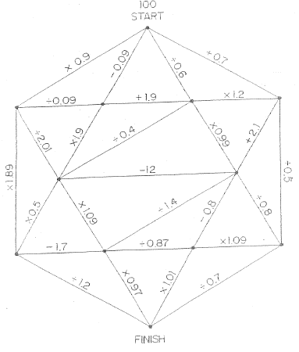

Investigations
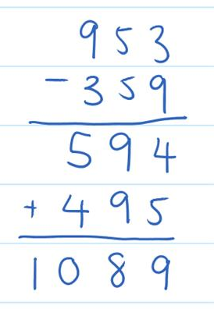
- Write down any three digit number where the first and last digits are different. Reverse the digits and subtract the smaller from the bigger. Now reverse the digits of the answer, write it underneath and add. An example of this process for the number 359 is included on the right. Do this a few times and comment on what you notice. Then, try to explain EXACTLY why this happens.

- Below is a magic matrix. It doesn’t look overly magical, It doesn't look very magical does it?
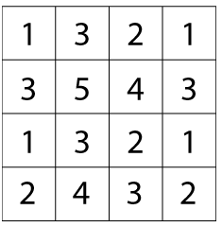
This is how you find out the "magic" in the matrix:
Circle any number in the matrix, for example, 5. Draw a line through all the squares that lie in the same row and column as your selected number:  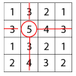 | Then circle another number that has not got a line through it, for example, the 1 in the top right hand corner, and again cross out all squares in the same row and column:  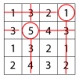 | Repeat for a third time, for example:  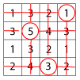 | Then circle only the remaining number that has no line through it:  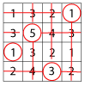
Add all the circled numbers together and note your answer. Try again with a different starting number. What do you notice? Can you work out why this happens?
From Nrich.org
- The golden ratio is a very special decimal. The following nrich activities will introduce you to the golden ratio. Enjoy!
- Research the history of decimal numbers. Write a paragraph in your own words of the part(s) you find most interesting.

Answers

1A Routine Questions (ans)
1. a. hundredths b. thousandths c. tenths d. tenths
e. ten-thousandths f. ten-thousandths g. tenths
h. hundredths i. tenths j. ten-thousandths
k. tenths l. hundredths m. tenths n. tenths
o. ten-thousandths BackToQns

1A Stretch Questions (ans)
2.a. 0.03 b. 0.0007 c. 0.6 d. 0.005 3.a. 0.3 b. 0.07
c. 0.0001 d. 0.009 4.a. one hundred and fifty thousand and three b. twenty billion, fifty million, four thousand c. seven trillion, three hundred billion, six million and twenty
d. twenty seven trillion, four hundred and fifty million, two thousand 5.a. 2 ten-thousandths b. 2 millionths
c. 2 hundred-millionths d. 2 ten trillionths BackToQns

1B Routine Questions (ans)
1.a. 4.6 b. 5.0 c. 0.19 d. 4.973 e. 0.97 f. 0.37 g. 31.9
h. 4.675 i. 1.940 j. 33.19 k. 1.9 l. 42.39 m. 3.69 n. 0.39
o. 36.8 p. 1.0 q. 2.942 r. 21.91 s. 1.4 t. 0.35 BackToQns

1B Stretch Questions (ans)
2.a. 0.26 b. 4.2939 c. 3.8755 d. 19.87475 3.a. 6.0 b. 3.20 c. 3.158 d. 4.00 4.a. 15.4 b. 15.45 c. 15.450 d. 15.4500 5.a. 4.5 b. 2.32 c. 1.23 d. 1.45 BackToQns

1C Routine Questions (ans)
1.a. 1.06 > 1.053 b. 8.13 = 8.130 c. 0.063 > 0.06
d. 15.621 > 6.06729 e. 0.7 < 0.96 f. 1.35 < 1.35612
g. 1.324 > 1.2431 h. 5.9 > 5.15 i. 0.1 > 0.01 j. 3.1206 > 3.12 k. 0.02 < 0.20 l. 0.5 = 0.50 m. 4.6 > 4.06 n. 3.21 = 3.210
o. 0.39 > 0.197 p. 1.75 > 1.08 q. 7.601 > 7.016
r. 0.005 < 0.500 s. 0.2 > 0.103 t. 0.90 = 0.9000 BackToQns

1C Stretch Questions (ans)
2.a. 0, 0.01, 0.1, 0.251, 0.41, 0.7 3.a. 51.56, 51.06, 47.60, 43.49, 37.41 b. 1st 4.a. -5 < -2 b. -8 < -1 c. -1 > -4
d. -3 < -2 5.a. -2.1 < -2.01 b. -0.7 < -0.16 c. -1.09 > -1.1
d. -0.05 = -0.050 BackToQns

2A Routine questions (ans)
1. a. 34 000 b. 80 c. 543 d. 700 e. 354 000 f. 104
g. 35 000 h. 8 i. 710 j. 10 k. 19 000 l. 80 m. 6 n. 180 000 o. 52 000 p. 631 q. 4700 r. 9500 s. 260 t. 31 BackToQns

2A Stretch Questions (ans)
2.a. 37 b. 120 sec, 2 min 3.a.i. 20 ii. 200 b.i. 24 ii. 240
c.i. 35 ii. 350 d.i. 27 ii. 270 4.a. 184 b. 330 c. 180
5.a. ten thousand b. ten million c. one billion d. ten trillion 6.a. 4000 b. 4000 c. 460 000 000 d. 70 670 000 7.a. 900
b. 7200 c. 860 d. 6040 BackToQns

2B Routine Questions (ans)
1. a. 3.5 b. 0.0103 c. 20.7 d. 32 e. 5.9 f. 1.06 g. 0.0053
h. 0.76 i. 38 j. 2.3 k. 0.012 l. 36.7 m. 26 n. 30.91 o. 7.3 p. 4.03 q. 7.5 r. 0.5603 s. 2.07 t. 37 BackToQns

2B Stretch Questions (ans)
2.a. $139 b. 3000c, $30 3.a. 0.6 b. 3.5 c. 0.0057 4.a. 3
b. 30 c. 0.003 d. 0.03 5.a. 2 b. 20 c. 0.02 d. 0.2 e. 25 f. 2.5 g. 0.025 h. 0.0025 6.a. 4.4 b. 4.6 c. 4.14 d. -9 7.a. 0.0003
b. 0.0003 c. 0.056 d. 0.35 8.a. 0.0009 b. 0.0072
c. 0.00086 d. 0.00000604 BackToQns

2C Routine Questions (ans)
1. a. 3.01 b. 0.231 c. 0.25 d. 180 e. 0.41 f. 0.0034 g. 850 h. 0.93 i. 3.01 j. 0.231 k. 601 l. 20.5 m. 3.5 n. 0.203
o. 6730 p. 0.0032 BackToQns

2C Stretch Questions (ans)
2. $715÷{10}^{5}$, $0.075÷10$, $0.000705×{10}^{2}$, $0.0072×10$ 3.$\frac{721}{1000}$, $\frac{72}{100}, 0.075$, $0.071$, $\frac{0.7}{10}$ 4.a. 5 b. 6 c. 6 d. 2 e. 4.2
f. -0.04 5.a. 680 minutes b. 1000 chocolates 6.a. 100
b. 1000 c. 100 000 d. 3 640 000cm e. 0.000 276km BackToQns

3A PART 1 Routine questions (ans)
1.a. 2528 b. 11 826 c. 6440 d. 2847 e. 1429 f. 4486
g. 4222 h. 2718 i. 3429 j. 2240 k. 3332 l. 3535 m. 1918 n. 3052 o. 4322 p. 4421 q. 1590 r. 2514 s. 3931 t. 1831 BackToQns

3A PART 1 Stretch Questions (ans)
2. 1854 3.a. 38+53=91 b. 114+77=191 c. 167+847=914 4. 440 5. Multiply the digit sum by 22. Can you explain why this works? BackToQns

3A PART 2 Routine Questions (ans)
1.a. 1063 b. 814 c. 568 d. 399 e. 526 f. 477 g. 346 h. 486 i. 359 j. 172 k. 329 l. 651 m. 815 n. 694 o. 125 p. 459
q. 276 r. 389 s. 139 t. 880 BackToQns

3A PART 2 Stretch Questions (ans)
2.495 3. We are taking away the second number from the first, so we would have 1-6=-5. We borrow when the top number is smaller to avoid getting negative values when subtracting. 4.a. 62-28-34 b. 265-184=81
c. 3092-927=2165 5. 1560 6.a. Reading across the rows 62,67,60/61,63,65/66,59,64 b. check your own answer by making sure each row, column and diagonal add to 434 BackToQns

3B Routine Questions (ans)
1. a. 1.69 b. 13.48 c. 1.83 d. 4.66 e. 17.24 f. 8.32 g. 0.68 h. 8.59 i. 5.03 j. 6.59 k. 5.28 l. 0.87 m. 3.42 n. 5.29
o. 0.58 p. 4.19 q. 29.61 r. 2.79 s. 68.58 t. 7.17 BackToQns

3B Stretch Questions (ans)
2. $54.30 3.a. 8.038 b. 0.182 c. 1.438 d. 1.308 4. (below)
$$+$$ | $$0.01$$ | $$0.38$$ | $$0.99$$
$$0.3$$ | $$0.31$$ | $$0.68$$ | $$1.29$$
$$0.75$$ | $$0.76$$ | $$1.13$$ | $$1.74$$
$$1.2$$ | $$1.21$$ | $$1.58$$ | $$2.19$$
5.a. a=2.51 b. b=22.14 c. c=9.18 d. d=18.422 BackToQns

3C Routine Questions (ans)
1.a. -1146 b. 23 c. 196 d. 276 e. -383 f. -91 g. 556 h. -214 i. 283 j. -84 k. 136 l. -1673 m. -465 n. -56 o. 136 p. -444 q. -621 r. 125 s. -373 t. 354 BackToQns

3C Stretch Questions (ans)
2.a. -4.02 b. -4.33 c. 16.26 d. 15.03 3.a. -5.418 b. 2.438
c. -2.438 d. -6.548 4. (below)
$$+$$ | $${}_{}^{-}{3.5}$$ | $${}_{}^{-}{8.13}$$ | $$1.78$$
$${}_{}^{-}{1.21}$$ | $${}_{}^{-}{4.71}$$ | $${}_{}^{-}{9.34}$$ | $$0.57$$
$${}_{}^{-}{4.37}$$ | $${}_{}^{-}{7.87}$$ | $${}_{}^{-}{12.5}$$ | $${}_{}^{-}{2.59}$$
$$10.71$$ | $$7.21$$ | $$1.58$$ | $$12.49$$
5.a. a=-5.49 b. b=-3.08 c. c=57.42 d. -11.202 BackToQns

4A Routine questions (ans)
1.a. 5826 b. 963 c. 4298 d. 1845 e. 2556 f. 3738 g. 1496
h. 1173 i. 4950 j. 3248 k. 4648 l. 2397 m. 2852 n. 1062 o. 2394 p. 4818 q. 1239 r. 2779 s. 2055 t. 1908 BackToQns

4A Stretch Questions (ans)
2. 1680 3.a. 27x7=189 b. 39x9=351 c. 232x5=1160
d. 314x7=2198 4. 876x9=7884 5.a. 78 885 b. 788 886
c. 788 888 889 BackToQns

4B Routine Questions (ans)
1.a. 2.94 b. 20.35 c. 0.1205 d. 5.22 e. 0.0261 f. 0.00816
g. 0.312 h. 0.1455 i. 8.37 j. 0.861 k. 0.944 l. 4.5 m. 182.4 n. 14.67 o. 1.467 p. 0.0344 q. 0.00062 r. 7.44 s. 0.004
t. 2.862 BackToQns

4B Stretch Questions (ans)
2.a. 3.56kg b. $20.22
3.
$$×$$ | $$0.009$$ | $$0.09$$ | $$0.9$$ | $$9$$
$$0.08$$ | $$0.00072$$ | $$0.0072$$ | $$0.072$$ | $$0.72$$
$$0.8$$ | $$0.0072$$ | $$0.072$$ | $$0.72$$ | $$7.2$$
$$8$$ | $$0.072$$ | $$0.72$$ | $$7.2$$ | $$72$$
$$80$$ | $$0.72$$ | $$7.2$$ | $$72$$ | $$720$$
4.a.i. 254 ii. 2540 b.i. 0.0371 ii. 37.1 c.i. 0.0068 ii. 68 5.a. 0.09 b. 0.64 c. 0.0064 d. 0.000049 BackToQns

4C Routine Questions (ans)
1.a. 9.126 b. 0.03927 c. 4.158 d. 0.08019 e. 40.17 f. 28.38 g. 16.092 h. 2.948 i. 2.4274 j. 1117.8 k. 6.578 l. 101.92 m. 0.4125 n. 8.995 o. 720.9 p. 186.66 q. 137.25 r. 4.484 s. 20.24 t. 0.10353 BackToQns

4C Stretch Questions (ans)
2.a. $1.77 b. $14.84 c. $12.15 3.a. 737.01 b. 1.805 c. 48 4.a. 333.333 b. 555.555 c. 666.666. The key to this pattern is the fact that: $85.47×1.3=111.111$. So if we multiply by a single digit number, say $a,$ we get $aaa.aaa$ 5. 1.5x3.2, there is only one solution because in _._x3.2 the second digit must be 5 to avoid having 2 decimal places in the answer, and the next smallest number for the ones place is 4 and 4.5x3.2 is bigger than 10. 6. & 7. Ask your teacher to check your answer. BackToQns

5A Routine questions (ans)
1.a. 4 rem. 2 b. 10 rem. 3 c. 0 rem. 3 d. 1 rem. 1
e. 1 rem. 4 f. 1 rem. 7 g. 2 rem. 4 h. 9 rem.1 i. 3 rem. 6
j. 10 rem. 5 k. 1 rem. 1 l. 0 rem. 4 m. 9 rem. 1 n. 1 rem. 5 o. 0 rem. 7 p. 4 rem. 5 q. 3 rem. 1 r. 11 rem. 6 s. 0 rem. 4 t. 0 rem. 3 BackToQns

5A Stretch Questions (ans)
2.a. 7 b. 18 c. 18 rem. 3 3.a. 17=5x3+2 b. 41=13x3+2
c. 73=24x3+1 d. 151=50x3+1 4. 41 5.a. 13 b. 61 c. 61
d. 421 BackToQns

5B Routine Questions (ans)
1.a. 1790 b. 766 c. 2069 d. 212 e. 782 f. 359 g. 1495
h. 350 i. 729 j. 654 k. 633 l. 866 m. 2328 n. 2307 o. 2042 p. 896 q. 2758 r. 570 s. 825 t. 1288 BackToQns

5B Stretch Questions (ans)
2.a. $243 b. 5575 steps c. 5 slices d. 56 208 3.a. 567
b. 1077 c. 2796 d. 327 060 4. When using the division algorithm, all remainders carry over to the next digit. Doing this creates numbers bigger than 7.
5. A possible answer is: 7632 $÷$ 4 = 1908 (though this isn’t the biggest!) 6.a. 361 b. 2461 c. 1357 BackToQns

5C PART 1 Routine Questions (ans)
1.a. 0.35 b. 26 c. 1.525 d. 285.5 e. 2.755 f. 458.5 g. 0.59
h. 3.95 i. 3.4 j. 0.6 k. 2.85 l. 0.935 m. 2.87 n. 48.5 o. 1.85 p. 1.8 q. 0.264 r. 440 s. 0.305 t. 98.55 BackToQns

5C PART 1 Stretch Questions (ans)
2.a. 4 taxis b. $3.40 c. 3.4m d. 3 days e. 2 3.a. 125.45
b. 753.13 4.a. 2.3kg b. $53.70 c. Apples are $3.25/kg and bananas are $3.10/kg so bananas are the best value
5.a. P=9.52m, b. 26.26m² 6.a. 24.53 b. 2.453 c. 24.53
d. 19.7 BackToQns

5C Part 2 Routine Questions (ans)
1.a. x=2.66 b. x=4.52 c. x=88.8 d. x=3.464 e. x=11.78
f. x=53.2 g. x=4.09 h. x=15.4 i. x=47.8 j. x=6.776 k. x=5.32 l. x=12.21 m. x=30.05 n. x=4.98 o. x=7.17 p. x=52.2
q. x=51.1 r. x=5.21 s. x=62.6 t. x=9.81 BackToQns

5C Part 2 Stretch Questions (ans)
2.a. x=0.5 b. x=0.3 c. x=0.01 d. x=4.8 3.a. x=5.9788
b. x=3.7 c. x=34.45 4.a. x=-0.75 b. x=-10.889 c. x=-4.45 BackToQns

6A Routine questions (ans)
1.a. 0.04 b. 0.56 c. 0.3 d. 1.2 e. 0.13 f. 0.5 g. 1.13 h. 0.07 i. 0.9 j. 0.22 k. 0.03 l. 1.6 m. 1.35 n. 0.1 o. 0.87 p. 0.02
q. 0.08 r. 0.7 s. 1.45 t. 0.72 BackToQns

6A Stretch Questions (ans)
2.a. 1 b. 0.035 c. 0.006 d. 4 3.a. 125% b. 75% c. 100.3% d. 99.7% 4. 1.2%, 2%, 0.12, 0.2, ¼, ½ 5. 40% BackToQns

6B Routine Questions (ans)
1.a. 1.05 b. 2.95 c. 16.8 d. 47.2 e. 59.2 f. 1.77 g. 3.76
h. 38.4 i. 2 j. 3.76 k. 5.2 l. 1.2 m. 24.6 n. 49.7 o. 1.3
p. 0.64 q. 3.64 r. 0.72 s. 26.4 t. 9.6 BackToQns

6B Stretch Questions (ans)
2.a. 18 b. $18.80 and $28.20 3.a. 0.512 b. 0.243 c. 297.6 d. 5.58 4.a. 62 b. 91.2 c. 64 5.a. 44.1 b. 12.16 c. 14.7288 6.a.i. 3.6, ii. 3.6. b.i. 1.62 ii. 1.62 c.i. 5.95 ii. 5.95 BackToQns

6C Routine Questions (ans)
1.a. 481.6 b. 3238.2 c. 17.68 d. 0.1982 e. 1550 f. 0.12012 g. 1070.1 h. 365.5 i. 188.94 j. 7.2 k. 0.104 l. 33.04
m. 850 n. 3128 o. 1330 p. 5089 q. 0.385 r. 6.05 s. 0.35
t. 705.6 BackToQns

