
SANDRINGHAM COLLEGE
YEAR 7 MATHS

Topic 3: Measurement

Contents
Reminder: 2
1. Perimeter 3
2. Area 11
Early Finisher Activities 21

Reminder:
Minimum Expectations
It is through regular practice and high expectations that you will maximise your progress in maths!
There are three things that will need to be included before work is considered complete:
- Copying of the question if in blue text – if it is in blue it is in our books!
- Inclusion of working out (where appropriate)
- Corrections. A tick ✓ if correct and retry until correct if incorrect.
In most cases, your teacher will require you to complete at least one set of questions for each big idea. Most students will start with Routine Questions at the Core Level, though there are options to move onto more challenging questions or less challenging questions as needed.
Assessed Learning Task (ALT)
At the end of this unit students will complete a creative paper and pipe cleaner creation! To accurately determine students’ Victorian Curriculum level a verification test assessing individual skills will be completed under test conditions.

Some questions have come from Don Steward’s fantastic website Median and also Mr Corbett Maths.

Perimeter

Setting the Goal
Learning intention:
- What does perimeter mean?
- How are sides of the same length represented?
- Why do we learn about perimeter?
Success criteria: I know perimeter means “length around a 2D shape” and that the dashes represent equal lengths.

Key words
Perimeter is the length around a 2D shape

Activate prior knowledge
Sides with the same markings are of equal length.
Q1. How many sides does each shape have?
Q2. What are the lengths of each side?
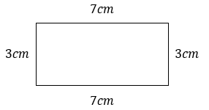 | 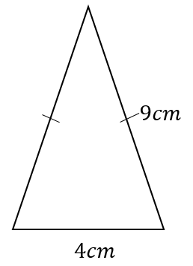 | 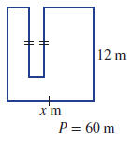

Explicit teaching
[NEW PAGE] Skill 1: Perimeter
- Perimeter is the length around the outside of a 2D shape
- Sides with the same markings are of equal length
Tip. To ensure you include every side, mark one corner of the shape and a direction, and try to work your way around.
Worked Examples:
1. Calculate the perimeter of the shape below. |  | 2. Calculate the perimeter of the shape below.  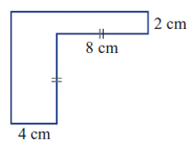 |  |  | 3. Determine the value of $x$ by creating and solving an appropriate equation.
What we write:  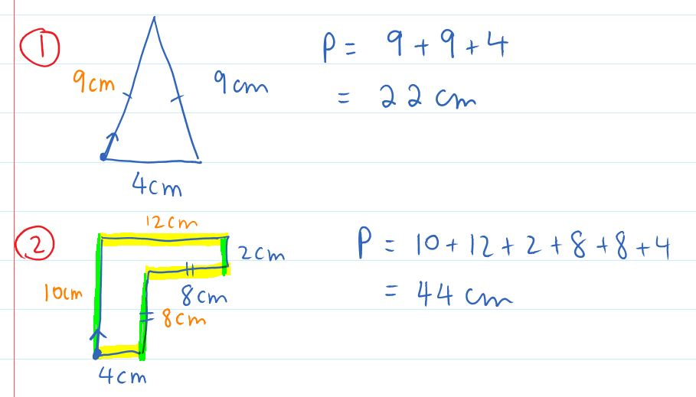  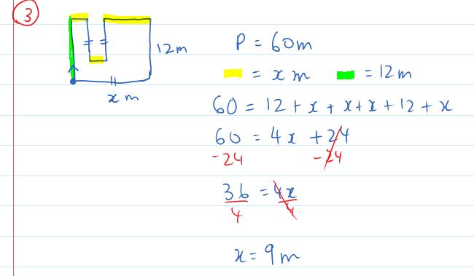 |  |  | What we think:  Sides with the same markings are of equal length so we write 9cm on side with the marking.  The perimeter is the length around the outside of the shape so we need to add up all of the sides. We mark the bottom left corner and work our way around clockwise. We add up the values and then include the units of cm.  There are a few missing side lengths. Some lengths we can’t work out exactly, however we know their sum. This has been shown with the highlights.  The perimeter is the length around the outside of the shape so we need to add up all the sides. We mark the bottom left corner and work our way around clockwise (as much as we can!). We have 10+12+2+8+8+4=44cm  There are a few missing side lengths. Some lengths we can’t work out exactly, however, we know their sum. This has been shown with highlights.  We create an equation knowing that the perimeter is equal to 60 and also equal to the sum of the side lengths.  We group our $x$ values as $x+x+x+x=4x.$We then solve the equation using opposite operations and doing the same to both sides.
Your turn:
1. Calculate the perimeter of the shape below.  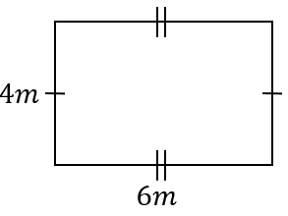 | 2. Calculate the perimeter of the shape below.  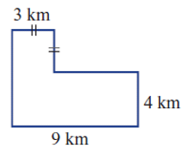 |  |  | 3. Given that the perimeter of the shape below is 50cm, determine the value of $x$.  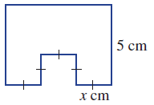

PRACTICE

1A ROUTINE QUESTIONS
- Calculate the perimeter of the following shapes. 4First Five Live
- 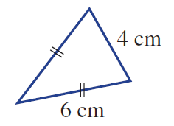 | - 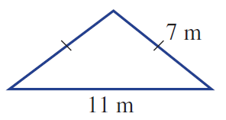 | - 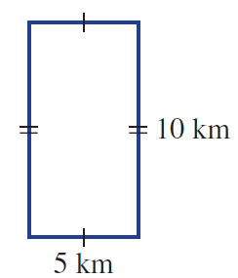
- 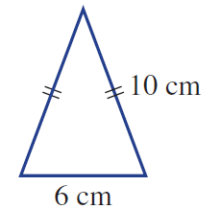 | - 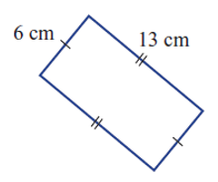 | - 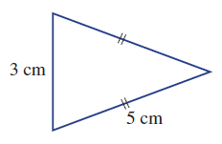
- 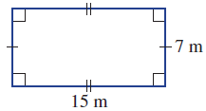 | - 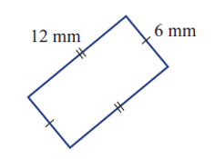 | - 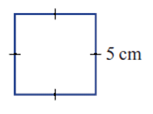
- 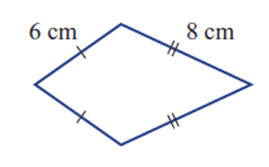 | - 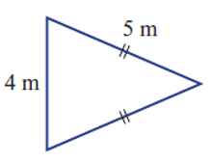 | - 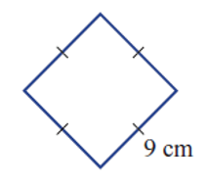

☑ Correction Time! Click here for answers to questions

1A STRETCH QUESTIONS
- A grazing paddock is to be fenced on all sides. It is rectangular in shape with a length of 200m and a width of 150m. If fencing it costs $5 a metre.
  - Sketch a diagram of the fence.
  - What is the perimeter of the fence?
  - How much will the fencing cost?
- It is true that 1cm = 10mm. Fill in the gaps in the following questions.
- 2cm = __mm | - 5cm = __mm | - 10cm = __mm | - 57cm = __mm
- __cm = 40mm | - __cm = 100mm | - __cm = 150mm | - _cm = 3000mm
- Calculate the perimeter of the shape below. Give your answer in centimetres.

- 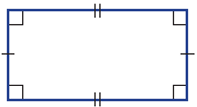 | - 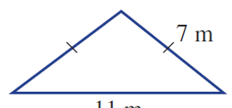
☑ Correction Time! Click here for answers
Finished Early? Head to the Early Finishers Page to engage in a game, puzzle or investigation.

1B Routine questions
- Calculate the perimeter of the following shapes. 4First Five Live
- 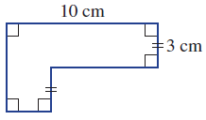 | - 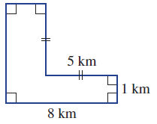 | - 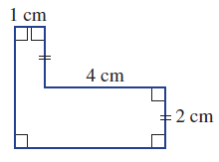
- 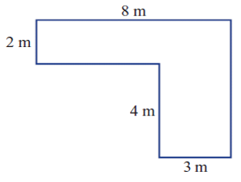 | - 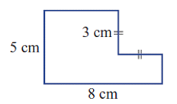 | - 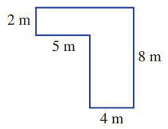
- 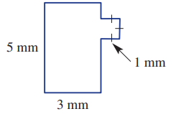 | - 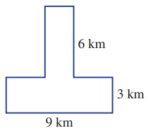 | - 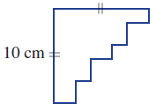
- *Challenge  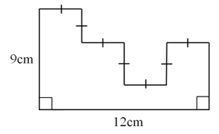 | - *Challenge. 1cm = 10mm  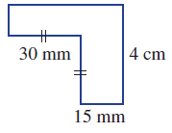 | - *Challenge  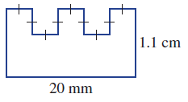

☑ Correction Time! Click here for answers to questions

1B Stretch questions
- The perimeter of each shape is given. Find the missing side length for each shape.
- 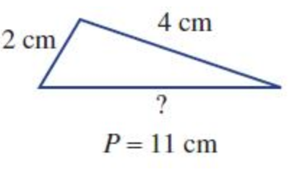 | - 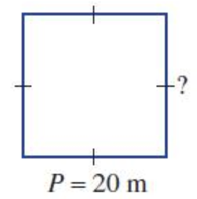 | - 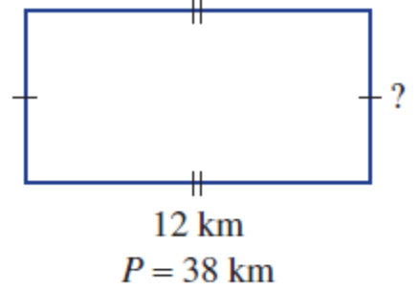
- It is true that 1cm = 10mm and that 1m = 100cm. Fill in the gaps in the following questions.
- 7cm = __mm | - 8.2cm = __mm | - 3.5m = __cm | - 3.5cm = __mm
- __cm = 45mm | - __cm = 0.1mm | - __m = 1cm | - _m = 3427mm

- Find the perimeter of each of these shapes. Give your answers in centimetres.
- 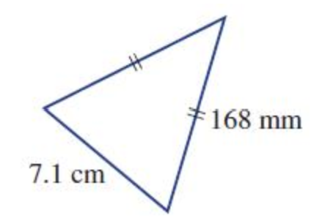 | 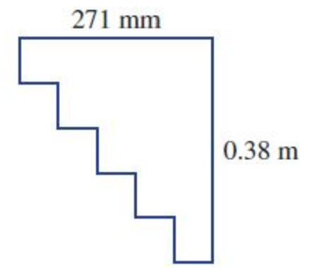 | - 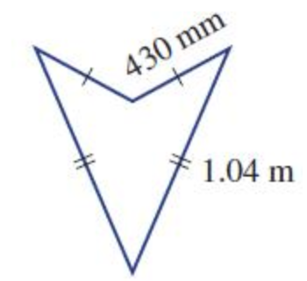
- A square paddock has 100 equally-spaces posts that are 4 metres apart, including one in each corner. What is the perimeter of the paddock?

☑ Correction Time! Click here for answers
Finished Early? Head to the Early Finishers Page to engage in a game, puzzle or investigation.

1C routine Questions
- Find the value of $x$ in the following by creating and solving an appropriate equation (diagrams are not to scale).
4First Five Live
- 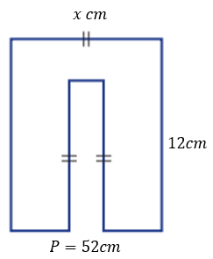 | - 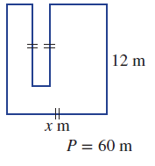  56m | - 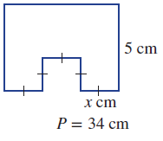
- 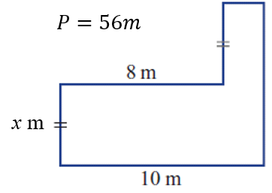 | - 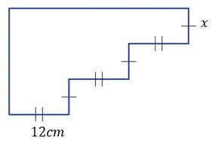  P = 138 cm | - 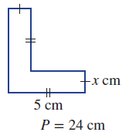
☑ Correction Time! Click here for answers to questions

1c stretch questions

Worked Example | What we write: | What we think:
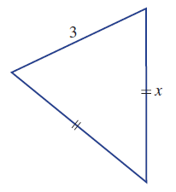  Express $x$ in terms of $P$, where $P$ is the perimeter of the shape. | 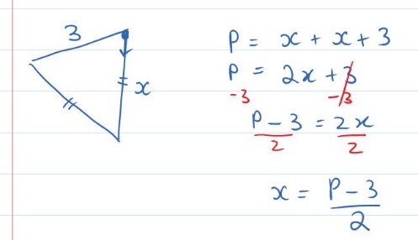 | The perimeter is:  $P=x+x+3$  Since $x+x=2x$, we can simplify this to:  $P=2x+3$  We have been asked to express $x$ in terms of $P$, this means we have to re-write the equation with “$x$ as the subject.” This means we need to have $x=…$  $P=2x+3$ (take away 3 from both sides)  $P-3=2x$ (divide both sides by 2)  $x=\frac{P-3}{2}$ (written with $x$ in the left)
- Express $x$ in terms of $P$, where $P$ is the perimeter of the shape. See above for an example if needed.
(Note that repeated additions of pronumerals are written as multiplications, e.g. $x+x+x=3x$)
- 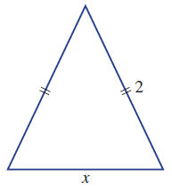 | 7 | - 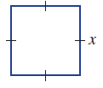
- 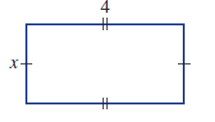 | - 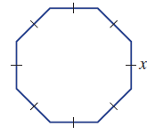 | - 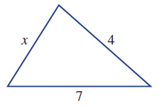
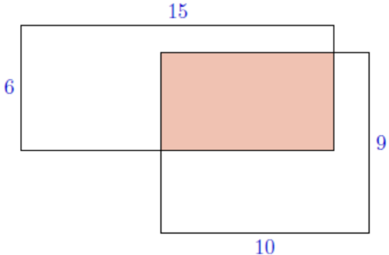
- Two rectangles overlap to create three regions, each of equal area. The original rectangles are 6 cm by 15 cm and 10 cm by 9 cm as shown. The sides of the smaller shaded rectangle are each a whole number of centimetres. What is the perimeter of the smaller shaded rectangle, in centimetres?

- The perimeter of a rectangle whose dimensions are $x$ cm × 4 cm is 13 cm. Find the value of $x$.

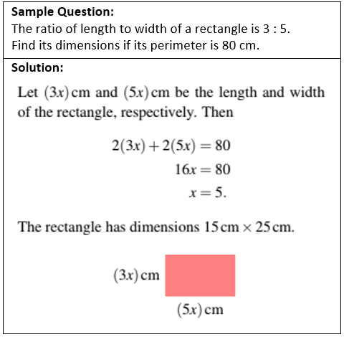
- The ratio of length to width of a rectangle is 2 : 3. Find its dimensions if its perimeter is 120 cm. (see sample question if needed)

- The side lengths of a triangle are in the ratio 2 : 4 : 5. Find its three side lengths if the perimeter of the tri-angle is 33 cm.

- The width of a rectangle is 4 cm longer than its length. Find its dimensions if its perimeter is 36 cm.

- Find the minimum perimeter of a rectangle that is made using 40 square tiles of side length 1 cm.

- Sally measure three sides of a rectangle, and their lengths total 27cm. Sam measures three sides of the same rectangle, and their lengths total 33 cm. Find the perimeter of the rectangle.

- Rectangle A has dimensions $x$ cm × $y$ cm. It may be cut in half vertically and its parts rearranged to give rectangle B, which has a perimeter of 30 cm. Rectangle A may also be cut in half horizontally and its parts rearranged to give rectangle C, which has a perimeter of 45 cm. Find the perimeter of rectangle A.

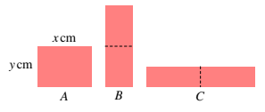
- If you have finished everything above, do some research to learn all you can about the perimeter of a circle!
☑ Correction Time! Click here for answers to questions

Finished Early? Head to the Early Finishers Page to engage in a game, puzzle or investigation.

PRE-1A questions
- Calculate the perimeter of the following shapes.
- 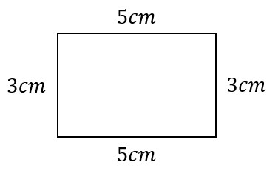 | - 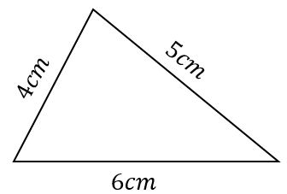 | - 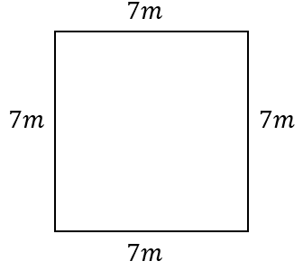
- 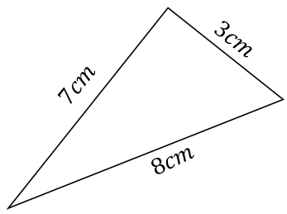 | - 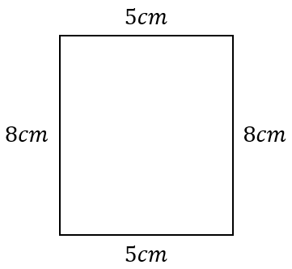 | - 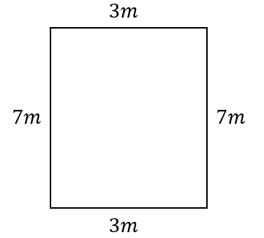
- 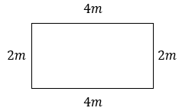 | - 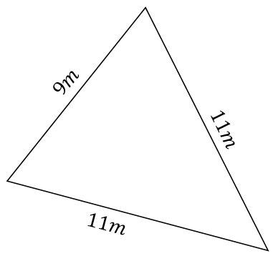 | - 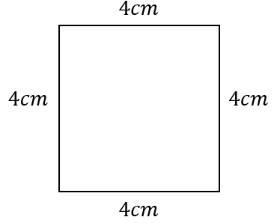
- 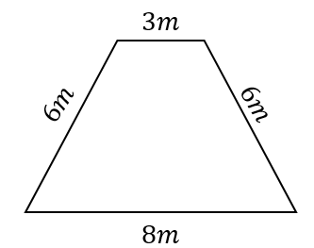 | - 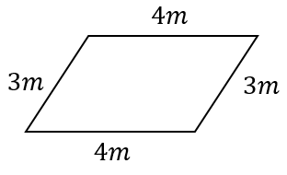 | - 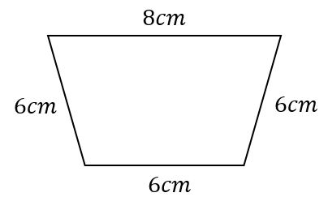

☑ Correction Time! Click here for answers

Skill 1 Reasoning Questions

Entry | Core | Advanced
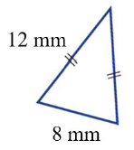  John said the perimeter of the triangle above was 20mm. What error did John make? | Explain why it is possible to calculate the perimeter of a shape without all side lengths being given. For example, why is it possible to calculate the perimeter of the shape below?  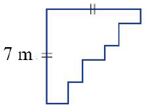 | Which of the following are correct ways of expressing the sum of the sides on the right side of this shape? Which is the best? Why?  - $10$  - $x+(10-x)$  - $10+x$  - $10-x$  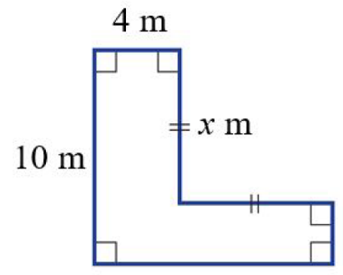

COLLABORATIVE TASK:
Using grid paper, cut out 5 rectangles that each measure 6cm by 3cm. You will connect these rectangles together along an edge (without overlapping them) to solve the following puzzles.
- What is the smallest perimeter you can create using two rectangles? What is the largest perimeter you can make using two rectangles?
- What about the smallest and largest perimeter when you have 3 rectangles?
- What about 4 or 5?
- Is there a pattern?

Assessment for Learning
Your progress will be monitored through your classwork and weekly homework sheets.

Reflection and Recognition
Let’s reflect on some key questions. Choose one or more of the questions below to answer.
- What does perimeter mean?
- How are sides of the same length represented?
- Why do we learn about perimeter?
Let’s recognise something that went well and something that could be improved.
- What component of this work caused the most growth in your learning?
- Is there anything you’d like to improve?

Area

Setting the Goal
Learning intention:
- What is the formula for the area of a rectangle? What is the formula for the area of a triangle?
- How do we calculate the area of a rectangle, triangle or parallelogram?
- Can you explain the relationship between the formulas for the area of a rectangle and a triangle and a parallelogram and a rectangle?
Success criteria: I can calculate the area of a shape by choosing the correct formula and substituting in the correct values.

Key words
Area
- An informal definition “area is the amount of flat space is inside a shape”.
- The formal definition “the area of a flat shape is the number of unit squares that are needed to cover it completely.”

Activate prior knowledge
Calculate the following after substituting in the given values.
Q1. If $b=5$ and $h=4$, calculate the value of:  $$A=bh$$ | Q2. If $b=12.44$ and $h=7.23$, calculate the value of:  $$A=\frac{bh}{2}$$  Give your answer to the nearest whole number.

Explicit teaching
[NEW PAGE] Skill 2: Area
- Area is the amount of flat space inside a shape.  - Area is measured in units squared. Eg. $cm^{2}$  - We use formulas to find areas:  - The base and height of a triangle and parallelogram must meet at right angles. |  | - Hint: When you are calculating the area of a shape using a formula it is helpful to follow these steps.  - Name the shape  - Write out the formula  - Substitute in the values  - Calculate the answer (round if required)  - Include units
  Rectangle | Triangle | Parallelogram
  $$A=l×w$$ | $$A=\frac{bh}{2}$$ | $$A=bh$$
Worked Examples:
1. Calculate the area of the shape below.  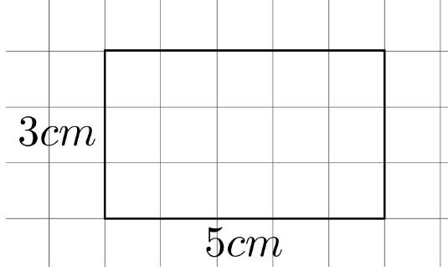 | 2. Calculate the area of the shape below. Give answer to the nearest whole number.  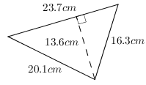 |  |  | 3. Calculate the area of the shape below by first expressing the area as a single calculation and then evaluating using line by line working.  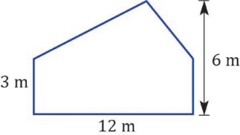
What we write:  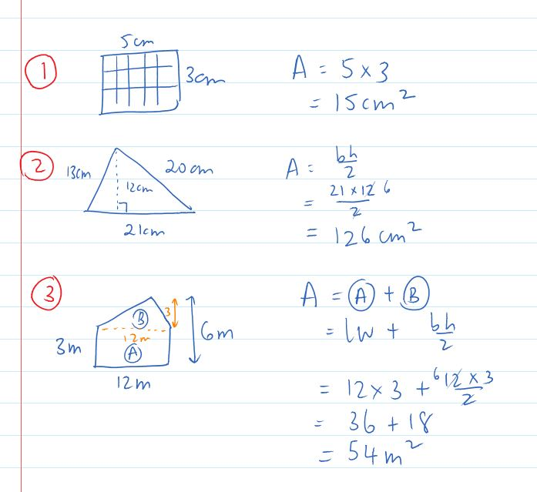  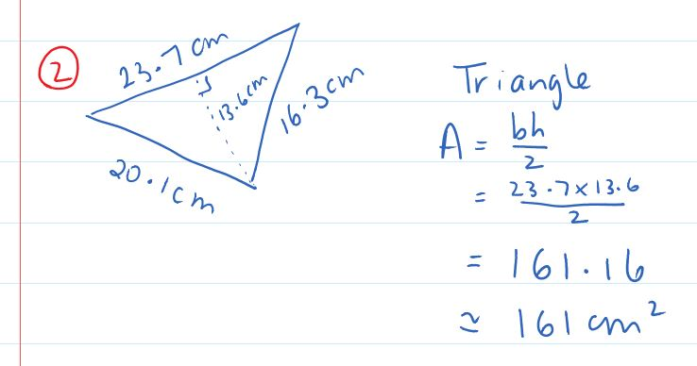 |  |  | What we think:  - This is a rectangle  - The area of a triangle is $A=l×w$.  - The length is the longest side, so here it is 5cm. The width is the shorter side, so here it is 3cm.  $$A=5×3$$  - Calculating the answer we get 15  - Including the units we see that the area is 15cm²  ---------  - This is a triangle  - The area of a triangle is $A=\frac{bh}{2}$.  - The base and height must meet at right angles and so the base is 23.7 and the height is 13.6.  - Calculating the answer we get 161.16, rounding to the nearest whole number we have 161  - Including the units we see that the area is 161cm²  ---------  This is a composite shape (a shape made up of more than one basic shape).  - We see that there is a rectangle Shape A and a triangle Shape B.  - We calculate the area of the composite shape as the sum of the areas of Shape A and Shape B and write out their formulas.  - We substitute in the values  - Calculate the answer  - Include units.
Your turn:
1. Calculate the area of the shape below.  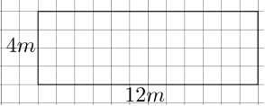 | 2. Calculate the area of the shape below. Give answer to the nearest whole number.  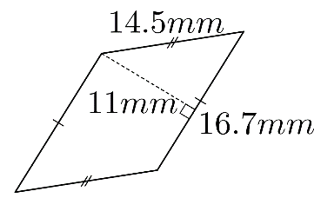 |  |  | 3. Calculate the area of the shape below.  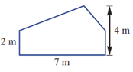

PRACTICE

2A routine questions
- Calculate the area of the rectangles below. 4First Five Live
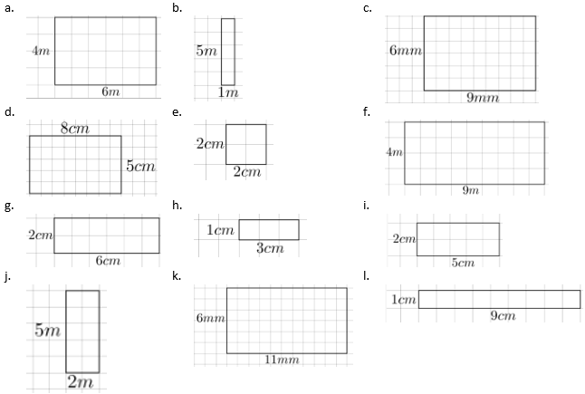

☑ Correction Time! Click here for answers

2a stretch questions
- Miss G’s class cut out some rectangles where each square is 1cm long. They tore a piece out of each. Calculate the area of each original rectangle.
- 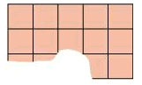 | - 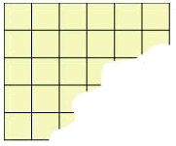 | - 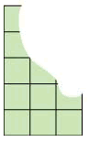
- Mrs Laursen’s class decided that they would attach two rectangles, and then tear out a piece of each shape. Calculate the area of each original shape.
- 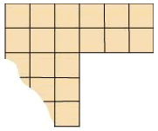 | - 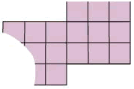

- Ms Ashkar’s class had the same activity and a student tore a little bit too much off their shape. The shape is below.
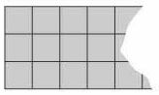
What is the smallest number of squares it could have had?
☑ Correction Time! Click here for answers
Finished Early? Head to the Early Finishers Page to engage in a game, puzzle or investigation.

2B routine questions
- Calculate the area of the shapes below. Round all answers to the nearest whole number. 4First Five Live
- 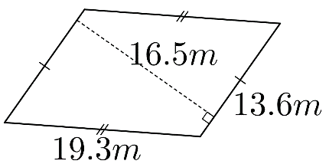 | - 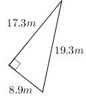 | - 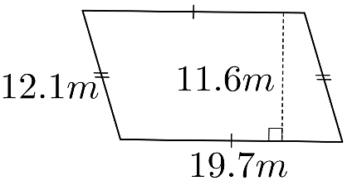
- 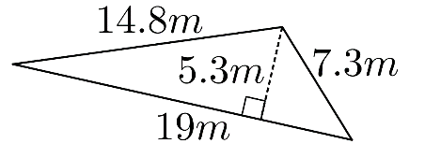 | - 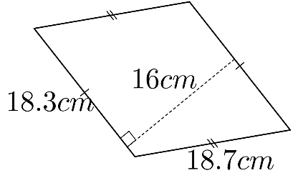 | - 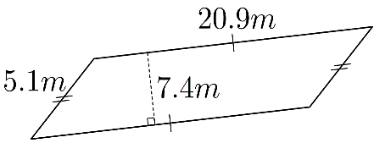
- 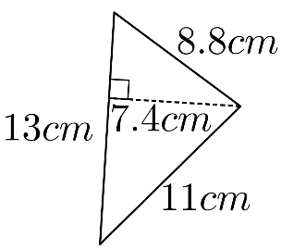 | - 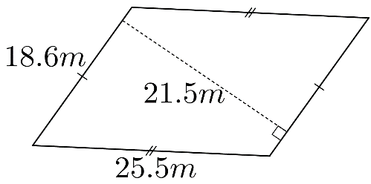 | - 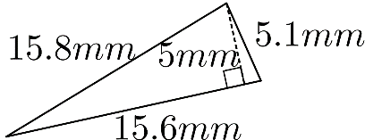
- 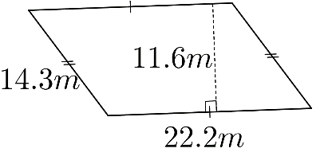 | - 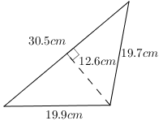 | - 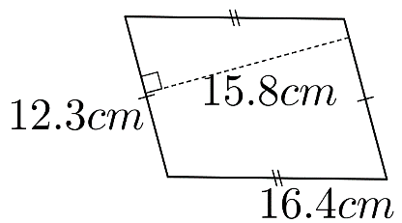

☑ Correction Time! Click here for answers

2b stretch questions
- A proposed rectangular flag for a new country is yellow with a red stripe in the shape of a parallelogram, as shown.
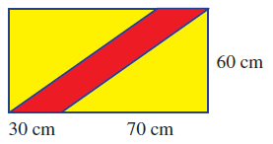
  - Find the area of the red stripe.
  - Find the yellow area.

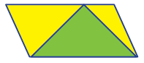
- A parallelogram includes a green triangular area, as shown. What fraction of the total area is the green area? Give reasons for your answer.

  - A triangle has area 20 cm² and base 4 cm. Find its height.
  - Find the side length of a square if its area is 49cm²
  - Find the side length of a square if its area is 2.25cm²
  - Find the perimeter of a rectangle that has area 40cm² and length 8cm.
  - Find the base of a triangle that has area 24cm² and height 12cm.

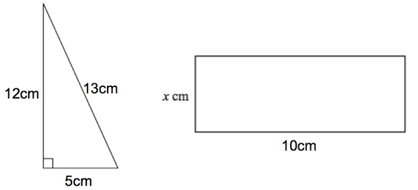
- Here is a right-angled triangle and a rectangle. The area of the right-angled triangle is equal to the area of the rectangle. Calculate $x$.

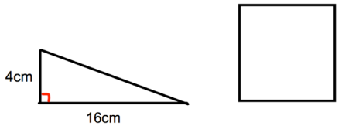
- Here is a diagram of a right-angled triangle and a square. The area of the square is twice the area of the triangle. Calculate the length of each side of the square.

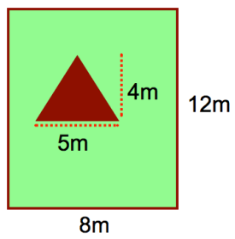
- This diagram below shows a garden. The garden has a triangular vegetable patch and the rest of the garden is grass.
  - Calculate the area of the garden that is grass.
  - The grassed area is to be replaced. If a bag of seeds covers 4m² and each bag costs $6 how much will it cost to buy seed to re-do the grassed area?

☑ Correction Time! Click here for answers
Finished Early? Head to the Early Finishers Page to engage in a game, puzzle or investigation.

2C routine questions
- Calculate the area of the shapes below by first expressing the area as a single calculation and then evaluating using line by line working. 4First Five Live
- 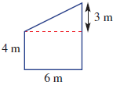 | - 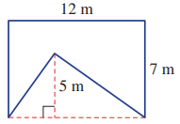 | - 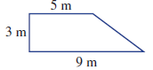
- 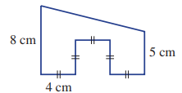 | - 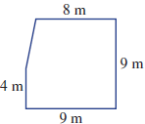 | - 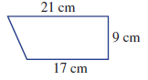
- 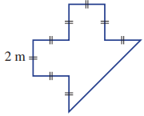 | - 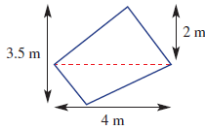 | - 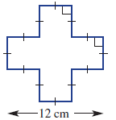
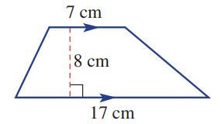 | - 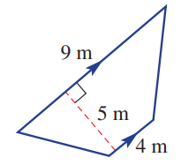 | - 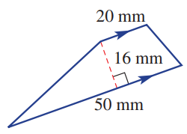

☑ Correction Time! Click here for answers

2c stretch questions
Worked Example: | What we write: | What we think:
Write a simplified expression for the area of the shape below. | 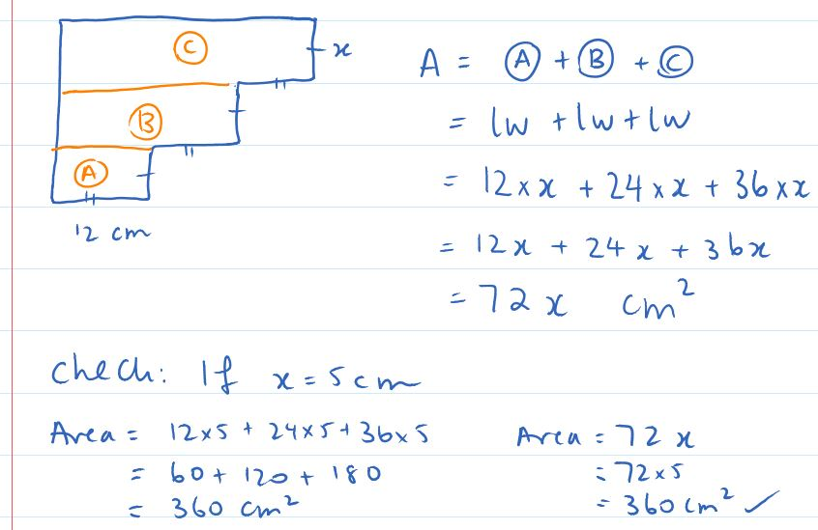 | This is a composite shape (a shape made up of more than one basic shape).  - We see that there are three rectangles (A), (B) and (C)  - We calculate the area of the composite shape as the sum of the areas of Shapes A, B and C and write out their formulas.  - We substitute in the values  - We re-write the multiplications without the multiplication sign  - We add the like terms (12 lots of $x$ plus 24 lots of $x$ plus 36 lots of $x$ is 72 lots of $x$.  - Include units.  We check if our formula works when $x=5$. Since both answers are the same we are confident that we’ve answered the question correctly – yay!
- Write a simplified expression for the area of the following shapes. To check your answer, let $x=5$ and calculate the area using your formula and also the standard approach for calculating the area of a composite shape. Do you get the same answer? Hopefully!! See above for an example of this problem if needed.
- 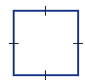  $x$cm | - 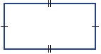  $3$cm | - 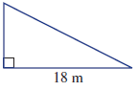  $x$m
$x$cm | $x$m  $x$cm | $2$m  $3$m  $$x$$
- Each picture is made up of some number of identical small rectangles. Using the information given determine the perimeter of one small rectangle.
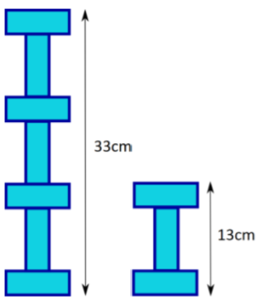 |  | - 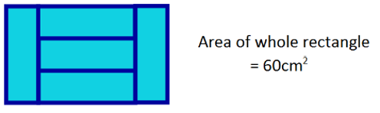 |  | - 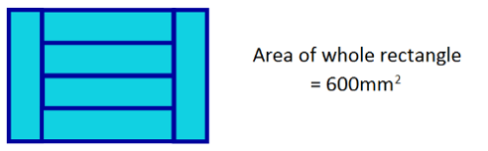
- The length and width of a rectangle each increase by 20%. By what percentage does the area increase by?

- These questions are about halving the area of a rectangle.
  - There are infinitely many lines that will cut a single rectangle into two regions of equal area. Describe these lines.
  - A small rectangular region is removed from a larger rectangular region. Using a single straight line, how can you cut what remains into two regions of equal area?


- Two identical rectangles are placed one on top of the other at right angles to form the symmetric cross shown below. All sides of the cross have integer lengths in centimetres.
  - If the rectangles have dimensions 6 cm × 30 cm, find the perimeter and area of the cross.
  - If the area of the cross is 28 cm² and its perimeter is 32 cm, find the dimensions of the rectangle.

- A rectangle is divided into four triangles as shown below. Show that the blue region has the same total area as the orange region. Note: you don’t need to calculate anything to show this.


- A rectangle is divided into six triangles as shown below. Show that the blue region has the same total area as the orange region. Note: you don’t need to calculate anything to show this.

- Super challenge: The incircle of a triangle is inscribed in a triangle so as to touch (but not cross) each side. Find the radius of the incircle of the triangle shown below.
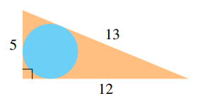

☑ Correction Time! Click here for answers
Finished Early? Head to the Early Finishers Page to engage in a game, puzzle or investigation.

SkillS 1 & 2 Application Questions – Think, Pair, Share/Teacher Modelling
Answer the questions you can. Explain your reasoning for at least one of the questions.
You may use your calculator at any time.
1. | 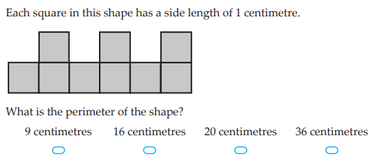
2. | 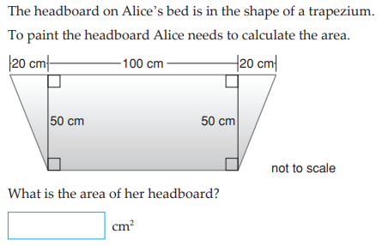
3. | 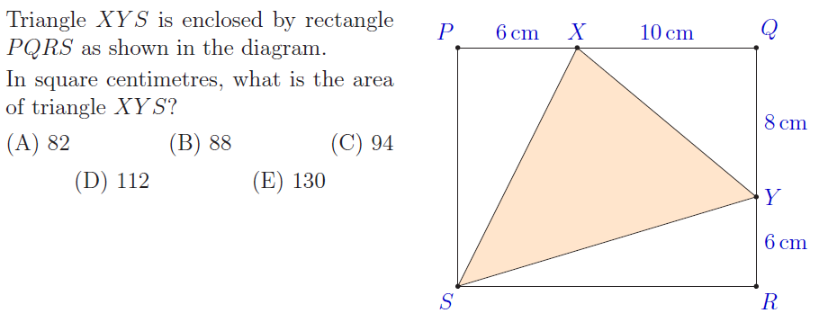
4. | In the following questions, we consider a 4x1 rectangle and a 1x4 rectangle as the same rectangle. Whereas a 2x2 rectangle and a 1x4 rectangle are different rectangles (yes, a square is a rectangle!). The some approach is taken for rectangular prisms and so a 1x1x4, a 1x4x1 and a 1x1x4 are all the same rectangular prism too.  - How many different rectangles of area 25cm² can be made using 1cm² tiles? List them all.  - How many different rectangles of area 64cm² can be made using 1cm² tiles? List them all.  - How many different rectangular prisms of volume 20cm³ can you make using 1cm³ blocks? List them all.  - How many different rectangular prisms of volume 60cm³ can you make using 1cm³ blocks? List them all.  Further exploration: A plong is made up of $a$ blocks in the first dimension, $b$ blocks in the second dimension, $c$ blocks in the third dimension and $d$ blocks in the fourth. The size of a plong is calculated by multiplying the dimensions: $a×b×c×d$. How many differnet plongs of size 60 exist? What about even higher dimensions? Of course, plongs, just like rectangles and rectangular prisms are considered the same if the dimensions are the same but just in a different order.

Skill 2 Reasoning Questions

Entry | Core | Advanced
John says that if you double the sides of a rectangle you double its area. Is John correct? | Is the following statement always, sometimes, or never true?  “Two shapes that have the same perimeter will also have the same area”  Give examples to justify your answer. | 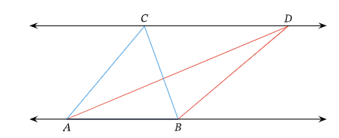  John says triangle ABC has a larger area than triangle ABD, Jodie says that triangle ABC has the same area as triangle ABD. Who do you agree with and why?

COLLABORATIVE TASK:
- A shape is equable if the numerical value of its perimeter is equal to the numerical value of its area. A shape is orthogonal if all sides meet at 90 degrees. A shape is an octagon if it has exactly 8 sides.
  - The following shapes are orthogonal octagons, show that they are all equable too.
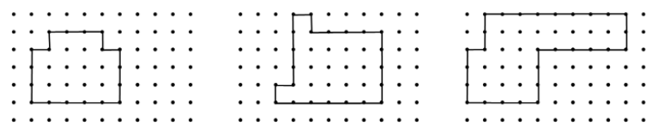
  - Create three more equable orthogonal octagons.
  - For which other polygons do equable orthogonal shapes exist? Explore this, giving examples where they exist or explaining cases where they don’t.

Assessment for Learning
Your progress will be monitored through your classwork and weekly homework sheets.

Reflection and Recognition
Let’s reflect on some key questions. Choose one or more of the questions below to answer.
- What is the formula for the area of a rectangle? What is the formula for the area of a triangle?
- How do we calculate the area of a rectangle, triangle or parallelogram?
- Can you explain the relationship between the formulas for the area of a rectangle and a triangle and a parallelogram and a rectangle?
Let’s recognise something that went well and something that could be improved.
- What component of this work caused the most growth in your learning?
- Is there anything you’d like to improve?

Early Finisher Activities
Games | Puzzles | Investigations

Games
Individual Games:
- https://www.abcya.com/games/mystic_numbers - Online addition puzzle / one player game
- https://www.topmarks.co.uk/maths-games/hit-the-button - Timed practice for number bonds and times tables. What is the best score you can get?
- https://www.nctm.org/Classroom-Resources/Illuminations/Interactives/Product-Game/ - One/two player multiplication game
- https://incoherency.co.uk/countdown/practice/#numbers – Countdown Numbers Game
Games in Pairs:
- https://mathsbot.com/puzzles/fourOpsPuzzle - Online number puzzle involving the four operations
- https://nrich.maths.org/strike-it-out - A number line game played in pairs

Puzzles
- Two rectangles overlap in a smaller rectangle as shown. Find the shaded area in square meters.
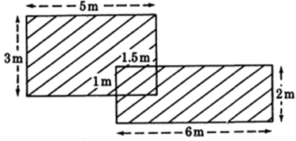
- Nine squares are arranged as shown. If A has area 1cm² and square B has area 81cm². What is the area of square I?
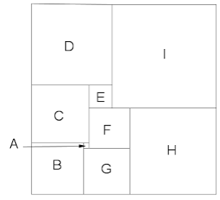

Investigations
- Create a poster about the area of quadrilaterals. Include a formula for each and an example showing how the formula is used for a specific shape.
- A shape is equable if the numerical value of its perimeter is equal to the numerical value of its area. A shape is orthogonal if all sides meet at 90 degrees. A shape is an octagon if it has exactly 8 sides.
  - The following shapes are orthogonal octagons, show that they are all equable too.
  - Create three more equable orthogonal octagons.
  - Each of the following are equable orthogonal octagons. Find the value of each unknown
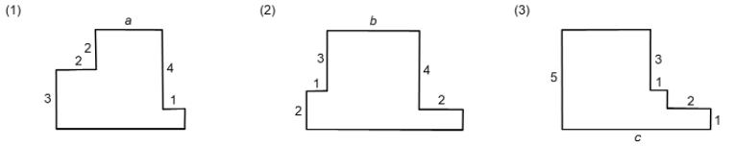
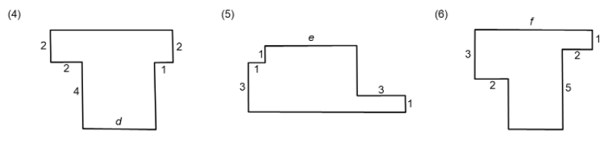
  - For which other polygons do equable orthogonal shapes exist? Explore this giving examples where they exist or explaining cases where they don’t.

Answers

1A routine Questions (ans)
1.a. 16cm b. 25m c. 30km d. 26cm e. 38cm f. 13cm
g. 44m h. 36mm i. 20mm j. 28cm k. 14m l. 36cm BackToQns

1A stretch Questions (ans)
2.a.

b. 700m c. $3500 3.a. 20 b. 50 c. 100 d. 570 e. 4 f. 10 g. 15 h. 300 4.a. 40cm b. 17cm BackToQns

1B routine Questions (ans)
1.a. 32cm b. 28km c. 18cm d. 28m e. 26cm f. 34m
g. 18mm h. 36km i. 40 cm j. 48cm k. 170mm or 17cm
l. 78mm or 7.8cm BackToQns

1b stretch Questions (ans)
2.a. 5cm b. 5m c. 7km 3.a. 70 b. 82 c. 350 d. 35 e. 4.5 f. 0.01 g. 0.01 h. 3.427 4.a. 40.7cm b. 130.2cm c. 294cm 5. 40cm BackToQns

1C routine Questions (ans)
1.a.$52=24+4x, x=7$ b. $56=24+4x, x=8$
c. $34=8x+10, x=3$ d. $56=4x+20, x=9$
e. $6x+72=138, x=11$ f. $24=20+2x, x=2$BackToQns

1c stretch Questions (ans)
2.a. $x=P-4$ b. $x=\frac{P-7}{2}$ c. $x=\frac{P}{4}$d. $x=\frac{P-8}{2}$ e. $x=\frac{P}{8}$
f. $x=P-11$ 3. 28cm 4. 2.5 cm 5. 24cm x 36cm 6. 6cm, 12cm and 15cm 7. 7cm x 11cm 8. 26cm 9. 40cm 10. 30cm BackToQns

Pre 1A Questions (ans)
1.a. 16cm b. 15cm c. 28m d. 18cm e. 26cm f. 20m g. 12m h. 31m i. 16cm j. 23m k. 14m l. 26cm BackToQns

2A routine questions (ans)
1.a. $24m^{2}$ b. $5m^{2}$ c. $54{mm}^{2}$ d.$40{cm}^{2}$ e. $4cm^{2}$ f. $36m^{2}$ g. $12{cm}^{2}$ h. $3{cm}^{2}$ i. $10cm^{2}$ j. $10m^{2}$ k. $66mm^{2}$ l. 9${cm}^{2}$
BackToQns

2A stretch questions (ans)
2.a. $15{cm}^{2}$ b. $30cm^{2}$ c. $15{cm}^{2}$ 3.a.$21{cm}^{2}$ b. $18cm^{2}$ 4. $18cm^{2}$BackToQns

2B routine Questions (ans)
1.a. 224m² b. 77m² c. 229m² d. 50m² e. 293cm² f. 155m² g. 48cm² h. 400m² i. 39mm² j. 258m² k. 192cm² l. 194cm² BackToQns

2b stretch questions (ans)
2.a. $1800cm^{2}$ b. $4200cm^{2}$ 3. Half; area (parallelogram) = bh and area (triangle) = 0.5bh 4.a. 10cm b. 7cm c. 1.5cm d. 26cm e. 4cm 5. 3cm 6. 8cm 7.a. $86m^{2}$ b. $132 BackToQns

2C routine Questions (ans)
1.a. 33m² b. 54m² c. 21m² d. 62cm² e. 78.5m² f. 171cm²
g. 16m² h. 7m² i. 80cm² j. 96cm² k. 32.5m² l. 560mm²
BackToQns

2c stretch Questions (ANS)
2.a. $x^{2}$cm² b. $3x$ cm² c. $4x$ m² d. $5x^{2}$cm² e. $5.5x$ m²
f. $2x$m² 3.a. 20cm b. 16cm c. 50mm 4. 44% 5. Ask your teacher 6. a. P = 120 cm and A = 324 cm² b. 2 cm × 8 cm
7. We divide the four triangles into eight by drawing two lines parallel to each side, as shown. For every blue triangle, there is a matching orange triangle.
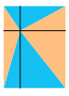
8. Draw four vertical lines as shown. For each of five orange triangles there is a matching blue triangle.
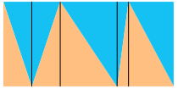
9. r = 2
BackToQns

