
SANDRINGHAM COLLEGE
YEAR 7 MATHS

Topic 4: Number Properties

Contents
Introduction: 2
1. Powers of Numbers 3
2. Factors and Multiples 11
3. Classifying Numbers 21
4. LCM and HCF 30
5. Square Roots 38
Early Finisher Activities 44
The big ideas of this topic are listed above.

Introduction:
Minimum Expectations
It is through regular practice and high expectations that you will maximise your progress in maths!
There are three things that will need to be included before work is considered complete:
- Copying of the question if in blue text – if it is in blue it is in our books!
- Inclusion of working out (where appropriate)
- Corrections. A tick ✓ if correct and retry until correct if incorrect.
In most cases, your teacher will require you to complete at least one set of questions for each big idea. Most students will start with Routine Questions at the Core Level, though there are options to move onto more challenging questions or less challenging questions as needed.
Assessed Learning Task (ALT)
At the end of the unit you will complete an ALT.
All skill based ALT questions will be developed from the questions in this book. All application questions will be of a similar structure, though not always familiar.
Most students will complete the mainstream ALT focusing on Core Level skills, though some students will complete a modified ALT focusing on Entry Level skills and others will complete an Enhanced ALT focusing on Enrichment Level Skills. Decisions around which ALT each student will do will happen towards the end of the topic ☺
You will be allowed to bring your maths workbook into the ALT and so there is great incentive to complete as many stretch questions as you can!!

Many stretch questions have come from Don Steward’s fantastic website Median.

Powers of Numbers

Setting the Goal
Learning Intention:
- What does a power of a number tell you to do?
- How do write a power in expanded form?
- Why do we use powers?
Success Criteria: I know that the power of a number tells me how many times the number appears in the multiplication

Key words
The power of a number tells you how many times the number appears in the multiplication.
When we write a power as a multiplication it is in expanded form. Eg. 3⁴ = 3 x 3 x 3 x 3
1, 4, 9, 16 and 25 are the first five square numbers. These are all equal to a whole number to the power of 2.

Skill A: Entry skill

Activate prior knowledge
Numberblocks Square Club

Explicit teaching
[NEW PAGE] 1A: Squaring Numbers
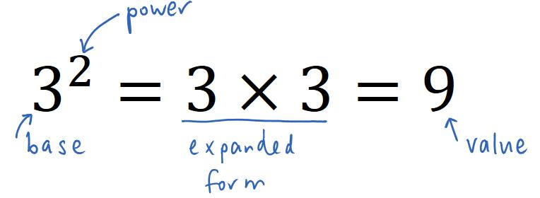
- Powers tell us how many times the number appears in the multiplication.

- A whole number to the power of 2 is a square number.
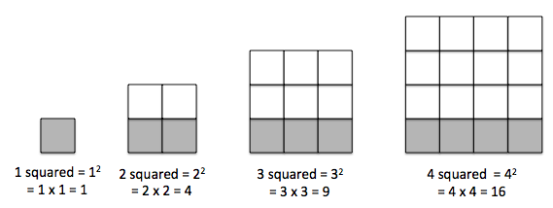
Worked Examples
1. $5^{2}$ |  |  | 2.$7^{2}$
What we write:  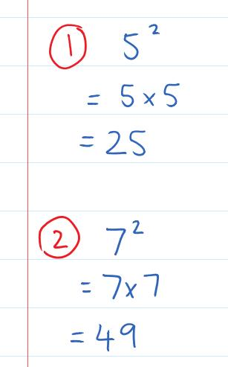 |  | What we think:  The number 5 has a power of 2. This tells us that the 5 appears 2 times in the multiplication.  The number 7 has a power of 2. This tells us that the 7 appears 2 times in the multiplication.
Your turn:
1. $6^{2}$ |  |  | 2. $8^{2}$

PRACTICE

1A Routine questions
- Calculate the following. 4First Five Live
- $4^{2}$ | - $8^{2}$ | - ${10}^{2}$ | - $2^{2}$
- ${12}^{2}$ | - $1^{2}$ | - ${11}^{2}$ | - $0^{2}$
- $5^{2}$ | - $3^{2}$ | - $9^{2}$ | - $6^{2}$
- $7^{2}$

þ Correction Time! Click here for answers

1A Stretch questions
- List all the square numbers smaller than 30.

- Calculate the following.
- ${13}^{2}$ | - ${20}^{2}$ | - ${50}^{2}$ | - ${1000}^{2}$
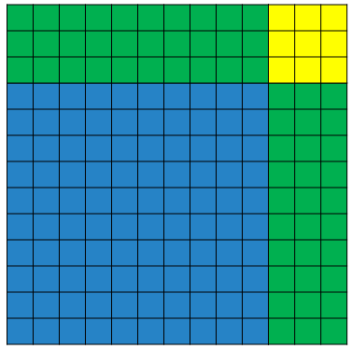
- The image on the right shows $13×13$ using Base 10 Blocks.
We can see that $13×13=10×10+2×3×10+3×3$

  - Sketch a similar picture for $14×14$ and use the image to calculate the value of ${14}^{2}$
  - Sketch a similar picture for $21×21$ and use the image to calculate the value of ${21}^{2}$

- Here we see the first four steps in a visual pattern.
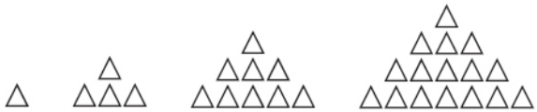
- How many triangles are in step 1, 2, 3 and 4?
- How is this pattern growing?
- How many triangles will be in the 5th step?
- How many triangles in step 43?
- What step will have 196 triangles?
- What is an algebraic rule for the number of triangles in the $n^{th}$ step?

- Here we see the first three steps in a visual pattern.
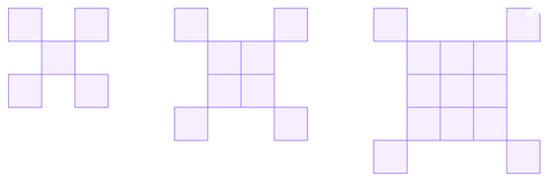
- How many squares are in step 1, 2 and 3?
- How is this pattern growing?
- How many squares will be in the 4th step?
- How many squares in step 43?
- What step will have 148 squares?
- What is an algebraic rule for the number of squares in the$n^{th}$ step?
- Consider the following sums. Describe what you notice and try to explain why this will always happen.
$$1$$ | $$1+3=4$$ | $$1+3+5=9$$ | $$1+3+5+7=16$$ | $$1+3+5+7+9=25$$

- Answer the following questions.
  - What digits can square numbers end in?
  - What square numbers end in a 6?

- In the following $a, b$ and $c$ are positive whole numbers. Can you find a solution to each equation? Challenge: Can you find 3 different solutions to the first 2 equations?
- $a^{2}+b^{2}+c^{2}=81$ | - $a^{2}+b^{2}+c^{2}=101$ | - $a^{2}+b^{2}+c^{2}=180$

þ Correction Time! Click here for answers to most questions
Finished Early? Head to the Early Finishers Page to engage in a game, puzzle or investigation.

Skill B: core skill

Activate prior knowledge
Mathematicians love efficiency. How can you write the following sums more succinctly?
SET 1  - $7+7$  - $3+3+3+3$  - $5+5+5+5+5+5$ | SET 2  - $7×7$  - $3×3×3×3$  - $5×5×5×5×5×5$

Explicit Teaching
[NEW PAGE] 1B: Powers of Numbers
- Powers allow us to write repeated multiplications more efficiently.
- Powers tell us how many times the number appears in the multiplication.
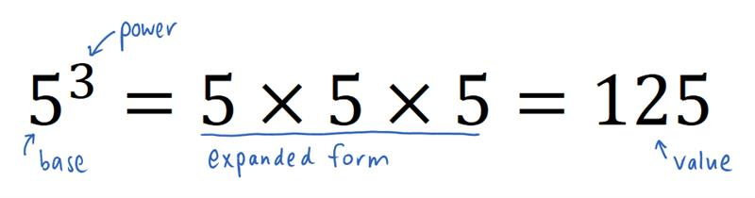
Worked Examples
1. $2^{4}$ |  |  | 2. $7^{1}$
What we write:  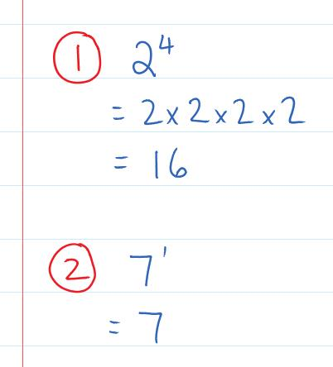 |  | What we think:  The number 2 has a power of 4. This tells us that the 2 appears 4 times in the multiplication.  The number 7 has a power of 1. This tells us that the 7 appears 1 time in the multiplication. This means we just have the number 7.
Your turn:
1. $4^{3}$ |  |  | 2. $1^{6}$

Practice

1B ROUTINE QUESTIONS
- Calculate the following. 4First Five Live
- $2^{3}$ | - ${11}^{1}$ | - $0^{3}$ | - $4^{2}$ | - ${10}^{3}$
- $7^{2}$ | - $3^{3}$ | - $5^{2}$ | - $2^{5}$ | - $4^{2}$
- $5^{3}$ | - ${10}^{2}$ | - $1^{5}$ | - $3^{2}$ | - $8^{2}$
- $1^{2}$ | - $1^{4}$ | - $9^{2}$ | - $3^{4}$ | - ${12}^{1}$
þ Correction Time! Click here for answers

1B STRETCH questions
- For each equation, state the value of $x$ that makes the equation true.
- $2^{x}=8$ | - $5^{x}=25$ | - $3^{x}=81$ | - ${10}^{x}=10$

- Calculate the following and comment on the patterns you observe.
- Powers of 2  i. $2^{2}-2^{1}$  ii. $2^{3}-2^{2}$  iii. $2^{4}-2^{3}$  iv. $2^{5}-2^{4}$ | - Powers of 3  i. $3^{2}-3^{1}$  ii. $3^{3}-3^{2}$  iii. $3^{4}-3^{3}$  iv. $3^{5}-3^{4}$ | - Powers of 10  i. ${10}^{2}-{10}^{1}$  ii. ${10}^{3}-{10}^{2}$  iii. ${10}^{4}-{10}^{3}$  iv. ${10}^{5}-{10}^{4}$
- Calculate the following.
- ${0.2}^{2}$ | - ${0.2}^{3}$ | - ${0.2}^{4}$ | - ${0.2}^{5}$

- Calculate parts a-e with your calculator and use your answers to predict the answers to parts f and g.
- ${\left(-2\right)}^{1}$ | - ${\left(-2\right)}^{2}$ | - ${\left(-2\right)}^{3}$ | - ${\left(-2\right)}^{4}$ | - ${\left(-2\right)}^{5}$ | - ${\left(-1\right)}^{231}$ | - ${\left(-1\right)}^{1000}$

- Calculate parts a-d carefully and use your answers to predict the answers to parts e and f. You may give your answer as a number to a power.
- ${(1+2)}^{2}-1^{2}$  - ${\left(1+2+3\right)}^{2}-{\left(1+2\right)}^{2}$  - ${(1+2+3+4)}^{2}-{(1+2+3)}^{2}$ | - ${(1+2+3+4+5)}^{2}-{(1+2+3+4)}^{2}$  - ${(1+2+3+4+5+6)}^{2}-{(1+2+3+4+5)}^{2}$  - ${(1+2+3+4+5+6+7)}^{2}-{(1+2+3+4+5+6)}^{2}$

þ Correction Time! Click here for answers
Finished Early? Head to the Early Finishers Page to engage in a game, puzzle or investigation.

Skill C: ENRICHMENT skill

Activate prior knowledge
Calculate the following:
$$5×2^{3}$$ | $${\left(5×2\right)}^{3}$$

Explicit Teaching
[NEW PAGE] 1C: Substitution with Powers
- Substitution means swap
- Powers represent a repeated multiplication
- More than one operation, use BIDMAS

Worked Examples
1. Substitute $a=3$ into $4a^{2}$ and evaluate. |  | 2. Substitute $a=3$ into ${(4a)}^{2}$ and evaluate.
What we write:  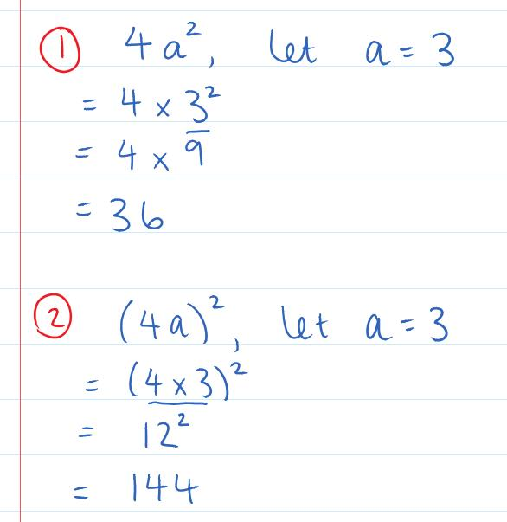 | What we think:  Substitute means swap.  Replace the $a$with 3.  Evaluate means calculate.  Following BIDMAS we calculate the power (index) first and then the multiplication.  Substitute means swap.  Replace the $a$with 3.  Evaluate means calculate.  Following BIDMAS we calculate the product inside the brackets first, then the multiplication.
Your turn:
1. Substitute $b=4$ into $2b$ and evaluate. |  | 2. Substitute $b=4$ into ${(2b)}^{2}$ and evaluate.

Practice

1C ROUTINE QUESTIONS
- Complete the following substitutions. 4First Five Live
- Substitute $a=3$ into $10a^{2}$ and evaluate | - Substitute$b=5$ into ${\left(2b\right)}^{2}$ and evaluate | - Substitute $c=4$ into ${4c}^{3}$ and evaluate | - Substitute $d=0$ into ${2d}^{2}$ and evaluate
- Substitute$e=2$ into $12e^{2}$ and evaluate | - Substitute $f=1$ into ${\left(2f\right)}^{4}$ and evaluate | - Substitute $g=2$ into ${\left(4g\right)}^{2}$ and evaluate | - Substitute$h=3$ into $9h^{2}$ and evaluate
- Substitute $i=2$ into ${\left(2i\right)}^{3}$ and evaluate | - Substitute $j=2$ into ${\left(3j\right)}^{3}$ and evaluate | - Substitute$k=5$ into ${\left(2k\right)}^{4}$ and evaluate | - Substitute $l=4$ into $4l^{2}$ and evaluate
- Substitute $m=5$ into $3m^{2}$ and evaluate | - Substitute$n=3$ into $2n^{3}$and evaluate | - Substitute $o=2$ into $3o^{2}$ and evaluate | - Substitute $p=2$ into $3p^{5}$ and evaluate
- Substitute$q=5$ into $4q^{2}$ and evaluate | - Substitute $r=3$ into $7r^{2}$ and evaluate | - Substitute$s=2$ into ${\left(7s\right)}^{2}$ and evaluate | - Substitute $t=4$ into $6t^{2}$ and evaluate
þ Correction Time! Click here for answers

1C STRETCH questions
- The table below summarises the effect of multiplying positive and negative numbers. Use this to help you calculate the following.
$$positive×positive=positive$$  Eg. $3×4=12$ | $$negative×positive=negative$$  Eg. ${}_{}^{-}3×4={}_{}^{-}{12}$
$$positive×negative=negative$$  Eg. $3×{}_{}^{-}4={}_{}^{-}{12}$ | $$negative×negative=positive$$  Eg. ${}_{}^{-}3×{}_{}^{-}4=12$

- Substitute $a=5$ into $-3a$ and evaluate | - Substitute $b=-5$ into $-3b$ and evaluate | - Substitute $c=-5$ into $c^{2}$ and evaluate
- Substitute $d=4$ into $-d^{2}$ and evaluate | - Substitute $e=-4$ into $-e^{2}$ and evaluate | - Substitute $f=-5$ into  $3f^{2}+f$ and evaluate
- Substitute $g=-4$ into $-2g^{2}-g$ and evaluate | - Substitute $h=-4$ into  $2h^{3}+h^{2}-5h$ and evaluate | - Substitute $i=-5$ into  $i^{2}+6i$ and evaluate

- Complete the following substitutions.
- Substitute $u=0.3$ into ${\left(2u\right)}^{2}$ and evaluate | - Substitute$v=0.4$ into $8v^{3}$ and evaluate | - Substitute $w=0.01$ into ${\left(2w\right)}^{3}$ and evaluate
- For each equation, state the value of $x$ that makes the equation true.
- ${0.1}^{x}=0.0001$ | - ${0.1}^{2x}=0.0001$ | - ${0.1}^{0.5x}=0.0001$

- Complete the questions below. If you are unsure you can follow the pattern or use your calculator.
- $2^{3}$ | - $2^{2}$ | - $2^{1}$ | - $2^{0}$
- $2^{-1}$ | - $2^{-2}$ | - $2^{-3}$ | - $2^{-4}$

- Consider the following expression
$$n^{2}+n+41$$
  - Substitute $n=1$ and evaluate
  - Substitute $n=2$ and evaluate
  - Substitute $n=3$ and evaluate
  - Substitute $n=4$ and evaluate
  - Substitute $n=5$ and evaluate
  - Substitute $n=6$ and evaluate
  - Substitute $n=7$ and evaluate
  - Do you notice something special about the answers??
  - Will this always happen?

þ Correction Time! Click here for answers
Finished Early? Head to the Early Finishers Page to engage in a game, puzzle or investigation.

SkillS 1 Application Questions – Think, Pair, Share/Teacher Modelling
Answer the questions you can. Explain your reasoning for at least one of the questions.
1. | 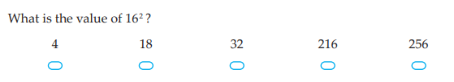
2. | 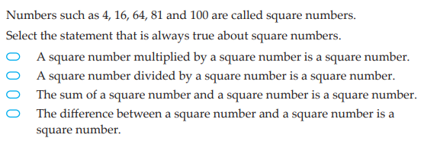
3. | Find values of $x$ and $y$ such that $3^{x}=9^{y}$  Optional: Can you find more than one solution? Can you describe all solutions?
4. | - What is the final digit of 2⁵?  - What is the final digit of 2²⁰?  - What is the final digit of 2²⁰²³?  - What is the final digit of 3²⁰²³?  Further Exploration: When is the first time the final two digits of a power of 2 repeat? What about the final two digits of a power of 3? Or 4? Etc…

Skill 1 Reasoning Questions

Entry | Core | Advanced
Explain why powers of two are called square numbers. | Is the following statement always, sometimes, or never true?  “Raising a number to a power makes it bigger” | Why is the following incorrect?  Let $x=4$ in $3x^{2}$, $3×4^{2}={12}^{2}=144$

COLLABORATIVE TASK:
Below shows the different towers of height two that can be made with two different coloured blocks:
- How many different towers of height three can be made with two different coloured blocks?
- How many different towers of height four can be made with two different coloured blocks?
- How many different towers of height five can be made with two different coloured blocks?
- How many different towers of height n can be made with two different coloured blocks?
- How many different towers of height n can be made with m different coloured blocks?

Assessment for Learning
Your progress will be monitored through your classwork and weekly homework sheets.

Reflection and Recognition
Let’s reflect on some Essential Questions. Choose one or more of the questions below to answer.
- What does a power of a number tell you to do?
- How do write a power in expanded form?
- Why do we use powers?
Let’s recognise something that went well and something that could be improved.
- What component of this work caused the most growth in your learning?
- Is there anything you’d like to improve?

Factors and Multiples

Setting the Goal
Learning Intention:
- What is a multiple? What is a factor?
- How do we list factors making sure we don’t miss any?
- Why do factors come in pairs?
Success Criteria: I know that multiples are just times tables and that factors come in pairs and fit into numbers exactly

Key words
The factors of a whole number are the numbers that divide it exactly. For example, the factors of 12 are 1, 2, 3, 4, 6 and 12.
A product is the answer when two or more numbers are multiplied together. For example, the product of 2 and 3 is 6.
A multiple of a number is a product of that whole number with any other whole number. For example, the first 5 positive multiples of 6 are 6, 12, 18, 24 and 30.

Skill A: Entry skill

Activate prior knowledge
Counting by 3s challenge:
Have everyone in the class stand in a circle. Choose a student to start. They will say 3. The student to their left will say 6, the next student says 9 and so on. How high can they get in 2 minutes? Complete the activity again and see if they can beat their previous score.

Explicit teaching
[NEW PAGE] 2A: Listing Multiples
- Multiples are the times tables
- Positive means greater than zero

Worked Examples
1. List the first 5 positive multiples of 7 | 2. List the first 6 positive multiples of 4
What we write:  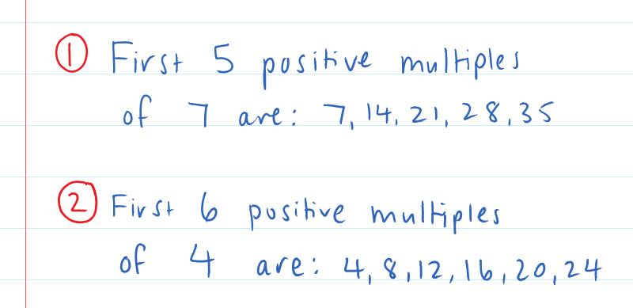 |  | What we think:  Multiples are the times tables so we start writing out the times tables for 7. We know we’ve reached the 5th multiple when we get to $5×7$  Multiples are the times tables so we start writing out the times tables for 4. We know we’ve reached the 6th multiple when we get to $6×4$
Your turn:
1. List the first 7 positive multiples of 3 | 2. List the first 4 positive multiples of 8

PRACTICE

2A Routine questions
- List the first 6 positive multiples of the following numbers. 4First Five Live
- 5 | - 8 | - 12 | - 4 | - 10
- List the first 8 positive multiples of the following numbers.
- 9 | - 2 | - 3 | - 11 | - 13
- List the first 7 positive multiples of the following numbers.
- 7 | - 6 | - 1

þ Correction Time! Click here for answers

2A Stretch questions
- In AFL football goals are worth 6 points. Which of the following team’s scores could possibly have come from only kicking goals?
- Richmond: 20 | - Collingwood: 18 | - Essendon: 16 | - West Coast: 30

- List the first 10 positive multiples of the following numbers.
- 15 | - 28 | - -15 | - -31 | - 2.8 | - -0.15

- Consecutive numbers follow on from each other by adding 1. For example, 6, 7, 8 are consecutive numbers.
  - Find three consecutive numbers larger than 10 that are multiples of 2, 3 and 4 (in this order)
  - Find three consecutive numbers larger than 10 that are multiples of 3, 4 and 5 (in this order)
  - Find three consecutive numbers larger than 10 that are multiples of 4, 5 and 6 (in this order)
  - (Challenge) How many different sets of consecutive numbers can you find that fit the rule for part a? Can you describe all possible solutions?

- What is the smallest number such that:
  - when you subtract 4 from it you get a multiple of 4,
  - when you subtract 5 you get a multiple of 5, and
  - when you subtract 6 you get a multiple of 6?

- M(15) means the number must be a multiple of 15 i.e. 15 or 30 or 45 or 60 or 75 or 90. Find four digits (all different) to go in each of the boxes to make 2-digit multiples of the required number when you read across and down. The first one has been started for you.
a. | b. | c. | d.
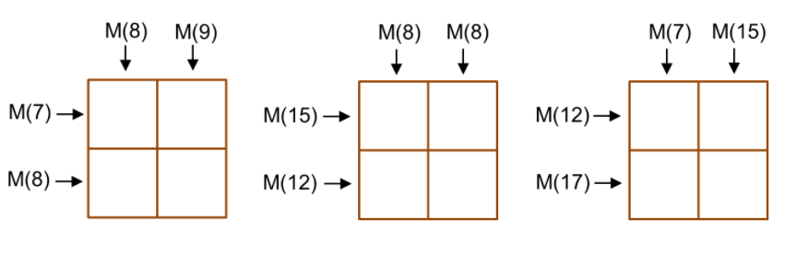  3 5 |  |  | 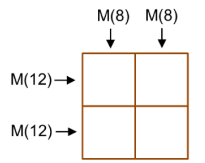

þ Correction Time! Click here for answers
Finished Early? Head to the Early Finishers Page to engage in a game, puzzle or investigation.

Skill B: core skill

Activate prior knowledge
Solve the following equations:
1. $5x=20$ | 2. $3x=21$ | 3. $2x=64$ | 4. $2x=54$

Explicit Teaching
[NEW PAGE] 2B Part 1: Missing Number Questions
- To solve missing number questions you can either use
  - related facts
  - the division algorithm

Worked Examples
1. $2×\boxed{}=78$ |  | 2. $5×\boxed{}=120$ | 3.$3×\boxed{}=54$
What we write:  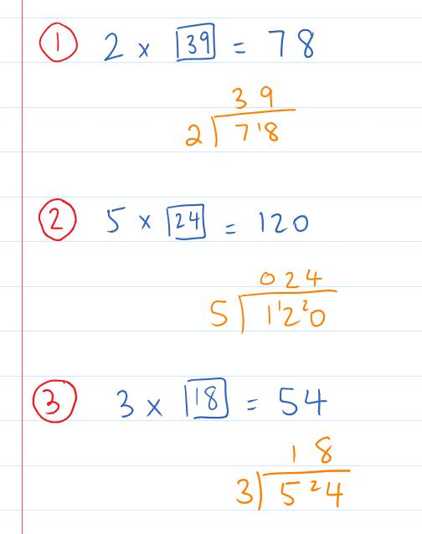 | What we think:  One possible mental strategy using related facts is:  $2×10=20$ so $2×40=80$ and so $2×39=78$.  One possible mental strategy using related facts is:  $5×10=50$ so $5×20=100$ and $5×4=20$ and so  $5×24=120$.  One possible mental strategy using related facts is:  $3×10=30$ so $3×20=60$ and $3×2=6$so $3×18=54$.
Your turn:
1. $3×\boxed{}=78$ |  | 2. $2×\boxed{}=96$ | 3.$5×\boxed{}=85$

Practice

2B Part 1 ROUTINE QUESTIONS
- Fill in each box with a whole number to make the equation true. 4First Five Live
- $2×\boxed{}=36$ | - $5×\boxed{}=70$ | - $3×\boxed{}=90$ | - $5×\boxed{}=100$
- $3×\boxed{}=48$ | - $2×\boxed{}=88$ | - $5×\boxed{}=110$ | - $2×\boxed{}=52$
- $5×\boxed{}=105$ | - $2×\boxed{}=90$ | - $3×\boxed{}=57$ | - $5×\boxed{}=80$
- $3×\boxed{}=84$ | - $5×\boxed{}=65$ | - $3×\boxed{}=51$ | - $2×\boxed{}=92$
- $5×\boxed{}=90$ | - $3×\boxed{}=63$ | - $5×\boxed{}=95$ | - $2×\boxed{}=82$
þ Correction Time! Click here for answers

2B Part 1 STRETCH questions
- Answer the following worded questions.
  - A number multiplied by three is equal to 87. Find the number.
  - Mary had to save $85 to buy some board games to play with her friends. She manages to save $5 a month. How many months will it take her to save enough money to buy the games?
  - In a game of Aussie Rules football, Michael scored 84 points just by scoring goals!! If each goal is worth six points, how many goals did Michael kick in total?
- Fill in each box with a whole number to make the equation true.
- $2×\boxed{}=336$ | - $5×\boxed{}=740$ | - $3×\boxed{}=21540$ | - $5×\boxed{}=2315$
- Fill in each box with a decimal number to make the equation true.
- $2×\boxed{}=5.8$ | - $3×\boxed{}=0.57$ | - $5×\boxed{}=0.39$ | - $4×\boxed{}=1.7$
- George wishes to put a whole number inside each box. What is the smallest number that can replace the $x$ in each case to make this possible.
- $5×\boxed{}=336-x$ | - $3×\boxed{}=7235+x$
- $7×\boxed{}=8746-x$ | - $12×\boxed{}=79731-x$
- Find the values of $a,$ $b$and $c$ in each case.
  - $ab=50, bc=30$ and $ac=15$
  - $ab=84, bc=140$ and $ac=15$
  - (challenge) $ab=0.048, bc=0.72$ and $ac=5.4$
  - (super challenge) $ab=0.12, bc=0.48$ and $ac=0.01$

þ Correction Time! Click here for SOME answers. Where answers aren’t given, check them with a peer or your teacher.
Finished Early? Head to the Early Finishers Page to engage in a game, puzzle or investigation.

Activate prior knowledge
Watch Numberblocks episode “Team Tag”

Explicit Teaching
[NEW PAGE] 2B Part 2: Listing Factors
- A factor of a number fits into the number exactly (with no remainder)
  - Factors come in pairs
  - Check factors in order so you don’t miss any!
- Helpful ways to spot factors:
    - 1 is a factor of every whole number
    - 2 is a factor of every number ending in a 0, 2, 4, 6 or 8
    - 5 is a factor of every number ending in 5 or 0
- A Possible Strategy:
  - Start by listing the possible first values of the factor pairs. [1-7 works for numbers less than 60]
  - Write the factor pair for numbers that are factors
  - Cross out values that aren’t factors.
- Copy the image below to help you remember the difference between a factor and a multiple.
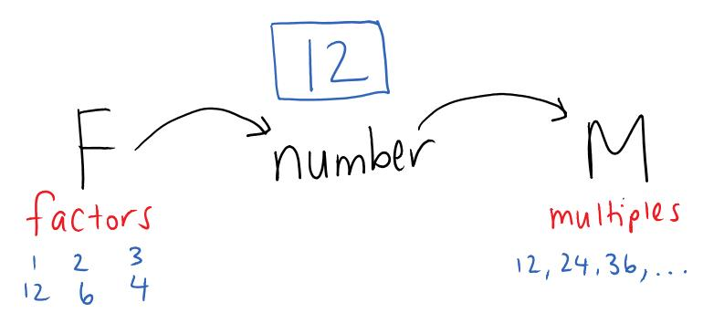

Worked Examples
1. List the factors of 44 | 2. List the factors of 17 |  |  | 3. List the factors of 36
What we write and think:  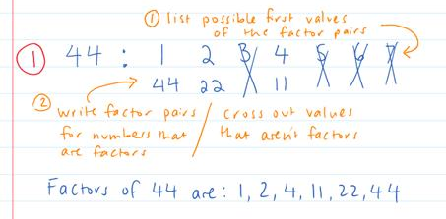 |  |  | What we write:  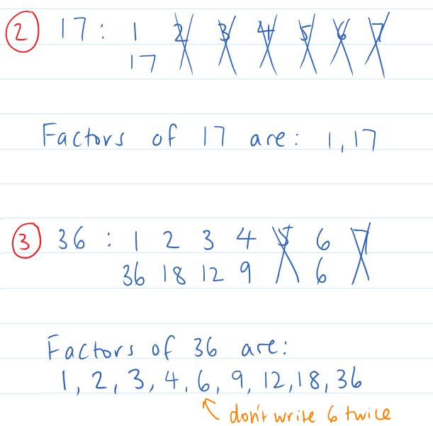
Your turn:
1. List the factors of 32 |  | 2. List the factors of 19 |  |  | 3. List the factors of 45

Practice

2B Part 2 ROUTINE QUESTIONS
- List the factors of each number. 4First Five Live
- 30 | - 27 | - 33 | - 46 | - 48
- 18 | - 16 | - 24 | - 23 | - 35
- 20 | - 25 | - 37 | - 41 | - 22
- 60 | - 53 | - 28 | - 17 | - 9
þ Correction Time! Click here for answers

2B Part 2 STRETCH questions
- A group of 20 people are going to be split into teams containing an equal number of people. What are the possible sizes of the teams?
- List the factors of each number. Note that when listing the possible first numbers in a factor pair, start at 1 and then stop when the number squared is bigger than the original.
- $72$ | - $84$ | - $96$ | - $100$
- Consider the numbers from 1 to 25.
  - Which number has the most factors?
  - Which number has the fewest factors?
  - Which numbers have an odd number of factors?

- Find the length and width of the following rectangles.
  - The perimeter is 28m and the area is 33m².
  - The perimeter is 34m and the area is 60m².
  - The perimeter is 58m and the area is 100m².

- 6 is a perfect number as the factors of 6 (other than itself) add to 6. What is the next perfect number?

þ Correction Time! Click here for SOME answers. Where answers aren’t given, check them with a peer or your teacher.
Finished Early? Head to the Early Finishers Page to engage in a game, puzzle or investigation.

Skill B: ENRICHMENT skill

Activate prior knowledge
True or false?
- If both 2 and 3 are factors of a number, then 6 is a factor too
- If both 2 and 6 are factors of a number, then 12 is a factor too

Explicit Teaching
[NEW PAGE] 2C Listing Factors of Larger Numbers
  - 2 is a factor if the whole numbers ends 0, 2, 4, 6 or 8
  - 5 is a factor if the whole number ends in 0 or 5
  - 3 is a factor if the digit sum is a multiple of 3
  - The first factor pair is always less than or equal to the square root of the number
  - If the second factor pair is a prime number the process will stop
  - Think carefully whether composite numbers are factors…
Worked Examples
1. List the factors of 148 | 2. List the factors of 149 | 3. List the factors of 405
What we write and think:
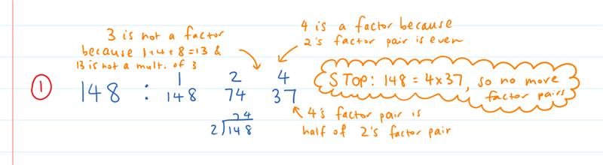
Second factor pair is prime
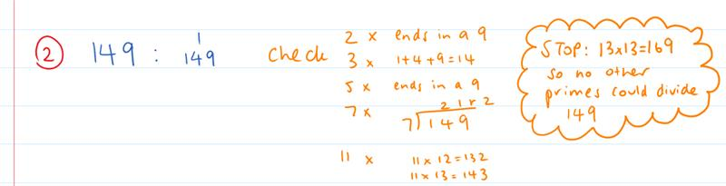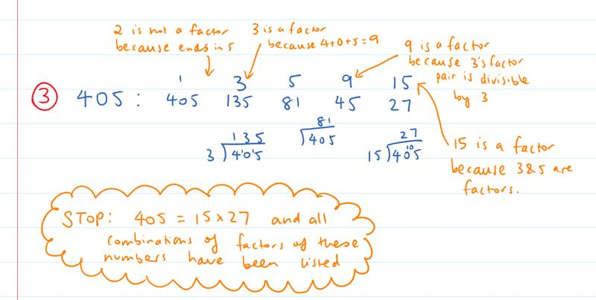
Your turn:
1. List the factors of 322 | 2. List the factors of 255 | 3. List the factors of 109

Practice

2C ROUTINE QUESTIONS
- List the factors of each number. 4First Five Live
- 184 | - 143 | - 127 | - 345 | - 119
- 170 | - 103 | - 129 | - 150 | - 117
- 190 | - 153 | - 130 | - 113 | - 105
- 104 | - 114 | - 152 | - 182 | - 108
þ Correction Time! Click here for answers

2C STRETCH questions
- Use the numbers 1 to 9 only once in each cell to obtain row and column products as shown.
a. | b. | c.
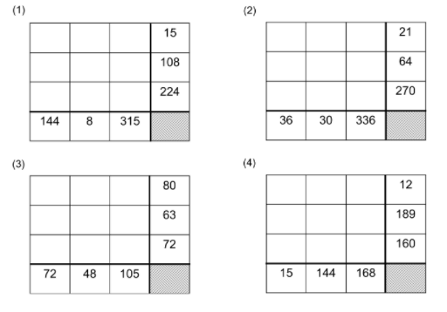

- (Challenge) A certain positive integer has exactly eight factors. Two of these factors are 15 and 21. What are the other 6 factors?

þ Correction Time! Click here for SOME answers. Where answers aren’t given, check them with a peer or your teacher.
Finished Early? Head to the Early Finishers Page to engage in a game, puzzle or investigation.

SkillS 2 Application Questions – Think, Pair, Share/Teacher Modelling
Answer the questions you can. Explain your reasoning for at least one of the questions.
1. | How many positive multiples of 13 are less than 100?
2. | 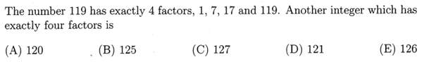
3. | 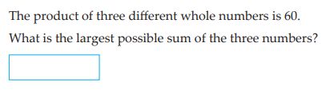
4. | There are some cubes on the table. Alice and Blair alternatively remove one or two cubes. The winner is the one who takes the last cube. On the principle of ‘ladies first’, Alice always takes the first turn. Alice and Blaire are expert players, and depending on the number of cubes they each know who will win.  - Who wins when there is one cube?  - Who wins when there are two cubes?  - Who wins when there are three cubes?  - Who wins when there are four cubes?  - Who wins when there are 21 cubes?  - Who wins when there are 31 cubes?  - How do Alice and Blaire know who will win?  Further Exploration: Blocks are placed arbitrarily in two piles. When it’s their turn Alice and Blair can take either one or two blocks provided they all come from one pile. The winner is the person with the last block. Again Alice goes first. Under what circumstances will Alice win? What if there were more piles?  Another game to consider – Nim J

Skill 2 Reasoning Questions

Entry | Core | Advanced
Julie thinks the first 5 positive multiples of 7 are 14, 28, 42, 56, 70. List the first 5 positives of 7 and explain Julie’s mistake. | George says that bigger numbers have more factors than smaller numbers. Is George always, sometimes or never true? Give examples to support your answer. | If both 12 and 8 are factors of a number, what other numbers are factors? Give reasons.

COLLABORATIVE TASK:
The Factors and Multiples Game (nrich)

Assessment for Learning
Your progress will be monitored through your classwork and weekly homework sheets.

Reflection and Recognition
Let’s reflect on some Routine questions. Choose one or more of the questions below to answer.
- What is a multiple? What is a factor?
- How do we list factors making sure we don’t miss any?
- Why do factors come in pairs?
Let’s recognise something that went well and something that could be improved.
- What component of this work caused the most growth in your learning?
- Is there anything you’d like to improve?

Classifying Numbers

Setting the Goal
Learning Intention:
- What is a prime number?
- How do we recognise if a number is even or odd? How do we work out if a number is a square number?
- Why is it helpful to have different classifications of numbers?
Success Criteria: I can classify a number as odd, even, square or prime. I can write a number as a product of its prime factors.

Key words
A whole number is even if it is a multiple of 2. Even numbers end in a 0, 2, 4, 6 or 8.
A whole number is odd if it is not a multiple of 2. Odd numbers end in a 1, 3, 5, 7 or 9.
A square number is a whole number that is made by multiplying another whole number by itself
A prime number has exactly two factors, 1 and itself.

Skill A: Entry skill

Activate prior knowledge
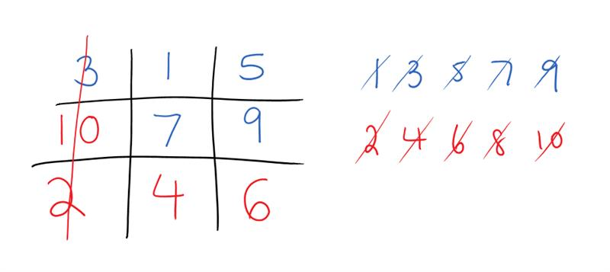
Number tic-tac-toe
- One player has the 'odd' numbers, 1, 3, 5, 7, 9 and goes first, the other has the 'even' numbers, 2, 4, 6, 8
- Players take turns playing a digit, trying to make a row, column or a diagonal add up to 15 using their own and the other person's numbers
- A player gets a point anytime they make a line that sums to 15.
Who is more likely to win, odds or evens? Why?

Explicit teaching
[NEW PAGE] 3A: Classifying Numbers Part 1
- Even numbers are whole numbers that end in 0, 2, 4, 6 or 8
- Odd numbers are whole numbers that end in 1, 3, 5, 7 or 9
- Square numbers are whole numbers made by multiplying another whole number by itself

Worked Examples
For each question, identify the words that describe the given number.
1. 42; Even, odd, square |  | 2. 9; Even, odd, square
What we write:  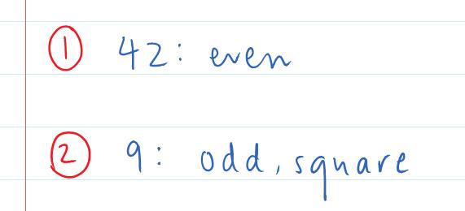 | What we think:  42 is an even number because it is a whole number that ends in a 2. 42 is not a square number.  9 is an odd number because it is a whole number that ends in a 9. 9 is a square number because 9=3x3.
Your turn:
1. 16; Even, odd, square |  | 2. 27; Even, odd, square

PRACTICE

3A Routine questions
- For each question, identify the words that describe the given number. 4First Five Live
- 45; Even, odd, square | - 40; Even, odd, square | - 2; Even, odd, square
- 25; Even, odd, square | - 9; Even, odd, square | - 12; Even, odd, square
- 49; Even, odd, square | - 17; Even, odd, square | - 37; Even, odd, square
- 3; Even, odd, square | - 0; Even, odd, square | - 13; Even, odd, square
- 60; Even, odd, square | - 15; Even, odd, square | - 1; Even, odd, square
- 36; Even, odd, square | - 31; Even, odd, square | - 18; Even, odd, square
- 7; Even, odd, square | - 19; Even, odd, square | - 8; Even, odd, square
þ Correction Time! Click here for answers

3A Stretch questions
- Answer the following worded questions:
  - Do animals generally have an even or odd number of legs?
  - Is the sum of 9 and 7 even or odd?
  - What is the most common number of legs on a chair? Is it even or odd? Why do you think this is?
- For each question, identify the words that describe the given number.
- 151; Even, odd, square | - 196; Even, odd, square | - 1000; Even, odd, square

- Jamie says 65.2 is an even number because it ends in a 2. Explain why Jamie is incorrect.

- Are the following statements always, sometimes or never true?
  - The sum of two even numbers is even
  - The sum of two odd numbers is odd
  - The product of two odd numbers is even

- Solve the following problems
  - Find three consecutive even numbers that add up to 42
  - Find four consecutive even numbers that add up to 60
  - Find five consecutive even numbers that add up to 60
  - Find three consecutive odd numbers that add up to 57
  - Find Four consecutive odd numbers that add up to 48

- Split the following sets of numbers into 4 groups so that each group adds up to a different square number.
  - 1, 2, 2, 2, 3, 3, 3, 3, 3, 4, 4, 4, 5
  - 1, 1, 3, 4, 4, 4, 4, 5, 5, 6, 6, 11, 12, 13, 20

þ Correction Time! Click here for answers
Finished Early? Head to the Early Finishers Page to engage in a game, puzzle or investigation.

Skill B: core skill

Activate prior knowledge
Activity 1: Square number challenge: Starting at 1, how many square numbers can you list in 1 minute? The person with the longest sequence will call out their answers and then we will see if we can beat our scores!
Activity 2: Let’s learn a song!
♫ I’m prime P. R. I. M. E
My only factors are 1 and me
Numbers that divide evenly
2, 3, 5, 7, 11 ♫

Explicit Teaching
[NEW PAGE] 3B: Classifying Numbers Part 2
- A prime number has exactly 2 factors 1 and itself.
  - The first 10 prime numbers are 2, 3, 5, 7, 11, 13, 17, 19, 23, 29
- A multiple is part of the numbers’ times table.

Worked Examples
For each question, identify the words that describe the given number.
1. 32; even, square, prime, multiple of 4 |  | 2. 31; odd, square, prime, multiple of 5
What we write:  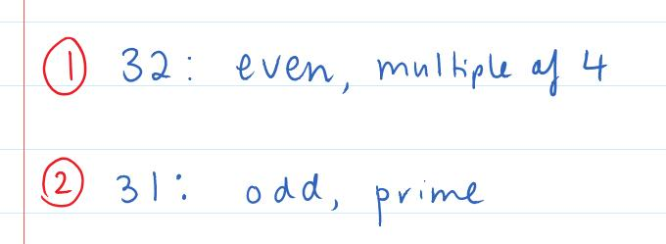 | What we think:  32 is an even number because it is a whole number that ends in a 2. 32 is not a prime as it has more than 2 factors. 32 is a multiple of 4 as 32=8x4.  31 is an odd number because it is a whole number that ends in a 1. 31 is a prime number because its only factors are 1 and 31.
Your turn:
1. 25; odd, square, prime, multiple of 5 |  | 2. 2; even, square, prime, multiple of 3

Practice

3B ROUTINE QUESTIONS
- For each question, identify the words that describe the given number. 4First Five Live
- 9; Odd, square, prime, multiple of 3 | - 4; Even, square, prime, multiple of 3
- 11; Even, square, prime, multiple of 2 | - 14; Even, square, prime, multiple of 4
- 2; Odd, square, prime, multiple of 2 | - 16; Odd, square, prime, multiple of 5
- 6; Even, square, prime, multiple of 3 | - 5; Odd, square, prime, multiple of 5
- 21; Odd, square, prime, multiple of 3 | - 28; Even, square, prime, multiple of 5
- 30; Even, square, prime, multiple of 5 | - 23; Odd, square, prime, multiple of 5
- 39; Odd, square, prime, multiple of 3 | - 33; Odd, square, prime, multiple of 2
- 20; Even, square, prime, multiple of 3 | - 26; Odd, square, prime, multiple of 3
- 48; Odd, square, prime, multiple of 2 | - 81; Even, square, prime, multiple of 5
- 41; Even, square, prime, multiple of 2 | - 79; Odd, square, prime, multiple of 4
þ Correction Time! Click here for answers

3B STRETCH questions
- How many squares of any size are on this grid?

- For each question, identify the words that describe the given number.
- 91; Odd, square, prime, multiple of 5 | - 201; Even, square, prime, multiple of 3
- 289; Odd, square, prime, multiple of 3 | - 401; Odd, square, prime, multiple of 2
- What two prime numbers are factors of the following numbers?
- 15 | - 21 | - 91 | - 87

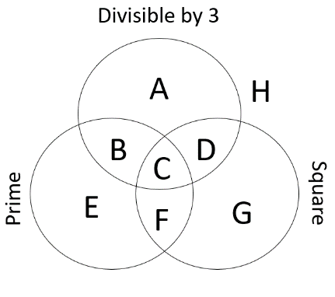
- Consider the Venn diagram shown on the right. Give an example of a whole number that could go in each region or explain why no such number exists. Note that “Divisible by 3” is the same as “A multiple of 3”.

- Goldbach’s conjecture states that “every even number greater than 2 is the sum of two primes”. Show that this is the case for all even numbers from 60 to 70. Note that the word “conjecture” refers to something we are almost certain is true but have not yet proven.

- Make exactly 6 one or two digit prime numbers using the digits 1 to 9 exactly once. (Challenge) How many different ways can you do this?

- (Challenge) Take an odd whole number, square it and then subtract one. Repeat for 5 other odd numbers. What is the largest number that is a factor of all of these numbers?

þ Correction Time! Click here for answers

Finished Early? Head to the Early Finishers Page to engage in a game, puzzle or investigation.

SKILL C: ENRICHMENT SKILL

Activate prior knowledge
Look at the image below and make a note of what you see, think and wonder J
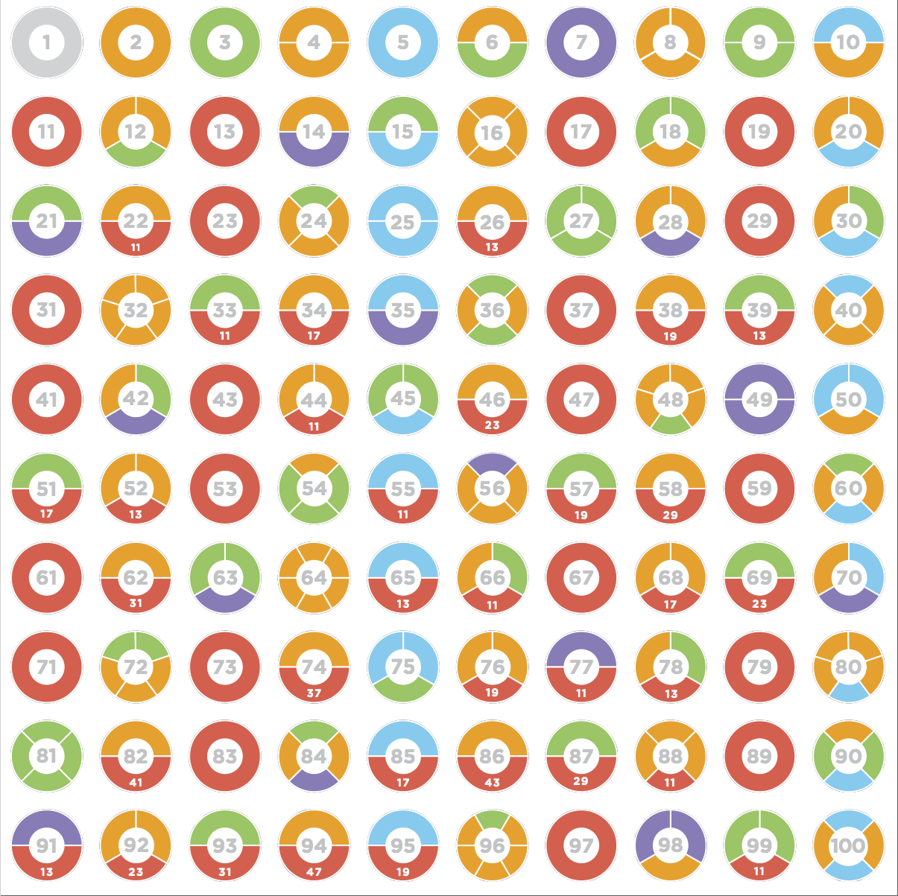

Explicit Teaching
[NEW PAGE] 3C: Prime Factorisations
- Recall:
  - Product means multiply
  - Powers are used to show repeated multiplications
- To write a number as a product of primes
  - First write a number as a product of two numbers (neither being 1)
  - Underline composite numbers
  - Copy down everything that isn’t underlined, split underlined values into a product of two numbers (neither 1)
  - Continue until all composite numbers have been split into primes
  - Write repeated factors using powers
- Note: The process used in the examples below is superior to factor trees for developing a strong understanding of how numbers are connected to their factors.

Worked Examples
Write the following as a product of prime factors. Use line by line working involving multiplications.
Use powers for repeated factors.
1. 99 |  | 2. 48
What we write:  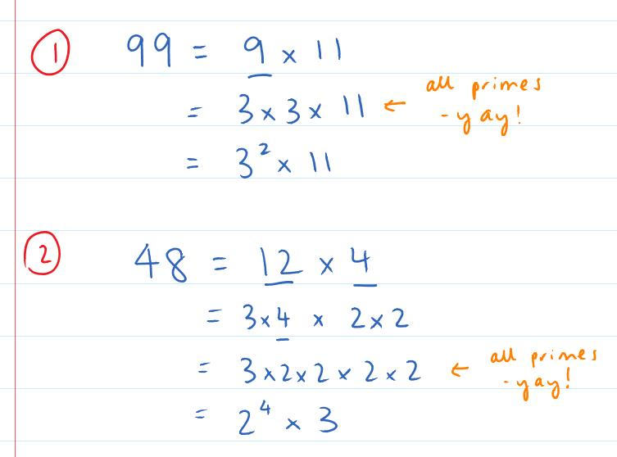 | What we think:  - 99 is a composite number so we write it as a product of two numbers, here we chose 9 and 11.  - We underline the composite number 9.  - On the next line of working we break 9 into a product of two numbers and copy the 11 down.  - We now stop since all numbers are prime.  - Since 3 appears 2 times in the multiplication we write 3².  - 48 is a composite number so we write it as a product of two numbers, here we chose 12 and 4.  - We underline the composite numbers 12 and 4.  - On the next line of working we break 12 into a product of two numbers and also break 4 into a product of two numbers.  - The 4 in the second line is composite so we underline it.  - One the next line of working we break 4 into a product of two numbers and copy the rest of the numbers down  - We now stop since all numbers are prime.  - Since 2 appears 4 times in the multiplication we write 2⁴.
Your turn:
1. 20 |  | 2. 36

Practice

3C ROUTINE QUESTIONS
- Write the following as a product of prime factors. Use line by line working involving multiplications. Use powers for repeated factors. 4First Five Live
- 54 | - 70 | - 64 | - 82 | - 75
- 10 | - 78 | - 86 | - 18 | - 42
- 66 | - 87 | - 99 | - 44 | - 84
- 36 | - 46 | - 12 | - 38 | - 21
þ Correction Time! Click here for answers

3C Stretch questionS
- Answer the following worded questions:
  - Explain why the number 1 is not a prime number.
  - Explain why all prime numbers except for 2 are odd.

- Write the following as a product of prime factors. Use line by line working involving multiplications. Use powers for repeated factors.
- 1000 | - 324 | - 289 | - 12600
- Jane is reading a novel. When she multiplies the two page numbers of the pages which currently holds open, the result is 3080. What were the page numbers of the two pages open?

- I’m thinking of two positive whole numbers that multiply to 1000. If neither of the numbers ends in a zero what must the two numbers be?

- The number of factors a number can be calculated efficiently using the number’s prime factorisation. For each of the following numbers, first write the number in prime factorisation form and then state how many factors it has (possibly by first listing all factors).

i. 12 | ii. 45 | iii. 28

i. 24 | ii. 54 | iii. 56

i. 36 | ii. 100 | iii. 225

- Use your answers to question 5 to predict how many factors the following numbers will have. Hint: Work out the prime factorisation of each number first J
a. 875 | b. 845 | c. 1225

- (A significant challenge!) It is a surprising fact that $1×2×3×4×5×6=8×9×10$. It is even more surprising that $8×9×10×11×12×13×14$ is equal to another such product of consecutive whole numbers. What are the 4 consecutive numbers that give the same product? [AMC 2006 Q30]

þ Correction Time! Click here for answers
Finished Early? Head to the Early Finishers Page to engage in a game, puzzle or investigation.

Skill 3 Application Questions – Think, Pair, Share/Teacher Modelling
Answer the questions you can. Explain your reasoning for at least one of the questions.
1. | 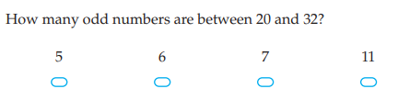
2. | 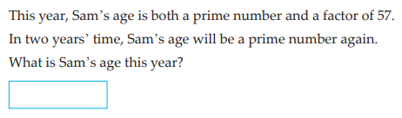
3. | 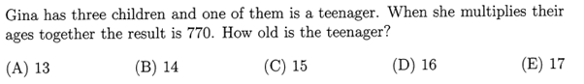
4. | - How many factors does 2 have?  - How many factors does 4 have?  - How many factors does 8 have?  - How many factors will 2^{n} have?  - How many factors will 3^{n} have?  - How many factors will 4^{n} have?  - How many factors will 10^{n} have?  Further exploration: The table below shows the product of the numbers in the grey cells, and then in brackets shows how many factors the number has. Complete the table below and use it to explore the number of factors of $2^{n}×3^{m}$.  What about $2^{n}×3^{m}×5^{r}$? etc..
  $$×$$ | $$2^{0}=1$$ | $$2^{1}=2$$ | $$2^{2}=4$$ | $$2^{3}=8$$
  $$3^{0}=1$$ | $$1 (1)$$ | $$2 (2)$$ | $$4 (3)$$
  $$3^{1}=3$$ | $$3 (2)$$ | $$6 (4)$$ | $$12 (6)$$
  $$3^{2}=9$$ | $$9 (3)$$
  $$3^{3}=27$$
5. | Choose one of the above questions and explain your reasoning.

Skill 3 Reasoning Questions

Entry | Core | Advanced
Why is an odd number + another odd number = an even number? | George says the number 5.8 is even because it ends with an 8. Explain why George is wrong. | Only one of the following is the correct set of prime factors for 424.  A. 2²x3²x5 B. 2x3²x5² C. 53x8 D. 2³x53  i. Why can you eliminate options A and B straight away?  ii. Why can you discard option C?  iii. How can you check that D is the correct answer?

COLLABORATIVE TASK:
Without using the internet, what is the largest number you are 100% sure is a prime.

Assessment for Learning
Your progress will be monitored through your classwork and weekly homework sheets.

Reflection and Recognition
Let’s reflect on some Routine questions. Choose one or more of the questions below to answer.
- What is a prime number?
- How do we recognise if a number is even or odd? How do we work out if a number is a square number?
- Why is it helpful to have different classifications of numbers?
Let’s recognise something that went well and something that could be improved.
- What component of this work caused the most growth in your learning?
- Is there anything you’d like to improve?

LCM and HCF

Setting the Goal
Learning Intention:
- What does LCM and HCF stand for?
- How do we find the LCM or HCF of two numbers?
- Why does a HCF and LCM exist for every pair of numbers?
Success Criteria: I can find the LCM of two numbers by first listing the multiples of each. I can find the HCF of two numbers by first listing the factors of each.

Key words
LCM stands for Lowest Common Multiple.
HCF stands for Highest Common Factor.

Skill A: Entry skill

Activate prior knowledge
Remember that Multiples are all about times tables.
Play a game of Buzz. Take turns to count by 1s going around the class. When you get to a number that is a multiple of 4 say buzz instead of the number. Repeat the game for 6. Repeat the game for 4 and 6 at the same time!!

Explicit teaching
[NEW PAGE] 4A: Lowest Common Multiple (LCM)
- To find the LCM, list multiples of each number until a common multiple is identified.

Worked Examples
1. Find the LCM of 4 and 10 | 2. Find the LCM of 4 and 7 |  | 3. Find the LCM of 6 and 12
What we write:  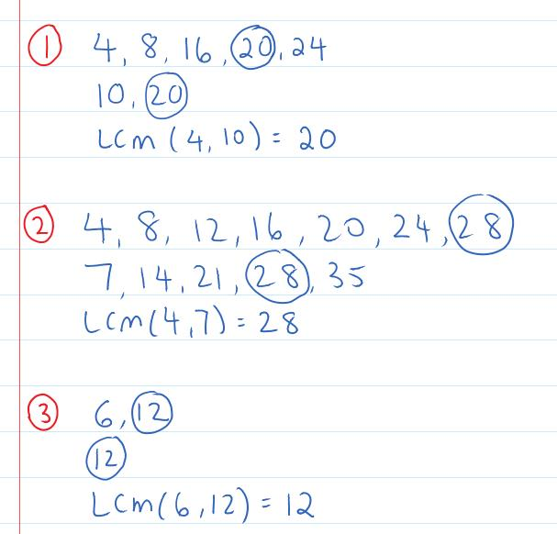 |  | What we think:  List five multiples of 4, list some multiples of 10. Stop when we see that 20 is part of both lists.  List five multiples of 4, list some multiples of 7. No common number so keep listing multiples of 4. Stop when we see that 28 is part of both lists.  List some multiples of 6, list some multiples of 12. Stop when we see that 12 is part of both lists.
Your turn:
1. Find the LCM of 3 and 5 | 2. Find the LCM of 5 and 20 |  | 3. Find the LCM of 6 and 8

PRACTICE

4A Routine questions
- Find the lowest common multiple (LCM) of each pair of numbers. 4First Five Live
- 8 and 12 | - 5 and 2 | - 10 and 15 | - 2 and 8
- 6 and 9 | - 7 and 14 | - 4 and 3 | - 11 and 44
- 7 and 9 | - 3 and 10 | - 3 and 15 | - 2 and 16
- 7 and 35 | - 5 and 6 | - 5 and 20 | - 6 and 8
- 4 and 10 | - 3 and 8 | - 9 and 5 | - 8 and 10

þ Correction Time! Click here for answers

4A Stretch questions
- Three sets of traffic lights (A, B and C) all turn red at 9am exactly. Light set A turns red every 2 minutes, light set B turn red every 3 minutes and light set C turns red every 5 minutes. How long does it take for all three lights to tur red at the same time again?

- Find the LCM of each pair of numbers.
- 40 and 120 | - 16 and 24 | - 18 and 90 | - 11 and 12

- Find the LCM of each set of numbers.
- 3, 4 and 6 | - 8, 9 and 12 | - 12, 8, 10 and 30

- Give 5 examples of each of the following. Can you generalise your answer? That is, can you explain what has to happen for each to occur?
- $LCM(a,b)=b$ | - $LCM(a,b)=ab$

- Below shows a strategy for how tree diagrams and a Venn diagram can be used to find the LCM of two large numbers. Notice how the factors that occur in both tree diagrams go in the middle (yellow) part of the diagram. The LCM is found by multiplying all numbers in the diagram. Can you use this strategy to find the LCM of 42 and 180.
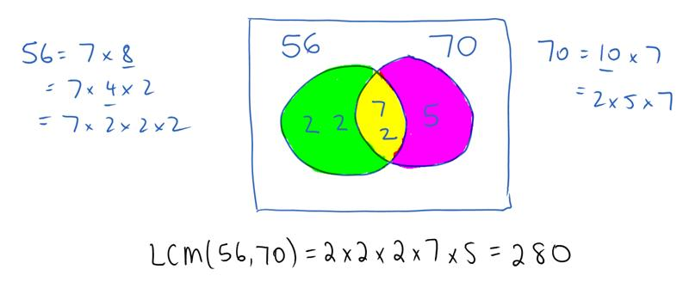
- (Challenge) Fill in the boxes using the digits 0 to 9 at most once each to make a true statement.
The lowest common multiple of and is

þ Correction Time! Click here for answers

Finished Early? Head to the Early Finishers Page to engage in a game, puzzle or investigation.

Skill B: core skill

Activate prior knowledge
List the factors of the following numbers
- 12 | - 18 | - 20 | - 96

Explicit Teaching
[NEW PAGE] 4B: Highest Common Factor (HCF)
- To find the HCF, list factors of each number and then identify the largest number common to both lists.
Worked Examples
1. Find the HCF of 20 and 14 |  | 2. Find the HCF of 10 and 5 | 3. Find the HCF of 8 and 15
What we write:  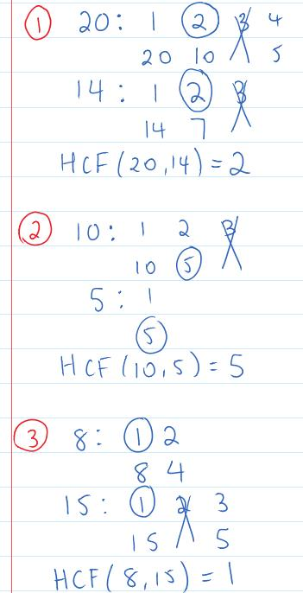 | What we think:  We list all factors of 20 and all factors of 14. The largest number common to both lists is 2.  We list all factors of 10 and all factors of 5. The largest number common to both lists is 5.  We list all factors of 8 and all factors of 15. The largest number common to both lists is 1.
Your turn:
1. Find the HCF of 6 and 18 |  | 2. Find the HCF of 6 and 7 | 3. Find the HCF of 24 and 9

Practice

4B ROUTINE QUESTIONS
- Find the highest common factor (HCF) of each pair of numbers. 4First Five Live
- 36 and 48 | - 24 and 40 | - 55 and 72 | - 24 and 42
- 24 and 60 | - 6 and 5 | - 8 and 24 | - 6 and 30
- 12 and 72 | - 18 and 27 | - 25 and 18 | - 8 and 16
- 9 and 90 | - 9 and 18 | - 27 and 36 | - 6 and 18
- 16 and 24 | - 4 and 8 | - 4 and 12 | - 4 and 36
þ Correction Time! Click here for answers

4B STRETCH questions
- Given that the HCF of a pair of different numbers is 8, find the two numbers:
  - If both numbers are less than 20
  - When one number is in the 20s and the other in the 30s

- Find the highest common factor (HCF) of each pair of numbers.
- 180 and 240 | - 75 and 150 | - 360 and 135 | - 147 and 105
- Find the highest common factor (HCF) of each set of numbers.
- 12, 18 and 30 | - 15, 6 and 14 | - 60, 20 and 10 | - 90, 75 and 105
- In the previous set of stretch questions we saw how a Venn diagram could be used to calculate the LCM of two numbers.
- How could the diagram be used to find the HCF of two numbers?
- Use this method to find the LCM and HCF of 224 and 336.

- Given the LCM and the HCF, can you work out what the two numbers could be?
- The LCM of two numbers is 24 and their HCF is 4. What could the two numbers be? Give 2 different solutions.
- The LCM of two numbers is 60 and their HCF is 6. What could the two numbers be? Give 2 different solutions.
- The LCM of two numbers is 180 and their HCF is 30. What could the two numbers be? Give 2 different solutions.
- The LCM of two numbers is 900 and their HCF is 30. What could the two numbers be? Give 2 different solutions.

- (Challenge) Three swimmers take 28 seconds, 44 seconds and 68 seconds to complete a lap of the pool. If they all start together, how long will it be until they are all side by side at one end of the pool again?

þ Correction Time! Click here for answers

Finished Early? Head to the Early Finishers Page to engage in a game, puzzle or investigation.

SKILL C: ENRICHMENT SKILL

Activate prior knowledge
Write the following as a product of prime factors. Use line by line working involving multiplications. Use powers for repeated factors.
- 63 | - 350 | - 40

Explicit Teaching
[NEW PAGE] 4C: Using Prime Factorisations to calculate HCF and LCM
- HCF and LCM can be found from two numbers’ prime factorisations.
  - The HCF of two numbers will be a product of the primes which appear in both numbers. The power above each prime in this product will be the smallest one of those from the original prime factorisations.
  - The LCM of two numbers will be a product of all primes which appear in either number. The power above each prime in this product will be the largest one of those from the original prime factorisations.
- A Venn diagram can assist if needed.

Worked Examples
1. Use prime factorisations to find the LCM and HCF of 120 and 252. You may leave your answer for the LCM in prime factorisation form.
What we write:  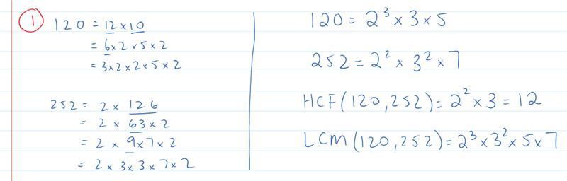 | What we think:  For the HCF, the 2 appears in both prime factorisations, the smallest power is 2. The 3 also appears in both prime factorisations, the smallest power is 1. So the HCF is $2^{2}×3$  For the LCM 2, 3, 5 and 7 are the primes that appear across both prime factorisations. We take the highest power in each case, the highest power of 2 is 3, the highest power of 3 is 2 and both 5 and 7 occur with highest power 1.  So the LCM is $2^{3}×3^{2}×5×7$  Alternatively, a Venn diagram can be used…  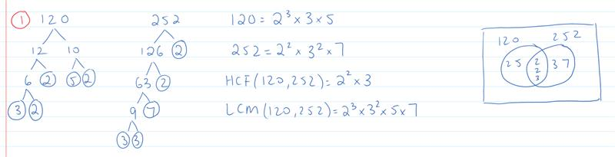
Your turn:
1. Use prime factorisations to find the LCM and HCF of 132 and 90. You may leave your answer for the LCM in prime factorisation form.

Practice

4C ROUTINE QUESTIONS
- Use prime factorisations to find the HCF and LCM of the following pairs of numbers. For parts k and l you may leave your answer for the LCM as a product of powers of primes. 4First Five Live
- 75 and 20 | - 90 and 84 | - 36 and 60 | - 60 and 84
- 24 and 60 | - 36 and 45 | - 60 and 72 | - 225 and 135
- 100 and 150 | - 180 and 126 | - 324 and 144 | - 495 and 525
þ Correction Time! Click here for answers

4C Stretch questionS
- Two bells are rung at the same time. After that the first bell is rung every 300 minutes, whereas the second bell is rung every 90 minutes. How long after they both sounded together until they ring again at the same time? Give your answer in hours.

- Use prime factorisation to find the HCF and LCM of the following sets of numbers.
- 28, 44, 68 | - 450, 84 and 88 | - 620, 480 and 120

- Jill and Sam are jogging around a 2 km track. Jill takes 756 seconds to complete one circuit whilst Sam completes one circuit every 900 seconds.
  - If they both start at the starting point at same time, how many seconds will elapse before they are both passing the starting point at the same time.
  - By the time they are passing the start line together for the first time after starting, how much further will have Jill run compared to Sam?

- There are 180 boys, 1350 girls and 45 teachers to be divided into groups in such a way that there must be an equal number of teachers across all the different groups, there must also be an equal number of boys across all the different groups and equal number of girls across all the different groups. Find the largest possible number of groups.

- (Challenge) $ϕ\left(n\right)$ finds the number of integers between 1 and $n$ that share no factors with $n$ other than 1 (i.e. the HCF is 1). For example $ϕ\left(6\right)=2$. This is because only HCF(6,1) = 1 and HCF(6, 5) = 1. For those interested, $ϕ(n)$’s posh name is ‘Euler’s Totient Function’.
  - What is $ϕ(10)$?
  - What is $ϕ(7)$?
  - What in general is $ϕ(p)$ for a prime number $p$?
  - If $HCF\left(m,n\right)=1$, then $ϕ\left(mn\right)=ϕ\left(m\right)ϕ\left(n\right)$. Use these facts to calculate $ϕ\left(1155\right)$
þ Correction Time! Click here for answers
Finished Early? Head to the Early Finishers Page to engage in a game, puzzle or investigation.

Skill 4 Reasoning Questions

Entry | Core | Advanced
How would you convince someone that the lowest common multiple of 8 and 6 is 24? | Explain why every pair of numbers must have a highest common factor | Explain why every pair of numbers must have a lowest common factor

COLLABORATIVE TASK:
Can you solve the following puzzles involving chains of consecutive numbers? Use the clues to find sets of increasing consecutive numbers. All numbers used are less than 100. Reference
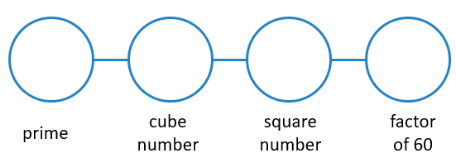 | 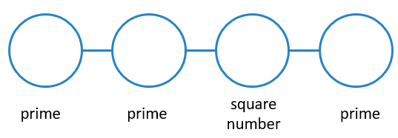
- 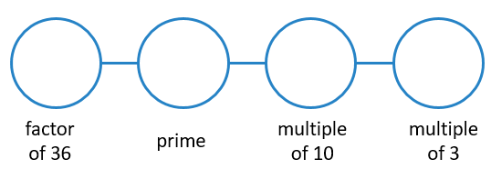 | - 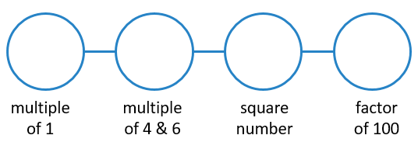
- 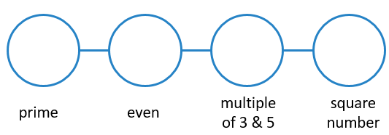 | - 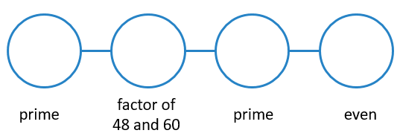
- 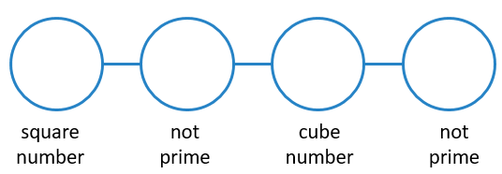 | - 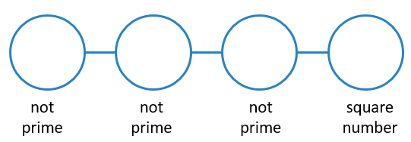
- 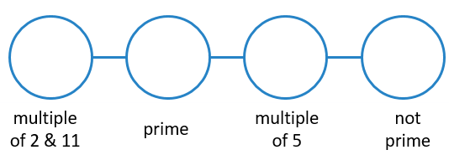 | - 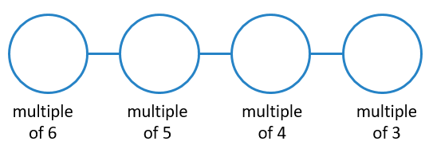
- 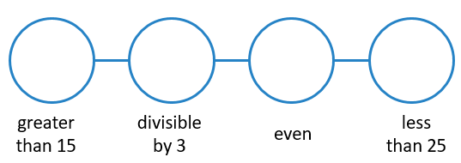 | - 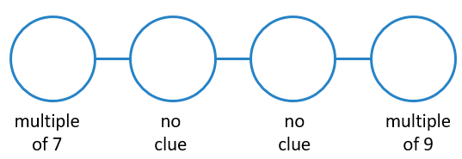

Assessment for Learning
Your progress will be monitored through your classwork and weekly homework sheets.

Reflection and Recognition
Let’s reflect on some Routine questions. Choose one or more of the questions below to answer.
- What does LCM and HCF stand for?
- How do we find the LCM or HCF of two numbers?
- Why does a HCF and LCM exist for every pair of numbers?
Let’s recognise something that went well and something that could be improved.
- What component of this work caused the most growth in your learning?
- Is there anything you’d like to improve?

Square Roots

Setting the Goal
Learning Intention:
- What is the connection between squares and square roots?
- How do we calculate a square root?
Success Criteria: I can calculate the square root of a perfect square.

Key words
The square root of a number is the opposite of squaring a number and you need to work out what number, multiplied by itself, will make the number under the square root sign.

Skill A & B: Entry & CORE skill

Activate prior knowledge
List all square numbers that occur between 1 and 150.

Explicit teaching
[NEW PAGE] 5A & B: Square Roots of Perfect Squares
- $\sqrt{49}$ is read as “the square root of 49” and means, what number multiplied by itself makes 49, so $\sqrt{49}=7$
Worked Examples
1. Calculate $\sqrt{81}$ |  | 2. Calculate $\sqrt{25}$
What we write:  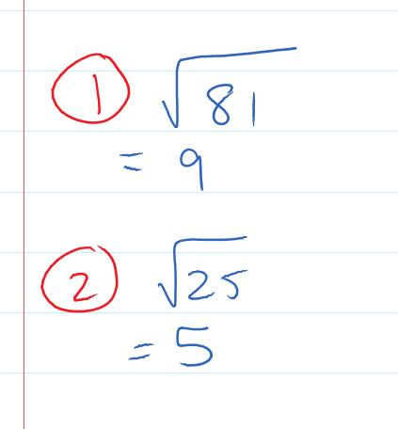 | What we think:  What numbered multiplied by itself makes 81?  What numbered multiplied by itself makes 25?
Your Turn
1. Calculate $\sqrt{9}$ |  | 2. Calculate $\sqrt{100}$

PRACTICE

5A&B Routine questions

- Calculate the following. This skill can be made “Entry Level” by using a times table grid for support. 4First Five Live
- $\sqrt{16}$ | - $\sqrt{49}$ | - $\sqrt{25}$ | - $\sqrt{100}$
- $\sqrt{144}$ | - $\sqrt{9}$ | - $\sqrt{121}$ | - $\sqrt{36}$
- $\sqrt{1}$ | - $\sqrt{64}$ | - $\sqrt{4}$ | - $\sqrt{81}$
þ Correction Time! Click here for SOME of the answers

5A&B Stretch questionS
- A square has an area of 25m².
  - What is its side length?
  - What is its perimeter?
- Calculate the following.
- $\sqrt{225}$ | - $\sqrt{196}$ | - $\sqrt{400}$ | - $\sqrt{900}$
- Calculate the following.
- $\sqrt{0.36}$ | - $\sqrt{3.24}$ | - $\sqrt{0.000144}$ | - $\sqrt{0.000049}$
- Between what two consecutive whole numbers do the following square roots lie between?
- $\sqrt{7}$ | - $\sqrt{50}$ | - $\sqrt{28}$ | - $\sqrt{300}$
- Solve the following equations, where $x$ is a positive number.
- $\sqrt{x}+5=12$ | - $\sqrt{x+5}=12$ | - $100={\left(3+x\right)}^{2}$ | - ${12}^{2}+x^{2}={13}^{2}$
- $\frac{\sqrt{x}+7}{3}=5$ | - $20=5\sqrt{x-3}$ | - $3=\frac{\sqrt{x}+10}{7}$ | - $\frac{\sqrt{x+3}}{5}+9=11$
- The square root of what number is equal to the sum of its digits?

þ Correction Time! Click here for answers
Finished Early? Head to the Early Finishers Page to engage in a game, puzzle or investigation.

SKILL C: ENRICHMENT SKILL

Activate prior knowledge
Write the following as a product of prime factors. Use line by line working involving multiplications. Use powers for repeated factors.
- 36 | - 81 | - 121 | - 144
What do you notice about the prime factorisations of perfect squares?

Explicit Teaching
[NEW PAGE] 5C: Square roots using Prime Factorisations
- All powers in the prime factorisation of a perfect square are even
- The square root of a number can be found by halving all powers in the prime factorisation
  - Note that powers of 1 are not written

Worked Examples
1. Use prime factorisation to find the square root of 576
What we write:  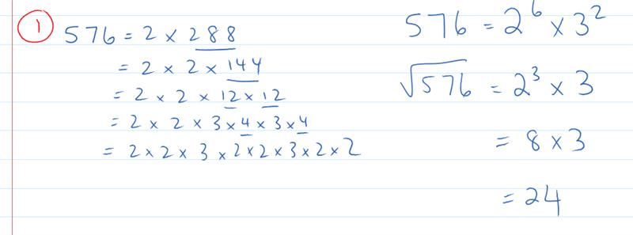 | What we think:  Breaking the number into products of primes we see that the prime factorisation of 576 is 2⁶ x 3².  The square root of 576 is found by halving the powers. Half of 6 is 3 and half of 2 is 1 (note we don’t write the power of 1).  We can now evaluate the square root by calculating 2³ x 3.
Your turn:
1. Use prime factorisation to find the square root of 324

Practice

5C ROUTINE QUESTIONS
- Use prime factorisation to find the square root of the following numbers. 4First Five Live
- 196 | - 784 | - 1024 | - 1225
- 1296 | - 1600 | - 2025 | - 2304
- 3136 | - 3969 | - 5184 | - 7056
þ Correction Time! Click here for answers

5C Stretch questionS
- Cube roots are the opposite operation of raising a number to the power of 3. Eg. $\sqrt[3]{8}=2$ because $2^{3}=8$. Calculate the following cube roots. If needed, you can work out the prime factorisation and divide every power by 3 J
- $\sqrt[3]{125}$ | - $\sqrt[3]{216}$ | - $\sqrt[3]{1728}$ | - $\sqrt[3]{5832}$
- We have seen that the powers in a prime factorisation of a perfect square are all even and that the powers in a prime factorisation of a perfect cube are all multiples of 3. After determining the prime factorisation of each of the following numbers classify each as a perfect square, a perfect cube, both or neither.
- $3375$ | - $4608$ | - $729$ | - $3888$

- $900=45×(4×5)$ and $24×\left(2×4\right)=192$. You’ll notice that these numbers are formed by multiplying a two-digit number by the product of its two digits.
  - Which two digit numbers when multiplied by the product of the two digits will give the following?
- $408$ | - $336$ | - $522$ | - $1134$
  - Prove that 420 cannot be reached.
- What is the smallest number that 1008 needs to be multiplied by to create a square number?

þ Correction Time! Click here for answers
Finished Early? Head to the Early Finishers Page to engage in a game, puzzle or investigation.

Skill 4 & 5 Application Questions – Think, Pair, Share/Teacher Modelling
Answer the questions you can. Explain your reasoning for at least one of the questions.
1. | 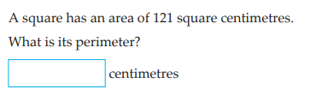
2. | 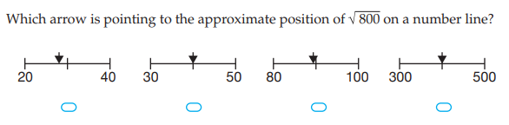
3. | 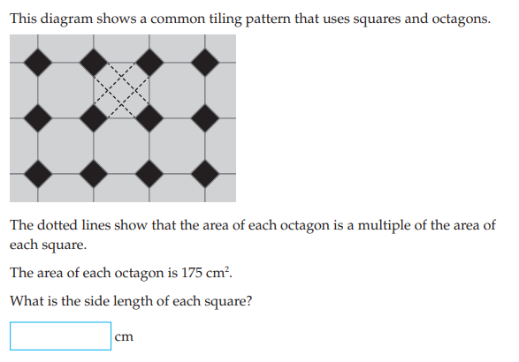
4. | The following are the requirements for a stack of cans to be neat:  • The stack of cans has at least two rows  • The stack of cans Is piled so that each new row has one less can than the row below it  What numbers can be neatly stacked?  Further Exploration: Why can some number be neatly stacked but others can't?

Skill 5 Reasoning Questions

Entry | Core | Advanced
The word “root” refers to where something comes from. Use this idea to explain the meaning of the word square root. | Explain why the square root of 10 will be bigger than 3 but smaller than 4. | Is $15680$ a perfect square? Why/why not?

COLLABORATIVE TASK:
Play the Products Game

Assessment for Learning
Your progress will be monitored through your classwork and weekly homework sheets.

Reflection and Recognition
Let’s reflect on some Routine questions. Choose one or more of the questions below to answer.
- What is the connection between squares and square roots?
- How do we calculate a square root?
Let’s recognise something that went well and something that could be improved.
- What component of this work caused the most growth in your learning?
- Is there anything you’d like to improve?

Early Finisher Activities
Games | Puzzles | Investigations

Games
Individual Games:
- https://nrich.maths.org/factorsandmultiples - Factors and Multiples game from nrich
- https://www.topmarks.co.uk/maths-games/hit-the-button - Timed practice for number bonds and times tables. What is the best score you can get?
- https://www.nctm.org/Classroom-Resources/Illuminations/Interactives/Product-Game/ - One/two player multiplication game
- https://incoherency.co.uk/countdown/practice/#numbers – Countdown Numbers Game
Games in Pairs:
- https://davidwees.com/products/ - Factors game

Investigations
- It was hinted at in 3C Stretch Question 5 that there was a relationship between the prime factorisation of a number and the number of factors it has. Do a little research and see if you can explain why 72 436 455 has 144 factors.

- There are lots of numbers that are named after shapes. We have seen square and cube numbers but there are also triangle numbers, pentagonal numbers and hexagonal numbers. You might like to do a bit of research on these and write a mini report.

- We saw in the Stretch Questions of Exercise 1A that the sum of odd numbers makes a square number. What does this picture show?
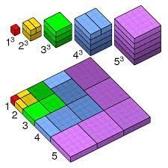

Answers

1A Routine Questions (ans)
1.a. 16 b. 64 c. 100 d. 4 e. 144 f. 1 g. 121 h. 0 i. 25 j. 9 k. 81 l. 36 m. 49 BackToQns

1A Stretch Questions (ans)
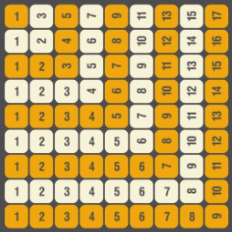
2.a. 1, 4, 9, 16, 25 3.a. 169 b. 400 c. 2500 d. 1 000 000 4.a. 196 b. 441 5.a. 1,4,9,16 b. I see the next odd number being added on to the base of the shape c. 25 d. 1849
e. 14th step f. $n^{2}$ 5.a. 5, 8, 13
b. I see the square in the middle getting bigger each time c. 20
d. 1853 e. 12
f. $n^{2}+4$ 7. When consecutive odd numbers are added together they make square numbers. As can be seen in the image on the right, we can build upon the previous square with the next odd number.
8.a. 1, 4, 9, 6, 5 b. If the final digit of the number is a 4 or a 6 its square will end in 6. 9.a. $8^{2}+4^{2}+1^{2}$
b. $8^{2}+6^{2}+1^{2}$ c. ${10}^{2}+8^{2}+4^{2}$ BackToQns

1B Routine Questions (ans)
1.a. 8 b. 11 c. 0 d. 16 e. 1000 f. 49 g. 27 h. 25 i. 32 j. 16 k. 125 l. 100 m. 1 n. 9 o. 64 p. 1 q. 1 r. 81 s. 81 t. 12 BackToQns

1B Stretch Questions (ans)
2.a. 3 b. 2 c. 4 d. 1 3.a.i. 2 ii. 4 iii. 8 iv. 16 b.i. 6 ii. 18
iii. 54 iv. 162 c.i. 90 ii. 900 iii. 9000 iv. 90 000. The general pattern is that we multiply the number being subtracted by 1 less than the base number.
That is: $a^{b+1}-a^{b}=a^{b}×(a-1)$
4.a. 0.04 b. 0.008 c. 0.0016 d. 0.00032 5.a. -2 b. 4 c. -8
d. 16 e. -32 f. -1 g. 1 6.a. 8 b. 27 c. 64 d. 125 e. 6³ = 216
f. 7³ = 343 BackToQns

1C Routine Questions (ans)
1.a. 90 b. 100 c. 256 d. 0 e. 48 f. 16 g. 64 h. 81
i. 64 j. 216 k. 10000 l. 64 m. 75 n. 54 o. 12 p. 96
q. 100 r. 63 s. 196 t. 96 BackToQns

1C Stretch Questions (ans)
2. a. -15 b. 15 c. 25 d. -16 e. -16 f. 70 g. -28 h. -92
i. -5 3.a. 0.36 b. 0.512 c. 0.000008 4.a. x=4 b. x=2 c. x=8
5.a. 8 b. 4 c. 2 d. 1 e. ½ or 0.5 f. ¼ or 0.25 g. 1/8 or 0.125 h. 1/16 or 0.0625 6.a. 43 b. 47 c. 53 d. 61 e. 71 f. 83
g. 97 h. they are all prime numbers i. no spoilers here! BackToQns

2A Routine questions (ans)
1.a. 5, 10, 15, 20, 25, 30 b. 8, 16, 24, 32, 40, 48
c. 12, 24, 36, 48, 60, 72 d. 4, 8, 12, 16, 20, 24
e. 10, 20, 30, 40, 50, 60
2.a. 9, 18, 27, 36, 45, 54, 63, 72 b. 2, 4, 6, 8, 10, 12, 14, 16
c. 3, 6, 9, 12, 15, 18, 21, 24 d. 11, 22, 33, 44, 55, 66, 77, 88
e. 13, 26, 39, 52, 65, 78, 91, 104
3.a. 7, 14, 21, 28, 35, 42, 49 b. 6, 12, 18, 24, 30, 36, 42
c. 1, 2, 3, 4, 5, 6, 7 BackToQns

2A Stretch Questions (ans)
4.a. B and D 5.a. 15, 30, 45, 60, 75, 90, 105, 120, 135, 150
b. 28, 56, 84, 112, 140, 168, 196, 224, 252, 280
c. -15, -30, -45, -60, -75, -90, -105, -120, -135, -150
d. -31, -62, -93, -124, -155, -186, -217, -248, -279, -310
e. 2.8, 5.6, 8.4, 11.2, 14, 16.8, 19.6, 22.4, 25.2, 28
f. -0.15, -0.3, -0.45, -0.6, -0.75, -0.9, -1.05, -1.2, -1.35,
-1.5 6. Some possible answers: a. 26, 27, 28 b. 63, 64, 65 c. 64, 65, 66 d. 14, 15, 16 d. All solutions are of the form 12n+2, 12n+3, 12n+4 6. 60 8. Reading across each top row first we have a. 3, 5, 2, 4 b. 2, 4, 8, 5 c. & d. check your answers with your teacher. BackToQns

2B Part 1 Routine Questions (ans)
1.a. 18 b. 14 c. 30 d. 20 e. 16 f. 44 g. 22 h. 26 i. 21 j. 45 k. 19 l. 16 m. 28 n. 13 o. 17 p. 46 q. 18 r. 21 s. 19 t. 41 BackToQns

2B Part 1 Stretch Questions (ans)
2.a. 29 b. 17 c. 14 3.a. 168 b. 148 c. 7180 d. 463 4.a. 2.9 b. 0.19 c. 0.078 d. 0.425 5.a. 1 b. 1 c. 3 d. 3
6.a. $a=5,b=10,c=3$ b. $a=3, b=28, c=5$
c. & d. check your answers with your teacher. BackToQns

2B Part 2 Routine Questions (ans)
1.a. 1,30,2,15,3,10,5,6 b. 1,27,3,9 c. 1,33,3,11
d. 1,46,2,23 e. 1,48,2,24,3,16,4,12,6,8 f. 1,18,2,9,3,6
g. 1,16,2,8,4 h. 1,24,2,12,3,8,4,6 i. 1,23 j. 1,35,5,7
k. 1,20,2,10,4,5 l. 1,25,5 m. 1,37 n. 1,41 o. 1,22,2,11
p. 1,60,2,30,3,20,4,15,5,12,6,10 q. 1,53
r. 1,28,2,14,4,7 s. 1,17 t. 1,3,9 BackToQns

2B Part 2 Stretch Questions (ans)
2.a. Teams with 1, 2, 4, 5 or 10 (note you can’t have 20 because we are looking for teams (and teams is plural)
3.a. 1,72,2,36,3,24,4,18,6,12,8,9
b. 1,84,2,42,3,28,4,21,6,14,7,12
c. 1,96,2,48,3,32,4,24,6,16,8,12
d. 1,100,2,50,4,25,5,20,10 4.a. 24 b. 1 c. square numbers 5.a. 11m, 3m b. 12m, 5m c. 25m, 4m 6. 28 BackToQns

2C Routine Questions (ans)
1.a. 1, 184, 2, 92, 4, 46, 8, 23 b. 1, 143, 11, 13 c. 1, 127
d. 1, 345, 3, 115, 5, 69, 15, 23 e. 1, 119, 7, 17
f. 1, 170, 2, 85, 5, 34, 10, 17 g. 1, 103 h. 1, 129, 3, 43
i. 1, 150, 2, 75, 3, 50, 5, 30, 6, 25, 10, 15
j. 1, 117, 3, 39, 9, 13 k. 1, 190, 2, 95, 5, 38, 10, 19
l. 1, 153, 3, 51, 9, 17 m. 1, 130, 2, 65, 5, 26, 10, 13 n. 1, 113 o. 1, 105, 3, 35, 5, 21, 7, 15 p. 1, 104, 2, 52, 4, 26, 8, 13
q. 1, 114, 2, 57, 3, 38, 6, 19 r. 1, 152, 2, 76, 4, 38, 8, 19
s. 1, 182, 2, 91, 7, 26, 13, 14
t. 1, 108, 2, 54, 3, 36, 4, 27, 6, 18, 9, 12 BackToQns

2C Stretch Questions (ans)
2. Reading across each top row first we have: a. 3, 1, 5, 6, 2, 9, 8, 4, 7 b. 1, 3, 7, 4, 2, 8, 9, 5, 6 c. Check your own J
3. Check with your teacher BackToQns

3A Routine questions (ans)
1.a. odd b. even c. even d. odd, square e. square
f. even g. odd, square h. odd i. odd j. odd k. even, square l. odd m. even n. odd o. odd, square p. even, square
q. odd r. even s. odd t. even u. even BackToQns

3A Stretch Questions (ans)
2.a. even b. even c. 4, even, balance. 3.a. odd b. even, square c. even 4. Even numbers must be whole numbers, 62.5 isn’t a whole number so is not even. 5.a. always b. never c. never 6.a. 12, 14, 16
b. 12, 14, 16, 18 c. 8, 10, 12, 14, 16 d. 17, 19, 21
e. 9, 11, 13, 15 7. Possible solutions are: a. (1), (4), (4, 5), (2,2,2,3,3,3,3,3,4) b. Check with your teacher BackToQns

3B Routine Questions (ans)
1.a. odd, square, mult. of 3 b. even, square c. prime
d. even e. prime, mult. of 2 f. square g. even, mult. of 3
h. odd, prime, mult. of 5 i. odd, mult. of 3 j. even
k. even, mult. of 5 l. odd, prime m. odd, mult. of 3 n. odd o. even p. none of these q. mult. of 2 r. square s. prime
t. odd, prime BackToQns

3B Stretch Questions (ans)
2. 14 3.a. odd (not prime because 91=13x7) b. mult. of 3
c. odd, square d. odd, prime 4.a. 3, 5 b. 3, 7 c. 7, 13
d. 3, 29 5. Some possible answers are: A. 6 B. 3 C. no value D. 9 E. 43 F. no value G. 49 H. 14 C and F have no value because all square numbers have an odd number of factors, and prime numbers have exactly two factors
6. Some possible answers are: a. 60=53+7 b. 62=59+3
c. 64=59+5 d. 66=61+5 e. 70=67+3 7. A possible solution is: 41, 67, 89, 2, 3, 5. How many different solutions did you find? 8. 1²-1=0, 3²-1=8, 5²-1=24, 7²-1=48, 9²-1=80, 11²-1=120. All of these numbers have 8 as a factor BackToQns

3C Routine Questions (ans)
1.a. 2x3³ b. 2x5x7 c. 2⁶ d. 2x41 e. 3x5² f. 2x5 g. 2x3x13
h. 2x43 i. 2x3² j. 2x3x7 k. 2x3x11 l. 3x29 m. 3²x11
n. 2²x11 o. 2²x3x7 p. 2²x3² q. 2x23 r. 2²x3 s. 2x19 t. 3x7 BackToQns

3C Stretch Questions (ans)
2.a. Prime numbers have exactly two factors. The number 1 has only 1 factor so is not prime. B. All even number have 2 as a factor. If the even number is not 2 then the number will have at least three factors (1, itself and 2) and so would not be prime. 3.a. 2³x5³ b. 2²x3⁴ c. 17² d. 2³x3²x5²x7
4. 55 and 56 5. 8 and 125 6.a.i. 2²x3, 6 ii. 3²x5, 6 iii. 2²x7, 6 b.i. 2³x3, 8 ii. 3³x2, 8 iii. 2³x7, 8 c.i. 2²x3², 9 ii. 2²x5², 9 iii. 3²x5², 9 7.a. 5³x7, 8 b. 5x13², 6 c. 5²x7², 9 8. You can check your answer on your calculator or ask your teacher for a hint J BackToQns

4A Routine questions (ans)
1.a. 24 b. 10 c. 30 d. 8 e. 18 f. 14 g. 12 h. 44 i. 63 j. 30
k. 15 l. 16 m. 35 n. 30 o. 20 p. 24 q. 20 r. 24 s. 45 t. 40 BackToQns

4A Stretch Questions (ans)
2. 30 minutes 3.a. 120 b. 48 c. 90 d. 132 4.a. 12 b. 72
c. 120 5. Some possible answers: a. (3,6), (3,9), (3,12), (4,8), (4,12). If $b$ is a multiple of $a$ then $LCM\left(a,b\right)=b$ b. (3,5), (4,7), (2,5), (2,3), (5,7). If the only factor that $a$ and $b$ have in common is 1 then $LCM\left(a,b\right)=ab$ 6. 1260 7. You can check your answer using the strategy in Q5 or ask your teacher for a hint J BackToQns

4B Routine Questions (ans)
1.a. 12 b. 8 c. 1 d. 6 e. 12 f. 1 g. 8 h. 6 i. 12 j. 9 k. 1 l. 8 m. 9 n. 9 o. 9 p. 6 q. 8 r. 4 s. 4 t. 4 BackToQns

4B Stretch Questions (ans)
2. some possible answers are: a. 16 and 8 b. 24 and 32
3.a. 60 b. 75 c. 45 d. 21 4.a. 6 b. 1 c. 10 d. 15
5.a. Multiply the numbers in the middle b. LCM = 672, HCF = 112 6. Some possible answers are:
a. 4&24 or 8&12 b. 6&60 or 12&30 c. 30&180 or 60&90
d. 30&900 or 90&300 6. Check with teacher BackToQns

4C Routine Questions (ans)
1.a. HCF= 5 LCM= 300 b. HCF=6 LCM=1260 c. HCF=12 LCM=180 d. HCF=12 LCM=420 e. HCF=12 LCM=120
f. HCF=9 LCM=180 g. HCF=12 LCM=360 h. HCF=45 LCM=675 i. HCF=50 LCM=300 j. HCF=18 LCM=1260
k. HCF=36 LCM=2⁴x3⁴ l. HCF=15 LCM=3²x5²x7x11 BackToQns

4C Stretch Questions (ans)
2. 15 hour 3.a. HCF=4 LCM=5236 b. HCF=2 LCM=138 600 c. HCF=20 LCM=14880 4.a. 18900 seconds b. 8km 5. 45 groups 6.a. 4 b. 6 c. $p-1$ d. 480 BackToQns

5A&B Routine questions (ans)
1.a. 4 b. 7 c. 5 d. 10 e. 12 f. 3 g. 11 h. 6 i. 1 j. 8 k. 2 l. 9 BackToQns

5A&B Stretch Questions (ans)
2a. 5m b. 20m 3.a. 15 b. 14 c. 20 d. 30 4.a. 0.6 b. 1.8
c. 0.012 d. 0.007 5.a. 2&3 b. 7&8 c. 5&6 d. 17&18
6.a. $x=49$ b. $x=139$ c. $x=7$ d. $x=5$ e. $x=64$
f. $x=19$ g. $x=121$ h. $x=97$
7. Check with your teacher BackToQns

5C Routine Questions (ans)
1.a. 14 b. 28 c. 32 d. 35 e. 36 f. 40 g. 45 h. 48 i. 56 j. 63 k. 72 l. 84 BackToQns

5C Stretch Questions (ans)
2.a. 5 b. 6 c. 12 d. 18 3.a. perfect cube b. neither
c. perfect cube and perfect square d. neither 4.a.i. 34x(3x4) ii. 42x(4x2) iii. Check on your calculator iv. Check on your calculator b. Check with your teacher 5. 7 BackToQns

