
SANDRINGHAM COLLEGE
YEAR 7 MATHS

Topic 5: Fractions

Contents
Introduction: 2
1. Fraction Models and Equivalence 3
2. Simplifying Fractions 12
3. Converting between FDP 19
4. Adding and Subtracting Fractions 29
5. Multiplying Fractions 37
6. Dividing Fractions 44
Early Finisher Activities 53
The big ideas of this topic are listed above.

Introduction:
Minimum Expectations
It is through regular practice and high expectations that you will maximise your progress in maths!
There are three things that will need to be included before work is considered complete:
- Copying of the question if in blue text – if it is in blue it is in our books!
- Inclusion of working out (where appropriate)
- Corrections. A tick ✓ if correct and retry until correct if incorrect.
In most cases, your teacher will require you to complete at least one set of questions for each big idea. Most students will start with Routine Questions at the Core Level, though there are options to move onto more challenging questions or less challenging questions as needed.
Assessed Learning Task (ALT)
At the end of the unit you will complete an ALT.
All skill based ALT questions will be developed from the questions in this book. All application questions will be of a similar structure, though not always familiar.
Most students will complete the mainstream ALT focusing on Core Level skills, though some students will complete a modified ALT focusing on Entry Level skills and others will complete an Enhanced ALT focusing on Enrichment Level Skills. Decisions around which ALT each student will do will happen towards the end of the topic ☺
You will be allowed to bring your maths workbook into the ALT and so there is great incentive to complete as many stretch questions as you can!!

Fraction Models and Equivalence

Setting the Goal
Learning Intentions:
- What does the denominator tell us? What does the numerator tell us?
- How do we model fractions using rectangles?
- Why are there so many ways to represent one fraction?
Success Criteria:
- I can connect shaded rectangles and numerical representations of fractions.
- I can create equivalent fractions by multiplying the numerator and denominator by the same value.

Skill A: Entry skill

Key words
A fraction is a number that is written as one whole number over another whole number. Eg. $\frac{1}{2}, \frac{15}{9}, \frac{12}{2}$ are all fractions, though $\frac{1.5}{3}$ is not a fraction.
The number on the top of a fraction is called the numerator.
The number on the bottom of a fraction is called the denominator.
Eg. in the fraction $\frac{5}{9}$ , 5 is the numerator and 9 is the denominator. To remember this you can think: “denominator down”.

Activate prior knowledge
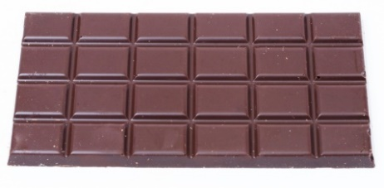
To the right there is a bar of chocolate.
Can you find a way in which you can halve it?
Can you find another way in which you can halve it?
Can you find other ways you could share this chocolate bar?

Explicit teaching
[NEW PAGE] 1A: Fraction Models
- The denominator tells you how many equal parts the whole is broken into
- The numerator tells you how many of those parts are taken.

Worked Examples:
1. |  | 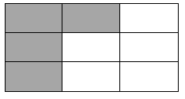  2.
What we write:  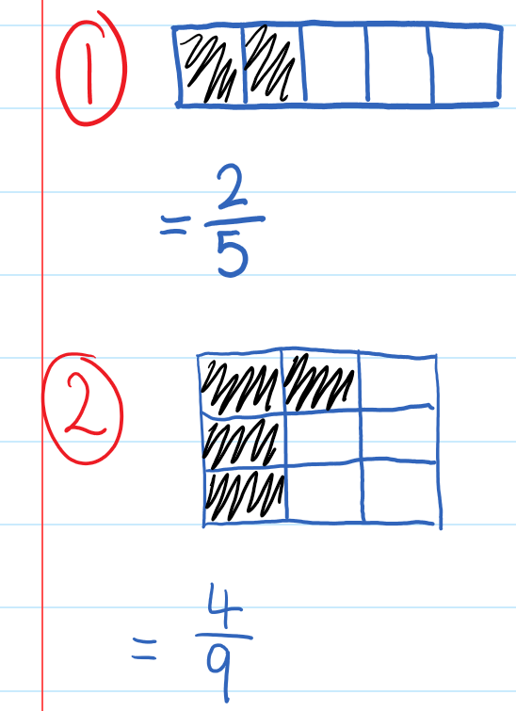 | What we think:  There are 2 sections shaded. This is my numerator.  There are 5 sections all together. This is my denominator.  There are 4 sections shaded. This is my numerator.  There are 9 sections all together. This is my denominator.
Your Turn:
1. |  | 2.

PRACTICE

1A Routine questions
- What fraction is represented in each diagram below? 4First Five Live

☑ Correction Time! Click here for answers

1A Stretch questions
- For each of the following, write the fraction that is describing part of the total.
  - After one day of a 43-kilometre hike, the walkers had completed 12 kilometres.
  - Out of 15 starters, 13 runners went on and finished the race.
  - One egg is broken in a carton that contains a dozen eggs.
  - It rained three days this week.

- A 250-millilitre glass of cordial is made by mixing four parts water to one part syrup.
  - What fraction of the cordial is syrup?
  - What amount of syrup is required?

- State whether the following statements are true or false.
- T or F: This diagram represents $\frac{1}{4}$  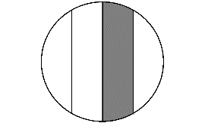 | - T or F: This diagram represents $\frac{1}{4}$  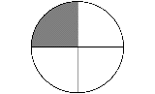 | - T or F: This diagram represents $\frac{1}{4}$  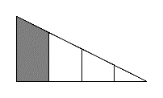
- T or F: This diagram represents $\frac{3}{5}$  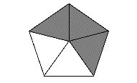 | - T or F: This diagram represents $\frac{3}{4}$  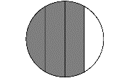 | - T or F: This diagram represents $\frac{3}{5}$  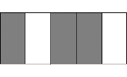
- What fraction is represented in each diagram below?
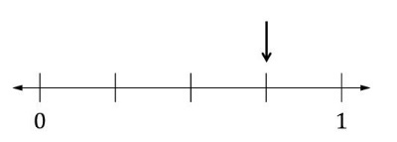 | 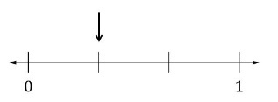 | 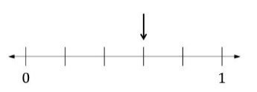
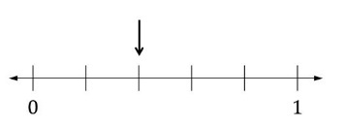 | 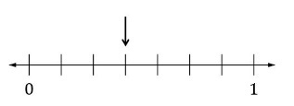 | 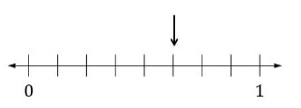

- (Challenge) For each of the diagrams, work out what fraction of the rectangle is coloured purple. Explain how you came to each of your answers.
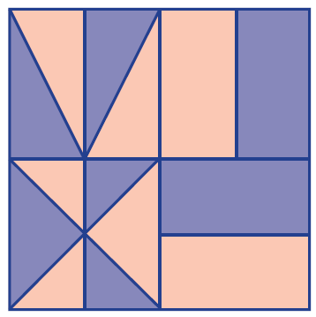 | 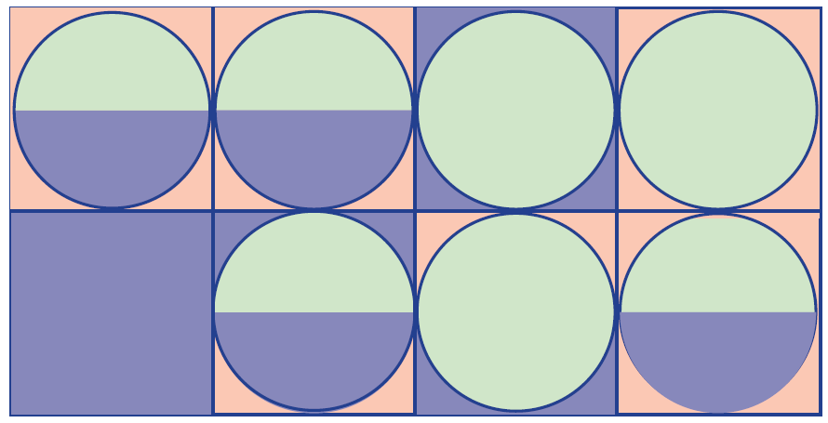 | 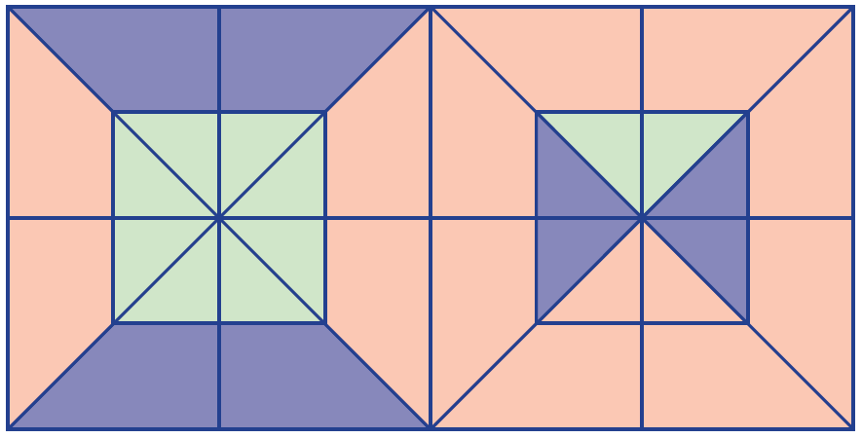

☑ Correction Time! Click here for answers to most questions

Finished Early? Head to the Early Finishers Page to engage in a game, puzzle or investigation.

Skill B: core skill

Key words
Equivalent fractions are different fraction representations of the same number.

Activate prior knowledge
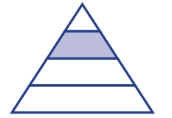
Activity 1:
Does this represent ¼?
Why/why not?
Challenge: Can you show exactly $\frac{1}{3}$ of the triangle?

Activity 2:
Look at the following diagrams, what do you see, think and wonder?

Diagram 1 | Diagram 2 | Diagram 3 | Diagram 4

Explicit Teaching
[NEW PAGE] 1B: Equivalent Fractions
To create an equivalent fraction, multiply the numerator and denominator by the same number.

Worked Examples:
- $\frac{3}{5}=\frac{\boxed{}}{15}$ |  |  | 2. $\frac{1}{7}=\frac{\boxed{}}{28}$
What we write:  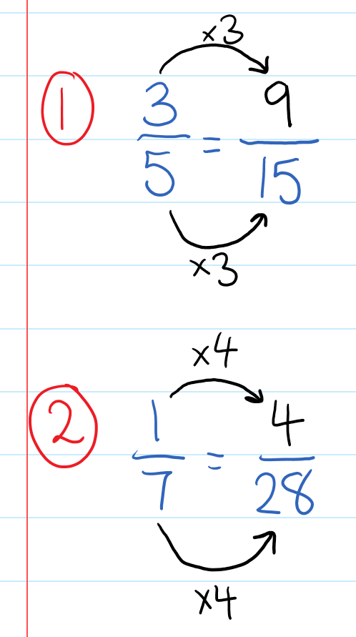 |  | What we think:  - 5 multiplied by what number equals 15? 3.  - Multiply the numerator and denominator by 3.  - 7 multiplied by what number equals 28? 4.  - Multiply the numerator and denominator by 4.
Your Turn:
1. $\frac{3}{8}=\frac{\boxed{}}{24}$ |  |  | - $\frac{7}{10}=\frac{\boxed{}}{100}$

Practice

1B ROUTINE QUESTIONS
- Fill in the boxes to create equivalent fractions. 4First Five Live
- $\frac{2}{5}=\frac{\boxed{}}{20}$ | - $\frac{3}{4}=\frac{\boxed{}}{24}$ | - $\frac{4}{7}=\frac{\boxed{}}{21}$ | - $\frac{3}{8}=\frac{\boxed{}}{56}$ | - $\frac{2}{5}=\frac{\boxed{}}{50}$
- $\frac{2}{7}=\frac{\boxed{}}{14}$ | - $\frac{1}{2}=\frac{\boxed{}}{10}$ | - $\frac{3}{7}=\frac{\boxed{}}{35}$ | - $\frac{1}{3}=\frac{\boxed{}}{15}$ | - $\frac{1}{6}=\frac{\boxed{}}{42}$
- $\frac{2}{5}=\frac{\boxed{}}{35}$ | - $\frac{5}{8}=\frac{\boxed{}}{32}$ | - $\frac{4}{7}=\frac{\boxed{}}{21}$ | - $\frac{1}{3}=\frac{\boxed{}}{12}$ | - $\frac{5}{8}=\frac{\boxed{}}{32}$
- $\frac{5}{6}=\frac{\boxed{}}{24}$ | - $\frac{1}{6}=\frac{\boxed{}}{48}$ | - $\frac{1}{7}=\frac{\boxed{}}{63}$ | - $\frac{1}{4}=\frac{\boxed{}}{16}$ | - $\frac{3}{8}=\frac{\boxed{}}{24}$
☑ Correction Time! Click here for answers

1B STRETCH questions
- Fill in the boxes to create equivalent fractions.
- $\frac{3}{\boxed{}}=\frac{15}{40}$ | - $\frac{11}{\boxed{}}=\frac{44}{8}$ | - $\frac{\boxed{}}{10}=\frac{24}{20}$ | - $\frac{\boxed{}}{1}=\frac{14}{7}$
- $\frac{19}{20}=\frac{190}{\boxed{}}$ | - $\frac{2}{7}=\frac{10}{\boxed{}}$ | - $\frac{5}{7}=\frac{145}{\boxed{}}$ | - $\frac{6}{9}=\frac{192}{\boxed{}}$
- Use a number line to show that the following fractions are equivalent.
- $\frac{1}{3}=\frac{2}{6}$ | - $\frac{1}{2}=\frac{3}{6}$ | - $\frac{2}{4}=\frac{3}{6}$ | - $\frac{2}{8}=\frac{1}{4}$
- Fill in the boxes to complete each set of equivalent fractions.
- $\frac{1}{3}=\frac{\boxed{}}{15}=\frac{\boxed{}}{75}=\frac{\boxed{}}{120}$ | - $\frac{3}{4}=\frac{6}{\boxed{}}=\frac{\boxed{}}{68}=\frac{\boxed{}}{100}$ | - $\frac{\boxed{}}{3}=\frac{10}{15}=\frac{60}{\boxed{}}=\frac{\boxed{}}{108}$
- Justin, Joanna and Jack are sharing a large pizza for dinner. The pizza has been cut into 12 equal pieces. Justin would like$\frac{1}{3}$of the pizza, Joanna would like $\frac{1}{4}$of the pizza and Jack will eat whatever is remaining. By considering equivalent fractions, determine how many slices each person gets served.

- Using any of the digits from 1 through 9 no more than once, create three equivalent fractions. (You do not need to use all the digits, you just cannot repeat any)
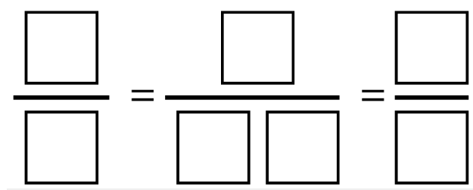

- (Challenge) Find all possible solutions to the above question.

☑ Correction Time! Click here for answers
Finished Early? Head to the Early Finishers Page to engage in a game, puzzle or investigation.

SKILL C: ENRICHMENT SKILL

Key words
A proper fraction is a fraction where the numerator is less than the denominator.
An improper fraction is a fraction where the numerator is greater than or equal to the denominator. For example, $\frac{1}{3} , \frac{2}{3}$ and $\frac{3}{7}$are proper fractions, while $\frac{4}{3} , \frac{8}{3}$and $\frac{9}{5}$ are improper fractions.
A mixed number has both a whole number and a fractional part. For example, $4\frac{2}{3}$ is a mixed number.
Converting means to change from one form to another. For example, we can convert the fraction $\frac{1}{2}$to the decimal 0.5.

Activate prior knowledge

At Pete’s cake shop, small cakes are cut into four equal slices, medium cakes are cut into six equal slices and large cakes are cut into eight equal slices.

For a 70th birthday party, 13 cakes were ordered all of which were eaten. After the last slice was eaten, a total of 82 slices of cake had been eaten. How many cakes of each size were ordered?

Hint: There are multiple answers.

Explicit Teaching
[NEW PAGE] 1C: Converting between whole numbers, mixed numbers and improper fractions
Diagrams can be helpful for understanding these processes. Use rectangles to represent the problem.
- To convert a whole number to an improper fraction, write the whole number with a denominator of 1.
- To convert from a mixed number to an improper fraction, multiply the whole number by the denominator, then add the numerator. The denominator does not change.
- To convert and improper fraction to a mixed number, complete short division showing the remainder as a fraction.

Worked Examples:
1. $4=\frac{\boxed{}}{2}$ |  | 2. $2=\frac{\boxed{}}{7}$ |  |  | 3. $2\frac{2}{3}=\frac{\boxed{}}{3}$ |  | 4. $\frac{19}{6}=3\frac{\boxed{}}{6}$
What we write:  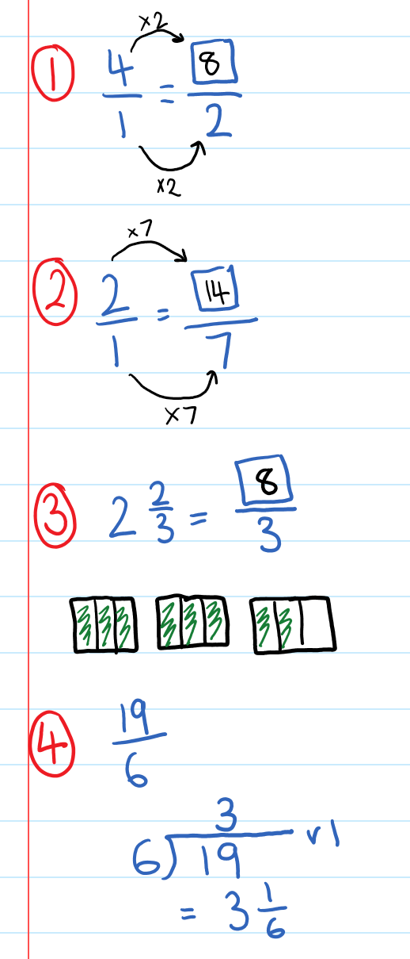 |  |  | What we think:  To convert a whole number to an improper fraction, write the whole number with a denominator of 1.  To convert a whole number to an improper fraction, write the whole number with a denominator of 1.  Multiply the whole number by the denominator, then add the numerator. The denominator stays the same.  To convert and improper fraction to a mixed number, complete short division showing the remainder as a fraction.
Your Turn:
1. $3=\frac{\boxed{}}{5}$ | 2. $4=\frac{\boxed{}}{8}$ |  |  | 3. 1$\frac{4}{5}=\frac{\boxed{}}{5}$ |  | 4. $\frac{23}{7}=3\frac{\boxed{}}{7}$

Practice

1C ROUTINE QUESTIONS
      - Fill in each box to make each equation involving a whole number and improper fraction true. 4First Five Live
a. | $3=\frac{\boxed{}}{4}$ | b. | $2\frac{3}{5}=\frac{\boxed{}}{5}$ | c. | $3\frac{\boxed{}}{2}=\frac{7}{2}$ | d. | $11=\frac{\boxed{}}{5}$
e. | $6\frac{4}{7}=\frac{\boxed{}}{7}$ | f. | $4\frac{\boxed{}}{5}=\frac{22}{5}$ | g. | $9=\frac{\boxed{}}{4}$ | h. | $4\frac{\boxed{}}{3}=\frac{14}{3}$
i. | $2\frac{2}{5} =\frac{\boxed{}}{5}$ | j. | $2\frac{3}{5}=\frac{\boxed{}}{5}$ | k. | $1\frac{1}{3}=\frac{\boxed{}}{3}$ | l. | $4=\frac{\boxed{}}{7}$
m. | $6\frac{5}{7}=\frac{\boxed{}}{7}$ | n. | $1=\frac{\boxed{}}{4}$ | o. | $4\frac{3}{4}=\frac{\boxed{}}{4}$ | p. | $4\frac{\boxed{}}{4}=\frac{19}{4}$
q. | $10=\frac{\boxed{}}{3}$ | r. | $4\frac{\boxed{}}{4}=\frac{17}{4}$ | s. | $4=\frac{\boxed{}}{7}$ | t. | $6\frac{\boxed{}}{2}=\frac{13}{2}$
☑ Correction Time! Click here for answers

1C STRETCH questions
      - Convert the following improper fractions to mixed numbers.
- $\frac{217}{100}$ | - $\frac{109}{4}$ | - $\frac{216}{7}$ | - $\frac{302}{9}$

      - Answer the following worded questions.
  - Patricia has three sandwiches that are cut into quarters and she eats all but one-quarter. How many quarters does she eat?
  - Phillip has five sandwiches that are cut into halves and he eats all but one-half. How many halves does he eat?
  - Crystal has $x$ sandwiches that are cut into quarters and she eats them all but one-quarter. How many quarters does she eat?
  - Byron has $y$ sandwiches that are cut into thirds and he eats all but one-third. How many thirds does he eat?
  - Felicity has $m$ sandwiches that are cut into n pieces and she eats them all. How many pieces does she eat?
      - What numbers are represented by the letters on the number line below? Give your answers as mixed numbers and as an improper fraction where possible.
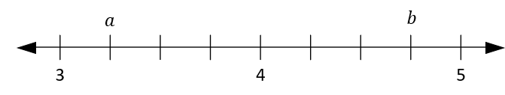
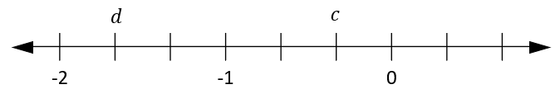
      - Without using 8 again, fill each box with a different digit to make a true statement where all fractions are in simplified form. Note: The first fraction is a mixed number and therefore the numerator has to be less than 8
$$\boxed{}\frac{\boxed{}}{8}=\frac{\boxed{}\boxed{}}{8}$$
For an extra challenge, find all possible solutions.
☑ Correction Time! Click here for answers
Finished Early? Head to the Early Finishers Page to engage in a game, puzzle or investigation.

Skill 1 Reasoning Questions

Entry | Core | Advanced
Explain why this fraction does not show $\frac{1}{3}.$  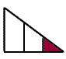 | Draw a picture to explain why  $$\frac{3}{5}=\frac{6}{10}$$ | Explain why the line in this triangle splits it into two equal areas.  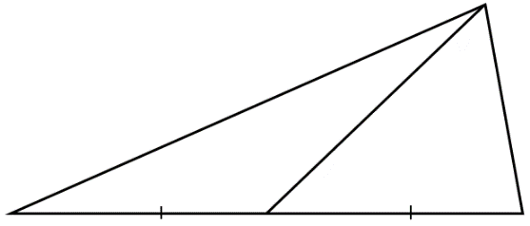

COLLABORATIVE TASK:
Start with a square sheet of paper and make folds to construct a new shape. Ten, explain how you know the shape you constructed has the specified area. (reference)
- Construct a square with exactly ¼ the area of the original square. Convince your partner that it is a square and has ¼ of the area.
- Construct a triangle with exactly ¼ the area of the original square. Convince your partner that it has ¼ of the area.
- Construct another triangle, also with ¼ the area, that is not congruent to the first one you constructed. Convince your partner that it has ¼ of the area.
- Construct a square with exactly ½ the area of the original square. Convince your partner that it is a square and has ½ of the area.
- Construct another square, also with ½ the area, that is oriented differently from the one you constructed in 4. Convince your partner that it has ½ of the area.

Assessment for Learning
Your progress will be monitored through your classwork and weekly homework sheets.

Reflection and Recognition
Let’s reflect on some key questions. Choose one or more of the questions below to answer.
- What does the denominator tell us? What does the numerator tell us?
- How do we model fractions using rectangles?
- Why are there so many ways to represent one fraction?
Let’s recognise something that went well and something that could be improved.
- What component of this work caused the most growth in your learning?
- Is there anything you’d like to improve?

Simplifying Fractions

Setting the Goal
Learning Intentions:
- What is a simplified fraction?
- How do we know if a fraction has been simplified?
- Why do we simplify fractions?
Success Criteria:
I can simplify fractions by dividing the numerator and denominator by a common factor until the only common factor is 1.

Skill A&B: CORE skill

Key words
The highest common factor (HCF) of two (or more) numbers is the largest number which is a factor of both numbers.

Activate prior knowledge
List the factors of the following numbers:
35 | 22 | 39 | 180
Find a number that has the most amount of factors you can think of.

Explicit teaching
[NEW PAGE] 2A&B: Simplifying Fractions

- In a simplified fraction, the only common factor of the numerator and denominator is 1.
- To simplify a fraction,
      - Identify the highest common factor (HCF) between the numerator and denominator.
      - Divide the numerator and denominator by the HCF.

Worked Examples: Simplify the following.
1. $\frac{4}{10}$ | 2. $\frac{15}{40}$ |  | 3. $\frac{12}{20}$ | 4. $\frac{28}{84}$
What we write:  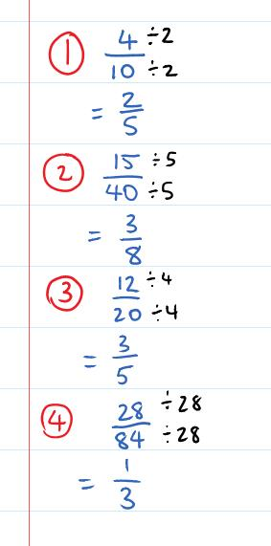 |  | What we think:  - The HCF of 4 and 10 is 2.  - Divide both the numerator and denominator by 2 to simplify the fraction.  - The HCF of 15 and 40 is 5.  - Divide both the numerator and denominator by 5 to simplify the fraction.  - The HCF of 12 and 20 is 4.  - Divide both the numerator and denominator by 4 to simplify the fraction.  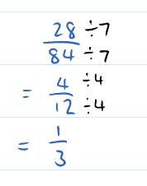  - The HCF of 28 and 84 is 28.  - Divide both the numerator and denominator by 28 to simplify the fraction.  Note: Identifying the HCF isn’t absolutely essential. Here is an alternate solution to Q4.
Your Turn:
- $\frac{3}{9}$ | - $\frac{14}{28}$ |  | - $\frac{16}{64}$ | - $\frac{36}{48}$

PRACTICE

2A Routine questions
      - Simplify the fractions below. (Note that the only 2 or 5 will be the HCF in each case.) 4First Five Live
- $\frac{5}{15}$ | - $\frac{8}{22}$ | - $\frac{22}{24}$ | - $\frac{16}{18}$ | - $\frac{20}{25}$
- $\frac{8}{10}$ | - $\frac{5}{10}$ | - $\frac{6}{8}$ | - $\frac{4}{6}$ | - $\frac{50}{55}$
- $\frac{15}{25}$ | - $\frac{8}{14}$ | - $\frac{2}{4}$ | - $\frac{25}{40}$ | - $\frac{25}{30}$
- $\frac{14}{16}$ | - $\frac{18}{22}$ | - $\frac{10}{35}$ | - $\frac{10}{12}$ | - $\frac{45}{50}$

☑ Correction Time! Click here for answers

2B Routine questions
      - Simplify the fractions below. 4First Five Live
- $\frac{18}{42}$ | - $\frac{48}{60}$ | - $\frac{16}{20}$ | - $\frac{15}{75}$ | - $\frac{12}{24}$
- $\frac{36}{48}$ | - $\frac{8}{80}$ | - $\frac{30}{42}$ | - $\frac{4}{8}$ | - $\frac{8}{16}$
- $\frac{42}{56}$ | - $\frac{12}{40}$ | - $\frac{16}{28}$ | - $\frac{27}{36}$ | - $\frac{6}{24}$
- $\frac{120}{135}$ | - $\frac{6}{30}$ | - $\frac{32}{40}$ | - $\frac{8}{24}$ | - $\frac{16}{30}$

☑ Correction Time! Click here for answers

2B STRETCH questions
      - Simplify these. What do you notice?
- $\frac{1+3}{5+7}$ | - $\frac{1+3+5}{7+9+11}$ | - $\frac{1+3+5+7}{9+11+13+15}$

      - Noor ate $\frac{4}{14}$’s of a pie and Alex ate $\frac{12}{28}$’s of a pie.
  - If both pies are the same size, then which person ate more pie? (show your working!)
  - Show how you can solve this problem in a different way than you did in part a.

      - After first simplifying the fraction, solve the following for the given pronumeral.
- $\frac{2x}{4}=10$ | - $16=\frac{4y}{12}$ | - $64=\frac{4c}{32}$
      - (Challenge) The following fraction contains each digit from 1 to 9 and simplifies to $\frac{1}{3}$. What is the original fraction?
$$\frac{5 \boxed{} 2 \boxed{}}{1 \boxed{} 4 \boxed{} 9}$$

      - (Challenge) Consider the fraction $\frac{n}{360}$ where $n$ can be any positive integer less than 360. How many different fractions could $\frac{n}{360}$ simplify to where the denominator is a single digit?

- (Challenge) In the previous topic we saw how a tree and Venn diagram could be used to find the LCM of large numbers.
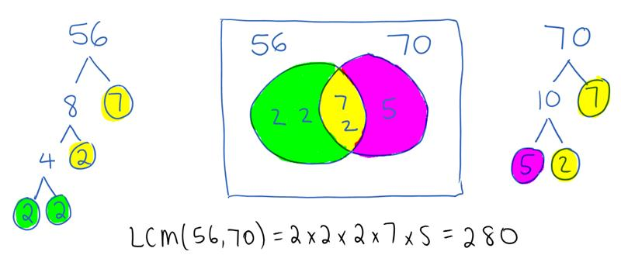

This picture also demonstrates that the LCM of two numbers can be found using the following formula:
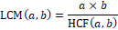
Use this formula to find the LCM of 38 and 96. Remember to simplify values in the numerator and denominator before calculating.

☑ Correction Time! Click here for SOME answers. Where answers aren’t given, check them with a peer or your teacher.

Finished Early? Head to the Early Finishers Page to engage in a game, puzzle or investigation.

Setting the Goal
Learning Intentions:
- How can fractions be compared?
Success Criteria:
I can identify which fraction is larger or smaller by comparing equivalent fractions.

Skill c: advanced skill

Key words
Ascending order is when numbers are ordered from smallest to largest.
Descending order is when numbers are ordered from largest to smallest. You could remember this by thinking
Descending goes Down.

Activate prior knowledge
- Copy the number line into your book
- Mark the following values on your number line: 1.5, 0.2, $\frac{3}{4}$ and $\frac{5}{3}$
- Explain why you put each value in the position you put them in
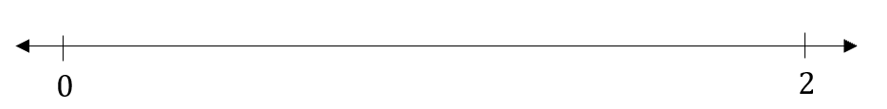

Explicit teaching
[NEW PAGE] 2C: Comparing Fractions
Fractions are easiest to compare when either the numerators or denominators are the same.
You may need to re-write one, or both, fractions using equivalence to achieve this.
- If the numerators are the same, the largest fraction is the one with the smallest denominator, as it has been divided up into fewer pieces. For example: $\frac{1}{2}>\frac{1}{7}$
- If the denominators are the same, the largest fraction is the one with the largest numerator. For example: $\frac{7}{10}>\frac{2}{10}$

Worked Examples:
1. $\frac{1}{4}\boxed{}\frac{1}{8}$ |  | 2. $\frac{2}{3}\boxed{}\frac{4}{12}$ |  |  | 3. $\frac{5}{6}\boxed{}\frac{6}{7}$ |  | 4. $\frac{3}{4}\boxed{}\frac{6}{8}$
What we write:  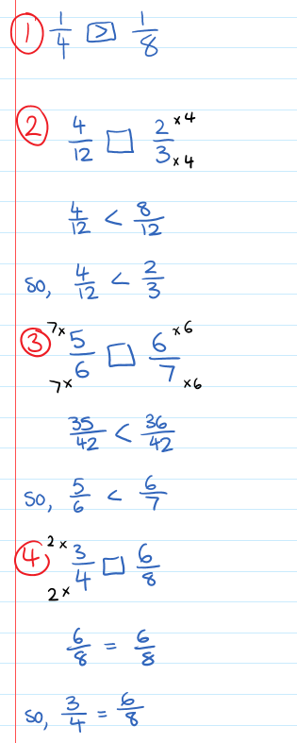 |  |  | What we think:  The numerators are the same, so the largest fraction is the one with the smallest denominator.  - Create equivalent fractions.  - Compare the fractions  - Create equivalent fractions.  - Compare the fractions  - Create equivalent fractions.  - Compare the fractions
Your Turn:
- $\frac{1}{7}\boxed{}\frac{1}{6}$ | - $\frac{2}{5}\boxed{}\frac{4}{15}$ |  |  | - $\frac{7}{8}\boxed{}\frac{5}{6}$ |  | - $\frac{1}{2}\boxed{}\frac{10}{20}$

PRACTICE

2C Routine questions
- Put a <, = or > between the fractions and, if possible, underline the larger fraction. 4First Five Live
- $\frac{3}{5}\boxed{}\frac{1}{5}$ | - $\frac{5}{9}\boxed{}\frac{5}{8}$ | - $\frac{12}{18}\boxed{}\frac{4}{6}$ | - $\frac{8}{9}\boxed{}\frac{6}{7}$ | - $\frac{3}{7}\boxed{}\frac{7}{15}$
- $\frac{1}{10}\boxed{}\frac{1}{20}$ | - $\frac{1}{7}\boxed{}\frac{1}{5}$ | - $\frac{3}{5}\boxed{}\frac{18}{30}$ | - $\frac{4}{5}\boxed{}\frac{3}{4}$ | - $\frac{5}{6}\boxed{}\frac{9}{10}$
- $\frac{2}{3}\boxed{}\frac{1}{3}$ | - $\frac{5}{7}\boxed{}\frac{15}{21}$ | - $\frac{7}{11}\boxed{}\frac{3}{5}$ | - $\frac{5}{7}\boxed{}\frac{1}{6}$ | - $\frac{4}{10}\boxed{}\frac{3}{11}$
- $\frac{10}{16}\boxed{}\frac{3}{8}$ | - $\frac{8}{8}\boxed{}\frac{3}{4}$ | - $\frac{2}{2}\boxed{}\frac{3}{3}$ | - $\frac{8}{9}\boxed{}\frac{6}{7}$ | - $\frac{10}{90}\boxed{}\frac{2}{18}$

☑ Correction Time! Click here for answers

2C STRETCH questions
- Decide what fraction of the cake each person would get of the cakes below, then place them in descending order.
  - Sponge cake shared equally by 4 people
  - Chocolate cake shared equally by 11 people.
  - Carrot and walnut cake shared equally by 8 people.

- For each of the following pairs of fractions, write a fraction that lies between them.
- $\frac{3}{5},\frac{3}{4}$ | - $\frac{1}{4},\frac{1}{2}$ | - $\frac{2}{7},\frac{1}{6}$
- Write all the whole number values that $x$ can take so that $\frac{x}{3}$lies between:
- $2 and 3$ | - $5 and 5\frac{1}{2}$

- Using the digits 1-9, fill all of the boxes to make the statements true.
$$\frac{\boxed{}+\boxed{}}{\boxed{}}<1$$ | $$\frac{\boxed{}+\boxed{}}{\boxed{}}=1$$ | $$\frac{\boxed{}+\boxed{}}{\boxed{}}>1$$
- Guarav’s income increases by $\frac{3}{7}$. Gen’s income increases by $\frac{2}{5}$. Guarav claims that his income will increase by more money than Gen’s. Explain why he may not be correct.

☑ Correction Time! Click here for SOME answers. Where answers aren’t given, check them with a peer or your teacher.
Finished Early? Head to the Early Finishers Page to engage in a game, puzzle or investigation.

Skill 1&2 Application Questions – Think, Pair, Share/Teacher Modelling
Answer the questions you can. Explain your reasoning for at least one of the questions.
You may use your calculator at any time.
1. | Helen has 24 green apples and 12 red apples. What fraction of the apples are red?
  - $\frac{1}{2}$ | - $\frac{1}{3}$ | - $\frac{1}{4}$ | - $\frac{1}{12}$
2. | 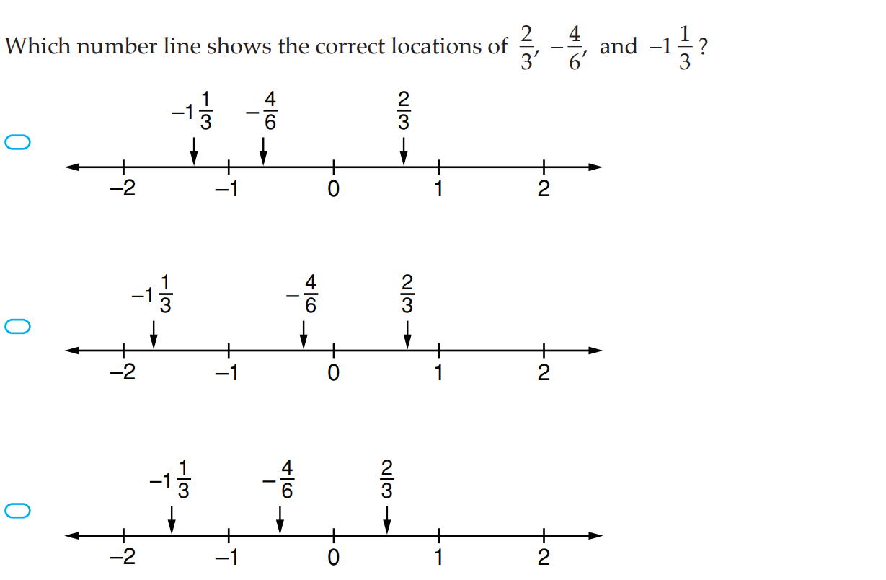
3. | Which of the following number 5, 6, 7, 8 or 9, when placed in the box below, gives the fraction which is closest to $2\frac{1}{2}$ ?  $$\frac{19}{\boxed{}}$$
  - 5 | - 6 | - 7 | - 8 | - 9
4. | - At a farm there are chooks and sheep. If there are 24 animals and 80 legs, how many sheep are there?  - How could you extend this problem?

Skill 2 Reasoning Questions

Entry | Core | Advanced
John says he found a simplified fraction where the numerator and denominator were even. Can you explain why this is impossible? | How many different fractions can simplify to $\frac{3}{5}.$ Explain your answer. | Explain why  $$\frac{1+1+1}{111}=37$$  $$\frac{2+2+2}{222}=37$$  $$\frac{3+3+3}{333}=37$$  $$\frac{4+4+4}{444}=37$$  Etc.

COLLABORATIVE TASK:
Can you solve the fraction sudoku?
Rules: Like regular sudoku, the numbers from 1-9 appear once in every row, column and 3x3 outlined square. The small clue-numbers in this Sudoku puzzle are simplified fractions. The clue-numbers are always placed on the border lines between selected pairs of neighbouring cells of the grid. Each clue-number on a vertical border line or horizontal border line is the fraction of the two numbers in the horizontally connecting cells or vertically connecting cells respectively. For example, the four possible number placements for the 2/3 clue are shown below.
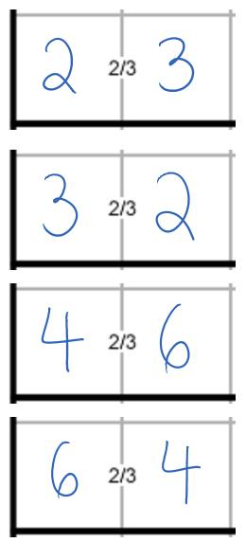

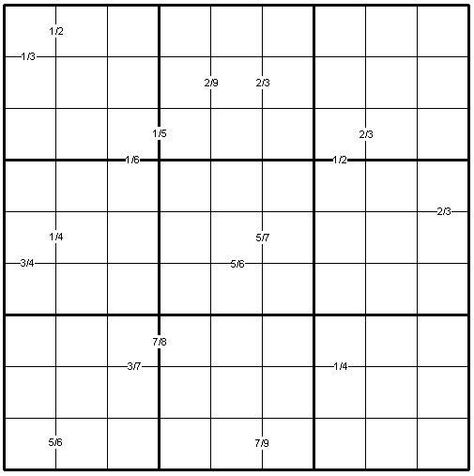

Assessment for Learning
Your progress will be monitored through your classwork and weekly homework sheets.

Reflection and Recognition
Let’s reflect on some key questions. Choose one or more of the questions below to answer.
- What is a simplified fraction?
- How do we know if a fraction has been simplified?
- Why do we simplify fractions?
Let’s recognise something that went well and something that could be improved.
- What component of this work caused the most growth in your learning?
- Is there anything you’d like to improve?

Converting between FDP

Setting the Goal
Learning intentions:
      - What does percent mean?
      - How are decimals connected to fractions? How are percentages connected to fractions?
      - Why do we convert between fractions, decimals and percentages?
Success criteria:
I can convert between fractions, decimals and percentages

Skill A: Entry skill

Key words
Percent means parts per 100. For example, 20% means 20 parts of 100.

Activate prior knowledge
Convert these percentages to decimals:
$$50\%$$ | 25% | 29% | 134%

Explicit teaching
[NEW PAGE] 3A: Conversions using Place Value
Recall the place values chart below:
 | - 3 tenths can be written as a fraction with 10 as the denominator ($\frac{3}{10}$)  - 4 hundredths can be written as a fraction with 100 as the denominator ($\frac{4}{100}$)  - 5 thousandths can be written as a fraction with 1000 as the denominator ($\frac{5}{1000}$)
  Tens | Ones | Decimal | Tenths | Hundredths | Thousandths
  1 | 2 | . | 3 | 4 | 5

Worked Examples:
- $\frac{3}{10}$ | - $\frac{4}{100}$ |  | - $0.08$ | - $0.2$
What we write:  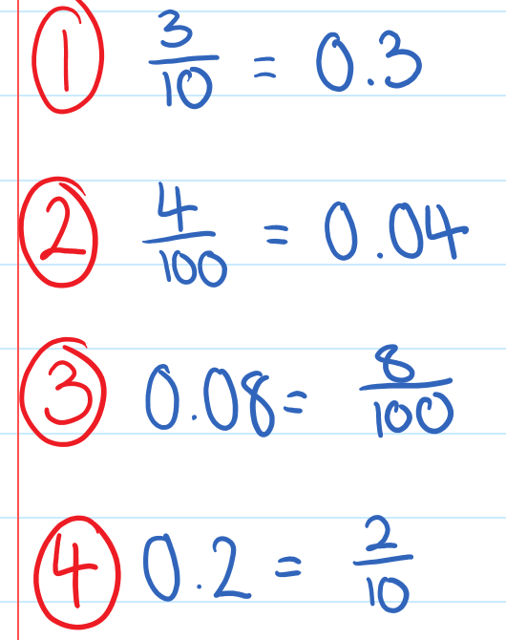 |  | What we think:  Both $\frac{3}{10}$and $0.3$ can be read aloud as “3 tenths” so $\frac{3}{10}=0.3$  Both $\frac{4}{100}$and $0.04$ can be read aloud as “4 hundredths” so $\frac{4}{100}=0.04$  8 hundredths can be written as a fraction with a denominator of 100.  2 tenths can be written as a fraction with a denominator of 10.
Your Turn:
- $\frac{2}{10}$ | - $\frac{15}{100}$ |  | - $0.12$ | - $0.6$

PRACTICE

3A Routine questions
- Convert the following fractions to decimals. 4First Three Live
- $\frac{3}{10}$ | - $\frac{7}{100}$ | - $\frac{9}{10}$ | - $\frac{1}{10}$ | - $\frac{1}{100}$
- $\frac{7}{10}$ | - $\frac{9}{100}$ | - $\frac{3}{100}$ | - $\frac{4}{10}$ | - $\frac{8}{100}$
- Convert the following decimals to fractions. 4First Three Live
- $0.01$ | - $0.7$ | - $0.03$ | - $0.3$ | - $0.9$
- $0.07$ | - $0.09$ | - $0.1$ | - $0.5$ | - $0.05$

☑ Correction Time! Click here for answers

3A Stretch questions
- Convert the following fractions to decimals.
- $\frac{3}{1 000}$ | - $\frac{30}{1000}$ | - $\frac{37}{1000}$ | - $\frac{3700}{10 000}$
- After first converting to an equivalent fraction with a denominator which is a power of 10, convert the following fractions to decimals.
- $\frac{7}{20}$ | - $\frac{9}{50}$ | - $\frac{4}{5}$ | - $\frac{5}{8}$
- Convert the following decimals to fractions.
- $0.0007$ | - $0.0041$ | - $0.00137$ | - $2.37$
- Convert the following decimals to fractions. Giving each answer in simplified form.
- $0.45$ | - $2.5$ | - $6.32$ | - $0.0056$
- A, B and C are digits where A > B > C. Write these numbers from smallest to largest (recall that ‘>’ means greater than). Note that the dot represents the decimal point.
  - A.B, B.C, A.C, C.C, C.A, B.A
  - A.BC, B.CA, B.BB, C.AB, C.BC, BA.CA, AB.AB, A.AA, A.CA
☑ Correction Time! Click here for answers
Finished Early? Head to the Early Finishers Page to engage in a game, puzzle or investigation.

Skill B: core skill

Activate prior knowledge
List the factors of 100.

Explicit Teaching
[NEW PAGE] 3B: Converting between FDP (whole number percentages)
The following tips will help you when converting between FDP:
- If you can, convert the given value to a fraction out of 100. This will make it easier to represent as a decimal or percentage.
- If you can’t, use this diagram:
x100

Fraction/decimal | Percentage
÷100

- Don’t forget to always simplify fractions (where possible)

Worked Examples:
1. | 2. |  | 3.
  P | F | D
   |  | 0.42
  P | F | D
   | $\frac{1}{20}$
  P | F | D
  22%
What we write:  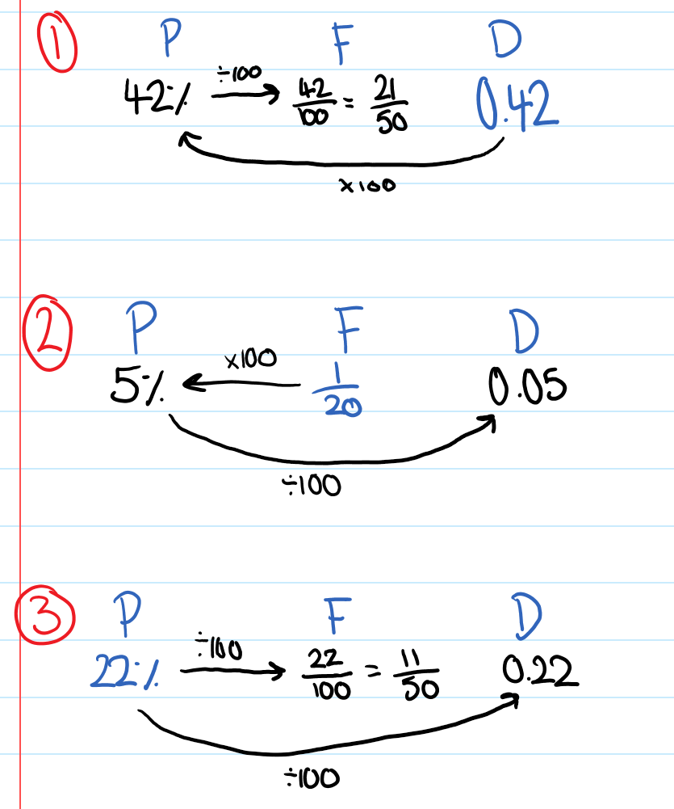 |  | What we think:  Use the diagram above to help convert between FDP.  Remember to show fractions in their simplest form.
Your Turn:
1. | 2. |  | 3.
  P | F | D
   |  | 0.34
  P | F | D
   | $\frac{7}{10}$
  P | F | D
  96%

Practice

3B ROUTINE QUESTIONS
      - Complete each table. Make sure your fraction is given in simplified form in each case. 4First Five Live
  P | F | D
   |  | 0.78
  P | F | D
   | $\frac{1}{25}$
  P | F | D
  40%
  P | F | D
   |  | 0.3
  P | F | D
   | $\frac{7}{20}$
  P | F | D
   |  | 0.46
  P | F | D
   |  | 0.2
  P | F | D
   |  | 0.58
  P | F | D
  18%
  P | F | D
   | $\frac{2}{25}$
  P | F | D
   | $\frac{19}{50}$
  P | F | D
   |  | 0.24
  P | F | D
  15%
  P | F | D
  94%
  P | F | D
   | $\frac{9}{10}$
  P | F | D
   |  | 0.03
  P | F | D
  80%
  P | F | D
   | $\frac{7}{25}$
  P | F | D
  54%
  P | F | D
   |  | 0.6

☑ Correction Time! Click here for answers

3B STRETCH questions
- A bottle of lemonade is only 25% full.
  - What fraction of the lemonade has been consumed?
  - What percentage of the lemonade has been consumed?
  - What fraction of the lemonade is left?
  - What percentage of the lemonade is left?

- Convert the following test scores to percentages without using a calculator. The first has been started for you.
- 27 out of 30 = $\frac{27}{30}=\frac{9}{10}=…$ | - 51 out of 60 | - 12 out of 15
- 32 out of 40 | - 34 out of 40 | - 33 out of 40
- 72 out of 80 | - 70 out of 80 | - 71 out of 80

- Write each of the following percentages as fractions
- $2\frac{1}{2}$% | - $8\frac{1}{4}$% | - $12\frac{1}{2}$% | - $33\frac{1}{3}$%

- In Miss Quaffley's class, the girls make up more than 45% of the pupils, but less than 50%. What is the smallest possible number of girls in her class?

- Given that $\frac{29}{32}=0.90625$ convert the following fractions to decimals. Parts c and d are a challenge.
- $\frac{29}{320}$ | - $\frac{290}{32}$ | - $\frac{3}{32}$ | - $\frac{21}{32}$

☑ Correction Time! Click here for answers

Finished Early? Head to the Early Finishers Page to engage in a game, puzzle or investigation.

SKILL C: ENRICHMENT SKILL

Key words
$$0.333333=0.\dot{3}$$ | $$0.121212…=0.\dot{1}\dot{2} or 0.\overline{12}$$
Recurring decimals are decimals with a repeated pattern. A dot, dots or a bar above a number or numbers indicates a repeated pattern. The following are examples of recurring decimals:

A terminating decimal is a decimal which has a finite number of decimal places. For example: 0.25, 0.047, or 0.7753.

Activate prior knowledge
How many different ways can you show that $\frac{3}{8} = 0.375$?

Explicit Teaching
[NEW PAGE] 3C: Converting fractions to recurring decimals
- To convert any fraction to a decimal, divide the numerator by the denominator.
- When there is a recurring pattern in the decimal, use a dot or bar to indicate that there is a repeating pattern.
- You may like to convert any mixed numbers to improper fractions so you can complete the division.

Worked Examples:
1. $\frac{3}{11}$ |  | 2. 1$\frac{1}{3}$
What we write:  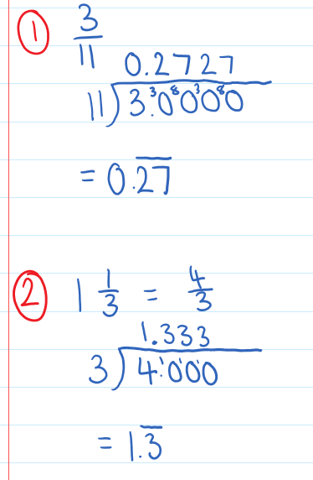 | What we think:  1. Divide the numerator by the denominator using short division.  2. Show that there is a repeating pattern using dots or a bar.  1. Convert the mixed number to an improper fraction.  2. Divide the numerator by the denominator using short division.  3. Show that there is a repeating pattern using dots or a bar.
Your Turn:
1. $\frac{4}{9}$ |  | 2. $1\frac{5}{6}$

Practice

3C ROUTINE QUESTIONS
      - Convert the following fractions to recurring decimals. Use a bar to indicate repeating digits. 4First Five Live
- $\frac{5}{9}$ | - $1\frac{7}{12}$ | - $\frac{16}{11}$ | - $2\frac{1}{6}$ | - $\frac{7}{11}$
- $\frac{5}{3}$ | - $\frac{2}{3}$ | - $\frac{6}{9}$ | - $\frac{1}{12}$ | - $1\frac{1}{6}$
- $\frac{7}{9}$ | - $1\frac{9}{11}$ | - $2\frac{5}{6}$ | - $\frac{1}{3}$ | - $\frac{13}{12}$
- $\frac{15}{11}$ | - $1\frac{5}{12}$ | - $\frac{2}{9}$ | - $3\frac{1}{3}$ | - $\frac{5}{6}$
☑ Correction Time! Click here for answers

3C Stretch questionS
- Express the following fractions as recurring decimals. You won’t need to calculate each individually. Look out for patterns ☺
- $\frac{1}{7}$ | - $\frac{2}{7}$ | - $\frac{3}{7}$ | - $\frac{4}{7}$ | - $\frac{5}{7}$ | - $\frac{6}{7}$

- When $\frac{4}{7}$ is expressed in decimal form, find the 23rd decimal place. Give a reason for your answer.

- Take a look at the fractions below.
$$\frac{2}{3}$$ | $$\frac{4}{5}$$ | $$\frac{17}{50}$$ | $$\frac{3}{16}$$
$$\frac{7}{12}$$ | $$\frac{5}{8}$$ | $$\frac{11}{14}$$ | $$\frac{8}{15}$$
        - Which ones do you think can be written as a terminating decimal?
        - Once you have made your predications, convert the fractions to decimals. Why might this have happened?
        - If you would like to explore terminating and recurring fractions more please head to Investigation 4

- (Challenge) True or False: $0.99999…=1$. Give reasons for your answer.

☑ Correction Time! Click here for answers

Finished Early? Head to the Early Finishers Page to engage in a game, puzzle or investigation.

Skill 3 Application Questions – Think, Pair, Share/Teacher Modelling
Answer the questions you can. Explain your reasoning for at least one of the questions.
You may use your calculator at any time.
1. | 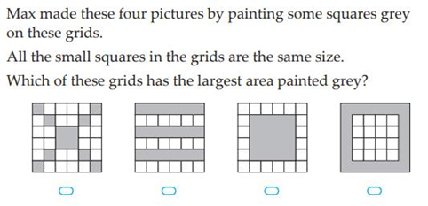
2. | 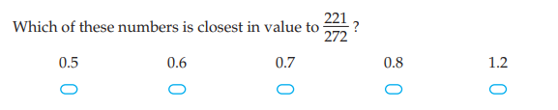
3. | A copier prints 1200 leaflets. One-third of the leaflets are on yellow paper and the rest are on blue paper. There are smudges on 5% of the blue leaflets. How many blue leaflets have smudges on them?
4. | 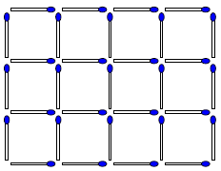  - How many matchsticks are required to make the 3 by 4 grid shown below?  - How could you extend or generalize this problem?

Skill 3 Reasoning Questions

Entry | Core | Advanced
Which number is larger out of $\frac{3}{10}$ and $0.7$. How do you know? | Put the following fractions in order of “easiest to convert to a decimal” to “hardest to convert to a decimal.” Give reasons for your answers.  $$\frac{3}{7}, \frac{3}{10}, \frac{3}{20}$$ | Explain why $0.999…=1$

COLLABORATIVE TASK:
Fraction Decimals Pairs Game

Assessment for Learning
Your progress will be monitored through your classwork and weekly homework sheets.

Reflection and Recognition
Let’s reflect on some key questions. Choose one or more of the questions below to answer.
- What does percent mean?
- How are decimals connected to fractions? How are percentages connected to fractions?
- Why do we convert between fractions, decimals and percentages?
Let’s recognise something that went well and something that could be improved.
- What component of this work caused the most growth in your learning?
- Is there anything you’d like to improve?

Adding and Subtracting Fractions

Setting the Goal
Learning intentions:
- What must we have before fractions can be added or subtracted?
- How do we set out our work?
- Why must we have a common denominator before we can add or subtract fractions?
Success criteria:
I can add and subtract fractions, creating common denominators first as required.

Skill A: Entry skill

Activate prior knowledge
In pairs, discuss the following.
- Which of the following pairs of numbers can be simply added without having to carry out any form of conversion?
- 6 goals, 2 goals | - 11 goals, 5 behinds | - 56 runs, 3 wickets
- 6 hours, 5 minutes | - 21 seconds, 15 seconds | - 47 minutes, 13 seconds
- 15cm, 3m | - 2.2 km, 4.1 km | - 5kg, 1680g
- $\frac{2}{7}$, $\frac{3}{7}$ | - $\frac{1}{4}$, $\frac{1}{2}$ | - $2\frac{5}{12}$, $1\frac{1}{3}$
- Why can we simply add some, but it’s not as easy for others?
- Solve as many as you can!

Explicit teaching
[NEW PAGE] 4A: Adding fractions with the same denominator
- When adding fractions with the same denominator, add the numerators and keep the denominator.

Worked Examples:
1. $\frac{3}{6}+\frac{2}{6}$ |  |  | 2. $\frac{3}{8}+\frac{4}{8}$
What we write:  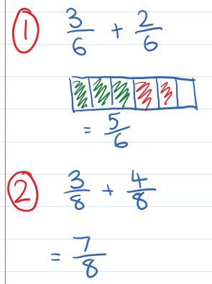 | What we think:  The denominators are the same, so we can add the numerators, and keep the same denominator.  The denominators are the same, so we can add the numerators, and keep the same denominator.
Your Turn:
1. $\frac{2}{7}+\frac{3}{7}$ |  | 2. $\frac{3}{6}+\frac{2}{6}$

PRACTICE

4A Routine questions

      - Calculate the following. Illustrate your calculation using the rectangles where provided. 4First Five Live
- $\frac{1}{3}+\frac{1}{3}$ | - $\frac{3}{5}+\frac{1}{5}$ | - $\frac{2}{4}+\frac{1}{4}$ | - $\frac{2}{5}+\frac{2}{5}$
- $\frac{3}{7}+\frac{2}{7}$ | - $\frac{2}{5}+\frac{2}{5}$ | - $\frac{1}{4}+\frac{2}{4}$ | - $\frac{1}{6}+\frac{4}{6}$
- $\frac{4}{8}+\frac{3}{8}$ | - $\frac{2}{6}+\frac{3}{6}$ | - $\frac{1}{8}+\frac{2}{8}$ | - $\frac{2}{5}+\frac{1}{5}$
- $\frac{1}{5}+\frac{2}{5}$ | - $\frac{3}{9}+\frac{2}{9}$ | - $\frac{4}{7}+\frac{1}{7}$ | - $\frac{2}{8}+\frac{3}{8}$
- $\frac{3}{7}+\frac{3}{7}$ | - $\frac{3}{5}+\frac{1}{5}$ | - $\frac{1}{9}+\frac{1}{9}$ | - $\frac{3}{10}+\frac{4}{10}$

☑ Correction Time! Click here for answers

4A Stretch questions

- Using a number line from 0 to 2, model and calculate each addition. Give answers as mixed or whole numbers where appropriate.
- $\frac{1}{5}+\frac{2}{5}$ | - $\frac{1}{3}+\frac{2}{3}$ | - $\frac{2}{3}+\frac{2}{3}$ | - $\frac{7}{5}+\frac{3}{5}$

- Calculate the following.
- $\frac{1}{6}+\frac{1}{6}+\frac{1}{6}+\frac{1}{6}+\frac{1}{6}$ | - $\frac{13}{7}+\frac{4}{7}+\frac{10}{7}+\frac{1}{7}$

- Find the unknown value in each equation.
- $\frac{2}{5}+\frac{x}{5}=1$ | - $\frac{2}{5}+\frac{x}{5}=3$ | - $\frac{2}{7}+\frac{x}{7}+\frac{8}{7}=4$ | - $8=3+\frac{x}{7}+\frac{1}{7}$

- Calculate the following.
- $-\frac{3}{7}+\frac{5}{7}$ | - $-\frac{3}{7}-\frac{5}{7}$ | - $\frac{17}{7}-\frac{36}{7}$ | - $-\frac{17}{7}-{}_{}^{-}{\frac{36}{7}}$

- (Challenge) In how many different ways can you add 2 or more fractions, each with a denominator of 8 to make $\frac{7}{8}$? Note that here $\frac{1}{8}+\frac{6}{8}$is not considered “different” from $\frac{6}{8}+\frac{1}{8}$.
☑ Correction Time! Click here for answers
Finished Early? Head to the Early Finishers Page to engage in a game, puzzle or investigation.

Skill B: core skill

Key words
Lowest common denominator (LCD) is the lowest common multiple of the different denominators. For example, the lowest common denominator of $\frac{1}{3}$and $\frac{1}{4}$ would be 12 as this is the lowest number that is a multiple of both 3 and 4.

Activate prior knowledge
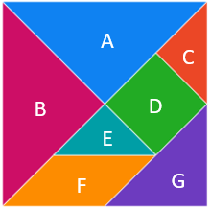
What fractional part of the whole does each shape represent of the whole?
Visit the link here for a manipulative version of the Tangram: mathigon.org/tangram

Explicit Teaching
[NEW PAGE] 4B: Adding and Subtracting Fractions
- When adding and subtracting fractions with different denominators, we can convert the fractions to fractions with the same lowest common denominator (LCD).
  - Step 1: Find the LCD
  - Step 2: Convert the fractions to their equivalent fractions with the LCD
  - Step 3: Add/subtract the numerators and write this total above the LCD.

Worked Examples:
1. $\frac{3}{5}+\frac{1}{10}$ |  | 2. $\frac{5}{8}-\frac{1}{3}$
What we write:  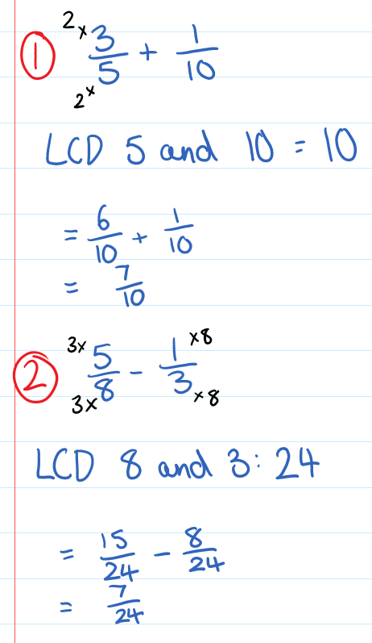 |  |  | What we think:  1. The LCD of 5 and 10 is 10.  2. Create an equivalent fraction with the new LCD  3. Add the fractions with the new LCD  1. The LCD of 8 and 3 is 24  2. Create equivalent fractions with the new LCD  3. Subtract the fractions with the new LCD
Your Turn:
1. $\frac{1}{6}+\frac{4}{12}$ | 2. $\frac{4}{7}+\frac{2}{5}$ | 3. $\frac{3}{4}-\frac{5}{8}$ |  | 4. $\frac{7}{8}-\frac{2}{9}$

Practice

4B ROUTINE QUESTIONS
- Calculate the following. Give all answers in simplified form. 4First Five Live
- $\frac{5}{6}+\frac{3}{8}$ | - $\frac{7}{10}-\frac{3}{5}$ | - $\frac{3}{4}-\frac{1}{6}$ | - $\frac{7}{8}+\frac{3}{5}$ | - $\frac{3}{4}-\frac{1}{12}$
- $\frac{5}{6}+\frac{8}{9}$ | - $\frac{2}{5}+\frac{1}{10}$ | - $\frac{4}{7}+\frac{1}{5}$ | - $\frac{6}{7}-\frac{3}{8}$ | - $\frac{4}{5}-\frac{1}{10}$
- $\frac{6}{7}-\frac{1}{14}$ | - $\frac{1}{2}-\frac{2}{7}$ | - $\frac{3}{4}-\frac{5}{8}$ | - $\frac{6}{7}-\frac{1}{8}$ | - $\frac{4}{7}-\frac{2}{9}$
- $\frac{4}{5}+\frac{1}{10}$ | - $\frac{1}{2}+\frac{4}{9}$ | - $\frac{2}{3}-\frac{2}{15}$ | - $\frac{1}{3}-\frac{1}{15}$ | - $\frac{5}{9}-\frac{1}{27}$
☑ Correction Time! Click here for answers

4B STRETCH questions
- Calculate the following.
- $\frac{3}{14}+\frac{5}{21}$ | - $\frac{7}{40}-\frac{1}{120}$ | - $\frac{5}{24}-\frac{1}{60}$ | - $\frac{7}{18}-\frac{11}{90}$ | - $\frac{7}{11}+\frac{5}{12}$
- Jackson is working on a 1000-piece jigsaw puzzle. After 1 week, he has completed $\frac{1}{10}$of the puzzle. After 2 weeks he has completed another $\frac{2}{5}$of the puzzle. In the third week, Jackson completed another $\frac{1}{4}$ of the puzzle.
  - By the end of the third week, what fraction of the puzzle has Jackson completed?
  - How many pieces of the puzzle does Jackson place in the second week?
  - What fraction of the puzzle is still unfinished by the end of the third week? How many pieces is this?

- Fill in the empty boxes to make the following fraction sums correct. Note that the numbers in the boxes are not necessarily the same.

- $\frac{1}{\boxed{]]]}}+\frac{1}{\boxed{]]]}}=\frac{7}{10}$ | - $\frac{1}{\boxed{]]]}}+\frac{1}{\boxed{]]]}}+\frac{1}{\boxed{]]]}}=\frac{7}{8}$ | - $\frac{3}{\boxed{]]]}}+\frac{\boxed{]]]}}{4}= \frac{17}{20}$

- (Challenge). Consider the sum of two fractions $\frac{\boxed{]]]}}{\boxed{]]]}}+\frac{\boxed{]]]}}{\boxed{]]]}} .$Where would you place the digits 2, 3, 4 and 5 so that the fraction sum has the smallest possible answer?
☑ Correction Time! Click here for answers
Finished Early? Head to the Early Finishers Page to engage in a game, puzzle or investigation.

Skill C: Enrichment Skill

Activate prior knowledge
Come up with an addition or subtraction question and place it in one of the regions in the Venn diagram
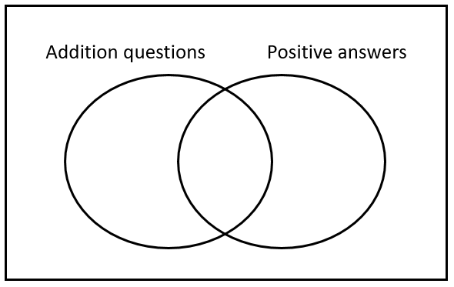
Extra questions once a class Venn has been filled in: What do you see, think wonder?

Explicit Teaching
[NEW PAGE] 4C: Adding and Subtracting Negative Fractions
- If an operation touches a sign, combine:
  - $+{}_{}^{-}→ -$
  - $-{}_{}^{-}→$ $+$
- Denominators must be the same before fractions can be added or subtracted
  - Combine numerators
  - Keep denominators
- Start at the first number, then
  - If adding a positive number, move $→$,
  - If subtracting a positive number, move $←$

Worked Examples:
1. $-\frac{2}{3}+\left(-\frac{7}{4}\right)$ |  | 2. $-\frac{5}{8}-\left(-\frac{3}{4}\right)$
What we write:  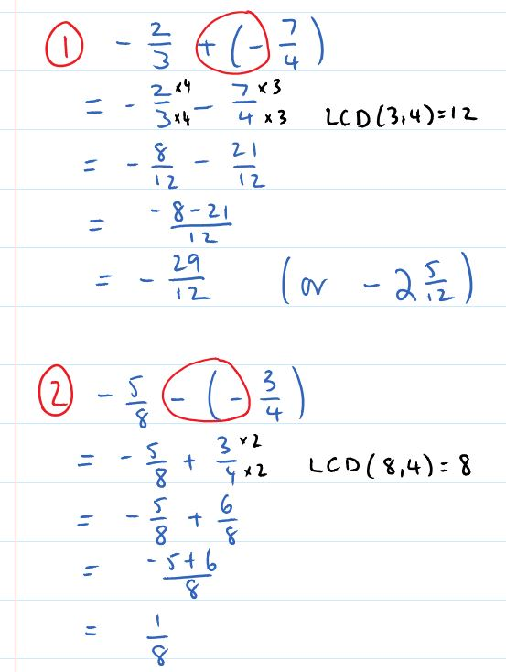 |  |  | What we think:  1. Operation is touching a sign, combine  2. Create common denominators using LCD  3. Combine numerators, keep denominators  1. Operation is touching a sign, combine  2. Create common denominators using LCD  3. Combine numerators, keep denominators
Your Turn:
1. $-\frac{1}{6}+\frac{4}{3}$ | 2. $\frac{4}{7}-\frac{12}{5}$ | 3. $\frac{3}{4}+\left(-\frac{5}{8}\right)$ |  | 4. $-\frac{7}{8}-\left(-\frac{2}{9}\right)$

4C ROUTINE QUESTIONS
- Calculate the following. 4First Five Live
- $-\frac{4}{5}+\frac{1}{10}$ | - $\frac{1}{2}-\frac{5}{9}$ | - $-\frac{2}{3}-\left(-\frac{11}{15}\right)$ | - $-\frac{1}{3}-\frac{1}{15}$ | - $\frac{1}{27}+\left(-\frac{5}{9}\right)$
- $-\frac{5}{6}+\frac{8}{9}$ | - $-\frac{2}{5}-\frac{1}{10}$ | - $\frac{4}{7}+\left(-\frac{1}{5}\right)$ | - $-\frac{6}{7}-\frac{3}{8}$ | - $\frac{1}{10}-\frac{4}{5}$
- $\frac{6}{7}-\left(-\frac{1}{14}\right)$ | - $\frac{2}{7}-\frac{1}{2}$ | - $-\frac{3}{4}-\left(-\frac{5}{8}\right)$ | - $-\frac{6}{7}+\frac{7}{8}$ | - $-\frac{4}{7}-\left(-\frac{2}{9}\right)$
- $\frac{3}{8}-\frac{5}{6}$ | - $-\frac{7}{10}+\frac{3}{5}$ | - $\frac{3}{4}-\left(-\frac{1}{6}\right)$ | - $-\frac{7}{8}-\frac{5}{7}$ | - $-\frac{3}{8}+\frac{3}{5}$
☑ Correction Time! Click here for answers

4C STRETCH questions
- If $a = -\frac{3}{5}$, $b = \frac{1}{2}$ and $c = \frac{3}{10}$, find:

- $a+b+c$ | - $a+b-c$ | - $c+b-a$ | - $c-(b+b)$
- Solve the following equations.
- $a+\frac{1}{8}=\frac{3}{4}$ | - $-\frac{4}{6}=b-\frac{2}{5}$ | - $-\frac{2}{3}={}_{}^{-}{\frac{1}{7}}+c$ | - $d-\frac{5}{12}=\frac{1}{2}$
- What number is halfway between $-\frac{2}{3}$ and $\frac{4}{5}$?
- (Challenge) Calculate the following without using your calculator.

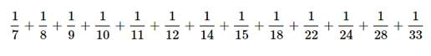
☑ Correction Time! Click here for answers
Finished Early? Head to the Early Finishers Page to engage in a game, puzzle or investigation.

Skill 4 Application Questions – Think, Pair, Share/Teacher Modelling
Answer the questions you can. Explain your reasoning for at least one of the questions.
You may use your calculator at any time.
1. | 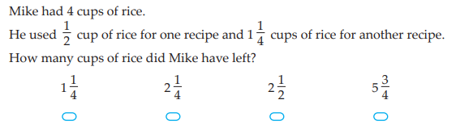
2. | 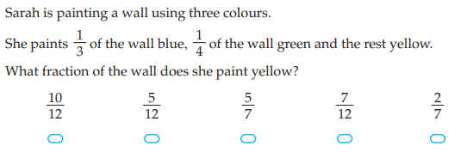
3. | 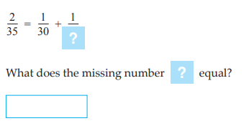
4. | - When 2/7 is written as a decimal, what number is in the 30th decimal place?  - How could you extend or generalise this problem?

Skill 4 Reasoning Questions

Entry | Core | Advanced
Explain why $\frac{1}{4}+\frac{1}{4}$ is not equal to $\frac{2}{8}$ | Explain why the following sum isn’t as hard as it looks. (That is, why don’t you need to start by finding the LCM of 800 and 2800?)  $$\frac{400}{800}+\frac{700}{2800}$$ | How do you find a fraction halfway between two fractions? For example, how would you find the fraction halfway between $-\frac{3}{7}$ and $\frac{2}{5}$?

COLLABORATIVE TASK:
Using the digits 1 to 9, at most one time each, place a digit in each box to make a true statement. Calculators can be used if needed.
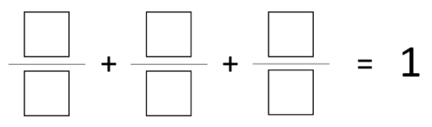

Assessment for Learning
Your progress will be monitored through your classwork and weekly homework sheets.

Reflection and Recognition
Let’s reflect on some key questions. Choose one or more of the questions below to answer.
- What must we have before fractions can be added or subtracted?
- How do we set out our work?
- Why must we have a common denominator before we can add or subtract fractions?
Let’s recognise something that went well and something that could be improved.
- What component of this work caused the most growth in your learning?
- Is there anything you’d like to improve?

Multiplying Fractions

Setting the Goal
Learning intentions:
            - What is the process for multiplying fractions?
            - Do fractions not need to have common denominators before they can be multiplied?
            - How do we set out our work?
            - Why is cancelling at the start of the process better than simplifying at the end?
Success criteria:
I can multiply fractions.

Skill A: Entry skill

Key words
The word product means multiply. For example, the product of 3 and 2 is 6 because $3 × 2 = 6$.

Activate prior knowledge
What fractions are shown here?

Explicit teaching
[NEW PAGE] 5A: Multiplying Fractions (simple case)
- Fractions do not need to have the same denominator to be multiplied.
- To multiply fractions, multiply the numerators and multiply the denominators.
Worked Examples:
1. $\frac{1}{3}×\frac{2}{5}$ |  |  | 2. $\frac{3}{8}×\frac{3}{7}$
What we write:  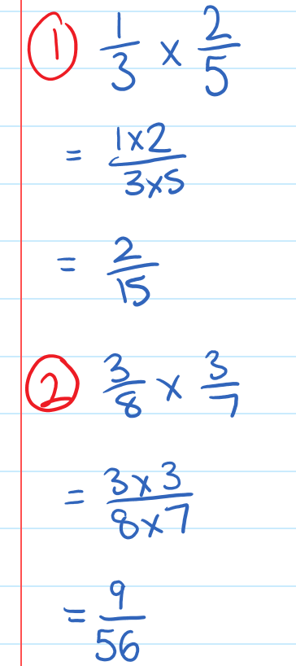 |  | What we think:  - Multiply the numerators.  - Multiply the denominators.  - Multiply the numerators  - Multiply the denominators
Your Turn:
1. $\frac{2}{3}×\frac{10}{11}$ |  |  | 2. $\frac{5}{7}×\frac{2}{3}$

PRACTICE

5A Routine questions
- Calculate the following. 4First Five Live
- $\frac{1}{5}×\frac{3}{8}$ | - $\frac{7}{10}×\frac{3}{5}$ | - $\frac{3}{4}×\frac{1}{5}$ | - $\frac{3}{8}×\frac{5}{7}$ | - $\frac{7}{8}×\frac{3}{5}$
- $\frac{5}{11}×\frac{8}{9}$ | - $\frac{3}{5}×\frac{1}{10}$ | - $\frac{4}{7}×\frac{1}{5}$ | - $\frac{1}{7}×\frac{3}{8}$ | - $\frac{1}{5}×\frac{7}{10}$
- $\frac{6}{7}×\frac{2}{5}$ | - $\frac{1}{2}×\frac{3}{7}$ | - $\frac{3}{4}×\frac{5}{8}$ | - $\frac{3}{7}×\frac{3}{8}$ | - $\frac{4}{7}×\frac{2}{9}$
- $\frac{4}{5}×\frac{1}{9}$ | - $\frac{1}{2}×\frac{5}{9}$ | - $\frac{2}{3}×\frac{2}{5}$ | - $\frac{1}{3}×\frac{1}{5}$ | - $\frac{5}{9}×\frac{1}{4}$

☑ Correction Time! Click here for answers

5A Stretch questions
- Calculate the following.
- $\frac{1}{10}×\frac{99}{100}$ | - $\frac{1}{1000}×\frac{1}{2}$ | - $\frac{5}{7}×\frac{99}{101}$ | - $\frac{1}{4}×\frac{25}{36}$ | - $\frac{13}{15}×\frac{1}{2}$
- Use each picture below to represent and answer the multiplication questions. These pictures are designed to help you to see why we multiply the numerators and denominators when multiplying fractions.
- $\frac{1}{4}×\frac{1}{5}$ | - $\frac{3}{4}×\frac{1}{5}$ | - $\frac{3}{4}×\frac{3}{5}$
- $\frac{1}{3}×\frac{1}{5}$ | - $\frac{2}{3}×\frac{1}{5}$ | - $\frac{2}{3}×\frac{4}{5}$
- In mathematics, the word ‘of’ means times. Replace the word ‘of’ with the symbol $×$ and then calculate the answer.
- $\frac{1}{2}$ of $\frac{1}{2}$ | - $\frac{1}{2}$ of $\frac{1}{3}$ | - $\frac{1}{4}$ of $\frac{1}{7}$ | - $\frac{1}{4}$ of $\frac{5}{7}$
- Calculate the following.
- $\frac{1}{2}$ of $24$ | - $\frac{1}{3}$ of $24$ | - $\frac{1}{6}$ of 24 | - $\frac{5}{6}$ of $24$
- Write two fractions that multiply to:
- $\frac{3}{5}$ | - $\frac{3}{4}$ | - $\frac{1}{7}$
- (Challenge) In each case the decimals have been converted to fractions. Calculate the product of the fractions, then give your final answer as a decimal. After calculating the products, explain why the number of decimal places in the question gives us the number of decimal places in the answer.

- $3.23×0.4$  $.\frac{323}{100}×\frac{4}{10}$ | - $0.65×7$  $\frac{65}{100}×\frac{7}{1}$ | - $4.2×0.7$  $\frac{42}{10}×\frac{7}{10}$ | - $5.34×0.2$  $\frac{534}{100}×\frac{2}{10}$

☑ Correction Time! Click here for answers to most questions

Finished Early? Head to the Early Finishers Page to engage in a game, puzzle or investigation.

Skill B: core skill

Activate prior knowledge
Calculate the following multiplications, in each case you will need to simplify your answer after multiplying the numerator and denominator.
- $\frac{8}{9}×\frac{7}{12}$ | - $\frac{10}{12}×\frac{5}{7}$ | - $\frac{4}{15}×\frac{10}{11}$

Explicit Teaching
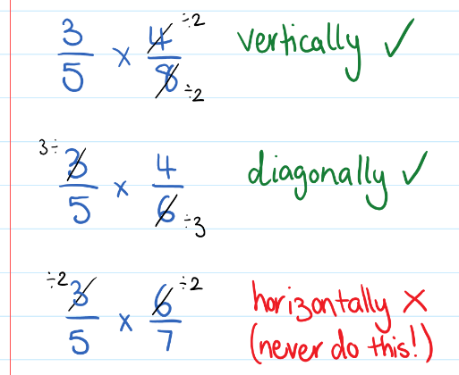
[NEW PAGE] 5B: Multiplying Fractions using Cancelling
- In order to make multiplying easier, we can simplify or ‘cancel’ before multiplying.
  - Cancelling can be done vertically or diagonally.
  - Cancelling can never be done horizontally.
  - Simplify where possible, you may even be able to ‘cancel’ more than once!
  - You may need to simplify again at the end.

Worked Examples:
1. $\frac{5}{4}×\frac{3}{10}$ |  |  | 2. $\frac{7}{9}×\frac{6}{10}$
What we write:  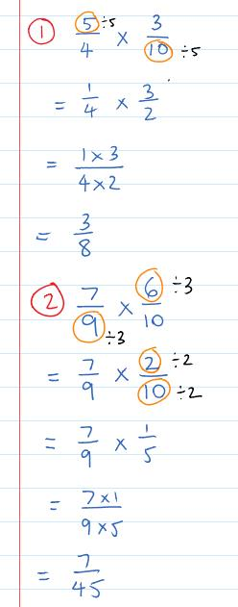 |  | What we think:  5 and 10 have a common factor of 5. Cancel these out diagonally.  Multiply the numerators and denominators.  6 and 9 have a common factor of 3. Cancel these out diagonally.  2and 10 have a common factor of 2. Cancel these out vertically.  Multiply the numerators and denominators.
Your Turn:
1. $\frac{4}{8}×\frac{3}{10}$ |  |  | 2. $\frac{8}{10}×\frac{15}{4}$

Practice

5B ROUTINE QUESTIONS
- Calculate the following by first cancelling any common factor that occurs in a numerator and denominator.
4First Five Live
- $\frac{3}{5}×\frac{2}{12}$ | - $\frac{7}{3}×\frac{2}{12}$ | - $\frac{4}{9}×\frac{7}{8}$ | - $\frac{9}{12}×\frac{7}{11}$
- $\frac{5}{7}×\frac{1}{5}$ | - $\frac{1}{2}×\frac{15}{18}$ | - $\frac{1}{2}×\frac{2}{4}$ | - $\frac{21}{27}×\frac{4}{10}$
- $\frac{3}{5}×\frac{4}{10}$ | - $\frac{5}{6}×\frac{3}{5}$ | - $\frac{3}{5}×\frac{2}{3}$ | - $\frac{7}{9}×\frac{14}{16}$
- $\frac{5}{8}×\frac{4}{7}$ | - $\frac{1}{3}×\frac{9}{10}$ | - $\frac{4}{5}×\frac{16}{18}$ | - $\frac{6}{7}×\frac{3}{4}$
- $\frac{4}{5}×\frac{1}{4}$ | - $\frac{9}{10}×\frac{4}{7}$ | - $\frac{6}{10}×\frac{3}{5}$ | - $\frac{6}{10}×\frac{3}{4}$
☑ Correction Time! Click here for answers

5B STRETCH questions
- Tallulah plants 60 tulip bulbs. When they flower, she notes the following:
Half the tulips are yellow
One third of those which are not yellow are red
One quarter of those which are neither red nor yellow are pink
The remainder are white
What fraction of the tulips are white?

- Charlie spent $\frac{1}{4}$ of his money on a book, gave his brother $\frac{2}{3}$ of what was left, and still had $9 remaining. How much money did he start off with?

- Using the clues provided, work out which two fractions are being discussed.
  - We are two proper fractions.
  - Altogether we consist of four different digits.
  - When added together our answer will still be a proper fraction.
  - When multiplied together you could carry out some cancelling.
  - The result of our product, when simplified, contains no new digits from our original four.
  - Three of our digits are prime numbers and the fourth digit is a cube number.
- (Challenge) Find the missing fractions
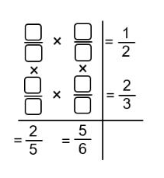

☑ Correction Time! Click here for answers

5C Routine Questions
- Use the method of cancelling to simplify the multiplication before answering. 4First Five Live
- $\frac{42}{8}×\frac{24}{189}$ | - $\frac{18}{56}×\frac{49}{126}$ | - $\frac{30}{8}×\frac{24}{174}$ | - $\frac{8}{16}×\frac{63}{90}$
- $\frac{14}{24}×\frac{5}{35}$ | - $\frac{2}{8}×\frac{108}{99}$ | - $\frac{6}{18}×\frac{4}{18}$ | - $\frac{6}{50}×\frac{100}{42}$
- $\frac{8}{30}×\frac{30}{40}$ | - $\frac{18}{27}×\frac{9}{30}$ | - $\frac{63}{45}×\frac{5}{18}$ | - $\frac{5}{36}×\frac{72}{45}$
- $\frac{30}{9}×\frac{8}{60}$ | - $\frac{36}{144}×\frac{30}{54}$ | - $\frac{36}{36}×\frac{6}{54}$ | - $\frac{18}{90}×\frac{9}{6}$
- $\frac{23}{63}×\frac{56}{84}$ | - $\frac{18}{18}×\frac{4}{54}$ | - $\frac{5}{24}×\frac{12}{10}$ | - $\frac{2}{90}×\frac{72}{6}$
☑ Correction Time! Click here for answers
Finished Early? Head to the Early Finishers Page to engage in a game, puzzle or investigation.

5C Stretch Questions
- Calculate the following by first cancelling any common factor that occurs in a numerator and denominator.
- $\frac{3}{4}×\frac{4}{5}×\frac{5}{6}$ | - $\frac{1}{2}×\frac{4}{6}×\frac{9}{12}×\frac{16}{20}$ | - $\frac{7}{12}×\frac{7}{12}×\frac{12}{7}×\frac{24}{14}$ | - $\frac{1}{2}×\frac{4}{7}×\frac{14}{9}×\frac{18}{20}$
- (Challenge) Calculate the following.
- $\left(1-\frac{1}{4}\right)\left(1-\frac{1}{9}\right)$ | - $\left(1-\frac{1}{4}\right)\left(1-\frac{1}{9}\right)\left(1-\frac{1}{16}\right)$
- $\left(1-\frac{1}{4}\right)\left(1-\frac{1}{9}\right)\left(1-\frac{1}{16}\right)\left(1-\frac{1}{25}\right)$ | - $\left(1-\frac{1}{4}\right)\left(1-\frac{1}{9}\right)\left(1-\frac{1}{16}\right)\left(1-\frac{1}{25}\right)\left(1-\frac{1}{36}\right)$

- (Challenge) Using your answers above, can you predict the answer to the following? Hint: First write each answer from the previous question with an even denominator.
$$\left(1-\frac{1}{4}\right)\left(1-\frac{1}{9}\right)\left(1-\frac{1}{25}\right)\left(1-\frac{1}{36}\right)…\left(1-\frac{1}{100}\right)$$
☑ Correction Time! Click here for answers
Finished Early? Head to the Early Finishers Page to engage in a game, puzzle or investigation.

Skill 5 Application Questions – Think, Pair, Share/Teacher Modelling
Answer the questions you can. Explain your reasoning for at least one of the questions.
You may use your calculator at any time.
1. | 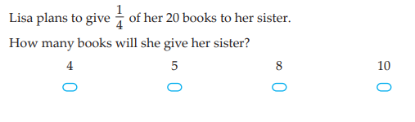
2. | 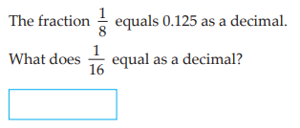
3. | 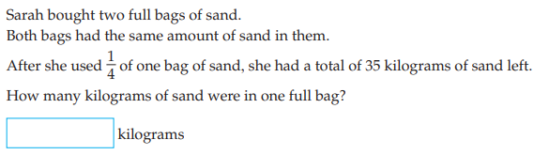
4. | A cube made of 27 red cubes is dipped in yellow paint so every face is covered.  - Of the 27 cubes, how many will have zero yellow faces? How many will have one yellow face? How many will have two yellow faces? How many will have three yellow faces? How many will have four yellow faces?  - How could you extend or generalise this problem?
  Before  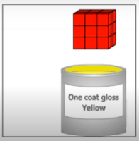 | After  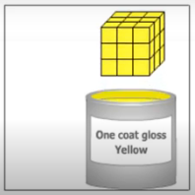

Skill 5 Reasoning Questions

Entry | Core | Advanced
Explain how this picture shows  $$\frac{4}{5}×\frac{2}{3}=\frac{8}{15}$$ | How is cancelling like simplifying? How is cancelling different from simplifying? | Explain why you can’t cancel horizontally

COLLABORATIVE TASK:
How many different 3-digit numbers can you make such that
- Their digits add to 1?
- Their digits add to 2?
- Their digits add to 3?
- Their digits add to 4?
- Their digits add to 5?
- Their digits add to 6?
- Their digits add to 7?
- Their digits add to 8?
- Their digits add to 9?
Can you see a pattern in your answers. Does this pattern go on forever? If so explain why, if not say when it stops.

Assessment for Learning
Your progress will be monitored through your classwork and weekly homework sheets.

Reflection and Recognition
Let’s reflect on some key questions. Choose one or more of the questions below to answer.
            - What is the process for multiplying fractions?
            - Do fractions need to have common denominators before they can be multiplied?
            - How do we set out our work?
            - Why is cancelling at the start of the process better than simplifying at the end?
Let’s recognise something that went well and something that could be improved.
- What component of this work caused the most growth in your learning?
- Is there anything you’d like to improve?

Dividing Fractions

Setting the Goal
Learning intentions:
            - What is the process for dividing fractions?
            - How do we set out our work?
            - Why can we “times and flip” when dividing by a fraction? [this is a stretch question!!]
Success criteria:
I can divide by a fraction.

Skill B: core skill

Key workds
A fractions reciprocal is the fraction flipped upside down. For example, the reciprocal of $\frac{2}{3}$is $\frac{3}{2}$ and the reciprocal of $4$ is $\frac{1}{4}$

Activate prior knowledge
Calculate the following multiplications
- $\frac{2}{5}×\frac{3}{7}$ | - $\frac{5}{9}×\frac{1}{4}$ | - $\frac{4}{3}×\frac{1}{12}$ | - $\frac{6}{5}×\frac{5}{2}$

Explicit Teaching
[NEW PAGE] 6A&B: Dividing Fractions
- When dividing by a fraction, multiply by the fraction’s reciprocal.
  - $\frac{a}{b}÷\frac{c}{d}$ = $\frac{a}{b}×\frac{d}{c}$
- You can remember this process as ‘Keep, change, flip’
  - Keep the first fraction
  - Change the sign to a multiplier
  - Flip the second fraction

Worked Examples:
1. $\frac{1}{3}÷\frac{4}{5}$ |  |  | 2. $\frac{4}{7}÷\frac{1}{14}$
What we write:  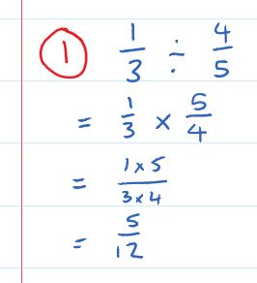  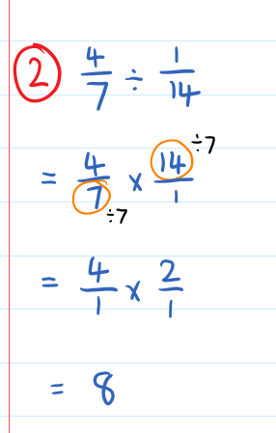 |  | What we think:  - Keep the first fraction, change the sign and flip the second fraction.  - Multiply numerators, multiply denominators  - Write answer  - Keep the first fraction, change the sign and flip the second fraction.  - 7 and 14 share a factor of 7. Cancel diagonally.  - Multiply. Note: Any fraction with a denominator of 1 should be written as a whole number.
Your Turn:
1. $\frac{5}{10}÷\frac{1}{2}$ |  |  | 2. $\frac{9}{2}÷\frac{3}{4}$

Practice

6A ROUTINE QUESTIONS (no cancelling required)
- Complete the following divisions. 4First Five Live
- $\frac{3}{4}÷\frac{5}{7}$ | - $\frac{5}{8}÷\frac{2}{9}$ | - $\frac{5}{2}÷\frac{9}{5}$ | - $\frac{5}{2}÷\frac{4}{3}$
- $\frac{3}{5}÷\frac{7}{2}$ | - $\frac{4}{3}÷\frac{3}{2}$ | - $\frac{2}{9}÷\frac{7}{5}$ | - $\frac{7}{2}÷\frac{2}{5}$
- $\frac{7}{5}÷\frac{4}{3}$ | - $\frac{3}{5}÷\frac{2}{7}$ | - $\frac{9}{7}÷\frac{4}{5}$ | - $\frac{5}{3}÷\frac{7}{2}$
- $\frac{2}{5}÷\frac{3}{2}$ | - $\frac{3}{2}÷\frac{4}{5}$ | - $\frac{5}{2}÷\frac{2}{7}$ | - $\frac{2}{7}÷\frac{9}{5}$
- $\frac{7}{4}÷\frac{5}{3}$ | - $\frac{2}{5}÷\frac{5}{7}$ | - $\frac{4}{9}÷\frac{5}{2}$ | - $\frac{3}{7}÷\frac{5}{2}$
☑ Correction Time! Click here for answers

6B ROUTINE QUESTIONS
- Complete the following divisions. 4First Five Live
- $\frac{3}{6}÷\frac{9}{8}$ | - $\frac{3}{4}÷\frac{5}{6}$ | - $\frac{4}{5}÷\frac{4}{7}$ | - $\frac{5}{10}÷\frac{3}{9}$
- $\frac{1}{9}÷\frac{4}{12}$ | - $\frac{6}{10}÷\frac{8}{10}$ | - $\frac{3}{8}÷\frac{1}{10}$ | - $\frac{4}{6}÷\frac{1}{5}$
- $\frac{9}{10}÷\frac{6}{9}$ | - $\frac{9}{10}÷\frac{4}{6}$ | - $\frac{8}{10}÷\frac{7}{8}$ | - $\frac{9}{10}÷\frac{4}{5}$
- $\frac{5}{6}÷\frac{9}{10}$ | - $\frac{5}{8}÷\frac{2}{6}$ | - $\frac{2}{3}÷\frac{2}{6}$ | - $\frac{1}{3}÷\frac{6}{10}$
- $\frac{3}{4}÷\frac{6}{7}$ | - $\frac{6}{7}÷\frac{3}{9}$ | - $\frac{1}{4}÷\frac{3}{4}$ | - $\frac{3}{10}÷\frac{4}{6}$
☑ Correction Time! Click here for answers

6B STRETCH questions
- Complete the following divisions.
- $\frac{7}{18}÷\frac{14}{27}$ | - $\frac{5}{24}÷\frac{15}{16}$ | - $\frac{72}{100}÷\frac{16}{25}$
- Pair up the equivalent expressions and state the simplified answer.
$\frac{1}{2}$ of $8$ | $$12÷4$$ | $$10×\frac{1}{2}$$ | $$10÷2$$
$$3÷\frac{1}{2}$$ | $$12×\frac{1}{4}$$ | $$\frac{1}{2}÷\frac{1}{8}$$ | $$3×2$$
- Evaluate the following.
- $\frac{4}{9}×\frac{3}{5}÷\frac{7}{15}$ | - $\frac{1}{2}÷\frac{1}{2}÷\frac{1}{2}÷\frac{1}{2}÷\frac{1}{2}$ | - $\frac{1}{2}×\frac{1}{2}÷\frac{1}{2}×\frac{1}{2}÷\frac{1}{2}×\frac{1}{2}$
- (Challenge) Each fraction in the equations below are in simplified form. Determine the values of the unknowns in each equation.
- $\frac{3}{4}÷\frac{a}{b}=\frac{9}{4}$ | - $\frac{3}{4}÷\frac{c}{d}=\frac{15}{4}$ | - $\frac{3}{4}÷e=\frac{3}{20}$
- $\frac{3}{4}÷f=\frac{3}{28}$ | - $\frac{3}{4}÷\frac{g}{h}=\frac{3}{2}$ | - $\frac{3}{4}÷\frac{i}{j}=6$
- $\frac{3}{4}÷\frac{k}{l}=\frac{7}{3}$ | - $\frac{3}{4}÷\frac{m}{n}=\frac{4}{5}$ | - $\frac{3}{4}÷\frac{p}{q}=\frac{5}{6}$

- (Challenge) Explain why each of the following equations is true. You will likely need to use part a. to help with part b. and part b. to help with part c. etc.
- $\frac{c}{d}×\frac{d}{c}=1$ | - $1÷\frac{c}{d}=\frac{d}{c}$ | - $1÷\frac{c}{d}=1×\frac{d}{c}$ | - $\frac{a}{b}÷\frac{c}{d}=\frac{a}{b}×\frac{d}{c}$
☑ Correction Time! Click here for answers
Finished Early? Head to the Early Finishers Page to engage in a game, puzzle or investigation.

SKILL C: ENRICHMENT SKILL

Activate prior knowledge
Convert the following to improper fractions
- $3\frac{2}{5}$ | - $1\frac{4}{7}$ | - $7$ | - $8$

Explicit Teaching
[NEW PAGE] 6C Part 1: Using the four operations with mixed numbers
- Using the four operations with mixed numbers can be quite difficult.
- To make it much simpler (in most cases), convert mixed numbers to improper fractions, then solve as in previous exercises!
  - A whole number can be written as an improper fraction with a denominator of 1. Eg. $4=\frac{4}{1}$
  - Don’t forget to simplify your final solution and convert back to a mixed number as required.
  - Final answers never have a denominator of 1.

Worked Examples:
1. $4\frac{1}{3}-1\frac{2}{3}$ | 2.$1\frac{2}{7}×7$ |  | 3. 2$\frac{4}{5}÷7$
What we write:  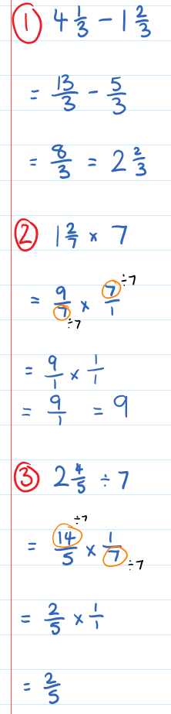 |  | What we think:  Convert mixed numbers to improper fractions and then calculate using standard methods.  Convert mixed numbers and whole numbers to improper fractions (7 is written as an improper fraction with a denominator of 1) and then calculate using standard methods.  Recall that final answers never have a denominator of 1 so we re-write $\frac{9}{1}$as $9.$  Convert mixed numbers and whole numbers to improper fractions (7 is written as an improper fraction with a denominator of 1) and then calculate using standard methods.
Your Turn:
1. $2\frac{4}{5}-1\frac{1}{5}$ | 2. $3\frac{3}{10}×\frac{2}{11}$ |  | 3.$1\frac{2}{3}÷3$

Practice

6C Part 1 ROUTINE QUESTIONS
      - Calculate the following showing all appropriate working. 4First Five Live
- $3\frac{1}{5}-1\frac{2}{5}$ | - $4\frac{1}{3}÷5$ | - $1\frac{3}{5}-\frac{4}{5}$ | - $1\frac{2}{3}×3$
- $2\frac{1}{5}÷\frac{1}{2}$ | - $1\frac{4}{5}×7$ | - $1\frac{1}{2}×4$ | - $3\frac{1}{5}-1\frac{2}{5}$
- $1\frac{2}{3}÷\frac{1}{5}$ | - $3\frac{4}{5}÷7$ | - $1\frac{1}{3}÷4$ | - $2\frac{1}{3}×\frac{2}{3}$
- $3\frac{1}{6}÷5$ | - $3\frac{4}{5}÷\frac{4}{5}$ | - $3\frac{1}{4}÷7$ | - $2\frac{1}{4}÷2$
- $1\frac{3}{4}÷3$ | - $1\frac{1}{4}-\frac{2}{4}$ | - $2\frac{2}{3}÷4$ | - $3\frac{2}{5}÷5$
☑ Correction Time! Click here for answers

6C Part 1 STRETCH questions
      - Calculate the following.
- $1\frac{2}{5}-3\frac{1}{5}$ | - $-1\frac{3}{10}-{}_{}^{-}{\frac{4}{5}}$ | - $-\frac{13}{5}+3$ | - $-3\frac{2}{5}-3\frac{5}{8}$
      - Complete the following substitutions:
- Substitute $a=\frac{1}{3}$ into $-3a$ and evaluate | - Substitute $b=-\frac{1}{5}$ into $-3b$ and evaluate | - Substitute $c=-\frac{5}{4}$ into $c^{2}$ and evaluate
- Substitute $d=\frac{4}{9}$ into $-\sqrt{d}$ and evaluate | - Substitute $e=-\frac{2}{3}$ into $54e^{3}$ and evaluate | - Substitute $f=-\frac{1}{2}$ into  $3f^{2}+f$ and evaluate
- Substitute $g=-\frac{3}{4}$ into $-2g^{2}-g$ and evaluate | - Substitute $h=-\frac{1}{3}$ into  $2h^{3}+h^{2}-5h$ and evaluate | - Substitute $i=-\frac{2}{5}$ into  $100i^{2}+30i$ and evaluate

      - Complete the following worded problems.
- The sum of two fractions is $\frac{11}{9}$. One of the fractions is $\frac{1}{3}$. What is the other fraction?
- Jake shares his liquorice strap equally between himself and 5 friends. If the strap is $1\frac{2}{3}$m long, how much will each person get?
- Find the average of $2\frac{1}{3}$ and $5\frac{1}{4}$.

      - Solve the following equations.
- $4x=2\frac{1}{3}$ | - $3\frac{2}{5}=\frac{x}{7}$ | - $4\frac{3}{5}=x-1$ | - $4\frac{3}{5}=x+9$
      - (Challenge) Mixed number multiplying.
$$\boxed{}\frac{\boxed{}}{\boxed{}} ×\boxed{}\frac{\boxed{}}{\boxed{}}$$
Rules:
- The six boxes must use all of the digits, 1 to 6.
- The fractional parts of the mixed numbers must be proper fractions (less than 1)

- What is the smallest number that can be made? (smaller than $4\frac{1}{3}$)
- What is the largest number that can be made? (larger than $36\frac{1}{4}$)
- How can these whole numbers be made?
- $\boxed{1}\frac{\boxed{}}{\boxed{}} ×\boxed{3}\frac{\boxed{}}{\boxed{}}=6$ | - $\boxed{6}\frac{\boxed{}}{\boxed{}} ×\boxed{1}\frac{\boxed{}}{\boxed{}}=12$
- $\boxed{}\frac{\boxed{}}{\boxed{}} ×\boxed{}\frac{\boxed{}}{\boxed{}}=28$

☑ Correction Time! Click here for SOME answers
Finished Early? Head to the Early Finishers Page to engage in a game, puzzle or investigation.

SKILL C: ENRICHMENT SKILL

Activate prior knowledge
Solve the following equations
- $5x+7=22$ | - $4+3z=13$ | - $18=2y+10$

Explicit Teaching
[NEW PAGE] 6C Part 2: Solving Equations with Fractional Solutions
- Sometimes when we solve for a pronumeral, the solution is not a whole number. However, this does not mean we solve them any differently to what we already know! Simply, give your final answer as a fraction!
  - Remember, whatever you do to one side, you must do to the other side!

Worked Examples:
1. $3x=1$ | 2. 8$x=3$ |  |  | 3. $9x+3=10$ |  | 4. $7=8x-5$
What we write:  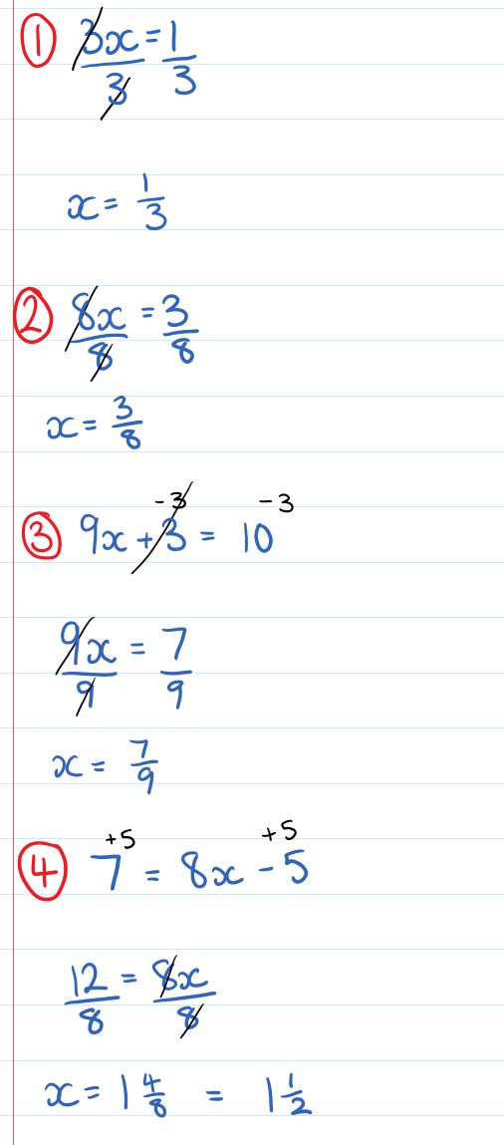 |  | What we think:  To solve for$x$, divide both sides by 3. Since dividing 1 by 3 does not give a whole number we leave the answer as a fraction.  To solve for$x$, divide both sides by 8. Since dividing 3 by 8 does not give a whole number we leave the answer as a fraction.  𝑥→ $×$ 9 → + 3. Undo the final step.  The opposite operation of + 3 is − 3. We − 3 from both sides  The opposite operation of $×$ 9 is ÷ 9. We ÷ both sides by 9.  Since dividing 7 by 9 does not give a whole number we leave the answer as a fraction.  𝑥→ $×$ 8 → − 5. Undo the final step.  The opposite operation of − 5 is + 5. We + 5 to both sides  The opposite operation of $×$ 8 is ÷ 8. We ÷ both sides by 8.  Since dividing 12 by 8 does not give a whole number we leave the answer as a fraction. However here we must convert the improper fraction to a mixed number and simplify.
Your Turn:
1. $8x=9$ |  |  | 2. $2x +3=8$ |  | 3. $15=12x-5$

Practice

6C (Part 2) ROUTINE QUESTIONS
- Solve the following equations. 4First Five Live
- $6x+5=13$ | - $9=3x+7$ | - $10=7+2x$ | - $10x-7=8$
- $8x-2=5$ | - $2=9x-4$ | - $8x+6=7$ | - $3=7x-6$
- $11=2x+8$ | - $4x+2=16$ | - $13=9x-10$ | - $8x-5=17$
- $14=2x+9$ | - $24=7x+4$ | - $3x-2=2$ | - $9x-3=25$
- $8x-8=4$ | - $5=12x-3$ | - $7=6x-8$ | - $2x+12=21$
☑ Correction Time! Click here for answers

6C (pART 2) STRETCH questions
- Solve the following. Include working that shows your use of opposite operations. Hint, sometimes it makes sense to create common denominators and equate the numerators.
- $\frac{x+3}{5}=\frac{2}{3}$ | - $\frac{16}{5}=\sqrt{x}+3$ | - $4x-9={}_{}^{-}{\frac{3}{5}}$ | - $\frac{2}{7}=\frac{x+3}{2}$
- $5\left(x-6\right)={}_{}^{-}{\frac{1}{9}}$ | - $\frac{5}{4}=\frac{x}{4}+4$ | - $\frac{4}{9}=2\left(x+12\right)$ | - $4x+4=\frac{7}{5}$
- $x+6=\frac{5}{11}$ | - $5\left(x-4\right)={}_{}^{-}{\frac{4}{7}}$ | - ${}_{}^{-}{\frac{7}{5}}=\frac{x-2}{6}$ | - ${}_{}^{-}{\frac{7}{11}}=2\left(x-5\right)$
- ${}_{}^{-}{\frac{5}{3}}=5\left(x-8\right)$ | - $\frac{9}{2}=3\left(x+7\right)$ | - $\frac{x-3}{5}={}_{}^{-}{\frac{12}{7}}$ | - $4\left(x+1\right)=\frac{4}{7}$
- ${}_{}^{-}{\frac{1}{5}}=2\left(x-11\right)$ | - $\frac{x-4}{2}={}_{}^{-}{\frac{3}{8}}$ | - ${}_{}^{-}{\frac{7}{6}=\frac{x-4}{5}}$ | - $9x-10={}_{}^{-}{\frac{11}{2}}$
☑ Correction Time! Click here for answers

Skill 6 Application Questions – Think, Pair, Share/Teacher Modelling
Answer the questions you can. Explain your reasoning for at least one of the questions.
You may use your calculator at any time.
1. | What is three-quarters divided by five-sevenths?
  - $\frac{15}{28}$ | - $\frac{21}{20}$ | - $\frac{28}{15}$ | - $\frac{20}{21}$
2. | A farmer buys a truckload of 30 bales of hay to feed his cattle. He intends to feed his cattle two thirds of a bale each day to supplement their diets. For how many days will this load last?
  - $36$ | - $39$ | - $42$ | - $45$ | - $48$
3. | Jean had an unusual experience while shopping; she found that every time she bought something, it took exactly 20% of the money she had in her purse. She bought three items, and finished her shopping with $64 in her purse. How many dollars did she have at the beginning of her shopping?
4. | A fraction with a numerator of 1 is called a unit fraction. Here are different sums of unit fractions which make $\frac{1}{6}$.  $$\frac{1}{7}+\frac{1}{42}=\frac{1}{6} \frac{1}{8}+\frac{1}{24}=\frac{1}{6} \frac{1}{9}+\frac{1}{18}=\frac{1}{6} \frac{1}{10}+\frac{1}{15}=\frac{1}{6}$$  - How many ways can you write $\frac{1}{8}$ as the sum of two different unit fractions?  - How could you extend or generalise this problem?

Skill 6 Reasoning Questions

Entry | Core | Advanced
How do you find the reciprocal of a fraction? | Is the following always, sometimes or never true?  “Dividing a fraction by another  fraction makes it larger”  Give reasons for your answer. | Why is the answer to a divided by b the reciprocal of the answer to b divided by a?

COLLABORATIVE TASK:
Here is a song about adding fractions. Create your own song song to help someone remember how to add, subtract, multiply or divide fractions.

Assessment for Learning
Your progress will be monitored through your classwork and weekly homework sheets.

Reflection and Recognition
Let’s reflect on some key questions. Choose one or more of the questions below to answer.
            - What is the process for dividing fractions?
            - How do we set out our work?
            - Why can we “times and flip” when dividing by a fraction? [this is a stretch question!!]
Let’s recognise something that went well and something that could be improved.
- What component of this work caused the most growth in your learning?
- Is there anything you’d like to improve?

Early Finisher Activities
Games | Puzzles | Investigations

Games
Individual Games:
- https://www.transum.org/Maths/Activity/PhET/Fraction_Matcher.asp - Fraction matcher game
- https://www.transum.org/Maths/Activity/Fractions/Pizzas.asp?Level=1 - Equivalent fraction activity
- https://www.topmarks.co.uk/maths-games/hit-the-button - Timed practice for number bonds and times tables. What is the best score you can get?
- https://incoherency.co.uk/countdown/practice/#numbers – Countdown Numbers Game
- https://www.brainpop.com/games/pearldiver/?topic_id - Number line game
Games in Pairs:
- Fraction “guess who.” Each player chooses one of the fractions from the list below and writes it down secretly. Take turns asking Yes/No questions to try and work out your opponent’s number.
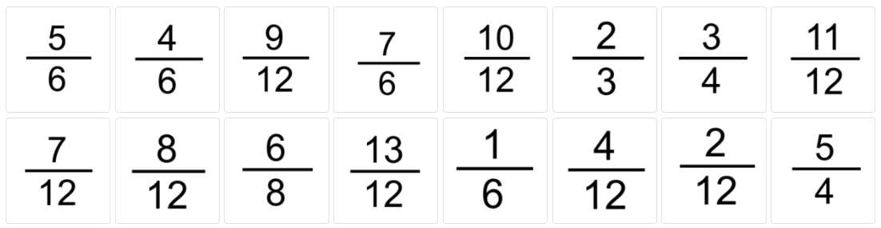

Puzzles
- What fraction of the whole square is shaded?
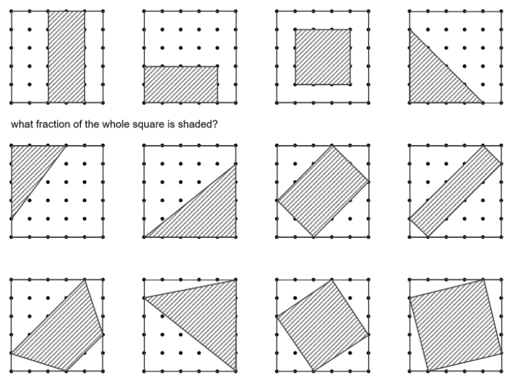
- Complete these addition pyramids
   |  | $$?$$
   | $$\frac{?}{20}$$ |  | $$\frac{?}{20}$$
  $$\frac{1}{5}$$ |  | $$\frac{1}{4}$$ |  | $$\frac{3}{10}$$
   |  | $$1$$
   | $$\frac{?}{12}$$ |  | $$\frac{?}{12}$$
  $$\frac{1}{?}$$ |  | $$\frac{1}{4}$$ |  | $$\frac{1}{6}$$
   |  | $$1$$
   | $$\frac{?}{18}$$ |  | $$\frac{?}{18}$$
  $$\frac{5}{9}$$ |  | $$\frac{1}{?}$$ |  | $$\frac{1}{9}$$
- Solve the following puzzles
- $\frac{1}{3}+\frac{6}{J}=1$ | - $\frac{2}{5}+\frac{6}{J}=\frac{7}{10}$ | - $\frac{3}{4}+\frac{6}{J}=\frac{11}{12}$
- $\frac{2}{3}+\frac{6}{J}=\frac{11}{12}$ | - $\frac{2}{3}+\frac{6}{J}=\frac{8}{15}$
Questions 1-3 from Don Steward’s Median

- Fraction Sudoku (will likely need to be printed). See below for rules.
The small clue-numbers in this Sudoku puzzle are simplified fractions. The clue-numbers are always placed on the border lines between selected pairs of neighbouring cells of the grid. Each clue-number on a vertical border line or horizontal border line is the fraction of the two numbers in the horizontally connecting cells or vertically connecting cells respectively. For example, the four possible number placements for the 2/3 clue are shown below.
The remaining rules are as in a "standard" Sudoku, and the object of the puzzle is to fill in the whole 9x9 grid with numbers from 1 to 9 (one number per cell) so that each horizontal line, each vertical line, and each of the nine 3x3 squares (outlined with the bold lines) must contain all the nine different numbers 1 to 9.
Source: nrich

Investigations
- Unit fractions (fractions which have numerators of 1) can be written as the sum of two different unit fractions. For example
$$\frac{1}{2}=\frac{1}{3}+\frac{1}{6}$$
  - Charlie thought he'd spotted a rule and made up some more examples.
$$\frac{1}{2}=\frac{1}{10}+\frac{1}{20}$$ | $$\frac{1}{3}=\frac{1}{4}+\frac{1}{12}$$ | $$\frac{1}{3}=\frac{1}{7}+\frac{1}{21}$$ | $$\frac{1}{4}=\frac{1}{5}+\frac{1}{20}$$
Which of Charlie’s examples are correct?
  - Find some other examples using the patterns you’ve noticed from Charlie’s correct sums.
  - Explain to Charlie how he could generate lots of different examples.

- Continuing our work from above we now look at unit fractions that can be written as the sum of two different unit fractions in more than one way.
  - Allison started playing around with $\frac{1}{6}$ and found 4 different unit fraction sums.
$$\frac{1}{6}=\frac{1}{7}+\frac{1}{42}$$ | $$\frac{1}{6}=\frac{1}{8}+\frac{1}{24}$$ | $$\frac{1}{6}=\frac{1}{9}+\frac{1}{18}$$ | $$\frac{1}{6}=\frac{1}{10}+\frac{1}{15}$$
By looking for patterns in Allison’s answers, how many different unit fraction sums can you create for $\frac{1}{8}$?
Hint: Work systematically and see which of the following sums work: $\frac{1}{8}=\frac{1}{9}+?$, $\frac{1}{8}=\frac{1}{10}+?$, $\frac{1}{8}=\frac{1}{11}+?$
  - Which unit fractions can be made with a unit fraction sum in more than one way? Which unit fractions can be made with a unit fraction sum in one way only?
  - Test your theories to your response to part b by choosing different fractions. You may like to use a calculator to test your theory out for some large denominators. Alternatively, you may like to explore algebraic proofs if you have these skills in your mathematical toolbox ☺

- Consider the following 5 products.
$$\frac{3}{4}×\frac{2}{3}=\frac{1}{2}$$ | $$\frac{2}{4}×\frac{1}{3}=\frac{1}{6}$$ | $$\frac{3}{6}×\frac{2}{5}=\frac{1}{5}$$ | $$\frac{2}{3}×\frac{1}{2}=\frac{1}{3}$$ | $$\frac{6}{10}×\frac{5}{9}=\frac{1}{3}$$

These products are all special in that that are all of the form
$$\frac{a}{b}×\frac{a-1}{b-1}=\frac{1}{n}$$

  - Find some more products of this form.
  - Describe how you can find infinitely many fractions of this form.

- Some fractions, like $\frac{1}{5}$ produce terminating decimals like 0.2. Some fractions, like $\frac{1}{3}$ produce recurring decimals like 0.333…. Classify each unit fraction from $\frac{1}{2}$to $\frac{1}{20}$ as terminating or recurring. Do you notice anything in common about the denominators of unit fractions that produce terminating decimals? Can you explain why these types of denominators will always result in a terminating decimal?

- This investigation looks at how we can convert between interesting fractions and recurring decimals.
  - Convert the following fractions to recurring decimals using short division. (They aren’t as difficult as they look)
i. $\frac{1}{9}$ ii. $\frac{1}{99}$ iii. $\frac{1}{999}$ iv. $\frac{1}{9999}$
  - How could you use the above information to represent the following recurring decimals as fractions?
i. $0.\dot{2}=0.222…$ | ii. $0.\dot{4}=0.444…$ | iii. $0.\overline{02}=0.020202…$
iv. $0.0\dot{2}=0.02222…$ | v. $0.1\dot{2}=0.12222…$ | vi. $0.\overline{12}=0.121212…$
vii. $0.\overline{123}=0.123123123…$

  - The following examples show an algebraic approach for converting recurring decimals to fractions.
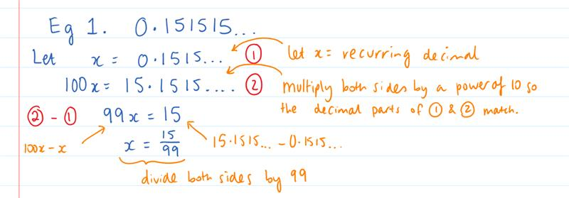
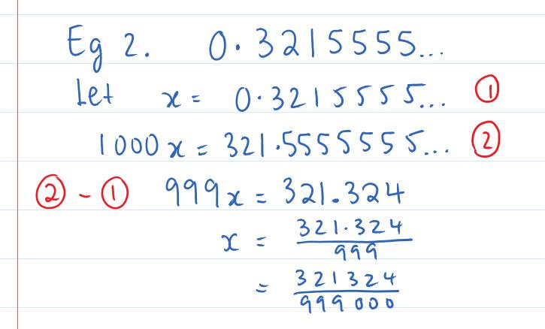
Use this method to confirm your answers to part b.

- The period of a decimal, is the number of digits which repeat. For example, $\frac{1}{3}=0.333…=0.\overline{3}$ has a period of 1, and $\frac{1}{11}=0.090909…=0.\overline{09}$ has a period of 2.
  - Use short division to show that the fraction $\frac{1}{7}$ has a period of 6.
  - The maximum period of a fraction $\frac{1}{n}$ is $n-1$. The first fraction to attain this maximum is $\frac{1}{7}$, what is the next value of $n$ for which this occurs?
  - Explain why the period of $\frac{1}{n}$ couldn’t possibly be any bigger than $n-1$.
  - If interested, you may like to do a little research on ‘Reptend Primes’

- Use each diagram to determine the value of each infinite sum.
a. $\frac{1}{2}+\frac{1}{4}+\frac{1}{8}+\frac{1}{16}+…$ | b. $\frac{1}{4}+\frac{1}{16}+\frac{1}{64}+\frac{1}{256}+…$
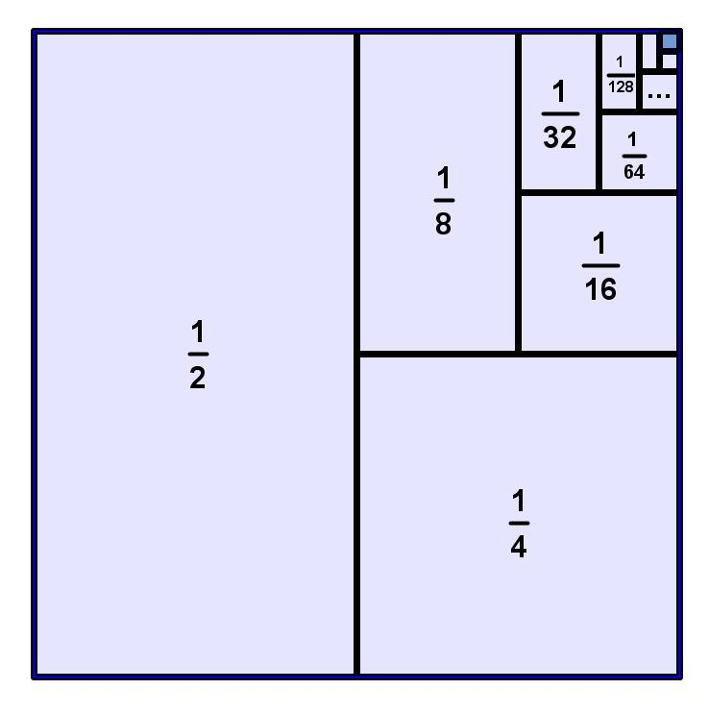 | 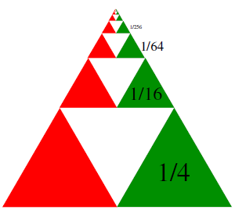

- What fraction of the square is shaded blue?
a.  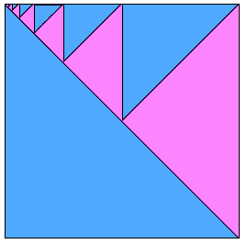 | b.  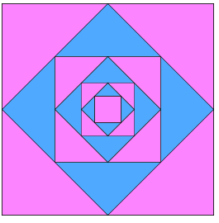

Answers

1A Routine Questions (ans)
1. a. $\frac{4}{9}$ b. $\frac{3}{4}$ c. $\frac{1}{4}$ d. $\frac{1}{4}$ e. $\frac{5}{9}$ f. $\frac{5}{8}$ g. $\frac{1}{9}$ h. $\frac{4}{5}$ i. $\frac{6}{7}$ j. $\frac{2}{3}$k. $\frac{3}{4}$ l. $\frac{3}{8}$ m. $\frac{5}{6}$
n. $\frac{5}{8}$ o. $\frac{3}{10}$ p. $\frac{2}{9}$ BackToQns

1A Stretch Questions (ans)
2. a. $\frac{12}{43}$ b. $\frac{13}{15}$ c. $\frac{1}{12}$ d. $\frac{3}{7}$ 3. $\frac{1}{5}$ a. 50ml 4. a. F b. T c. F d. T e. F f. T 5. a. $\frac{3}{4}$ b. $\frac{1}{3}$ c. $\frac{3}{5}$ d. $\frac{2}{5}$ e. $\frac{3}{7}$ f. $\frac{5}{8}$ BackToQns

1B Routine Questions (ans)
1.a. 8 b. 18 c. 12 d. 21 e. 20 f. 4 g. 5 h. 15 i. 5 j. 7 k. 14 l. 20 m. 12 n. 4 o. 20 p. 20 q. 8 r. 9 s. 4 t. 9 BackToQns

1B Stretch Questions (ans)
2. a. 8 b. 2 c. 12 d. 2 e. 200 f. 35 g. 203 h. 288
3. a.
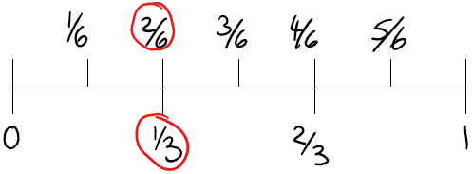
b.
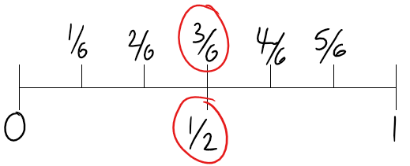
c.
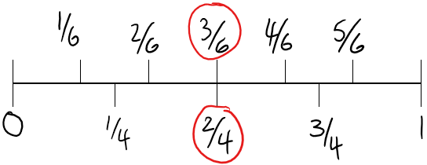
d.
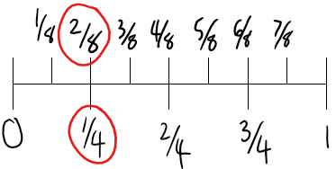
4. a. 5, 25, 40 b. 8, 51, 75 c. 2, 90, 72 5. Justin: 4, Joanna: 3, Jack: 5 6. $\frac{3}{4}=\frac{9}{12}=\frac{6}{8}$ BackToQns

1C Routine Questions (ans)
1.a. 12 b. 13 c. 1 d. 55 e. 46 f. 2 g. 36 h. 2 i. 12 j. 13 k. 4 l. 28 m. 47 n. 4 o. 19 p. 3 q. 30 r. 1 s. 28 t. 1 BackToQns

1C Stretch Questions (ans)
2. a. $2\frac{17}{100}$ b. $27\frac{1}{4}$ c. $30\frac{6}{7}$ d. $33\frac{5}{9}$ 3. a. 11 b. 9 c. $4x-1$ d. $3y-1$ e. $mn$ 4. $3\frac{1}{4}$ or $\frac{13}{4}$ b. $4\frac{3}{4}$ or $\frac{19}{4}$ c. $-\frac{1}{3}$
d. $-1\frac{2}{3}$ or $-\frac{5}{3}$ 5. One possible solution is $\boxed{2}\frac{\boxed{3}}{8}=\frac{\boxed{1} \boxed{9}}{8}$, how many different solutions can you find? BackToQns

2A Routine Questions (ans)
1.a. $\frac{1}{3}$ b.$\frac{4}{11}$ c. $\frac{11}{12}$ d. $\frac{8}{9}$ e. $\frac{4}{5}$ f. $\frac{4}{5}$ g. $\frac{1}{2}$ h. $\frac{3}{4}$ i. $\frac{2}{3}$ j. $\frac{10}{11}$ k. $\frac{3}{5}$ l. $\frac{4}{7}$ m. $\frac{1}{2}$ n. $\frac{5}{8}$ o. $\frac{5}{6}$ p. $\frac{7}{8}$ q. $\frac{9}{11}$ r. $\frac{2}{7}$ s. $\frac{5}{6}$ t. $\frac{9}{10}$ BackToQns

2B Routine Questions (ans)
2.a.$\frac{3}{7}$ b.$\frac{4}{5}$ c. $\frac{4}{5}$ d. $\frac{1}{5}$ e. $\frac{1}{2}$ f. $\frac{3}{4}$ g. $\frac{1}{10}$ h. $\frac{5}{7}$ i. $\frac{1}{2}$ j. $\frac{1}{2}$ k. $\frac{3}{4}$ l. $\frac{3}{10}$ m. $\frac{4}{7}$ n. $\frac{3}{4}$ o. $\frac{1}{4}$ p. $\frac{8}{9}$ q. $\frac{1}{5}$ r. $\frac{4}{5}$ s. $\frac{1}{3}$ t. $\frac{8}{15}$ BackToQns

2B Stretch Questions (ans)
3. a. $\frac{1}{3}$ b. $\frac{1}{3}$ c. $\frac{1}{3}$ They are all equal to $\frac{1}{3}$
4. a. $\frac{4}{14}=\frac{8}{28}$Alex ate more pie b. $\frac{12}{28}=\frac{6}{14}$ 5. a. $x=20$ b. $y=48$ c. $c=512$ 6. Check on your calculator
7. 1824 8. 21 (Can you list them?) BackToQns

2c Routine Questions (ans)
1.a. > b. < c. = d. > e. < f. > g. < h. = i. > j. < k. > l. = m. > n. > o. > p. > q. > r. = s. > t. = BackToQns

2c Stretch Questions (ans)
2. a. $\frac{1}{4}$ b. $\frac{1}{11}$ c. $\frac{1}{8}$ ($\frac{1}{4}$, $\frac{1}{8}$, $\frac{1}{11}$) 3. Answers may vary. a. $\frac{13}{20}$ b. $\frac{1}{3}$ c. $\frac{5}{21}$ 4. a. 7, 8 b. 16
5. Answers may vary. $\frac{1+2}{9}<1, \frac{3+5}{8}=1, \frac{4+6}{7}>1$
6. Guarav might have started with a lower income in the first place, meaning that it may increase by a lower amount than Gen. BackToQns

3A Routine questions (ans)
1.a. 0.3 b. 0.07 c. 0.9 d. 0.1 e. 0.01 f. 0.7 g. 0.09 h. 0.03
i. 0.4 j. 0.08 2.a. $\frac{1}{100}$ b. $\frac{7}{10}$ c. $\frac{3}{100}$ d. $\frac{3}{10}$ e. $\frac{9}{10}$ f. $\frac{7}{100}$ g. $\frac{9}{100}$
h. $\frac{1}{10}$ i. $\frac{5}{10}$ or $\frac{1}{2}$ j. $\frac{5}{100}$ or $\frac{1}{20}$ BackToQns

3A Stretch Questions (ans)
3. a. 0.003 b. 0.03 c. 0.037 d. 0.37 4. a. $\frac{35}{100}=0.35$
b. $\frac{18}{100}=0.18$ c. $\frac{80}{100}=0.8$ d. $\frac{625}{1000}=0.625$ 5.a. $\frac{7}{10000}$
b. $\frac{41}{10 000}$ c. $\frac{137}{100 000}$ d. $\frac{237}{100}$ 6. a. $\frac{9}{20}$ b. $2\frac{1}{2}$ c. $6\frac{8}{25}$ d. $\frac{7}{1250}$
7. a. C.C, C.A, B.C, B.A, A.C, A.B b. C.BC, C.AB, B.CA, B.BB, A.CA, A.BC, A.AA, BA.CA, AB.AB BackToQns

3B Routine Questions (ans)
1.a. 78%, $\frac{39}{50}$ b. 4%, 0.04 c. $\frac{2}{5}$, 0.4 d. 30%, $\frac{3}{10}$ e. 35%, 0.35
f. 46%, $\frac{23}{50}$ g. 20%, $\frac{1}{5}$ h. 58%, $\frac{29}{50}$ i. $\frac{9}{50}$, 0.18 j. 8%, 0.08
k. 38%, 0.38 l. 24%, $\frac{6}{25}$ m. $\frac{3}{20}$, 0.15 n. $\frac{47}{50}$, 0.94 o. 90%, 0.9 p. 3%, $\frac{3}{100}$ q. $\frac{4}{5},$ 0.8 r. 28%, 0.28 s. $\frac{27}{50},$0.54 t. 60%, $\frac{3}{5}$ BackToQns

3B Stretch Questions (ans)
2. a. $\frac{3}{4}$ b. 75% c. $\frac{1}{4}$ d. 25% 3. a. 90% b. 85% c. 80% d. 80% e. 85% f. 82.5% g. 90% h. 87.5% i. 88.75% 4. a. $\frac{1}{40}$ b. $\frac{33}{400}$ c. $\frac{1}{8}$ d. $\frac{1}{3}$ 5. 5 girls 6. a. 0.090625 b. 9.0625 c. 0.09375
d. 0.65625 BackToQns

3C Routine Questions (ans)
1.a. $0.\overline{5}$ b. $1.58\overline{3}$ c. $1.\overline{45}$ d. $2.1\overline{6}$ e. $0.\overline{63}$ f. $1.\overline{6}$ g. $0.\overline{6}$
h. $0.\overline{6}$ i. $0.08\overline{3}$ j. $1.1\overline{6}$ k. $0.\overline{7}$ l. $1.\overline{81}$ m. $2.8\overline{3}$ n. $0.\overline{3}$
o. $1.08\overline{3}$ p. $1.\overline{36}$ q. $1.41\overline{6}$ r. $0.\overline{2}$ s. $3.\overline{3}$ t. $0.8\overline{3}$ BackToQns

3C Stretch Questions (ans)
2. a. $0.\overline{142857}$ b. $0.\overline{285714}$ c. $0.\overline{428571}$ d. $0.\overline{571428}$ e. $0.\overline{714285}$ f. $0.\overline{857142}$ 3. 2 4. a&b. $\frac{4}{5}=0.8, \frac{17}{50}=0.34, \frac{3}{16}=0.1875, \frac{5}{8}=0.625$
5. Answers will vary. Check this link out for a cool solution! https://www.mathsisfun.com/9recurring.html BackToQns

4A Routine questions (ans)
1. a. $\frac{2}{3}$ b. $\frac{4}{5}$ c. $\frac{3}{4}$ d. $\frac{4}{5}$ e. $\frac{5}{7}$ f. $\frac{4}{5}$ g. $\frac{3}{4}$ h. $\frac{5}{6}$ i. $\frac{7}{8}$ j. $\frac{5}{6}$ k. $\frac{3}{8}$ l. $\frac{3}{5}$ m. $\frac{3}{5}$ n. $\frac{5}{9}$ o. $\frac{5}{7}$ p. $\frac{5}{8}$ q. $\frac{6}{7}$ r. $\frac{4}{5}$ s. $\frac{2}{9}$ t. $\frac{7}{10}$ BackToQns

4A Stretch Questions (ans)
2. a. $\frac{3}{5}$ 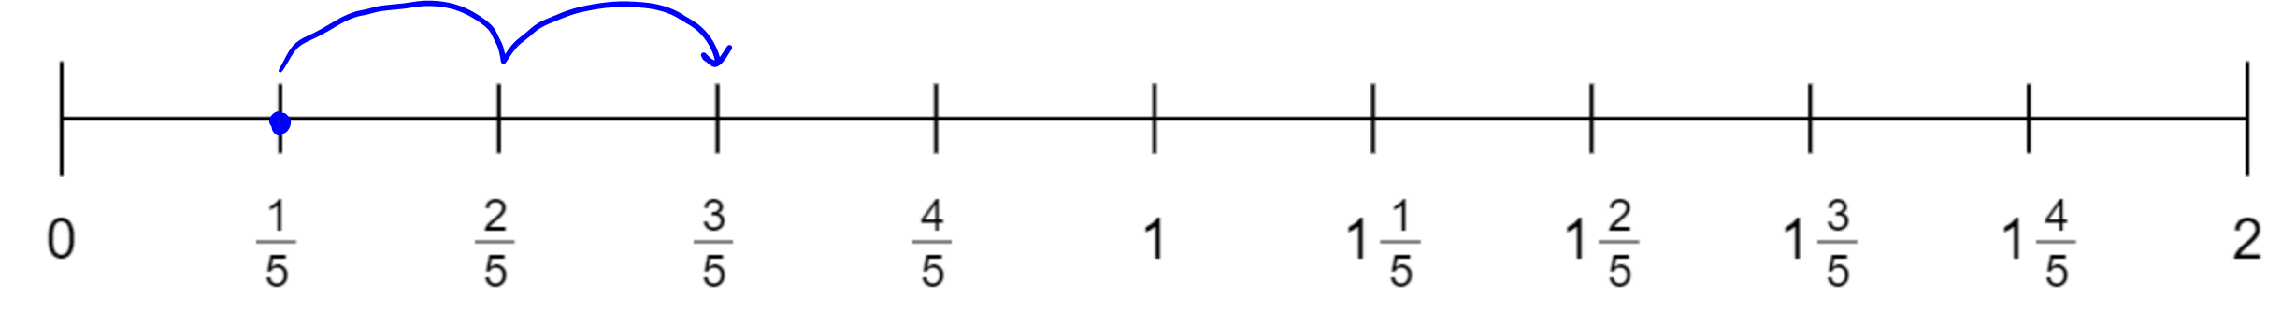 b. $1$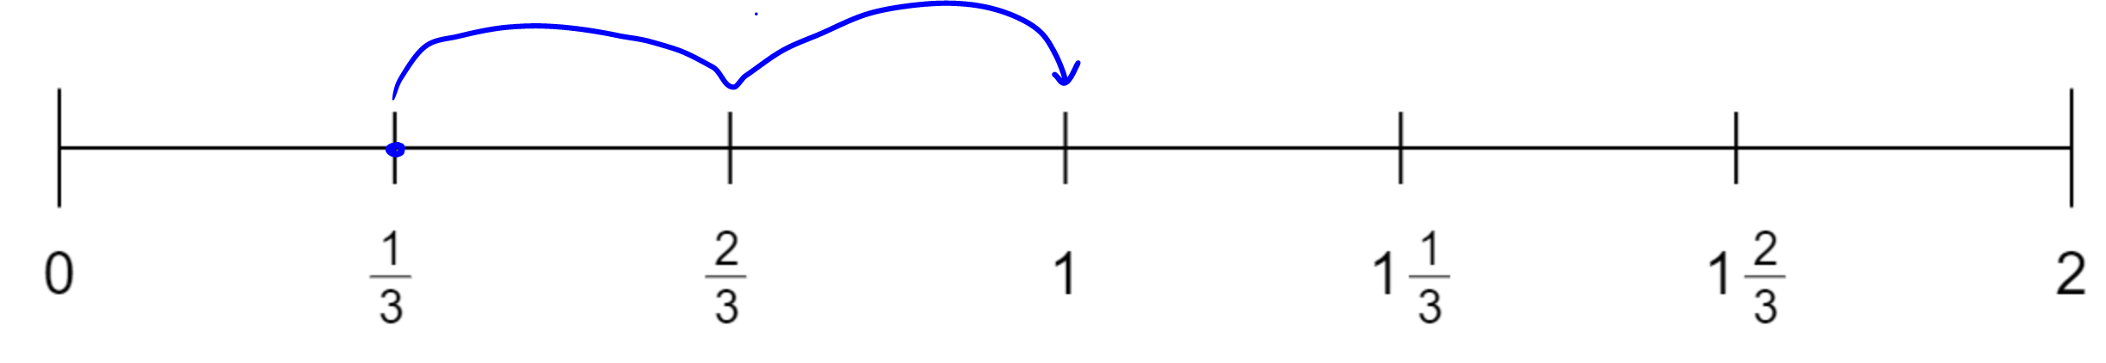
c. 1$\frac{1}{3}$ 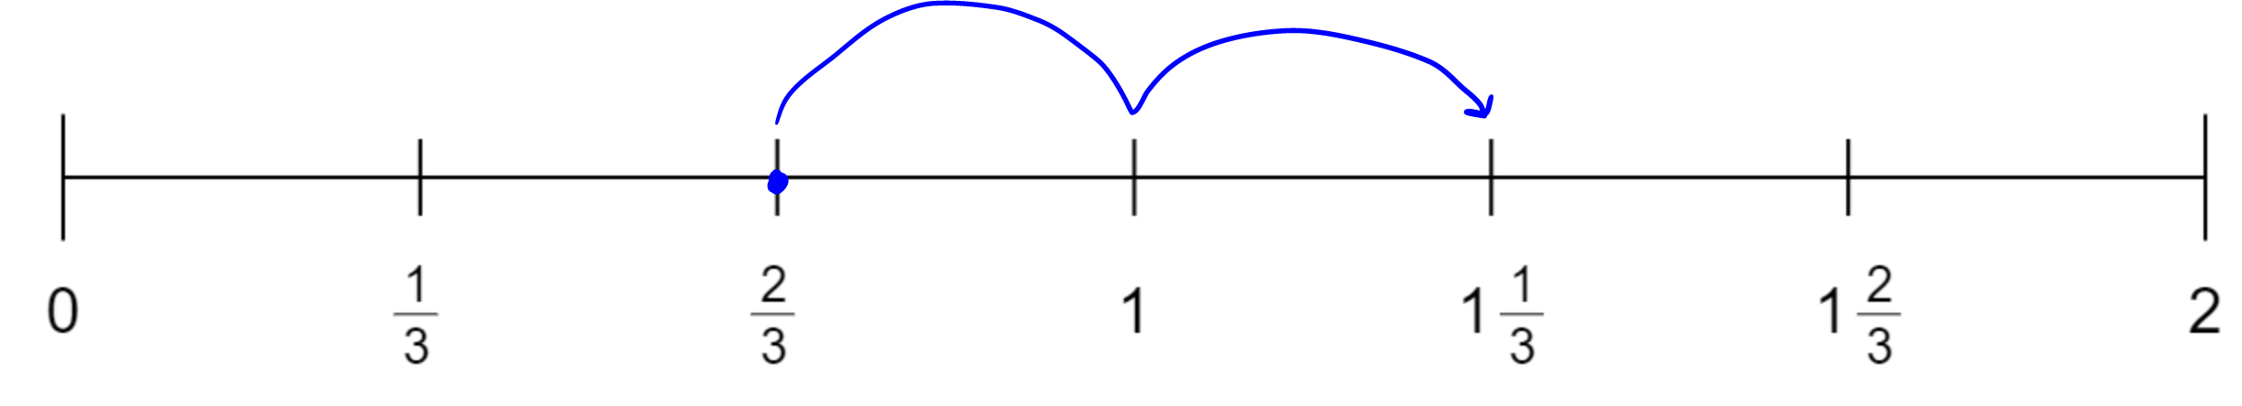
d. $2$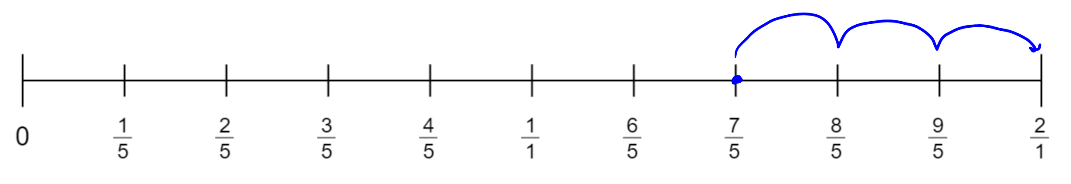
3. a. $\frac{5}{6}$ b. $4$ 4. a. 3 b. 13 c. 18 d. 34 5. a. $\frac{2}{7}$ b. $-1\frac{1}{7}$
c. $-2\frac{5}{7}$ d. $2\frac{5}{7}$
6. 12 different ways. Here are some, can you find the others?
- $\frac{1}{8}+\frac{1}{8}+\frac{1}{8}+\frac{1}{8}+\frac{1}{8}+\frac{2}{8}$  - $\frac{1}{8}+\frac{1}{8}+\frac{1}{8}+\frac{1}{8}+\frac{3}{8}$  - $\frac{1}{8}+\frac{1}{8}+\frac{2}{8}+\frac{4}{8}$ | - $\frac{1}{8}+\frac{3}{8}+\frac{3}{8}$  - $\frac{2}{8}+\frac{5}{8}$  - $\frac{1}{8}+\frac{6}{8}$
BackToQns

4B Routine Questions (ans)
1.a. $1\frac{5}{24}$ or $\frac{29}{24}$ b. $\frac{1}{10}$ c. $\frac{7}{12}$ d. $\frac{59}{40}$ or $1\frac{19}{40}$ e. $\frac{2}{3}$ f. $1\frac{13}{18}$ or $\frac{31}{18}$
g. $\frac{1}{2}$ h. $\frac{27}{35}$ i. $\frac{27}{56}$ j.$\frac{7}{10}$ k. $\frac{11}{14}$ l. $\frac{3}{14}$ m. $\frac{1}{8}$ n. $\frac{41}{56}$ o. $\frac{22}{63}$ p. $\frac{9}{10}$ q. $\frac{17}{18}$
r. $\frac{8}{15}$ s. $\frac{4}{15}$ t. $\frac{14}{27}$ BackToQns

4B Stretch Questions (ans)
2. a. $\frac{19}{42}$ b. $\frac{1}{6}$ c. $\frac{23}{120}$ d. $\frac{17}{45}$ e. $1\frac{7}{132}$ 3. a. $\frac{3}{4}$ b. 400
c. $\frac{1}{4}$, 250 pieces 4.a. 5, 2 b. 2, 4, 8 c. 5, 1 5. Check with your teacher BackToQns

4C Routine Questions (ANS)
1.a. $-\frac{7}{10}$ b. $-\frac{1}{18}$ c. $\frac{1}{15}$ d. $-\frac{2}{5}$ e. $-\frac{14}{27}$ f. $\frac{1}{18}$ g. $-\frac{1}{2}$ h. $\frac{13}{35}$
i. $-\frac{69}{56}$ or $-1\frac{13}{56}$ j. $-\frac{7}{10}$ k. $\frac{13}{14}$ l. $-\frac{3}{14}$ m. $-\frac{1}{8}$ n. $\frac{1}{56}$ o. $-\frac{22}{63}$ p. $-\frac{11}{24}$ q. $-\frac{1}{10}$ r. $\frac{11}{12}$ s. $-\frac{89}{56}$or $-1\frac{33}{56}$ t. $\frac{9}{40}$ BackToQns

4C Stretch Questions (ans)
2. a. $\frac{1}{5}$ b. $-\frac{2}{5}$ c. $1\frac{2}{5}$ d. $-\frac{7}{10}$ 3. a. $a=\frac{5}{8}$
b. $b=-\frac{4}{15}$ c. $c=-\frac{11}{21}$ d. $d=\frac{11}{12}$ 4. $\frac{1}{15}$
7. a. 5, 2 b. 2, 4, 8 c. 5, 1 5. 1… but why?? BackToQns

5A Routine questions (ans)
1.a. $\frac{3}{40}$ b. $\frac{21}{50}$ c. $\frac{3}{20}$ d. $\frac{15}{56}$ e. $\frac{21}{40}$ f. $\frac{40}{99}$ g. $\frac{3}{50}$ h. $\frac{4}{35}$ i. $\frac{3}{56}$ j. $\frac{7}{50}$ k. $\frac{12}{35}$ l. $\frac{3}{14}$ m. $\frac{15}{32}$ n. $\frac{9}{56}$ o. $\frac{8}{63}$ p. $\frac{4}{45}$ q. $\frac{5}{18}$ r. $\frac{4}{15}$ s. $\frac{1}{15}$ t. $\frac{5}{36}$ BackToQns

5A Stretch Questions (ans)
2. a. $\frac{99}{1000}$ b. $\frac{1}{2000}$ c. $\frac{495}{707}$ d. $\frac{25}{144}$ e. $\frac{13}{30}$
3. a. $\frac{1}{20}$ | b. $\frac{3}{20}$

c. $\frac{9}{20}$ | d. $\frac{1}{15}$
e. $\frac{3}{15}$ | f. $\frac{8}{15}$
4. a. $\frac{1}{4}$ b. $\frac{1}{6}$ c. $\frac{1}{28}$ d. $\frac{5}{28}$ 5. a. 12 b. 8 c. 4 d. 20 6. Answers may vary. a. $\frac{2}{5}×\frac{3}{2}$ b. $\frac{5}{4}×\frac{3}{5}$ c. $\frac{3}{7}×\frac{2}{6}$ 7. a. 1.292 b. 4.55
c. 2.94 d. 1.068 BackToQns

5B Routine Questions (ans)
1. a. $\frac{1}{10}$ b. $\frac{7}{18}$ c. $\frac{7}{18}$ d. $\frac{21}{44}$ e. $\frac{1}{7}$ f. $\frac{5}{12}$ g. $\frac{1}{4}$ h. $\frac{14}{45}$ i. $\frac{6}{25}$ j. $\frac{1}{2}$ k. $\frac{2}{5}$
l. $\frac{49}{72}$ m. $\frac{5}{14}$ n. $\frac{3}{10}$ o. $\frac{32}{45}$ p.$\frac{9}{14}$ q. $\frac{1}{5}$ r. $\frac{18}{35}$ s. $\frac{9}{25}$ t. $\frac{9}{20}$ BackToQns

5B Stretch Questions (ans)
2. 15 3. $36 4. $\frac{2}{7}, \frac{3}{8}$ 5. No spoilers here! BackToQns

5C Routine Questions (ANS)
1.a. $\frac{2}{3}$ b. $\frac{1}{8}$ c. $\frac{15}{29}$ d. $\frac{7}{20}$ e. $\frac{1}{12}$ f. $\frac{3}{11}$ g. $\frac{2}{27}$ h. $\frac{2}{7}$ i. $\frac{1}{5}$ j. $\frac{1}{5}$ k. $\frac{7}{18}$ l. $\frac{2}{9}$ m. $\frac{4}{9}$ n. $\frac{5}{36}$ o. $\frac{1}{9}$ p. $\frac{3}{10}$ q. $\frac{8}{27}$ r. $\frac{2}{27}$ s. $\frac{1}{4}$ t. $\frac{4}{15}$ BackToQns

5C Stretch Questions (ans)
2. a. $\frac{1}{2}$ b. $\frac{1}{5}$ c. 1 d. $\frac{2}{5}$ 3.a. $\frac{2}{3}$b. $\frac{5}{8}$ c. $\frac{3}{5}$ d. $\frac{7}{12}$
4. No spoilers here! BackToQns

6A Routine Questions (ANS)
1.a. $\frac{21}{20}$ b. $\frac{45}{16}$ c. $\frac{25}{18}$ d. $\frac{15}{8}$ e. $\frac{6}{35}$ f. $\frac{8}{9}$ g. $\frac{10}{63}$ h. $\frac{35}{4}$ i. $\frac{21}{20}$ j. $\frac{21}{10}$ k. $\frac{45}{18}$
l. $\frac{10}{21}$ m. $\frac{4}{15}$ n. $\frac{15}{8}$ o. $\frac{35}{4}$ p. $\frac{10}{63}$ r. $\frac{14}{25}$ s. $\frac{8}{81}$ t. $\frac{6}{35}$ BackToQns

6b Routine Questions (ans)
1.a. $\frac{4}{9}$ b. $\frac{9}{10}$ c. 1$\frac{2}{5}$ d. $1\frac{1}{2}$ e. $\frac{1}{3}$ f. $\frac{3}{4}$ g. $3\frac{3}{4}$ h. $3\frac{1}{3}$ i. $1\frac{7}{20}$ j. $1\frac{7}{20}$
k. $\frac{32}{35}$ l. $1\frac{1}{8}$ m. $\frac{25}{27}$ n. $1\frac{7}{8}$ o. 2 p. $\frac{5}{9}$ q. $\frac{7}{8}$ r. $2\frac{4}{7}$ s. $\frac{1}{3}$ t. $\frac{9}{20}$ BackToQns

6b Stretch Questions (ans)
2. a. $\frac{3}{4}$ b. $\frac{2}{9}$ c. $1\frac{1}{8}$ 3. 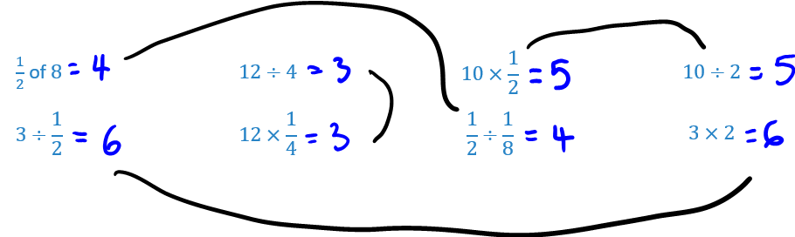
4. a. $\frac{4}{7}$ b. 8 c. $\frac{1}{4}$ BackToQns

6C (Part 1) Routine Questions (ans)
1. a. $\frac{9}{5}$b. $\frac{13}{15}$ c. $\frac{4}{5}$ d. $5$ e. $\frac{22}{5}$ or $4\frac{2}{5}$ f. $\frac{63}{5}$ or $12\frac{3}{5}$ g. $6$ h. $\frac{9}{5}$ or $1\frac{4}{5}$ i. $\frac{25}{3}$ or $8\frac{1}{3}$ j. $\frac{19}{35}$ k. $\frac{1}{3}$ l.$\frac{14}{9}$ or $1\frac{5}{9}$ m. $\frac{19}{30}$ n. $\frac{19}{4}$ or $4\frac{3}{4}$ o. $\frac{13}{28}$ p. $\frac{9}{8}$ or $1\frac{1}{8}$ q. $\frac{7}{12}$ r. $\frac{3}{4}$ s. $\frac{2}{3}$ t. $\frac{17}{25}$ BackToQns

6C (PArt 1) Stretch Questions (ans)
2. a. $-\frac{9}{5}$ b. $-\frac{1}{2}$ c. $\frac{2}{5}$ d. $-\frac{281}{40}$ 3.a. -1 b. $\frac{3}{5}$ c. $\frac{25}{16}$ or $1\frac{9}{16}$ d. $-\frac{2}{3}$ e. $-16$ f. $\frac{1}{4}$ g. $-\frac{3}{8}$ h. $\frac{46}{27}$ or $1\frac{19}{27}$ i. $4$ 4. a. $\frac{8}{9}$ b. $\frac{1}{3}$ m c. $\frac{91}{24}$ 5. a. $\frac{7}{12}$ b. $\frac{119}{5}$ c. $\frac{28}{5}$ d. $-\frac{22}{5}$ BackToQns

6C (PART 2) Routine Questions (ans)
1. a. $x=\frac{4}{3}$ b. $x=\frac{2}{3}$ c. $x=\frac{3}{2}$ d. $x=\frac{3}{2}$ e. $x=\frac{7}{8}$ f. $x=\frac{2}{3}$
g. $x=\frac{1}{8}$ h. $x=\frac{9}{7}$ i. $x=\frac{3}{2}$ j. $x=\frac{7}{2}$ k. $x=\frac{23}{9}$ l.$x=\frac{11}{4}$
m. $x=\frac{5}{2}$ n. $x=\frac{20}{7}$ o. $x=\frac{4}{3}$ p. $x=\frac{28}{9}$ q. $x=\frac{3}{2}$ r. $x=\frac{2}{3}$ s. $x=\frac{5}{2}$ t. $x=\frac{9}{2}$ BackToQns

6C (PART 2) Stretch Questions (ans)
2. a. $x=\frac{1}{3}$ b. $x=\frac{1}{25}$ c. $x=\frac{21}{10}$ d. $x=\frac{-17}{7}$ e. $x=\frac{269}{45}$
f. $x=-11$ g. $x=-\frac{106}{9}$ h. $x=-\frac{13}{20}$ i. $x=-\frac{61}{11}$ j. $x=\frac{136}{35}$
k. $x=-\frac{32}{5}$ l.$x=\frac{103}{22}$ m. $x=\frac{115}{15}$ n. $x=\frac{11}{2}$ o. $x=-\frac{39}{7}$
p. $x=\frac{-6}{7}$ q. $x=\frac{109}{10}$ r. $x=\frac{13}{4}$ s. $x=-\frac{11}{6}$ t. $x=\frac{1}{2}$ BackToQns

