
SANDRINGHAM COLLEGE
YEAR 7 MATHS

Topic 6: Statistics

Contents
Introduction: 2
1. Summary statistics 3
2. Data displays 8
Early Finisher Activities 16

Introduction:
Minimum Expectations
It is through regular practice and high expectations that you will maximise your progress in maths!
There are three things that will need to be included before work is considered complete:
- Copying of the question if in blue text – if it is in blue it is in our books!
- Inclusion of working out (where appropriate)
- Corrections. A tick ✓ if correct and retry until correct if incorrect.
In most cases, your teacher will require you to complete at least one set of questions for each big idea. Most students will start with Routine Questions at the Core Level, though there are options to move onto more challenging questions or less challenging questions as needed.
Assessed Learning Task (ALT)
At the end of the unit you will complete an ALT.
All skill based ALT questions will be developed from the questions in this book. All application questions will be of a similar structure, though not always familiar.
Most students will complete the mainstream ALT focusing on Core Level skills, though some students will complete a modified ALT focusing on Entry Level skills and others will complete an Enhanced ALT focusing on Enrichment Level Skills. Decisions around which ALT each student will do will happen towards the end of the topic ☺
You will be allowed to bring your maths workbook into the ALT and so there is great incentive to complete as many stretch questions as you can!!

Summary statistics

Setting the Goal
Learning intention:
- How do we calculate the mean and range?
- How can you identify the mode and median?
Success criteria: I can calculate the range and mode. I can identify the mean and median.

Key words
The mean is the average of the numbers in a data set.
The median is the exact middle number in an ordered data set.
The mode is the most occurring number in a data set.
The range is the difference between the largest and smallest number in a data set.

Activate prior knowledge

For each student in the class, find their height (in cm), their age (in years), and how many siblings they have.
- Which of these three sets of data would you expect to have the largest range?
- Which of these three sets of data would you expect to have the smallest range?
- What do you think is the mean height of students in the class? Try to calculate it if you can!

Explicit teaching
[NEW PAGE] Skill 1: Summary Statistics
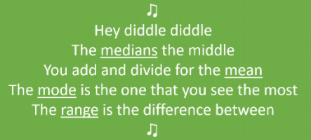
- To calculate the mean, add all of the data values together, then divide by however many numbers are in the data set.
- The median is the exact middle number in an ordered data set.
- The mode is the most occurring number in a data set.
- To find the range subtract the smallest value from the largest value in the data set.

Worked Examples:
1. Determine the range and mode of the following data set:  3, 6, 4, 0, 4, 7 | 2. Calculate the mean and median of the following data set:  6, 0, 1, 7, 3, 7 |  | 3. Calculate the mean and median of the following data set: (mean to 2dp)  2, 5, 3
What we write:  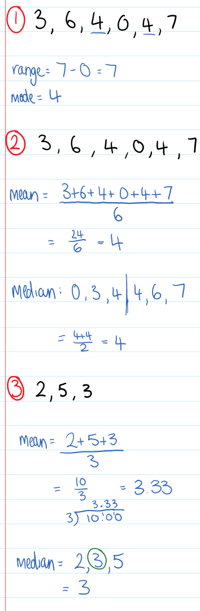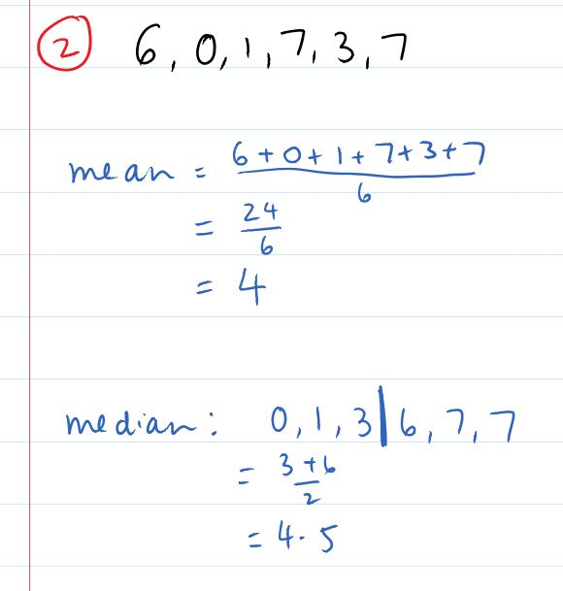 |  | What we think:  The range is the largest subtract the smallest value.  The mode is the most common value.  To calculate the mean, add all of the data values together, then divide by however many numbers are in the data set.  There are 6 numbers in the data set, so we divide by 6.  The median is the exact middle of an ordered set of data. When the exact middle falls between 2 values, we can take the average of those two numbers to find the exact middle.  To calculate the mean, add all of the data values together, then divide by however many numbers are in the data set.  There are 3 numbers in the data set, so we divide by 3.  When there are an odd number of data points, once we order the data, the median can be found by taking one data point off each side until we are just left with one in the middle.
Your turn:
1. Determine the range and mode of the following data set:  1, 10, 6, 3, 2, 2 | 2. Calculate the mean and median of the following data set: (mean to 1dp)  2, 3, 3, 6, 6, 7 |  | 3. Calculate the mean and median of the following data set:  5, 2, 3, 4, 1

PRACTICE

1A ROUTINE questions
- Calculate the range and mode of the following data sets: 4First Five Live
- 1, 7, 1, 2, 4 | - 2, 2, 10, 8, 13 | - 3, 11, 11, 14, 21, 14
- 25, 25, 20, 37, 25, 24 | - 1, 22, 20, 33, 10 | - 5, 7, 8, 10, 2
- 6, 6, 7, 7, 8, 8, 9 | - 55, 24, 55, 19, 15, 36 | - 114, 84, 83, 81, 39, 12, 84
- 43, 44, 73, 32, 44, 13 | - 70, 80, 90, 90, 60, 40 | - 82, 73, 42, 59, 40, 82, 73

☑ Correction Time! Click here for answers

1B ROUTINE questions
- Calculate the mean and median of the following data set. Give your answer to 1 decimal place where appropriate.
4First Four Live
- 1, 7, 1, 2, 4 | - 2, 2, 10, 8, 13 | - 3, 11, 11, 14, 21, 14
- 25, 25, 20, 37, 25, 24 | - 1, 22, 10, 20, 33, 10 | - 5, 7, 8, 10, 2
- 6, 6, 7, 7, 8, 8, 9 | - 55, 24, 55, 19, 15, 36 | - 114, 84, 83, 81, 39, 12, 84
- 43, 44, 73, 32, 44, 13 | - 70, 80, 90, 90, 60, 40 | - 82, 73, 42, 59, 40, 82, 73
☑ Correction Time! Click here for answers

1C ROUNTINE questions
4First Four Live
- List a set of three positive whole numbers such that:  Mean = 3  Mode = 2 | - List a set of three positive whole numbers such that:  Mean = 6  Mode = 7
- List a set of four positive whole numbers such that:  Mean = 7.5  Mode = 6  Median = 7 | - List a set of five positive whole numbers such that:  Mean = 7  Median = 9
- List all sets of three positive whole numbers such that:  Mean = 5  Median = 7  Range = 6 | - List all sets of five positive whole numbers such that:  Median = 5  Mode = 4  Range = 5
- a. Can you find a set of four numbers with:  Mean = 4  Mode = 1  Median = 2  Range = 10 | - i) How about a set of five numbers?  ii) Or six numbers?  Or...  iii) (Challenge) Or 100 numbers?

1D STRETCH Questions
- George replaces the 16 with a different number and in doing so increases the mean of the data set by 1. What number did George replace the 16 with?
3, 6, 7, 16

- In the rich country of Emerald, the mean income is £20,000.
In the poorer, neighbouring country of Flint, the mean income is £16,000.
Charlie lives in Emerald and earns £18,000 a year.
He moves to Flint and says "I've made both countries richer!"
Charlie thinks that the mean income in both countries has increased. Is he correct? Why/why not?
- Six people are standing in a line. The height of the first person is 150 cm and the height of the sixth person is 180 cm. The height of each other person is the average of the heights of the person directly in front and the person directly behind. What is the height of the fourth person in the line?

- Find the value of x if the mean of the set of numbers 1, x + 3, x, 3, 0, x − 4, 0 and 1 is 9.5.
- Here’s an interesting set of five numbers: 2, 5, 5, 6, 7. The mean, median, mode and range are all 5.
Can you find other sets of five positive whole numbers where: Mean = Median = Mode = Range?

- The list below shows the number of books the eight members of a book club read last year.
4, 4, 6, 9, 10, 13, 13, 13
Which if the following statements is true?
- mean > median = mode
- mean < median < mode
- mean = median = mode
- mean = median < mode

- Can you find sets of five positive numbers that satisfy the following properties? Not all of these can be satisfied. Can you explain why?
  - Mode < Median < Mean
  - Mode < Mean < Median
  - Mean < Mode < Median
  - Mean < Median < Mode
  - Median < Mode < Mean
  - Median < Mean < Mode

☑ Correction Time! Click here for answers to MOST questions
Finished Early? Head to the Early Finishers Page to engage in a game, puzzle or investigation.

A HELPFUL SONG
The following song is a really helpful way for remembering what each of the key summary statistics is:
Hey diddle diddle, the MEDIAN is the middle
You add and divide for the MEAN
The MODE is the one that you see the most
and the RANGE is the difference between

Skill 1 Reasoning Questions

Entry | Core | Advanced
Joan says that the mode of the data set below is 3, 4 and 5. Why is Joan incorrect?  3,3,4,4,5,5  What is the correct answer? | Explain a condition that must be met for the median to be higher than the mean. | Explain why it is impossible for a set of 5 numbers to have a mean of 23, a median of 6, a range of 7 and a mode of 2.

COLLABORATIVE TASK:
Here’s an interesting set of five numbers: 2, 5, 5, 6, 7. The mean, median, mode and range are all 5.
Can you find other sets of five positive whole numbers where: Mean = Median = Mode = Range?

Assessment for Learning
Your progress will be monitored through your classwork and weekly homework sheets.

Reflection and Recognition
Let’s reflect on some key questions. Choose one or more of the questions below to answer.
- What does the mean tell you?
- How can we efficiently calculate the mean/median/mode/range?
- Why do we learn about mean/median/mode/range?
Let’s recognise something that went well and something that could be improved.
- What component of this work caused the most growth in your learning?
- Is there anything you’d like to improve?

Data displays

Setting the Goal
Learning intention:
- How do we make a bar chart?
- How do we make a stem and leaf plot?
- How do we analyse a stem and leaf plot?
Success criteria: I can display data in a bar chart and in a stem and leaf plot.

Key words
A bar chart displays categorical data. Below is an example of a bar chart containing information on students’ favourite colour.
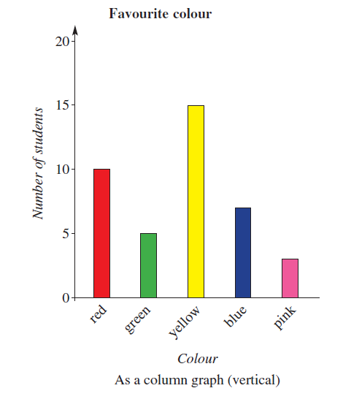
A Stem and leaf plot displays numerical data. Each number is split into a stem (the first digit or digits) and a leaf (the last digit). Below is a stem and leaf plot recording students test result out of a total score of 50.
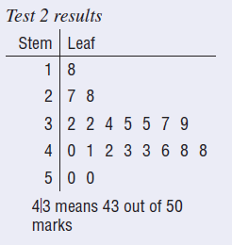

Activate prior knowledge
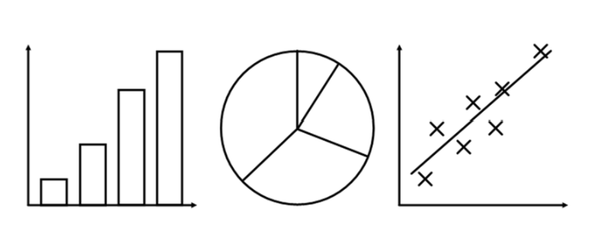
What do you know?
What do you think?
What do you wonder?

Explicit teaching
[NEW PAGE] Skill 2: Data displays
- Bar charts are used for displaying categorical data
- Stem and leaf plots are used for numerical data.
Tips
- Remember to use a ruler so that you can ensure you have an even scale.
- Remember to include a key in your stem and leaf plots.

Worked Examples:
1. Construct a bar chart for the data collected below: | 2. Construct a stem and leaf plot for the temperatures below:  13, 16, 16, 20, 20, 21, 22, 25, 25, 26, 28, 29, 30, 32 |  | 3. Construct a back to back stem and leaf plot for the data below:
  Type of Pets | Frequency
  Dog | 6
  Cat | 4
  Fish | 2
  Rabbit | 0
  Other | 1
  None | 4
  Girls heights (cm) | Boys heights (cm)
  121, 123, 126, 132, 133, 134,  138, 140, 144,  145, 146, 147, 151, 160, 162,  173 | 138, 143, 144, 147, 149, 150, 151, 152, 154, 156, 162, 163, 166, 168
What we write:  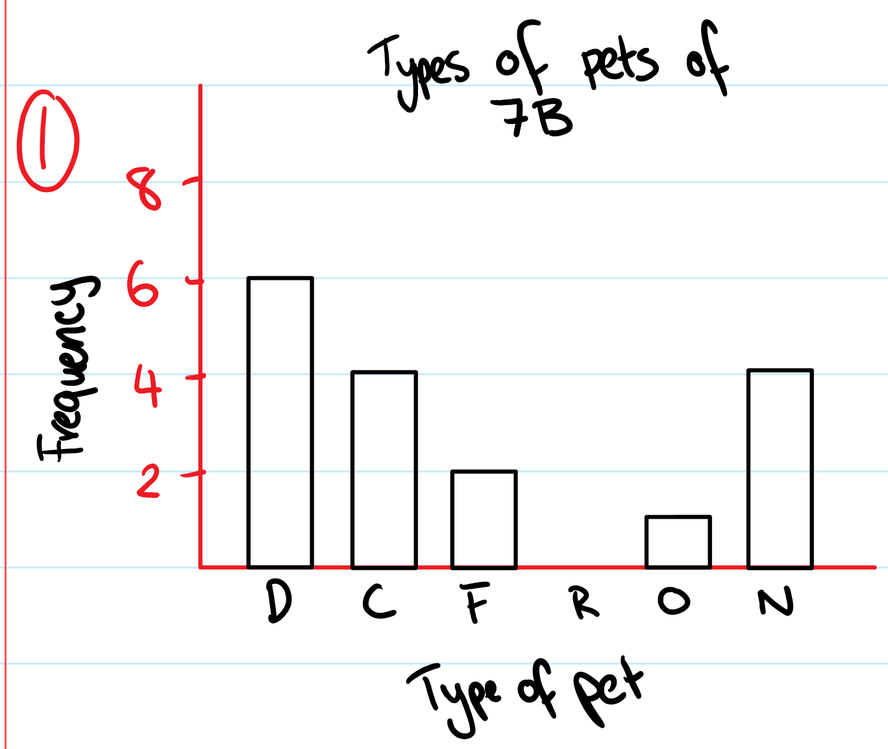  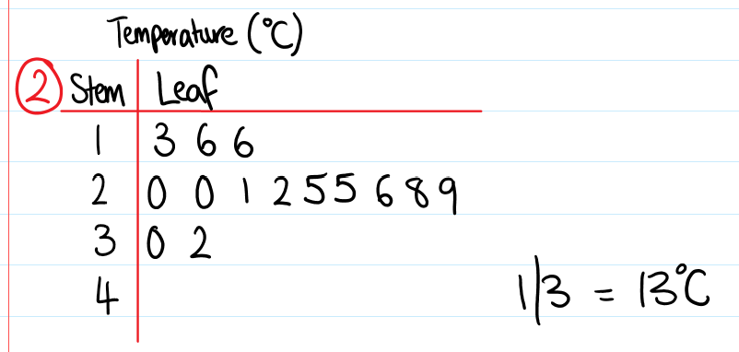  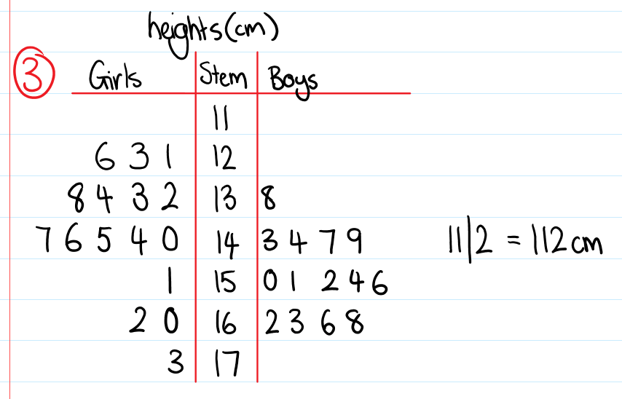 |  | What we think:  Remember to use an even scale and a ruler for your axes and for your bars!  Don’t forget a key!
Your turn:
1. Construct a bar chart for the data collected below: | 2. Construct a stem and leaf plot for the temperatures below:  8, 10, 14, 14, 15, 19, 20, 23, 25, 26, 41, 42 |  |  | 3. Construct a back-to-back stem and leaf plot for the data below:
  Eye colours | Frequency
  Blue | 3
  Green | 2
  Brown | 6
  Other | 1
  Victorian Temperature (°C) | Northern Territory Temperature (°C)
  12.1, 12.4, 12.5, 12.5, 12.6, 13.0, 13.4, 13.8, 13.9  14.5, 14.7, 17.2 | 15.2, 15.6, 17.5, 19.3, 19.5, 19.7, 19.8, 21.1, 21.2, 21.5, 23.0

PRACTICE

2A Routine questions
- For each of the data sets below, construct a bar chart. 4First Two Live

  Favourite sport | Frequency
  Netball | 4
  Basketball | 11
  AFL | 7
  Soccer | 6
  Subject | Frequency
  Maths | 15
  English | 7
  Science | 10
  Sport | 8
  Art | 6
  Favourite colour | Frequency
  Red | 10
  Green | 8
  Pink | 7
  Blue | 5
  Orange | 2

  Favourite Food | Frequency
  Sushi | 3
  Pizza | 6
  Burgers | 8
  Desert | 2
  Age (years) | Height (cm)
  8 | 120
  9 | 125
  10 | 135
  11 | 140
  12 | 145
  Ages (years) | Height (cm)
  8 | 125
  9 | 132
  10 | 140
  11 | 147
  12 | 150

☑ Correction Time! Click here for answers

2B Routine questions
- Construct a stem and leaf plot for each data set below and then calculate the mode, median and range of each.
4First Two Live
- Age of guests: 64, 36, 55, 63, 65, 35, 51, 45, 62 | - Goals scored in a basketball game:  7, 17, 14, 17, 22, 29, 9, 17, 20 | - Heights of 2 year old children:  73, 53, 70, 52, 66, 66, 57, 80, 60
- Time taken to walk to school:  12, 23, 35, 23, 14, 25, 32, 18 | - Scores for the Geography test:  45, 46, 57, 58, 67, 57, 68, 47, 10 | - Age of family members:  4, 17, 6, 21, 32, 18, 11, 1, 3, 29
- Length of bugs:  2.3, 4.5, 3.7, 2.1, 3.5, 3.0, 4.2, 2.6, 3.3, 6.2 | - Time taken to complete race:  33.4, 35.6, 37.1, 33.5, 33.1, 34.2, 34.7, 35.9, 36.0 | - Number of goals scored in a season:  803, 799, 820, 834, 843, 796, 808, 815, 843, 806, 795

☑ Correction Time! Click here for answers

2C Rountine questions
- Construct a back-to-back stem and leaf plot for the data sets. 4First One Live
- Age of guests at two restaurants.
A | 55 | 39 | 33 | 21 | 57 | 40 | 33 | 52 | 47 | 24 | 31 | 26
B | 27 | 59 | 22 | 47 | 33 | 56 | 27 | 24 | 39 | 43 | 27 | 53

- Number of goals scored across two different seasons.
A | 405 | 418 | 411 | 397 | 405 | 391 | 417 | 390 | 405 | 392
B | 417 | 395 | 405 | 417 | 392 | 392 | 406 | 418 | 399 | 401

- Length of two types of bugs.
A | 6.5 | 8.9 | 7.2 | 8.2 | 6.2 | 7.7 | 8.2 | 6.9 | 7.5
B | 8.1 | 7.8 | 6.7 | 7.6 | 8.1 | 6.3 | 7.5 | 8.2 | 6.7

☑ Correction Time! Click here for answers

2D Stretch Questions

- Two radio stations poll their audience to determine their ages.

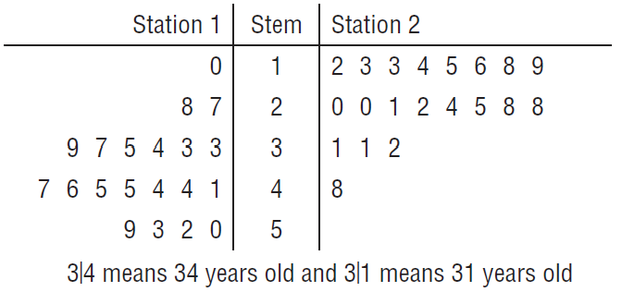
  - One of the radio stations plays contemporary music that is designed to appeal to teenagers and the other plays classical music and broadcasts the news. Which radio station is most likely to be the one that plays classical music and news? Why do you think this is the case?
  - What percentage of all listeners are older than 40 years old?
  - What is the median age of listeners of each station? What does this mean?

- A teacher has compiled her students’ recent test scores out of 50 as a stem-and-leaf plot. However, some values are missing, as represented by the letters a, b, c and d.
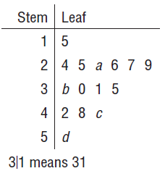
  - How many students passed the test if the passing mark is 25 marks or higher?
  - State the possible values of the missing digits a to d.
  - What is the median of the data set?
  - What is the range of the data set? (Hint: Show your answer as an expression)

- For the stem and leaf plot below:

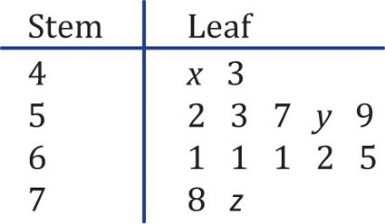
  - What value(s) could $x$ represent? Explain your answer.
  - What is the lowest possible value for ‘$y$ minus$x’$? Explain your answer.
  - Write a simplified algebraic expression for the range of the data set.

- The digits 0 to 9 (inclusive) are used in a stem and leaf plot. The lowest number is 30, the range is 22 and the median is 48. Complete the stem and leaf plot using this information.
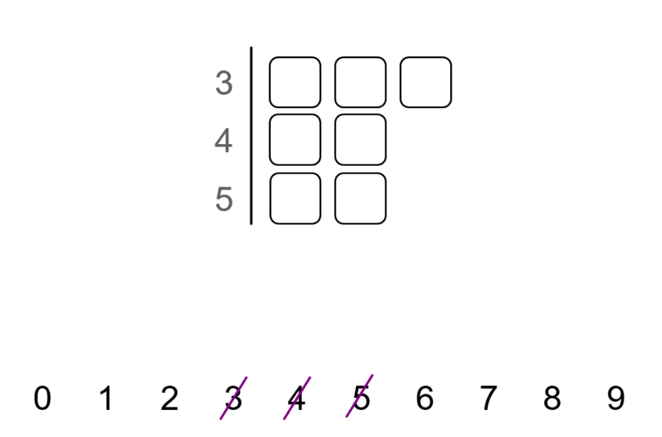
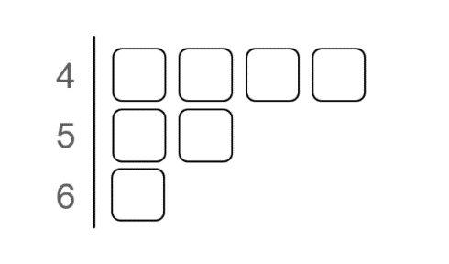
- The digits 0 to 9 (inclusive) are used in the stem and leaf plot below. Why is the mean of all options 50?

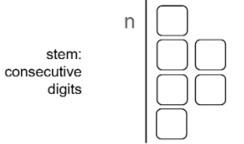
- Super challenge: The digits from 0 to 9 inclusive are used in an ordered stem and leaf plot diagram shown here. Show that the sum of the 6 numbers is always 56n+129.

☑ Correction Time! Click here for answers
Finished Early? Head to the Early Finishers Page to engage in a game, puzzle or investigation.

Skill 1 & 2 Application Questions – Think, Pair, Share/Teacher Modelling
Answer the questions you can. Explain your reasoning for at least one of the questions.
You may use your calculator at any time.
1. | 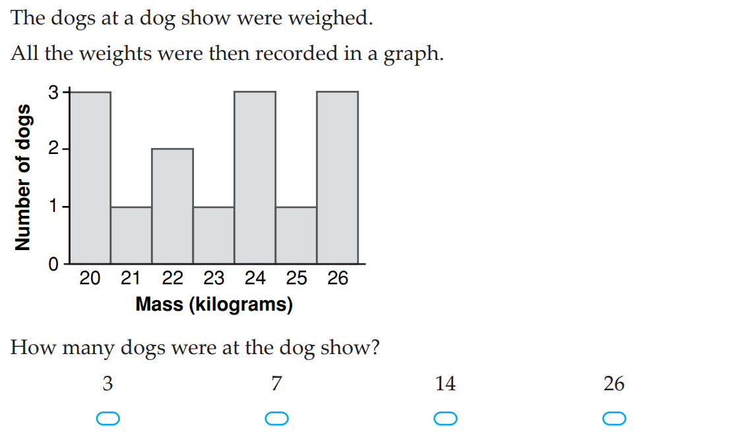
2. | 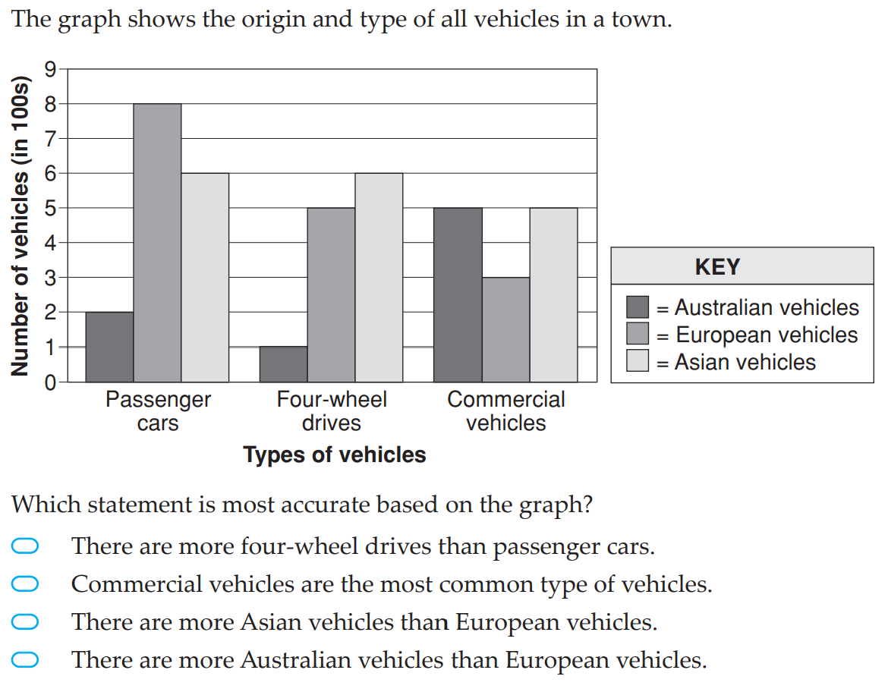

3. | 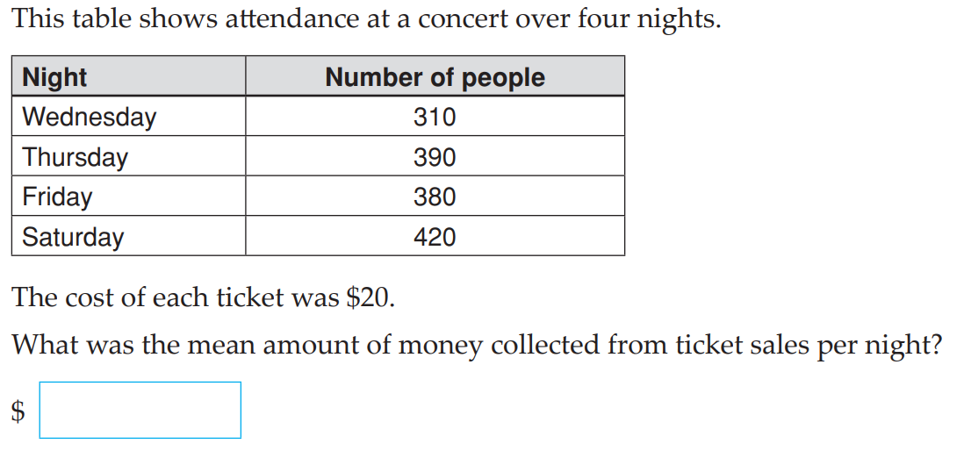
4. | Complete as many of the following as you can. Conisder how these problems connect to others you have seen in past skills  - If there are 4 people in a room and everyone was to fist bump every other person, 6 fist bumps would occur. How many fist bumps would occur if there were 100 people in the room?  - There are spiders, pigs and chooks on a farm. There are 32 legs, how many of each animal could there be?  - I have the build a footpath, 60cm by 6m, out of bricks that are 30cm by 60cm. The bricks can lie vertically and horizontally, but in on other direct. Three possible brick arrangements are shown below. How many different ways are there to build the walkway?  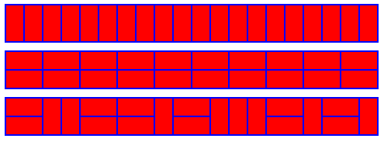  - To solve the puzzle of the Tower of Hanoi, you are required to move all disks to Tower 3 whilst never putting a larger disk onto a smaller disk.  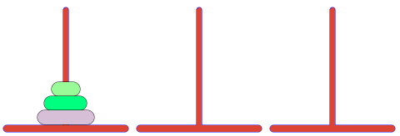  - i. What is the smallest number of moves this puzzle can be completed in?  - ii. What if there were 10 disks instead of 3, what is the smallest number of moves this puzzle can be completed in?

Skill 2 Reasoning Questions

Entry | Core | Advanced
State two errors in the following bar chart:  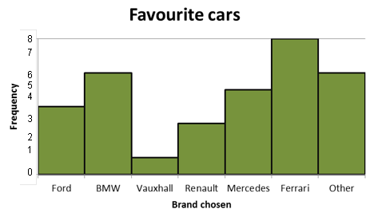 | Explain what two errors have been made in the following stem and leaf plot. | The smallest and largest numbers are missing from the stem and leaf plot below. Explain why the range must be bigger than 40 but smaller than 50
  Stem | Leaf
  1 | 1, 2, 4
  2 | 7, 9
  3 | 2, 7, 8, 8
  6 | 0, 0
  7 | 3, 8
  Stem | Leaf
  4 | 4
  5 | 7 9
  6 | 2 7 8 8
  7
  8 | 3

COLLABORATIVE TASK:
How well can you estimate time? Activity

Assessment for Learning
Your progress will be monitored through your classwork and weekly homework sheets.

Reflection and Recognition
Let’s reflect on some key questions. Choose one or more of the questions below to answer.
- What important things do we need to include in a bar chart?
- What information can we represent in a stem and leaf plot?
Let’s recognise something that went well and something that could be improved.
- What component of this work caused the most growth in your learning?
- Is there anything you’d like to improve?

Early Finisher Activities
Games | Puzzles | Investigations

Games
Individual Games:
- https://www.abcya.com/games/mean_median_mode_range - Online mean, median mode one player game
- https://www.topmarks.co.uk/maths-games/hit-the-button - Timed practice for number bonds and times tables. What is the best score you can get?
- https://www.nctm.org/Classroom-Resources/Illuminations/Interactives/Product-Game/ - One/two player multiplication game
- https://incoherency.co.uk/countdown/practice/#numbers – Countdown Numbers Game
Games in Pairs:
- https://mathsbot.com/puzzles/fourOpsPuzzle - Online number puzzle involving the four operations
- https://nrich.maths.org/strike-it-out - A number line game played in pairs

Puzzles
- Wiped Out:
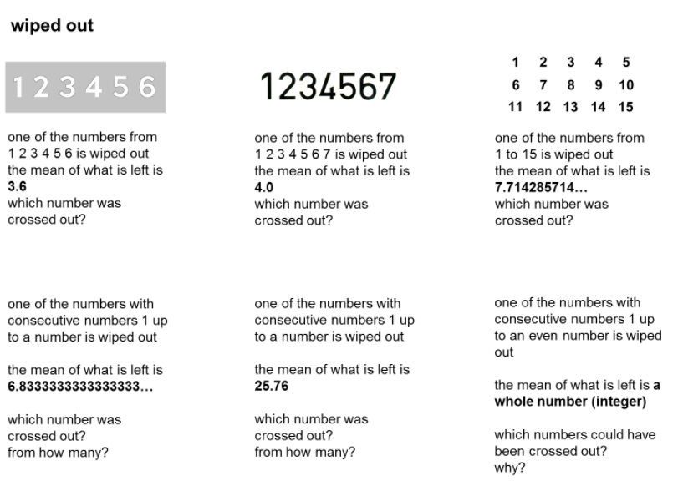
- Which chart goes with which data set?
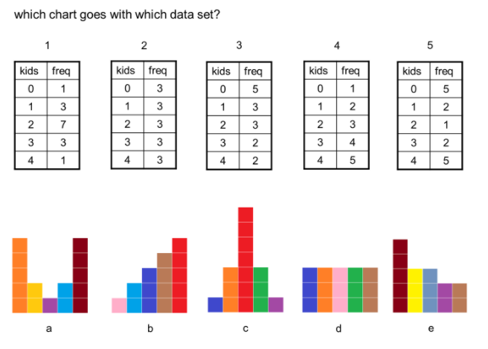

Investigations
- How well can you estimate time? https://nrich.maths.org/10629
- Which country performed the best in the 2012 Olympics? https://nrich.maths.org/whosthebest

Answers

1A ROUTINE Questions (ans)
1.a. 6, 1 b. 11, 2 c. 18, (11 and 14) d. 17, 25 e. 32, no mode f. 8, no mode g. 3, (6, 7 and 8) h. 40, 55 i. 102, 84 j. 60, 44 k. 50, 90 l. 82, 73
BackToQns

1B ROUTINE Questions (ans)
2.a. 3, 2 b. 7, 8 c. 12.3, 12.5 d. 26, 25 e. 16, 15 f. 6.4, 7
g. 7.29, 7 h. 34, 30 i. 71, 83 j. 41.5, 43.5 k. 71.67, 75 l. 64.4, 73
BackToQns

1C ROUTINE Questions (ans)
Possible answers: 3. {2, 2, 5} 4. {4, 7, 7} 5. {6, 6, 8, 10}
6. {1, 5, 9, 10, 10} 7. {1, 7, 7}
8. {4, 4, 5, 6, 9}, {4, 4, 5, 7, 9}, {4, 4, 5, 8, 9}
9. a. {1, 1, 3, 11} b. Possible answers: i. {1, 1, 2, 5, 11}
ii. {1, 1, 1, 3, 7, 11} BackToQns

1D STRETCH Questions (ans)
10. 20 11. When Charli leaves Emerald, he removes a value lower than the mean which in turn reduces the mean. When he arrives in Flint he adds a value higher than the mean and in turn raises the mean. 12. 169cm 13. $x=24$ 14. Some examples are 1, 2, 3, 3, 4; 3, 4, 5, 5, 8; 3, 6, 6, 6, 9. 15. B. 16. Both c and e cannot be done… why? BackToQns

2A ROUTINE questions (ans)
1.a.
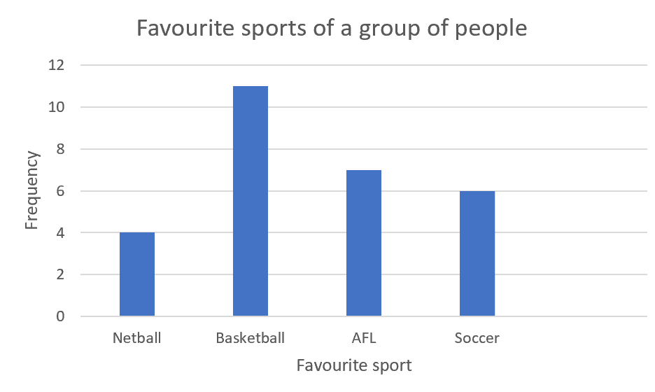
b.
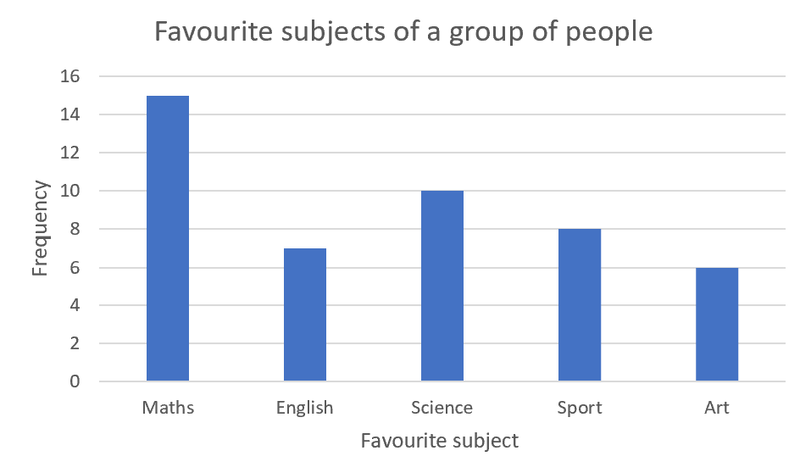

c.
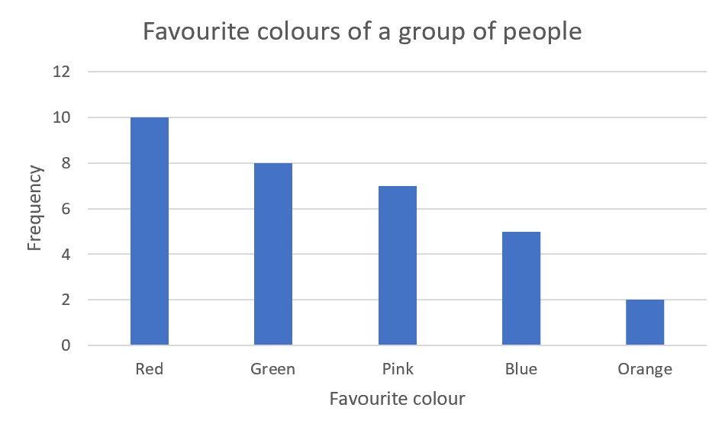

d.
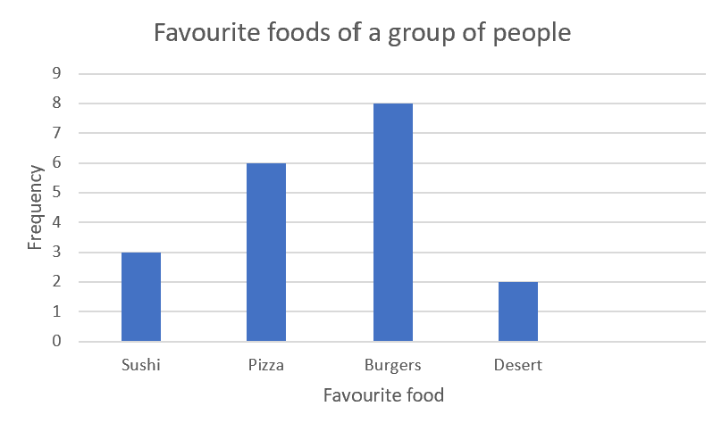
e.
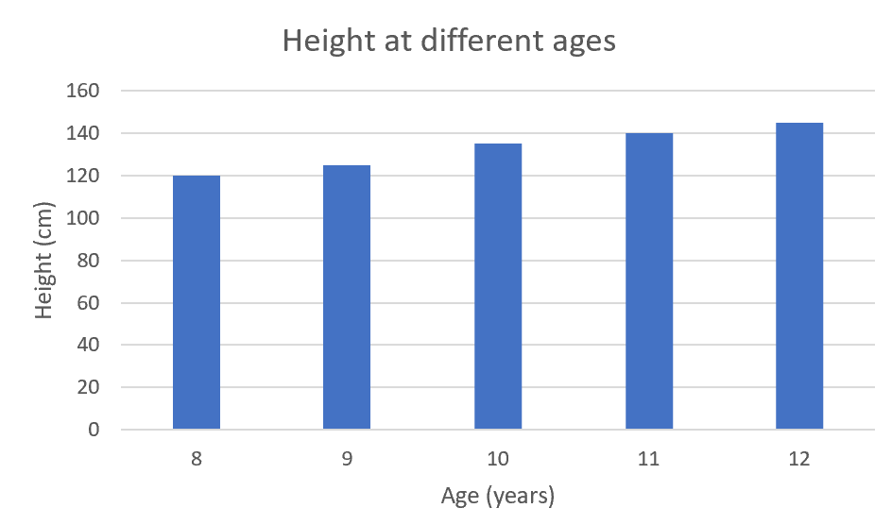
f.
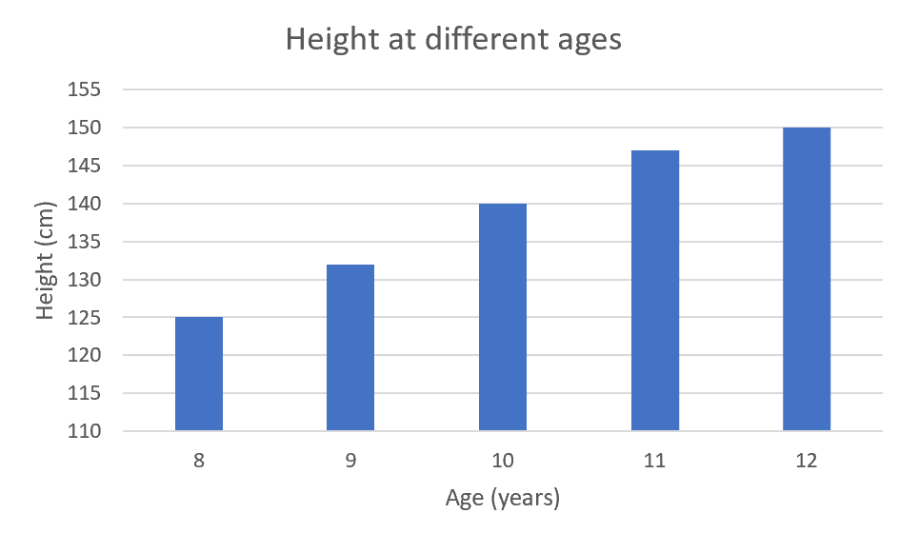
BackToQns

2B ROUTINE questions (ans)
2. a.
a. $\left.3\right|5=35$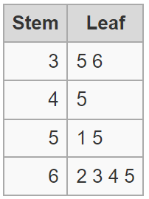  Mode = no mode,  median = 55, range = 30 | b. $\left.1\right|4=14$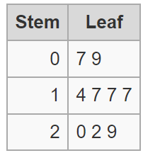  Mode = 17,  median = 17, range = 22 | c. $\left.5\right|2=52$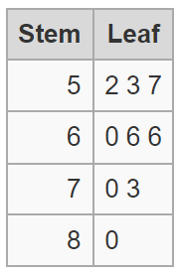  Mode = 66,  median = 66, range = 28
- $\left.1\right|2=12$  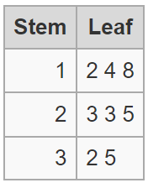  Mode = no mode,  median = 23, range = 23 | - $\left.1\right|0=10$  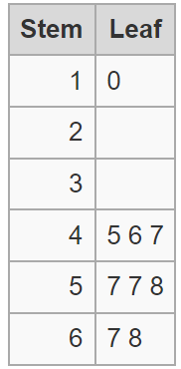  Mode = 57,  median = 57, range = 58 | - $\left.2\right|1=2$  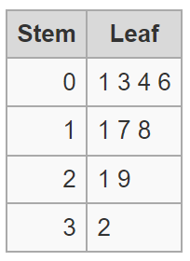  Mode = no mode,  median = 14, range = 31
- $\left.2\right|3=2.3$  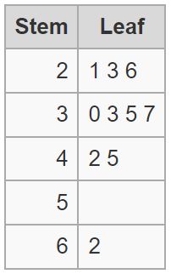  Mode = no mode,  median = 3.4, range = 4.1 | - $\left.33\right|1=33.1$  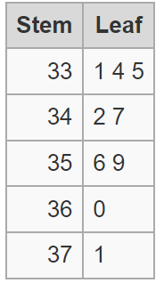  Mode = no mode,  median = 34.7, range = 4 | - $\left.80\right|3=803$  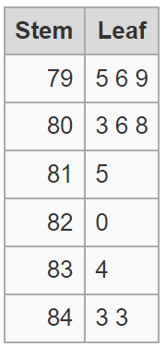  Mode = 843,  median = 808, range = 48
BackToQns

2c ROUTINE questions (ans)
3. a. $\left.2\right|1=21$
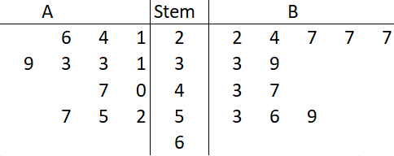
b. $\left.39\right|0=390$
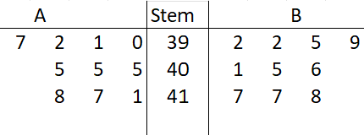
c. $\left.6\right|3=6.3$
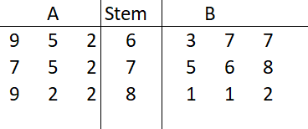
BackToQns

2D STRETCH questions (ans)
4. a. Station 1 as the audience tends to be older than Station 2 and older people are more likely to listen to classical music and news.
b. 30% c. Station 1: 42.5, Station 2: 20.5
5. a. 13 b. a = 5 or 6, b = 0, c= 8 or 9, d = any of 0-9
c. 30 d. $50+d-15$
6. a. any of 0-3 as it must be ≤ 3 and ≥ 0.
b. 4. The smallest value for y is 7 and the largest value for x is 3 and that will give us the smallest difference between the 2 variables.
BackToQns

