 |  | 7 Mathematics
 |  | Practice ALT 5: Fractions
 |  | Name:

DESCRIPTION
In this Assessed Learning Task, you will use you understanding of fractions to answer a variety of questions using the skills listed in the rubric.
Extension | This section will test your understanding of enrichment levels skills and how you apply enrichment level skills in problem solving and reasoning sections.
Core | This section will test your understanding of core levels skills and how you apply core level skills in problem solving and reasoning sections.
Entry | This section will test your understanding of entry levels skills and how you apply entry level skills in problem solving and reasoning sections.
This ASSESSED LEARNING TASK will be used to measure your growth and achievement against the skills and understandings in the unit of work studied before this assessment.
Type of Task: | Test in two sections
Conditions: | Section 1: 60 mins writing time  - Technology free  - Workbook |  | Section 2: 30 mins writing time  - Scientific calculator  - Workbook
Materials Allowed | - Workbook  - Pen / pencil / eraser

KEY SKILLS
 | Entry level | Core level | Enrichment level | Extension level
- Fraction Representations and Equivalence | Can identify a fraction from a shaded rectangle | Can calculate equivalent fractions | Can convert between whole numbers, mixed numbers and improper fractions | Can place fractions on a number line, including negative fractions and mixed numbers
- Simplifying fractions | Can simplify a fraction where only 2 or 5 is a common factor | Can simplify fractions | Can compare fractions with different denominators | Can use formulas like $LCM\left(a,b\right)=\frac{a×b}{HCF(a,b)}$
- Fractions, decimals and percentages | Can convert between fractions and decimals where numerator is a whole number and denominator is 10 or 100 | Can convert between fractions, decimals and percentages where the percentage equivalent is a whole number between 1 and 100 | Can convert fractions to recurring decimals | Can convert percentages involving fractional parts into fractions and decimals
- Adding fractions | Can add and subtract fractions with the same denominator | Can add and subtract fractions with a related denominator, then extend this to unrelated denominator | Can add and subtract fractions involving negative numbers | Can solve equations involving fractions, including those with negative results
- Multiplying fractions | Can multiply fractions where cancelling/simplifying isn’t required | Can multiply fractions, preferably using cancelling | Can multiply fractions where cancelling is required | Can simplify fraction multiplications involving more than two fractions
- Dividing fractions | Can divide fractions with the assistance of a calculator | Can divide fractions | Part 1: Can use the four operations with mixed numbers  Part 2: Can solve equations involving fractions | Can solve equations involving division of fractions  Can solve multistep equations involving fractions
- Problem Solving Applications | Apply entry level skills in a context | Apply entry level skills in a context | Apply extension level skills in a context | Apply enrichment level skills in a context
- Reasoning | Can reason with entry level skills | Can reason with core level skills | Can reason with enrichment level skills | Can reason with enrichment level skills

STUDENT DECLARATION
By submitting this task, I declare that this assessment is my individual work after seeking and receiving feedback from my peers and teacher. I have not copied from another student’s work or from any other source, except where due acknowledgement is made explicit, nor has any part being written or completed for me by another person.

Section 1: Entry Level Skills

- What fraction is shaded?

- Simplify the following fraction:
$$\frac{18}{16}$$

- Convert $\frac{7}{10}$ to a decimal.

- Calculate $\frac{3}{5}+\frac{1}{5}$

- Calculate $\frac{1}{5}×\frac{2}{3}$

- Calculate $\frac{2}{7}÷\frac{5}{3}$

Section 2: Core Level Skills

- Fill in the box to create an equivalent fraction
$$\frac{3}{8}=\frac{\boxed{}}{48}$$

- Simplify the following fraction:
$$\frac{24}{60}$$

- Complete the table below:

Percentage | Fraction | Decimal
 | $$\frac{7}{20}$$

- Calculate $\frac{5}{8}-\frac{1}{6}$

- Calculate $\frac{3}{12}×\frac{6}{8}$

- Calculate $\frac{5}{8}÷\frac{10}{3}$

Section 3: ENRICHMENT Skills

- Fill in the boxes to make each equation true.

- $5=\frac{\boxed{}}{3}$ | - $2\frac{3}{7}=\frac{\boxed{}}{7}$

- Put a <, = or > between the fractions:
$$\frac{3}{7}\boxed{}\frac{6}{12}$$

- Express $\frac{5}{11}$ as a recurring decimal. Use a line to indicate repeated digits.

- Calculate $-\frac{5}{6}+\left(-\frac{2}{9}\right)$

- Calculate $\frac{32}{6}×\frac{20}{112}$

- Calculate $4\frac{2}{5}÷2\frac{1}{5}$

- Solve $7=9x+4$, include line by line working.

SECTION 4: EXTENSION LEVEL SKILLS

- Label the following values on the number line below: $\frac{2}{3}$, $1\frac{1}{3}$ and $-\frac{7}{3}$

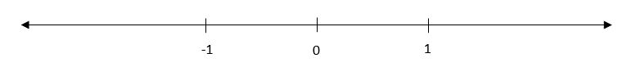

- $18×30=540$ and $HCF\left(18,30\right)=6$. Work out the $LCM\left(18,30\right)$ using the formula $LCM\left(a,b\right)=\frac{a×b}{HCF\left(a,b\right)}$

- Convert $15\frac{2}{3}\%$ to a fraction.

- Solve the following:
$$-\frac{1}{8}=d-\frac{3}{7}$$

- Calculate $\frac{1}{18}×\frac{36}{51}×\frac{17}{10}$

- The fraction in the equation below is in simplified form. Determine the values of the unknowns.
$$\frac{2}{7}÷\frac{a}{b}=14$$

- Solve the following:
$$\frac{8}{9}=\frac{\sqrt{3x-9}}{6}$$


Year 7 Post Unit Summative Assessment Unit 5 – Fractions Pt 2: Calculator Allowed

Student Name……………………………………….………………
Technology Active – Calculator Allowed

problem solving Application questions
1. | 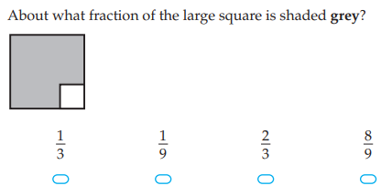
2. | 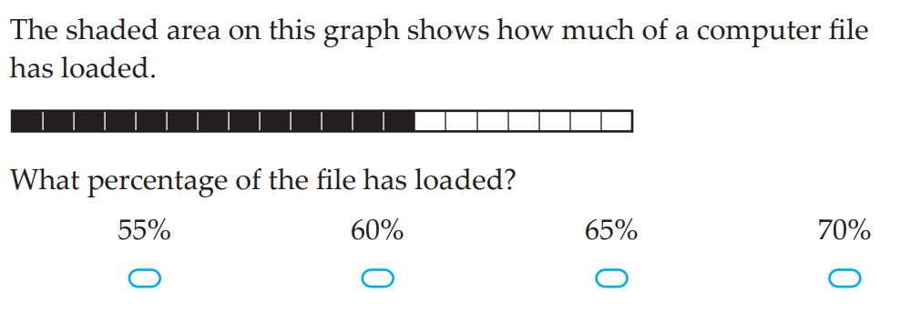
3. | 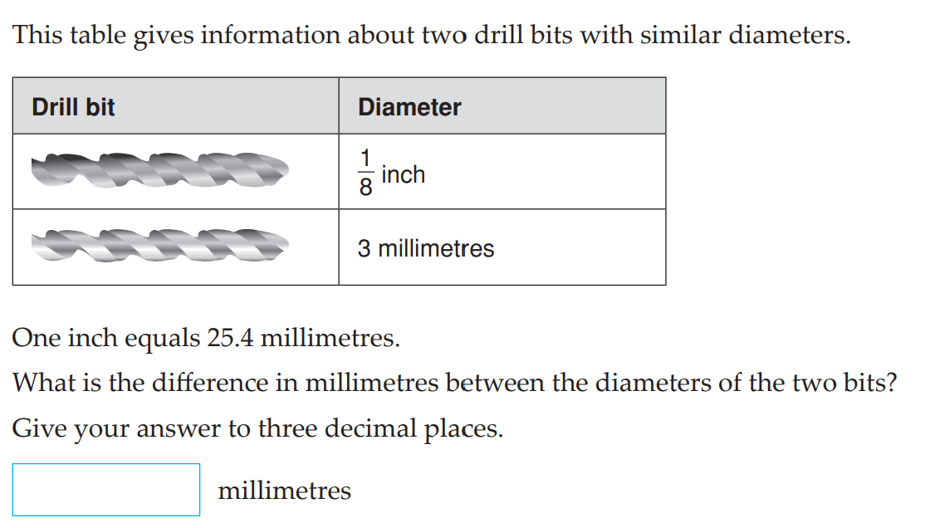
4. | Consider the fraction $\frac{n}{360}$ where $n$ can be any positive integer less than 360. How many different fractions could $\frac{n}{360}$ simplify to where the denominator is a single digit?

reasoning questions
1. | 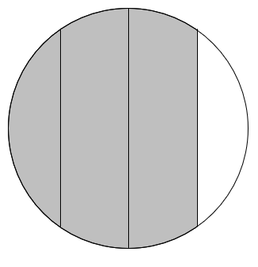  Explain why this fraction does not have $\frac{3}{4}$ shaded.
2. | 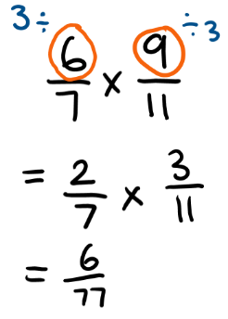  Ms Longley is calcualting the product to the right, including her working. What error is has been made?  What is the correct answer?
3. | Give 2 different reasons why $\frac{5}{8}=0.675$.
4. | Under what circumstances is the product of two fractions, say $\frac{a}{b}$ and $\frac{c}{d}$ greater than 1?

