
Mathematics 2022 PRACTICE EXAM

Student Name:

Year 7 Mathematics
Written Examination

Revision Week – Term 4 Week 6
Reading Time: 5 minutes
Writing Time: 70 minutes

Question and Answer Book

Structure of book
Section | Number of questions | Number of questions to be answered | Number of marks
A | 6 | 6 | 6
B | 7 | 7 | 28
 |  |  | Total 34

- Students are permitted to bring into the examination room: pens, pencils, highlighters, erasers, sharpeners, rulers, a protractor, set squares, aids for curve sketching, one bound reference, one approved technology (calculator or software) and, if desired, one scientific calculator. Calculator memory DOES NOT need to be cleared. For approved computer-based CAS, full functionality may be used.
- Students are NOT permitted to bring into the examination room: blank sheets of paper and/or correction fluid/tape.
Materials supplied
- Question and answer book of 13 pages
- Formula sheet
- Answer sheet for multiple-choice questions
Instructions
- Write your student name in the space provided above on this page.
- Check that your name is on your answer sheet for multiple-choice questions l
- Unless otherwise indicated, the diagrams in this book are not drawn to scale.
- All written responses must be in English.
At the end of the examination
- Place the answer sheet for multiple-choice questions inside the front cover of this book.
- You may keep the formula sheet.

Students are NOT permitted to bring mobile phones and/or any other unauthorised electronic devices into the examination room.

SECTION A – Multiple-choice questions
Instructions for Section A
Answer all questions in pencil on the answer sheet provided for multiple-choice questions. Choose the response that is correct for the question.
A correct answer scores 1; an incorrect answer scores 0. Marks will not be deducted for incorrect answers.
No marks will be given if more than one answer is completed for any question. Unless otherwise indicated, the diagrams in this book are not drawn to scale.

Question 1

The fraction shaded in grey on the right is:

A | $\frac{4}{9}$
B | $\frac{4}{10}$
C | $\frac{5}{9}$
D | $\frac{5}{8}$
E | $\frac{5}{10}$

Question 2

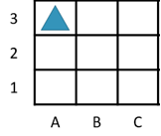
State the grid reference of the triangle.

A | $A1$
B | $A2$
C | $A3$
D | $B3$
E | C3

Question 3

Which of the following describes the number 42:

A | Even and square
B | Even and prime
C | Odd and a multiple of 3
D | Even and a multiple of 6
E | Odd and a multiple of 7

Question 4

What is the solution to the equation $3x=12$?

A | $$x=4$$
B | $$x=36$$
C | $x=15$
D | $$x=9$$
E | None of the above

Question 5

$4.5273$ is rounded to 2 decimal places, is:

A | 4.50
B | 4.52
C | 4.527
D | 4.53
E | 4.530

Question 6

The LCM of $2^{3}×3^{2}×7^{3}$ and $2^{5}×3^{3}×5^{2}$ is:

A | $$2^{3}×3^{2}$$
B | $2×3×5×7$
C | $$2^{5}×3^{3}×5^{2}×7^{3}$$
D | $2^{3}×3^{2}×5^{2}×7^{3}$
E | $$2^{8}×3^{2}×5^{2}×7^{3}$$

Section B
Instructions for Section B
Answer all questions in the spaces provided.
In all questions where a numerical answer is required, an exact value must be given unless otherwise specified. In questions where more than one mark is available, appropriate working must be shown.
Unless otherwise indicated, the diagrams in this book are not drawn to scale.

Question 1 (3 Marks)

Alice and Ben decide to share a block of chocolate.

- Alice eats 9 pieces and Ben eats 8 pieces. How many pieces of chocolate do they eat altogether?
1 mark

- The diagram represents the chocolate that Alice and Ben shared. Shade the chocolate to show the total number of pieces eaten by Alice and Ben.
1 mark

- What fraction of the chocolate has been eaten?
1 mark

Question 2 (4 Marks)

Paper clips come in packets of each contains 172 paper clips. Sandy College decided to buy 8 packets for their staff and students.

- Use the multiplication algorithm to work out the total number of paper clips.
2 marks

- Jane needed to split 714 paper clips to 7 classes. She tried work out how many paper clips per class using division algorithm below.

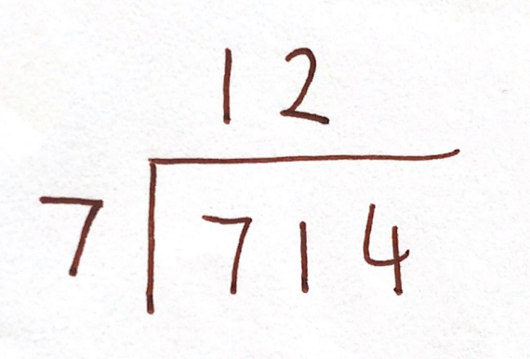

- What error did Jane make?
1 mark

- What is the correct answer?
1 mark

Question 3 (5 Marks)

Students in a Year 7 class were asked:

“How did you go to school?”

The following data was collected.
Transportation | Number of students
On foot | 6
Bus | 4
Car | 1
Bike | 5
Total | 16

- The bar chart below is incomplete. Complete it by including a bar for the number of students who take the bus to school.
1 mark

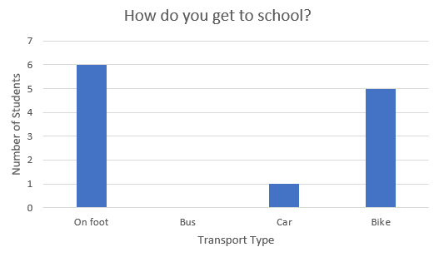

Students were also asked:

“In minutes, how long does it take you to get to school”

The following data was collected.

Student 1 | Student 2 | Student 3 | Student 4 | Student 5 | Student 6 | Student 7 | Student 8
28 | 15 | 17 | 11 | 22 | 31 | 14 | 23

Student 9 | Student 10 | Student 11 | Student 12 | Student 13 | Student 14 | Student 15 | Student 16
17 | 12 | 16 | 11 | 5 | 15 | 11 | 8

- What is the mode of time taken to get to school in this class?
1 mark

- What is the range of time taken to get to school in this class?
1 mark

- What is the median of time taken to get to school?
1 mark

- What is the mean of time taken to get to school?
1 mark

Question 4 (2 Marks)

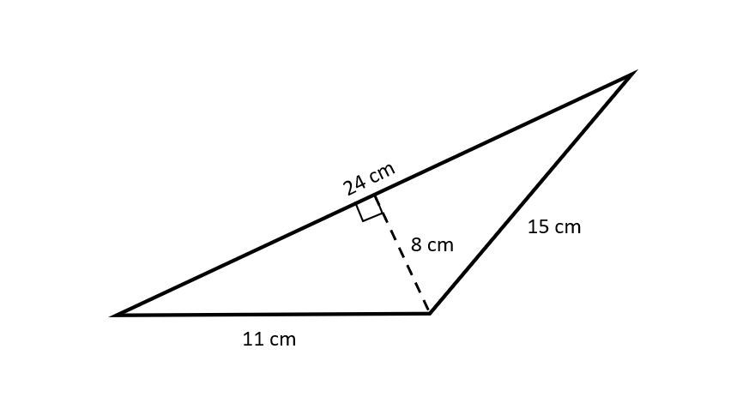
Sam and Jimmy are discussing how to figure out the area of a tringle using the formula
$A=\frac{base ×height}{2}$. Sam says the base is 11cm, whereas Jimmy says the base is 24cm. Who is right and why?
2 marks

Question 5 (6 Marks)

- Fill in the boxes to create equivalent fractions.
- Find the equivalent fraction of the following 1 mark
$$\frac{3}{8}=\frac{\boxed{}}{24}$$

- Find the equivalent fraction of the following 1 mark
$$\frac{3}{8}=\frac{\boxed{}}{40}$$

- The fraction $\frac{a}{b}$ in the equation below is in simplified form. Use one of your answers above to help you find the value of $a$ and $b$. 2 marks
$$\frac{5}{4}×\frac{a}{b}=\frac{3}{8}$$

$$a=________ b=_________$$

- Check your answer to part b above by calculating $\frac{3}{8}÷\frac{5}{4}$. Show all your working.
2 marks

Question 6 (2 Marks)

John agrees to a pocket money scheme. He gets 2¢ in Week 1, 4¢ in Week 2, 8¢ in Week 3 and continue to get double the amount of money each week.

How much pocket money does John get in Week 15? Give your answer in dollars.
2 marks

Question 7 (6 Marks)

Ms Ashkar is creating an artwork, which when viewed from above, resembles Pinocchio’s face. She has 310 m of rope and needs the face to be 65 m tall.

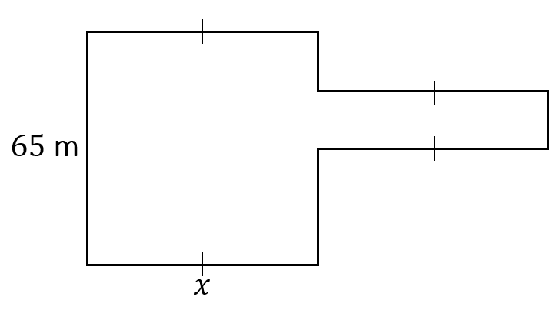
$P=310$m

- What is the length of Pinocchio’s nose? 2 marks

- The area of Pinocchio’s face, shaded in grey below, is 3900 m².

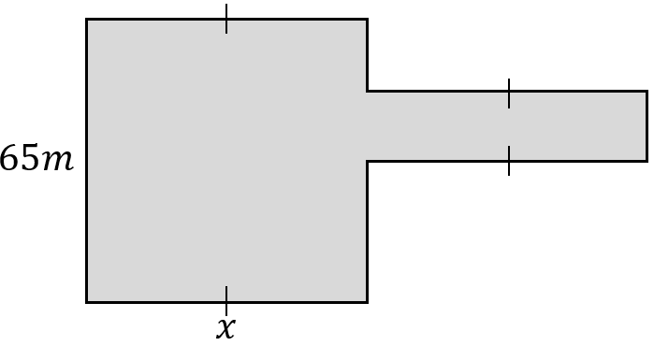

A triangle will be included as an eye for Pinocchio, and its area is 5% of the shaded area in the diagram above. What is the area of the triangular eye?
1 mark

- Given that the eye must be contained within the face (with no part contained within the nose), the height of the triangle is greater than the base and that the base and height must be whole numbers, determine all possible dimensions of the triangle.
3 marks



