
Mathematics 2022 PRACTICE EXAM

Student Name:

Year 7 SEAL Mathematics
Written Examination

Revision Week – Term 4 Week 6
Reading Time: 5 minutes
Writing Time: 70 minutes

Question and Answer Book

Structure of book
Section | Number of questions | Number of questions to be answered | Number of marks
A | 4 | 4 | 4
B | 10 | 10 | 23
C | 7 | 7 | 20
 |  |  | Total 37

- Students are permitted to bring into the examination room: pens, pencils, highlighters, erasers, sharpeners, rulers, a protractor, set squares, aids for curve sketching, one bound reference, one approved technology (calculator or software) and, if desired, one scientific calculator. Calculator memory DOES NOT need to be cleared. For approved computer-based CAS, full functionality may be used.
- Students are NOT permitted to bring into the examination room: blank sheets of paper and/or correction fluid/tape.
Materials supplied
- Question and answer book of 11 pages
- Formula sheet
- Answer sheet for multiple-choice questions
Instructions
- Write your student name in the space provided above on this page.
- Check that your name is on your answer sheet for multiple-choice questions l
- Unless otherwise indicated, the diagrams in this book are not drawn to scale.
- All written responses must be in English.
At the end of the examination
- Place the answer sheet for multiple-choice questions inside the front cover of this book.
- You may keep the formula sheet.

Do you have your calculator with you today? Please circle:

Yes / No

Do you have your summary page with you today? Please circle:

Yes / No

Remember, for the real exam, I will only be reporting a percentage for Section A and Section B. Only a written comment will be made on Section C. Section C is intended to provide a high level of challenge.

Students are NOT permitted to bring mobile phones and/or any other unauthorised electronic devices into the examination room.

SECTION A – Multiple-choice questions
Instructions for Section A
Answer all questions in pencil on the answer sheet provided for multiple-choice questions. Choose the response that is correct for the question.
A correct answer scores 1; an incorrect answer scores 0. Marks will not be deducted for incorrect answers.
No marks will be given if more than one answer is completed for any question. Unless otherwise indicated, the diagrams in this book are not drawn to scale.

Question 1

Which of the following describes the number 42:

A | Even and square
B | Even and prime
C | Odd and a multiple of 3
D | Even and a multiple of 6
E | Odd and a multiple of 7

Question 2

What is the solution to the equation $3x=12$?

A | $$x=4$$
B | $$x=36$$
C | $x=15$
D | $$x=9$$
E | None of the above

Question 3

$4.5273$ is rounded to 2 decimal places, is:

A | 4.50
B | 4.52
C | 4.527
D | 4.53
E | 4.530

Question 4

The LCM of $2^{3}×3^{2}×7^{3}$ and $2^{5}×3^{3}×5^{2}$ is:

A | $$2^{3}×3^{2}$$
B | $2×3×5×7$
C | $$2^{5}×3^{3}×5^{2}×7^{3}$$
D | $2^{3}×3^{2}×5^{2}×7^{3}$
E | $$2^{8}×3^{3}×5^{2}×7^{3}$$

Section B
Instructions for Section B
Answer all questions in the spaces provided.
In all questions where a numerical answer is required, an exact value must be given unless otherwise specified. In questions where more than one mark is available, appropriate working must be shown.
Unless otherwise indicated, the diagrams in this book are not drawn to scale.

Question 1 (2 Marks)

Jane needed to split 714 paper clips to 7 classes. She tried work out how many paper clips per class using division algorithm below.

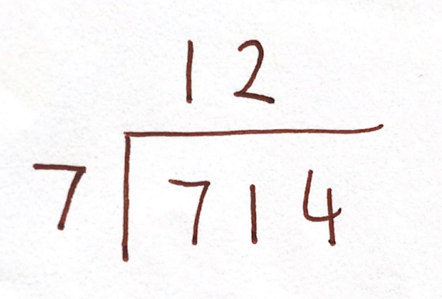

- What error did Jane make?
1 mark

- What is the correct answer?
1 mark

Question 2 (2 Marks)

Students in a Year 7 class were asked:

“In minutes, how long does it take you to get to school”

The following data was collected.

Student 1 | Student 2 | Student 3 | Student 4 | Student 5 | Student 6 | Student 7 | Student 8
28 | 15 | 17 | 11 | 22 | 31 | 14 | 23

Student 9 | Student 10 | Student 11 | Student 12 | Student 13 | Student 14 | Student 15 | Student 16
17 | 12 | 16 | 11 | 5 | 15 | 11 | 8

- What is the median of time taken to get to school?
1 mark

- What is the mean of time taken to get to school? Give your answer to one decimal place.
1 mark

Question 3 (2 Marks)

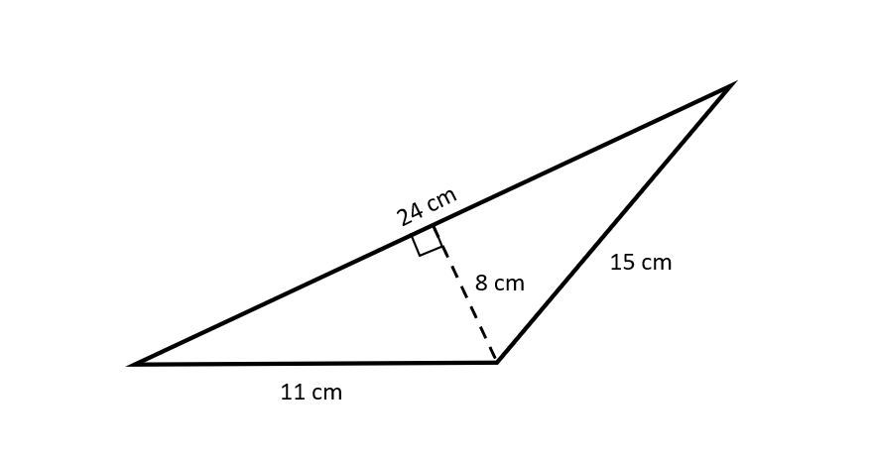
Sam and Jimmy are discussing how to figure out the area of a tringle using the formula
$A=\frac{base ×height}{2}$. Sam says the base is 11cm, whereas Jimmy says the base is 24cm. Who is right and why?
2 marks

Question 4 (6 Marks)

- Fill in the following boxes to create equivalent fractions.
- 1 mark
$$\frac{3}{8}=\frac{\boxed{}}{24}$$

- 1 mark
$$\frac{3}{8}=\frac{\boxed{}}{40}$$

- The fraction $\frac{a}{b}$ in the equation below is in simplified form. Use one of your answers above to help you find the value of $a$ and $b$. 2 marks
$$\frac{5}{4}×\frac{a}{b}=\frac{3}{8}$$

$$a=________ b=_________$$

- Check your answer to part b) above by calculating $\frac{3}{8}÷\frac{5}{4}$. Show all your working.
2 marks

Question 5 (2 Marks)

John agrees to a pocket money scheme. He gets 2¢ in Week 1, 4¢ in Week 2, 8¢ in Week 3 and continue to get double the amount of money each week.

How much pocket money does John get in Week 15? Give your answer in dollars.

Question 6 (3 Mark)

Solve $\frac{9\sqrt{x-1}}{3}+1=\frac{19}{4}$
3 marks

Question 7 (6 Marks)

Ms Ashkar is creating an artwork, which when viewed from above, resembles Pinocchio’s face. She has 310 m of rope and needs the face to be 65 m tall.

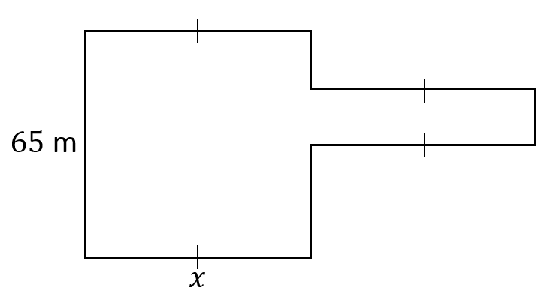
$P=310$m

- What is the length of Pinocchio’s nose? 2 marks

- The area of Pinocchio’s face, shaded in grey below, is 3900 m².

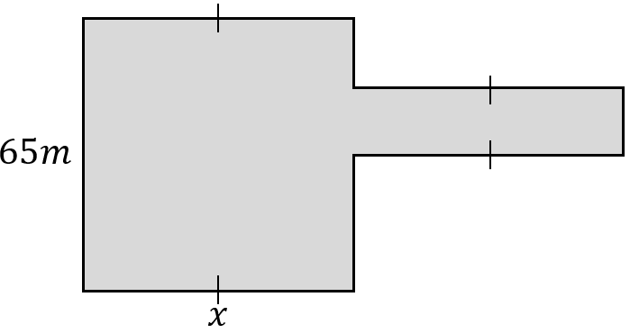

A triangle will be included as an eye for Pinocchio, and its area is 5% of the shaded area in the diagram above. What is the area of the triangular eye?
1 mark

- Given that the eye must be contained within the face (with no part contained within the nose), the height of the triangle is greater than the base and that the base and height must be whole numbers, determine all possible dimensions of the triangle.
3 marks

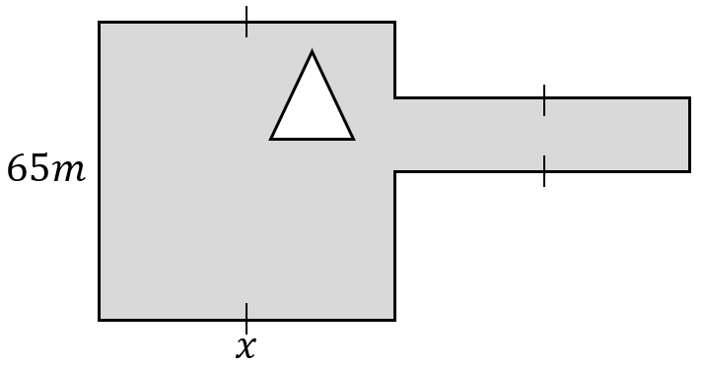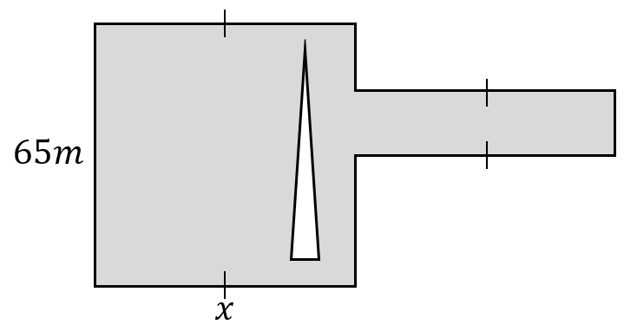

Section C
Instructions for Section C
Answer all questions in the spaces provided.
In all questions where a numerical answer is required, an exact value must be given unless otherwise specified. In questions where more than one mark is available, appropriate working must be shown.
Unless otherwise indicated, the diagrams in this book are not drawn to scale.

Question 1 (1 mark)

What is the 21st triangle number?
1 mark

Question 2 (3 marks)

Consider the number 365 172

- By stating the appropriate divisibility test, show that this number is divisible by 4.
1 mark

- By stating the appropriate divisibility test, show that this number is divisible by 6.
1 mark

- Which of the following statements is correct?
  - Since this number is divisible by 4 and 6 it is also divisible by 24
  - Since this number is divisible by 4 and 6 it is also divisible by 12
  - Since this number is divisible by 4 and 6 it is also divisible by 12 and 24

1 mark

- Explain your reasoning for question i) above.
1 mark

Question 3 (1 mark)

How many four-digit numbers can you create using the digits 1, 5, 5, 6?
Note that every digit must appear exactly as many times as it is listed. For example, 5156 is allowed though 1156 and 516 are not.
1 mark

Question 4 (3 marks)

How many factors does 10¹⁹ have?

Question 5 (3 marks)

Consider the following arithmetic sequence:

6, 10, 14, 18,…

- What is the 20th term?
1 mark

- What is the sum of the first 20 terms?
2 marks

Question 6 (3 marks)

What is the smallest value of n such that $\frac{n}{15840}$will produce a terminating decimal?

Question 7 (2 marks)

How many ways can the numbers 1, 2, 3, 4, 5 and 6 be arranged in a row so that the product of any two adjacent numbers is even?

Question 8 (3 marks)

Let $T_{n}$ be the n^{th} triangle number. Eg. $T_{1}=1$, $T_{2}=3$ and $T_{3}=6$. What is the value of:
$${\left(T_{1000}\right)}^{2}-{\left(T_{999}\right)}^{2}$$

